**IMAGE RECOGNITION USING IBM CLOUD VISUAL RECOGNITION**

**Image Recognition:**

Image recognition is the process of identifying an object or a feature in an image or video. It is used in many applications like defect detection, medical imaging, and security surveillance.

**Visual Recognition:**

Visual recognition is perceiving an item, animal, or person and knowing what is because you have seen it before or seen something similar. When we recognize something, we compare something in view to the huge library in our visual memory. We have a visual template that we are consistently using to match what we see.

The **Convolutional Neural Network(CNN)** is mainly used for image recognition.

The benefits of the image recognition is **Accuracy and Efficiency.**

**Flowchart for image recognition:**

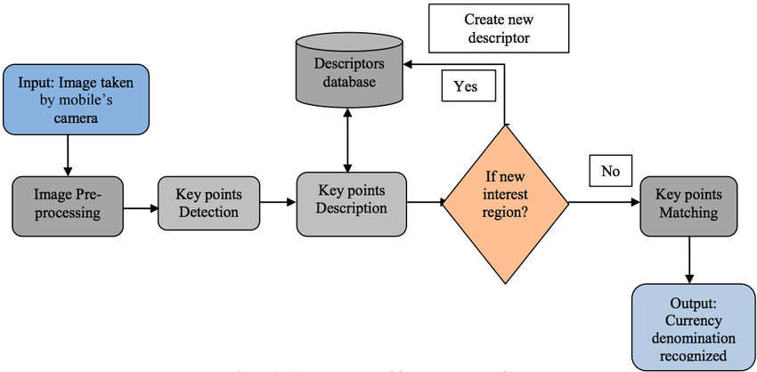

**Steps to complete the image recognition using IBM cloud visual recognition:**

**1.Sign Up for IBM Cloud**

**2.** **Create a Visual Recognition Service:**

Log in to your IBM Cloud account.

From the IBM Cloud dashboard, click "Create Resource" and search for "Visual Recognition" in the catalog.

Select the Visual Recognition service and create an instance of it. You can choose a Lite plan, which is typically free within certain usage limits.

**3.Collect and Prepare Your Images:**

Gather a dataset of images you want to recognize. Make sure your images are labeled or categorized appropriately for your use case.

**4.Train a Custom Model:**

In the IBM Cloud Visual Recognition service, navigate to your instance.

Click on "Create a Model."

Upload your labeled images and organize them into classes or categories.

Start the training process. The service will create a custom model for image recognition based on your data.

**5.Test Your Model:**

After training is complete, you can test your model by uploading new images to the service and checking the recognition results. You can do this through the IBM Cloud dashboard or by using the API.

**6.Use the API for Integration:**

To integrate image recognition into your applications, you can use the API provided by IBM Cloud Visual Recognition.

The API allows you to send images for recognition and receive responses with classification results.

**7.Refine and Improve:**

Evaluate the accuracy of your model and refine it as needed. You can retrain the model with additional data to improve its recognition capabilities.

IBM Cloud Visual Recognition provides tools for retraining and adding more data to your model.

**8.Deploy in Production:**

Once you are satisfied with the performance of your custom recognition model, you can deploy it in your production applications.

**9.Monitor and Maintain:**

Continuously monitor the performance of your image recognition model and make adjustments or retrain it as your data and requirements change.

**10.Cost Considerations:**

Be aware of the pricing structure of IBM Cloud services, including Visual Recognition. Monitor your usage to ensure it stays within your budget, especially if you are using a paid plan.

**Procedure :**

1. To complete our project, we want to create an account on IBM cloud. Search IBM cloud in the search bar. It shows the IBM cloud link in the top of the search result. Click the link shown in the top of the page.

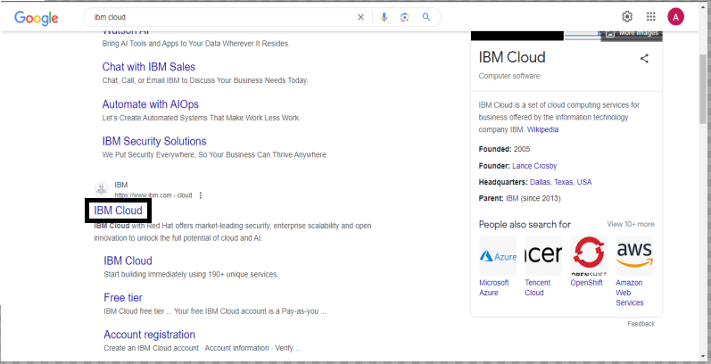

**2.**Next it asks to allow all the cookies of this website. Click accept all cookies option and in the interface it shows create your free account option. Click that option.

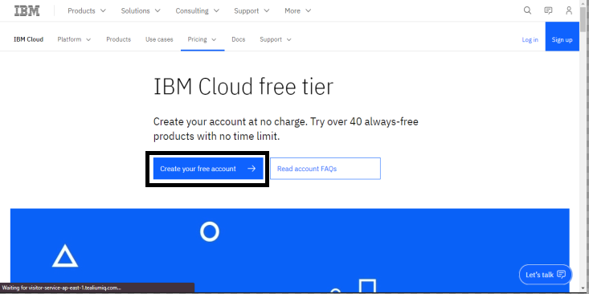

**3.**After click the create your free account option, we are redirect to the sign up page. In that page, we want to enter the email and password and want to verify that email. After verifying our email, it asks personal details of us, enter the details.

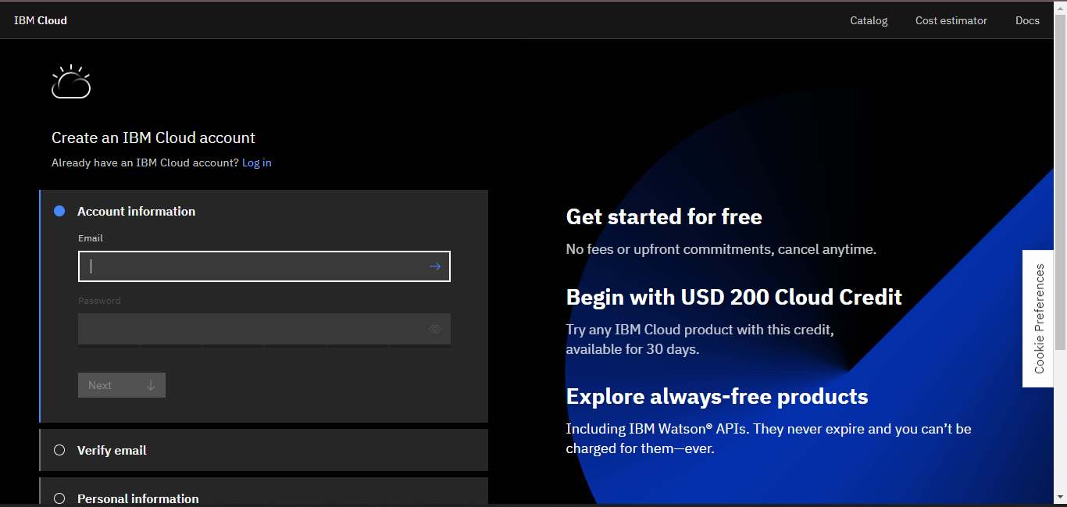

**4.** After provide the personal details, it asks for the company y details and the credit card details. Without using credit card details we can register using the activation code provide in the skillup.

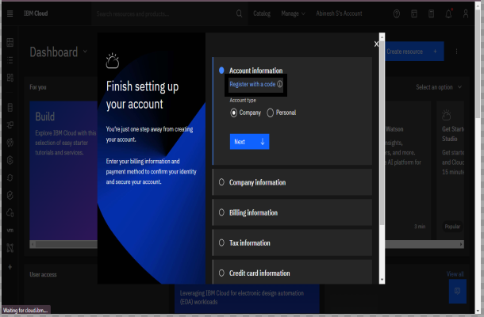

**5.**In skillup search for a course Introduction to cloud and enrol in the that course and in module 1 there is an option “open tool”. Click that option.

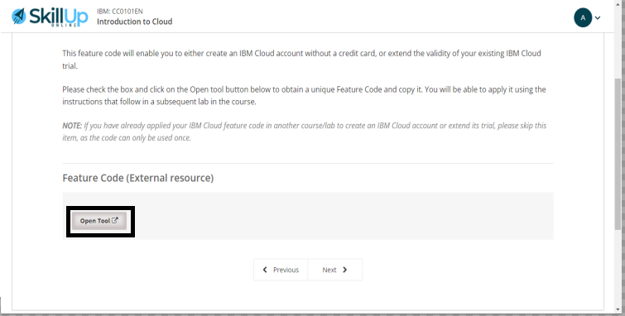

**6.** After the open tool option it ask to click ok to redirect to another page which contains activation code. Copy that code .

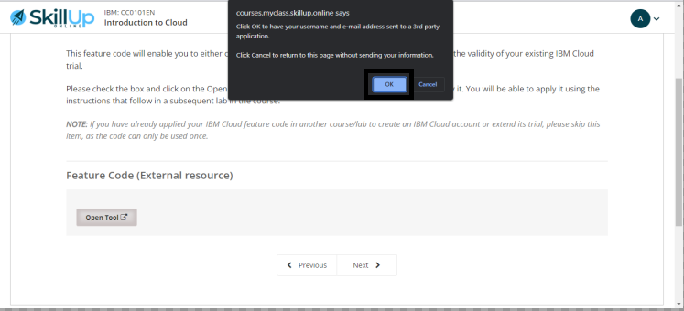

**7.** Enter the code in the IBM cloud Register page and click update account option.

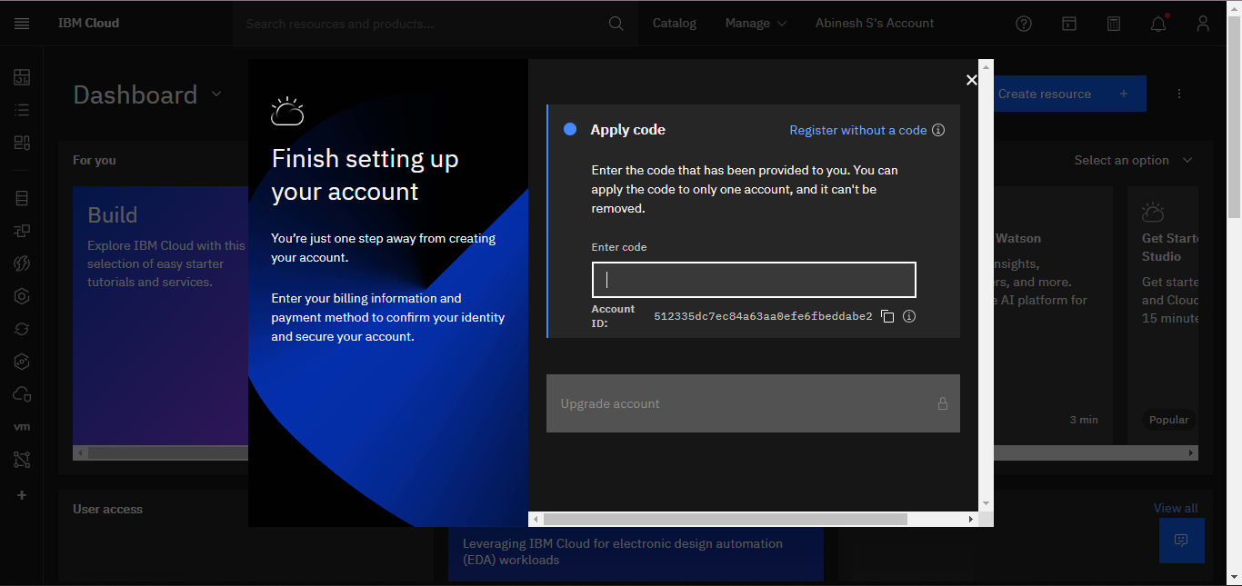

**8.** After the activation code was successfully updated, the interface should be like this. Now you can use the Visual Recognition service to develop the Image Recognition project and test your project that it classify the objects correctly or not.

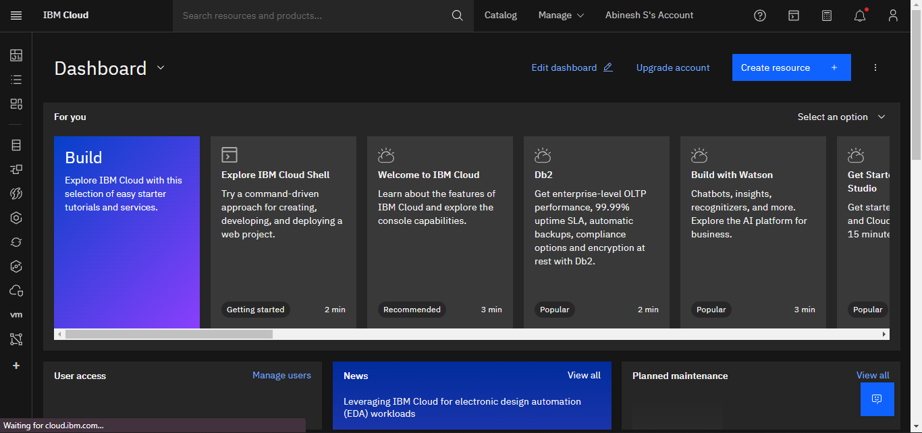

**Step 1:**

After creating the IBM cloud account, we want to get the Visual Recognition service and the API’s which are required.

**1.**Search for the Visual Recognition service in the search catalogue and the results are shown. In the result, select the Visual Recognition service.

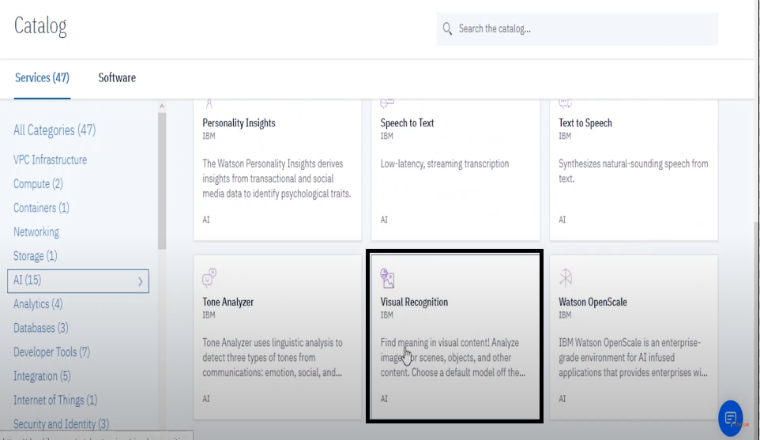

**2.**After that we want set the Region, Service name and Resource group and also select which plan want(free or cost). Then, click the create option to create the service.

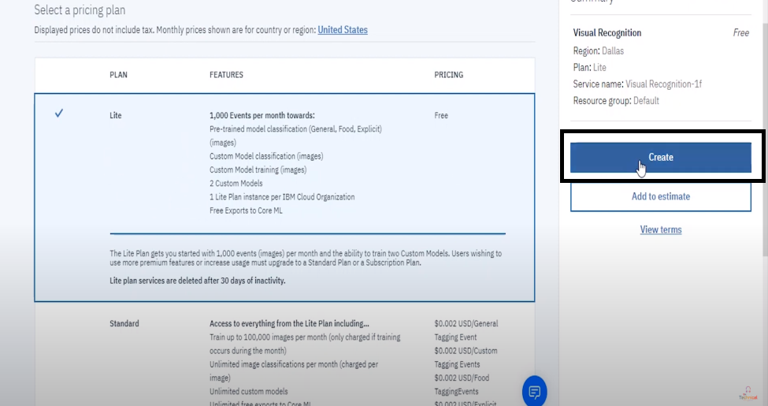

**3.**After created the Visual Recognition service, then you want to create a new project. For that, click the create model option.

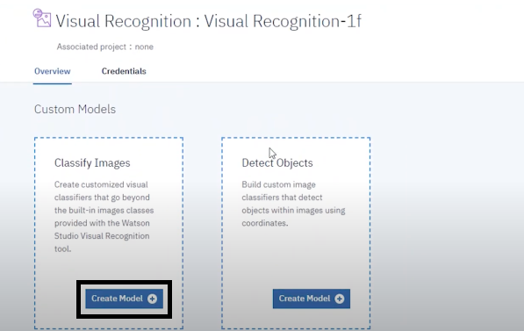

Then, you want to specify the project name, project description, storage and Watson visual recognition. After specified all the details click the create option.

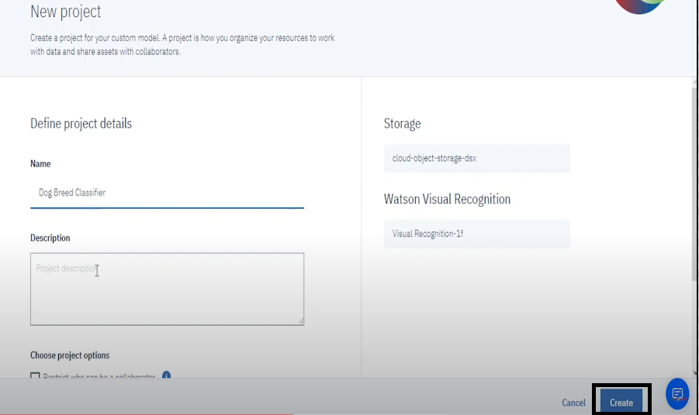

**Step 2:**

**1.**After created the project, then we want to train the model of the dataset. For that, first we want the upload the different images to train the model. Click the browse option, then upload the images.

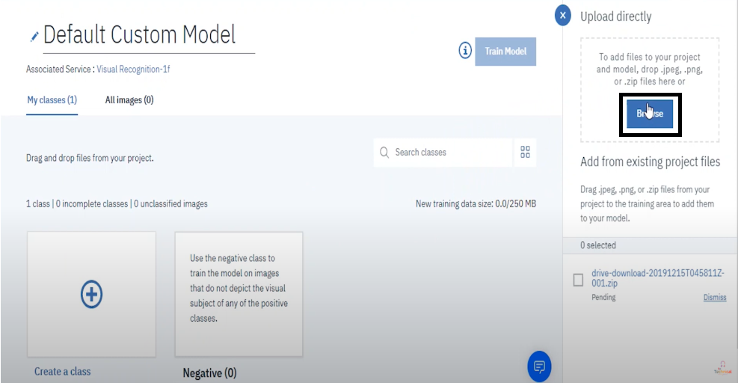

**2.**After the images are uploaded, then we want to train the model. For that, click the Train model option in the top right corner.

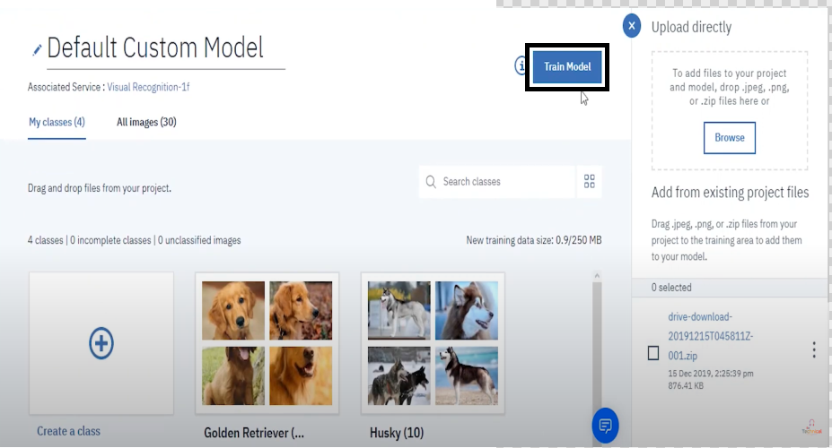

**Step 3:**

After the model was trained, the interface should bee like this.

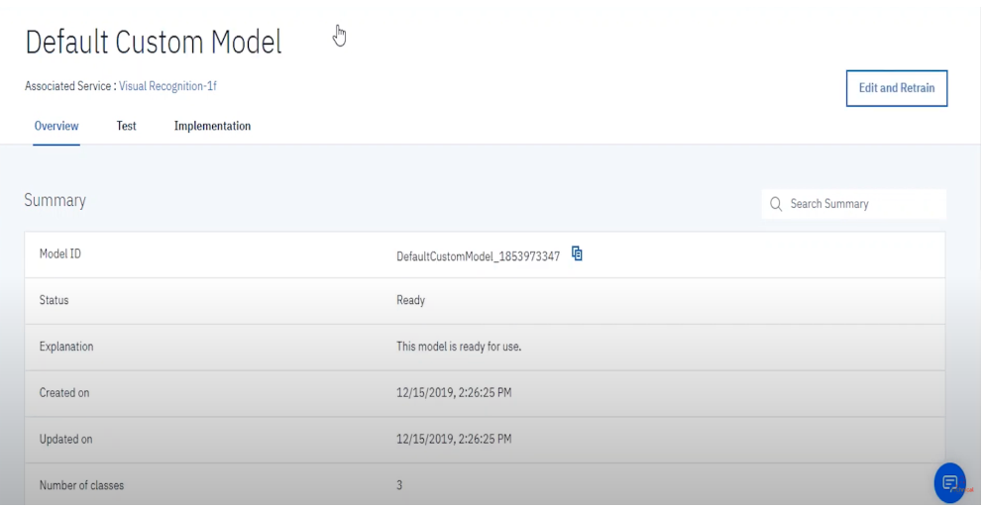

**Step 4:**

Next, we want to test the model to check whether the trained model is correct or wrong. Click test in the menu bar. After that, insert the images which you want to test.

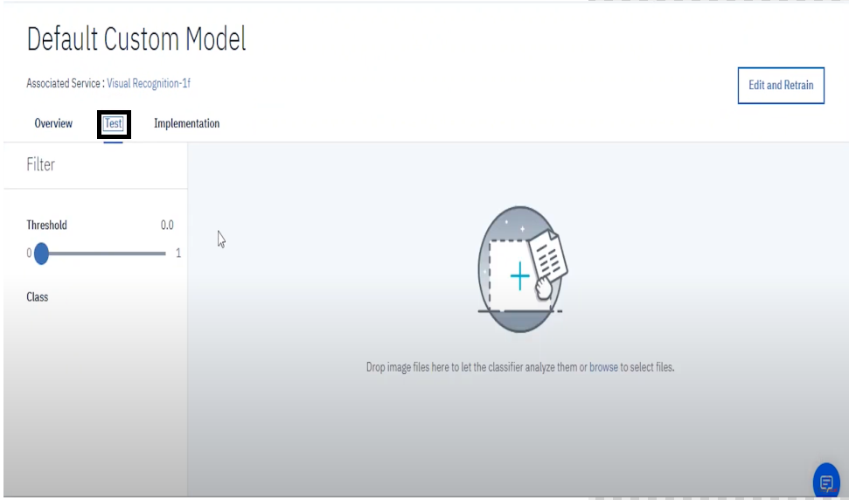

**Step 5:**

In last step, the output of the test model was displayed. By analyse the result, we can check that our trained model was recognize the images accurately or not.

**OUTPUT:**

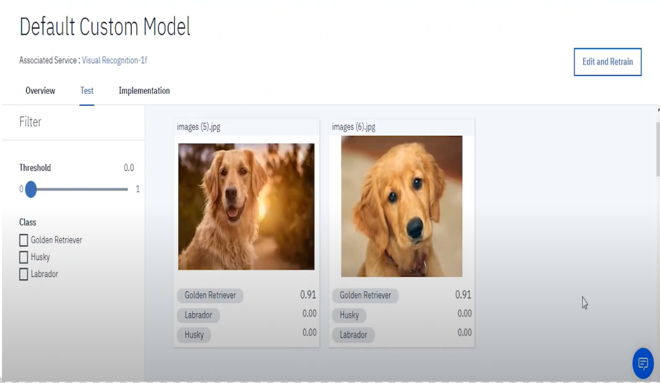

**Result:**

Thus, our project to implement the Image Recognition using IBM Cloud Visual Recognition was successfully developed and deployed in IBM cloud.