A Multi-Level Data-Driven Analysis of Road Traffic Accidents in India:
Geographical, Temporal, Seasonal, Environmental and Severity Assessment
B.Tech Research Report — 2026
[Candidate Name / Roll No. / Department / Institute — to be completed]
LPU-specific official template was not available in the supplied project materials; conventional academic formatting was applied.

Certificate
[Guide certificate placeholder.]

Declaration
[Candidate declaration placeholder.]

Acknowledgement
[Candidate to complete: guide, department, data publishers.]

Abstract
Background: India recorded 487,707 accidents and 177,175 deaths in 2024 (+3.7%/+12.4% since 2018) with severity rising 33.50 -> 36.33 deaths/100 accidents, yet exposure denominators are missing. Objective (RQ1-RQ11): relate geography, time, weather, road-user, violation, and collision factors to occurrence and severity using verified sources. Methods: MoRTH 2018-2024 panel (254 state-years, 38 entities); conditional AR2017 2014-2017 candidate; NCRB ADSI 2024 monthly (separate vintage); IMD rain/temp to states (236 matched of 254 state-years across 38 reporting entities); AR-2024 supporting tables; OLS/corr/chi2/Friedman + BH-FDR; lag-only ML (train 2019-22 N=141; test 2023-2024 N=72) vs naive baseline (acc RMSE 1038.6); K-means (K=2-6). Results: pooled rain r=-0.234/-0.376, Tmax r=+0.452/+0.498, Tmin r=+0.366/+0.340 (associational); severity-weather null; Friedman p=3.0e-4 (descriptive zone differences); NCRB May 8.84%/Jul 7.46%; no trained model beat persistence (acc RMSE 1038.6 vs 2148.6 best trained); K=2 (silhouette 0.356). Conclusion: severity rises while counts fluctuate; risk ranking, causal, and forecasting claims are unsupported; state vehicle stock and microdata are binding gaps. Keywords as above.

Table of Contents

List of Figures

List of Tables

Abbreviations
MoRTH — Ministry of Road Transport and Highways; NCRB — National Crime Records Bureau; ADSI — Accidental Deaths and Suicides in India; IMD — India Meteorological Department; CMPG — Climate Monitoring and Prediction Group; ABDB — Administrative Boundary Database; RGI — Registrar General of India; BRSI — Basic Road Statistics of India; TRW — Transport Research Wing; OLS — Ordinary Least Squares; FDR — False Discovery Rate; BH — Benjamini-Hochberg; RMSE — Root Mean Square Error; MAE — Mean Absolute Error; KNN — K-Nearest Neighbours (supervised); NV — Not Verified.

Chapter 1 — Introduction
Background: India recorded 487,707 accidents and 177,175 deaths in 2024 (+3.7%/+12.4% since 2018); severity rose 33.50 to 36.33 deaths per 100 accidents.
Problem: counts without exposure denominators; fragmented vintages; no microdata. Research gap: reconciliation, geography, and missing-denominator work rarely combined. Research question (observational): how do geographical, temporal, seasonal, environmental, roadway, vehicle and other available factors associate with occurrence and severity?
Objectives 1-13 per Phase 11 (trends; geography; temporal; weather; violations; collisions; road-users; licence/safety; validation; prediction-vs-baseline; clustering; limitations; reusable framework). Scope: 2018-2024 benchmark; conditional history; separate NCRB/IMD/supporting layers.

Chapter 2 — Literature Review
LITERATURE REVIEW SOURCES REQUIRED — no external literature was collected in this package; no citations invented.

Chapter 3 — Research Methodology

Data sources
MoRTH Road Accidents in India reports 2014-2024 (state tables; benchmark 2018-2024, 254 state-years,
38 entities); NCRB ADSI 2024 Table 1A.5 (monthly, separate vintage); IMD Pune CMPG daily grids
(rain 0.25°, Tmax/Tmin 1°, 2018-2024) aggregated to state level via Survey of India ABDB polygons
(equal-cell weighting; area-weighting sensitivity <=0.6%); RGI population projections Table 11
(1 July); BRSI 2020-22 road length (2021-2022 only); MoRTH AR 2024 supporting tables via OpenCity
extraction mirror (collision, violation, road-user, licence, safety-device, cities, exposure).

Verification
State sums reconciled against published India totals for every year/variable (exact matches;
full audit tables in research_acquisition/). NCRB kept vintage-separate (2024 road total 467,967
vs MoRTH 487,707). Historical 2014-2017 extracted single-vintage (AR2017) with 12/12 reconciliations.

Geography
Year-aware harmonization: Telangana direct; J&K undivided pre-2020 (break flagged at 2019-2020);
DNH/Diu summed pre-2020 (MEDIUM, arithmetic); Ladakh values from 2021, NV before.

Statistics
Descriptives, YoY, OLS slopes with 95% CI (N=7/state; low power disclosed), Pearson+Spearman,
chi-square goodness-of-fit, Friedman test (years as blocks), BH-FDR multiple-testing correction,
effect sizes (r, R2, Kendall W). Association language throughout; no causal claims.

Predictive modeling
State-year panel, lag-only features (cutoff T-1), chronological train (targets 2019-2022, N=141)
vs test (2023-2024, N=72), naive persistence baseline, rolling-origin validation, no test-set tuning,
5 supervised regressors incl. KNN Regression (supervised). K-means on standardized state profiles
(K=2-6 diagnostics; K=2 by max silhouette 0.356; ARI stability; PCA for display).

Software
Python (pandas, scipy, scikit-learn, pypdf); all scripts in research_analysis/; seeds fixed (42).

Chapter 4 — Data Sources and Validation
Benchmark: 254 state-years, 38 entities, 0 mismatches. NCRB monthly separate (gap -19,740 vs MoRTH 2024). IMD 236 matched/18 excluded. 7 supporting modules VERIFIED-MIRROR. TN districts reconciled. AR2017 history conditional (12/12 MATCH). RGI projections (not census); BRSI 2021-22 only.

Chapter 5 — India-Level Analysis
Accidents 470,403 to 487,707 (+3.7%) with 2020 dip -18.6%; fatalities 157,593 to 177,175 (+12.4%); OLS slopes ns (N=7).
Figure F01. F01. Annual road accidents in India, 2018-2024 (verified MoRTH benchmark). Recorded totals
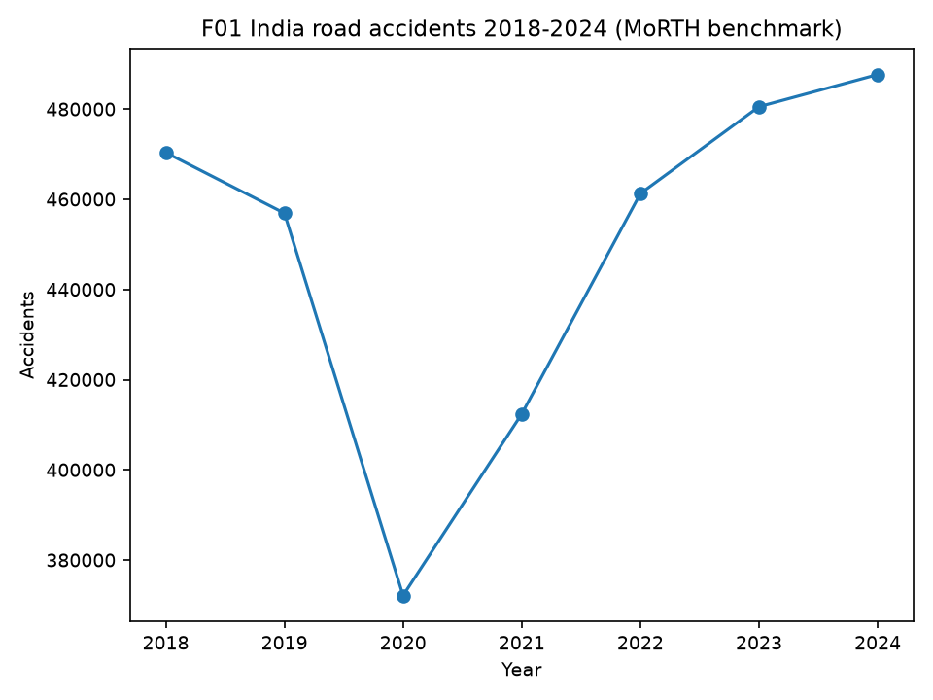
Figure F02. F02. Annual road fatalities in India, 2018-2024 (MoRTH benchmark). Fatalities rose 12.4%, faster
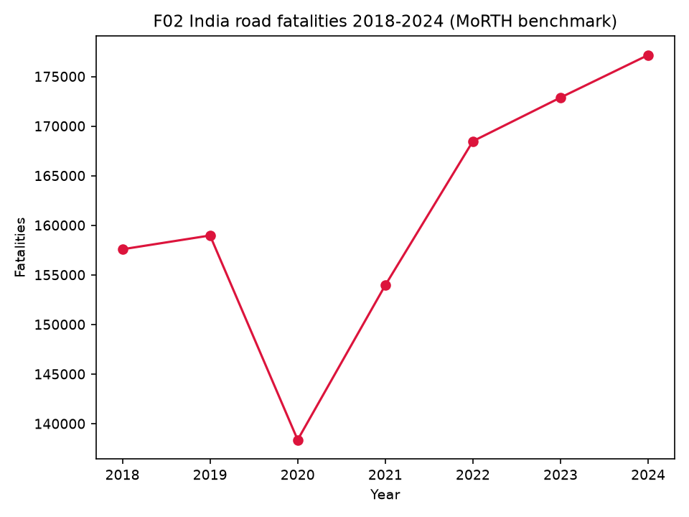
Figure F03. F03. Fatality ratio, deaths per 100 accidents, 2018-2024 (derived). Rose 33.50 to 36.33; a
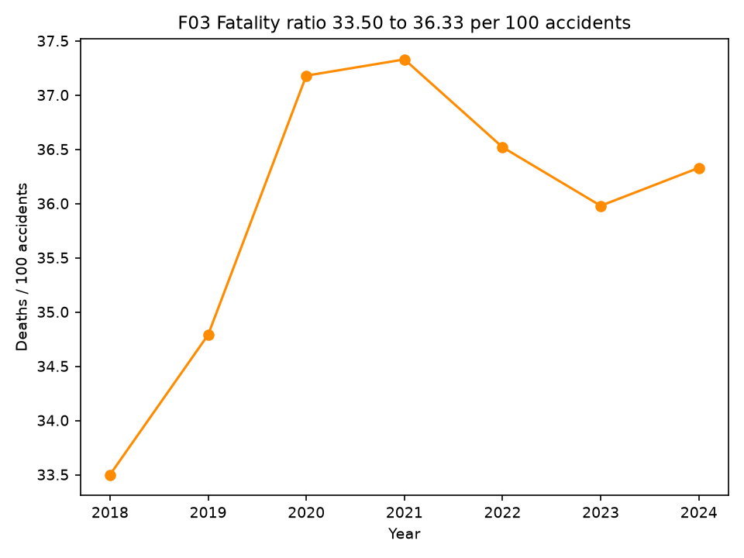

Chapter 6 — Geographical Analysis
38 entities; six zones; Friedman chi2=25.29, p=3.0e-4, W=0.72 (descriptive differences, no ranking). State slopes mostly non-detectable.
Figure F04. F04. Zone accident trends by six zones (benchmark + mapping). Descriptive differences only; no ranking.
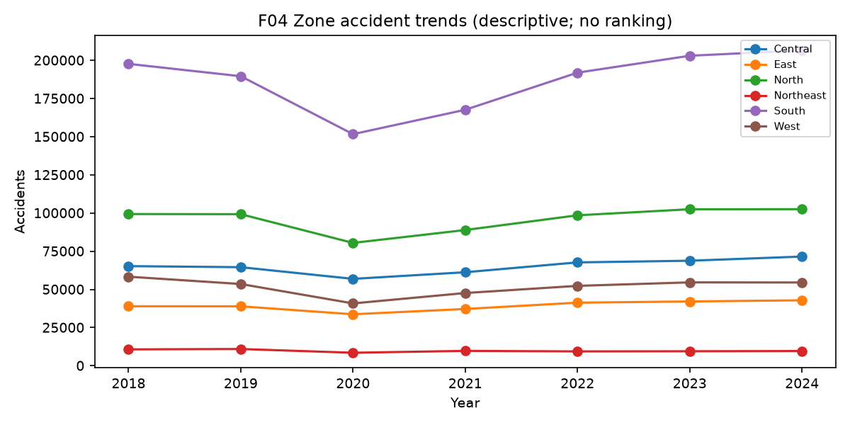
Figure F05. F05. State-year accident heatmap, 38 entities x 2018-2024. Missing (NV) shown as missing, never zero.
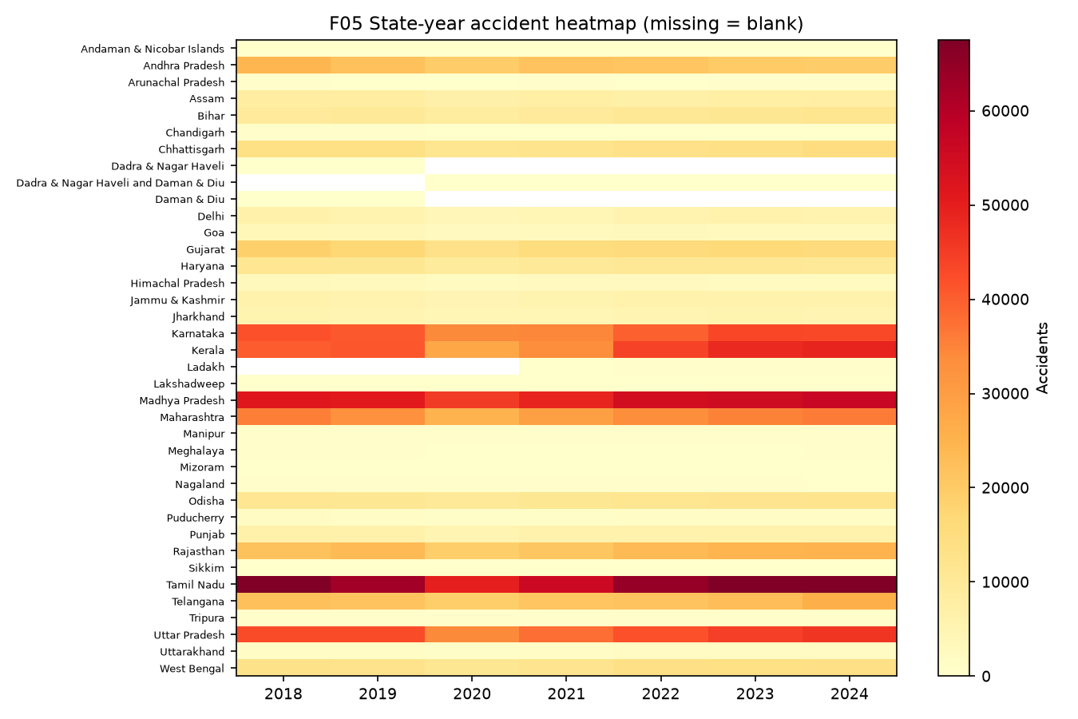
Figure F06. F06. State accident/fatality slopes with 95% CI (OLS, N=7). Wide intervals; most non-detectable.
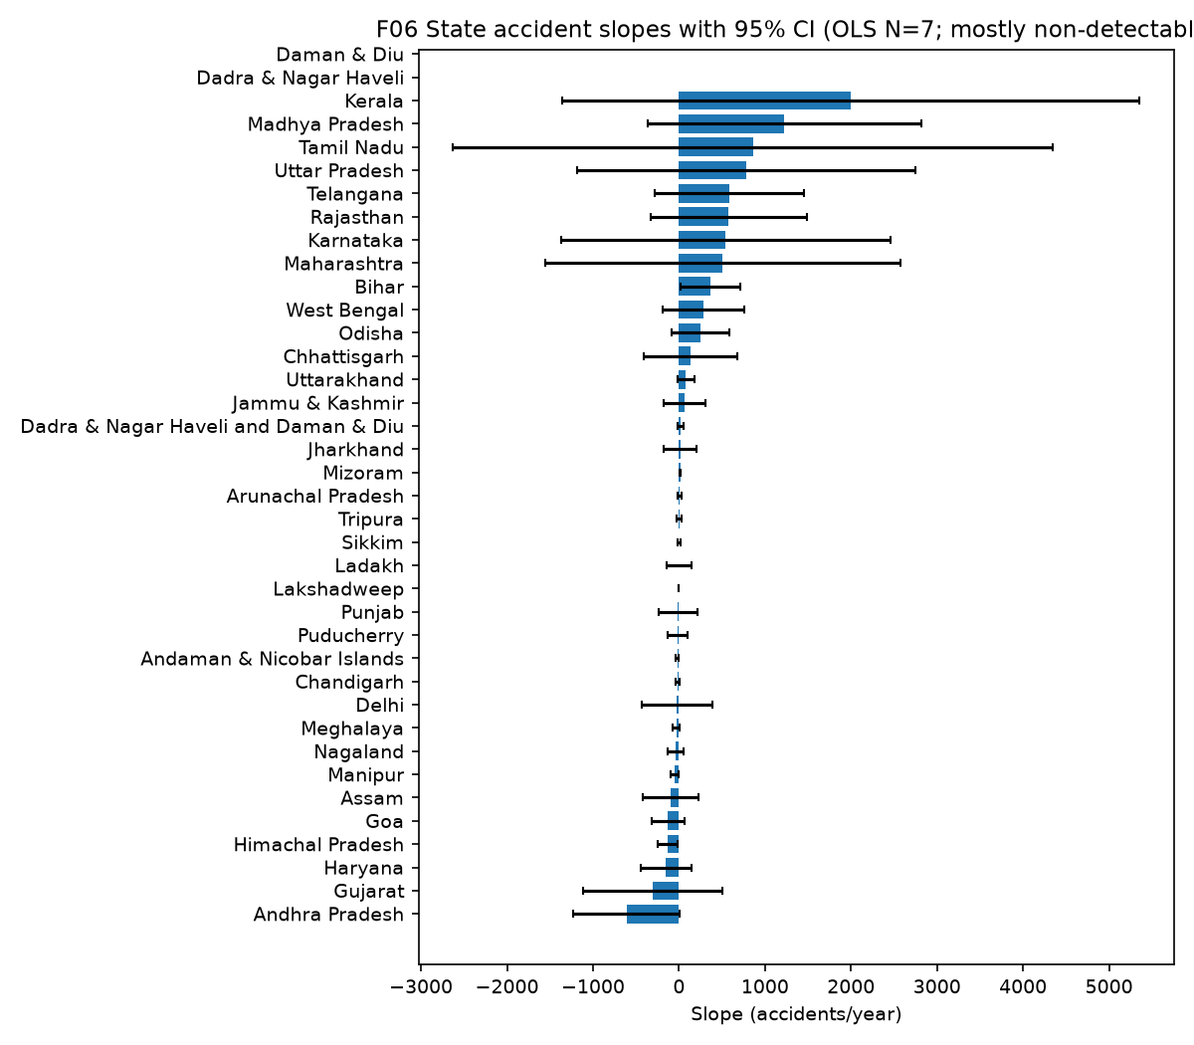

Chapter 7 — Temporal and Seasonal Analysis
Annual fluctuation with 2020 structural break; NCRB 2024 monthly peak May 8.84%, trough July 7.46% (NCRB vintage, never merged to MoRTH).
Figure F13. F13. 2024 monthly road accidents, NCRB ADSI Table 1A.5 Road-States (NCRB vintage, NOT MoRTH). May peak, July trough.
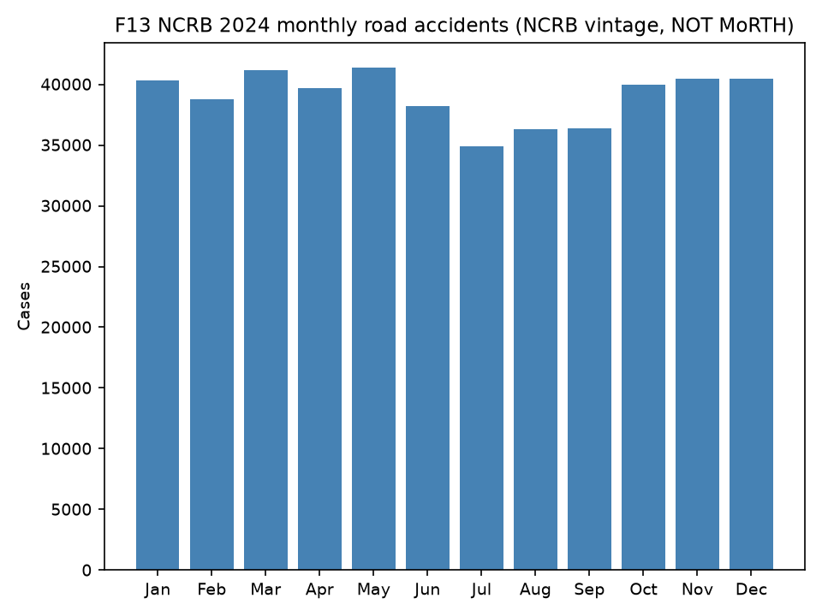

Chapter 8 — Environmental Analysis
Pooled rain r=-0.234/-0.376; Tmax +0.452/+0.498; Tmin +0.366/+0.340 (FDR-held, N=236). Scale confounding disclosed; severity null; never causal.
Figure F07. F07. State-year rainfall vs accidents (IMD join, N=236). Pooled r=-0.234; scale confounding likely; not causal.
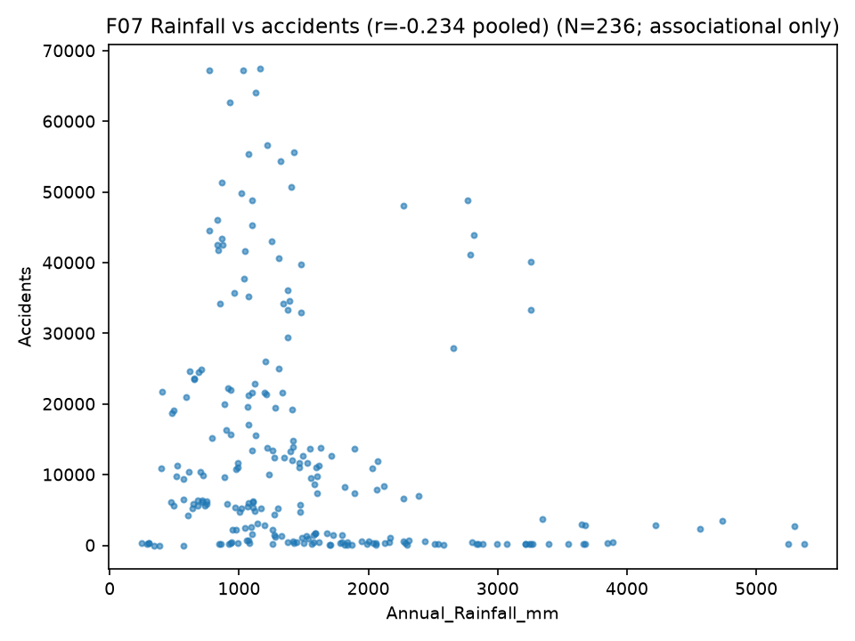
Figure F08. F08. State-year mean Tmax vs fatalities (N=236). Pooled r=+0.498; associational only.
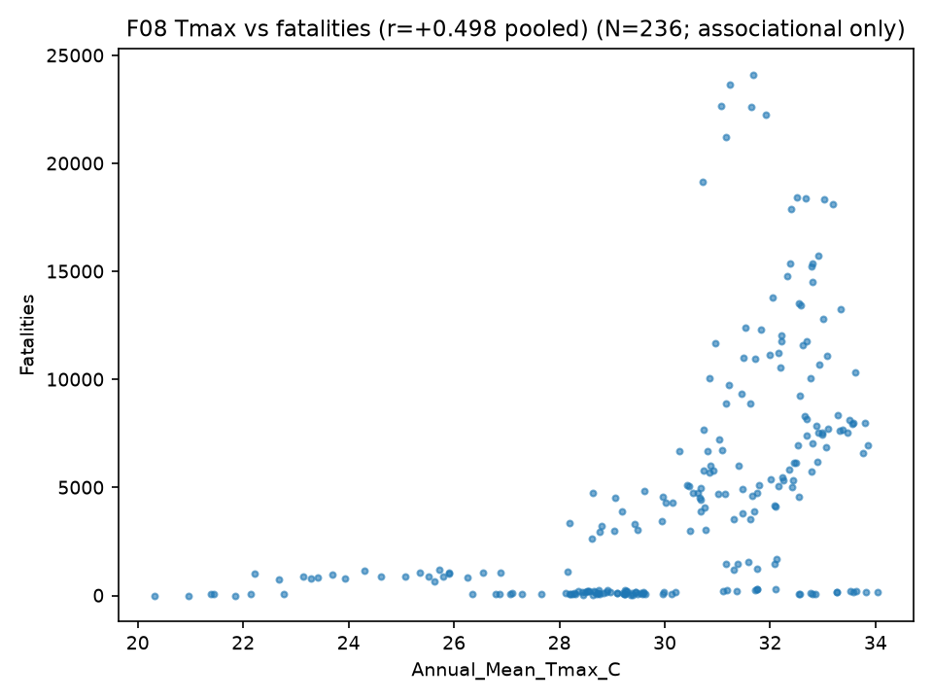

Chapter 9 — Severity, Cause, Collision and Road-User Analysis
Over-speeding 70.7% accidents / 70.3% fatalities (reported category). Hit from Back most frequent; Hit and Run ratio ~0.50. Two-wheelers 46.2%, pedestrians 20.6% (counts, not risk). Valid licence 68.2% of reported accidents. No-helmet 54,122 / no-seatbelt 14,466 deaths (toll).
Figure F09. F09. 2024 fatalities by reported violation category (MoRTH AR2024 mirror, India-level). Over-speeding
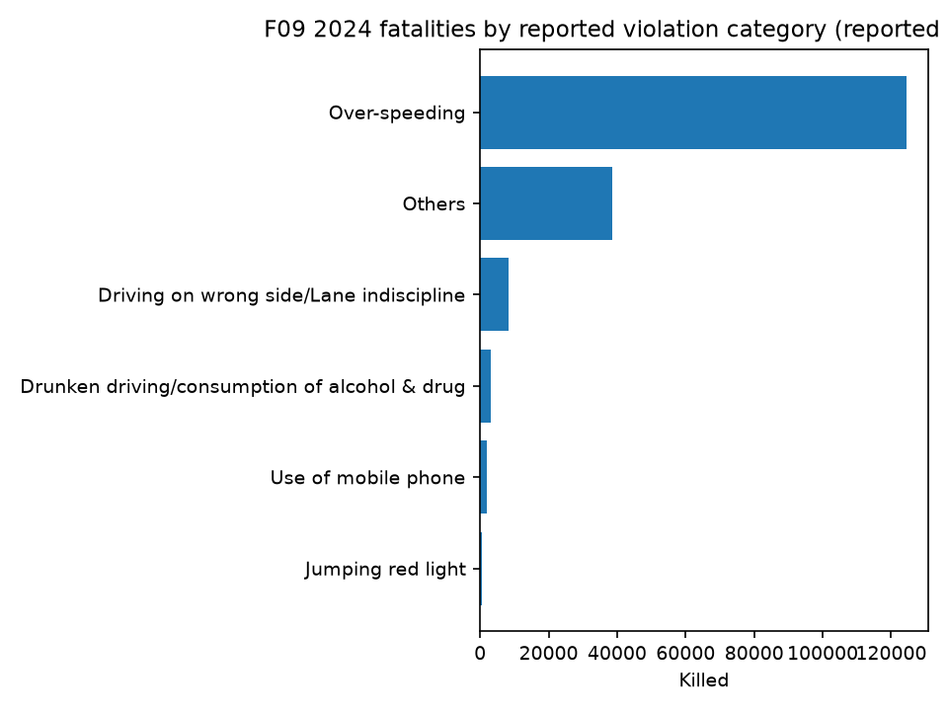
Figure F10. F10. 2024 accidents by collision type (AR2024 mirror). Descriptive configuration mix.
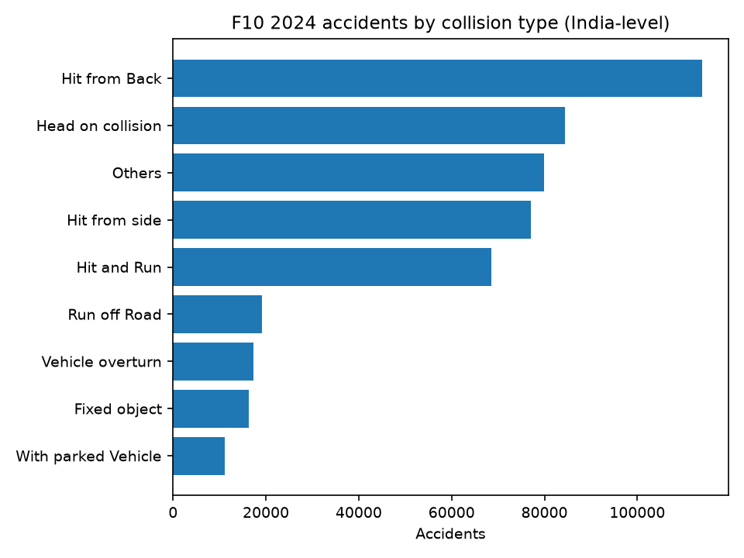
Figure F11. F11. 2024 fatalities by road-user mode (AR2024 mirror). Counts without exposure; largest count is not highest risk.
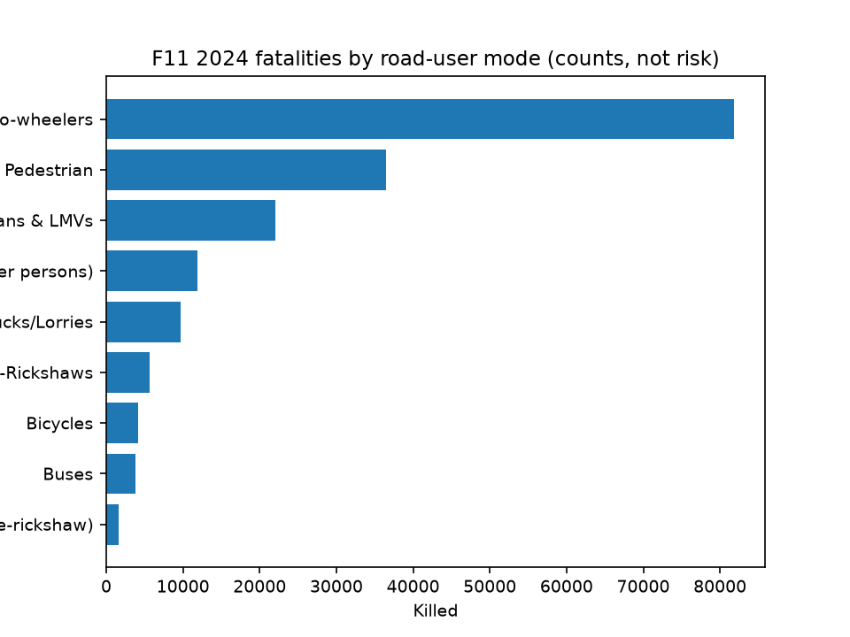
Figure F12. F12. 2024 licence-status accidents and safety-device non-use toll (AR2024 mirror). Reported categories only.
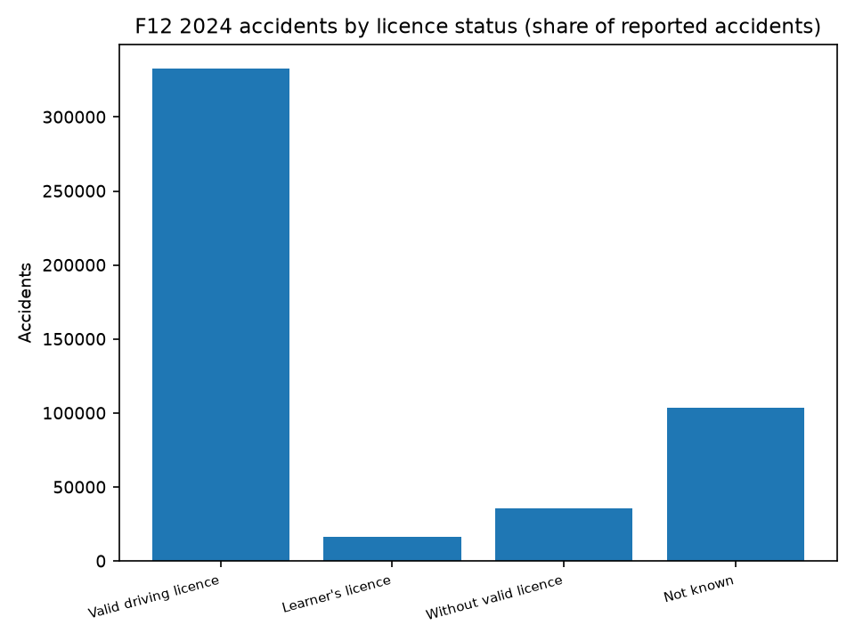
Figure F14. F14. Tamil Nadu district accidents 2021-2023 (district CSV; sums == benchmark TN). TN-only evidence.
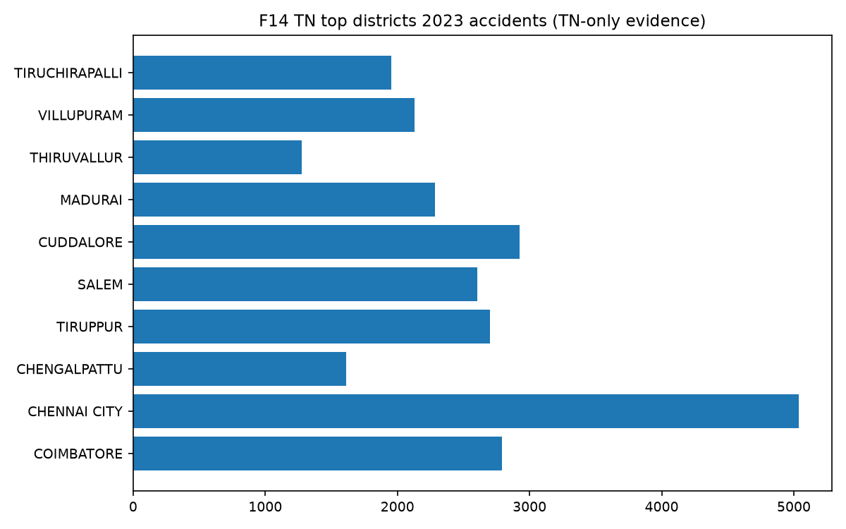

Chapter 10 — Statistical Analysis
OLS with CI; Pearson+Spearman; chi-square monthly (1276, large-N); Friedman; BH-FDR; effect sizes. Near-zero rule |slope|<=0.5% of mean (documented).

Chapter 11 — Machine Learning and Clustering
Lag-only features, train 2019-22 (N=141), test 2023-24 (N=72), naive baseline RMSE 1038.6/286.3 beats ALL trained models (honest null; GBR train R2~1.0 = overfitting). KNN supervised. K-means K=2, silhouette 0.356, descriptive labels, ARI stability.
Figure F15. F15. Actual vs predicted accidents with test-RMSE comparison (2023-2024 holdout). Naive persistence
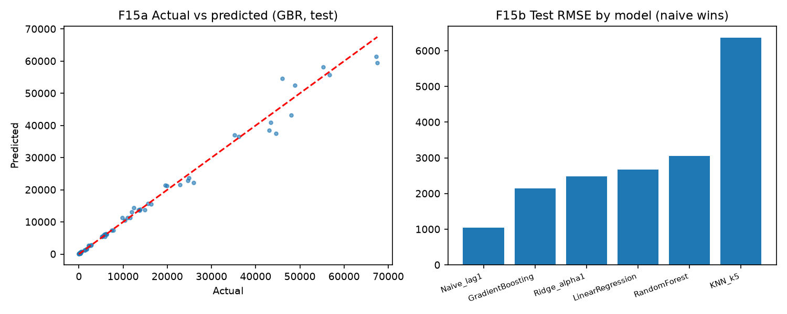
Figure F16. F16. K-means K-selection and PCA cluster scatter (K=2, silhouette 0.356). Exploratory typology; descriptive labels.
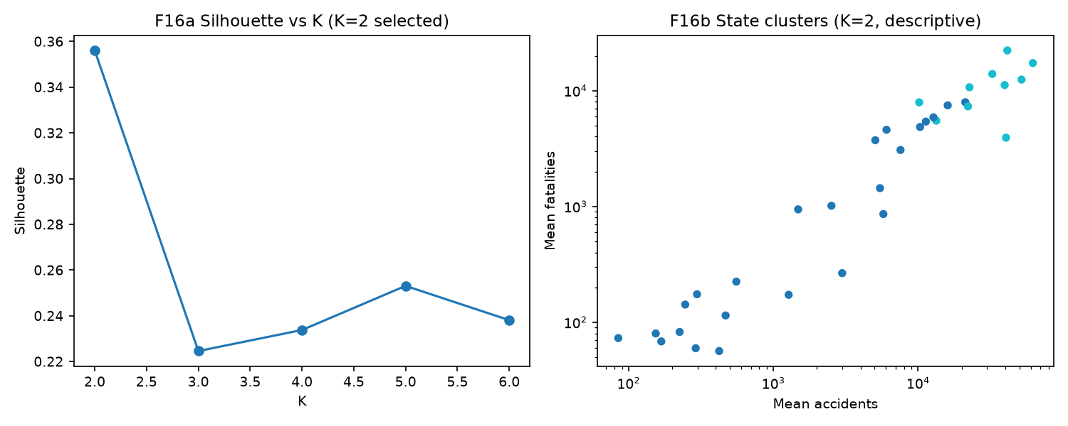

Chapter 12 — Discussion

What the results show
Deaths outpace accidents (+12.4% vs +3.7%), so severity rises (33.5 -> 36.3/100 acc) while counts
fluctuate. State patterns are heterogeneous but low-powered (N=7). Weather shows robust pooled
associations whose direction survives FDR, yet between-state scale differences plausibly drive much
of the pooled signal; within-state evidence is low-power. Severity shows no weather association.

What they do not show
No causal effects (observational, no identification); no risk ranking (no exposure denominators);
no reliable forecasting (persistence beats trained models); no climate-season claims (quarters only).

Counts vs risk
Raw counts reflect exposure (population, vehicles, road use). All state/zone/city comparisons use
"recorded counts", never "risk". Vehicle-stock exposure remains the binding missing denominator.

Why persistence won
Strong year-to-year autocorrelation + small panel + scale-dominated variance: last year's count is
the best predictor. GBR's train R2~1.0 vs test loss is textbook overfitting under small N.

K-means is exploratory
K=2 typology describes, never explains; no exposure-based risk labels.

Vintage discipline
NCRB monthly, AR2017 history, IMD weather, RGI projections each carry vintage labels; mixing them
would create false precision. The 2019 benchmark revision and J&K break are flagged, not smoothed.

Missing pieces that matter most
State vehicle stock, accident-level microdata with coordinates, MoRTH monthly series.

Chapter 13 — Limitations
Vehicle stock, microdata/coords, driver/vehicle detail, humidity etc., monthly MoRTH, single-state districts, 2023-24 state injuries, conditional history, N=213 panel. Full matrix: PHASE10_LIMITATIONS_MATRIX.csv.

Chapter 14 — Contributions
1. Verified 2018-2024 MoRTH state-year benchmark (254 obs, 0 mismatches) with vintage control.
2. Year-aware geography harmonization incl. conditional 2014-2024 candidate (396 rows, 11/11 reconciliations).
3. IMD weather integration (236 matched state-years) with boundary-validated aggregation.
4. Pooled weather-accident associations with FDR + scale-confounding disclosure.
5. 2024 supporting-factor evidence base (7 modules, reconciled, source-labeled).
6. NCRB 2024 monthly extraction kept vintage-separate (364 rows, exact reconciliation).
7. TN district verification (sums == benchmark).
8. Leakage-audited ML benchmark with honest null (naive wins) + descriptive K=2 typology.
9. Reusable upload/validation web platform with Mode A/B separation (existing app, preserved).
10. Full provenance chain (hashes, vintages, audit trail) for every dataset.

Chapter 15 — Application Vision
Mode A/B upload analytics platform; analytical tool, explicitly NOT a proven prediction system.

Chapter 16 — Conclusion
Recorded accidents fluctuated (+3.7%, 2020 dip) while fatalities rose faster (+12.4%) across
2018-2024, lifting severity to 36.3/100 accidents (RQ1). States/zones differ descriptively; most
state trends lack statistical detectability at N=7 (RQ2). Annual series fluctuate; 2024 NCRB monthly
peaks in May and troughs in July under a separate vintage (RQ3). Rainfall correlates negatively and
temperature positively with counts at pooled level; severity shows no association; nothing causal (RQ4).
Over-speeding dominates reported violations (70.3% of fatalities); Hit from Back leads collision counts
(RQ5-6). Two-wheelers are 46.2% of deaths by count, not risk (RQ7). Licence/safety data describe
reported categories only (RQ8). No trained model beat naive persistence on 2023-2024 holds (RQ9).
States split into two descriptive profiles (RQ10). Vehicle exposure, microdata, and monthly MoRTH
series remain unavailable, blocking risk and causal inference (RQ11).

References
A. MoRTH: Road Accidents in India 2014/2015/2016/2017 (AR2017 vintage for history); 2018-2024 state
tables underlying MoRTH_Primary_Dataset_3.xlsx; Road Accidents in India 2024 (supporting tables);
RTYB 2019-20 catalog page, data.gov.in (vehicle resource discovered, not downloaded); BRSI 2020-22.
B. Government: RGI Population Projections 2011-2036 Table 11 (MoHFW, 1 July).
C. NCRB: ADSI 2024 Table 1A.5 (via OpenCity mirror; NCRB original).
D. IMD: CMPG daily rainfall 0.25° + Tmax/Tmin 1° grids 2018-2024; SOI ABDB boundaries (local phase7_raw).
E. Mirrors (labeled as mirrors, never as direct govt URLs): OpenCity CKAN datasets
road-accidents-in-india[-2022/-2023/-2024], accidental-deaths-and-suicides-in-india-2024,
tamil-nadu-road-accidents-reports (Oorvani Foundation; source field morth.gov.in / NCRB).
F. No external papers cited (LITERATURE REVIEW SOURCES REQUIRED). No DOIs invented.

Appendices
Appendix A — Data dictionary (benchmark DATA_DICTIONARY + supporting schemas). Appendix B — MASTER_PARAMETER_AVAILABILITY.csv (52 params). Appendix C — Phase 7/8 statistical CSVs. Appendix D — PHASE9_MODEL_RESULTS/PREDICTIONS/BASELINE_COMPARISON. Appendix E — K_SELECTION/RESULTS/PROFILES. Appendix F — graph plans. Appendix G — seeds/scripts/PHASE10_REPRODUCIBILITY_AUDIT.csv.

Final Tables 1-15 (values from FINAL_TABLES.md; full detail in file)
# Final tables (values from Phase 10; see PHASE10_PAPER_TABLE_PLAN.csv)
Table 1 — sources/coverage: MoRTH benchmark 254 obs 2018-24; AR2017 candidate 144 rows; NCRB monthly
364 rows 2024; IMD 236 matched; 7 supporting modules; TN 38 districts 2021-23.
Table 2 — India: 2018: 470403/157593/33.50; 2019: 456959/158984/34.79; 2020: 372181/138383/37.18;
2021: 412432/153972/37.33; 2022: 461312/168491/36.52; 2023: 480583/172890/35.98; 2024: 487707/177175/36.33.
Table 3 — state slopes: 17+/15-/6~ acc (5 detectable); 26+/10-/2~ fat (9 detectable); N=7 each.
Table 4 — zones: Friedman chi2=25.29, p=3.0e-4, W=0.72 (descriptive).
Table 5 — weather: rain -0.234/-0.376; Tmax +0.452/+0.498; Tmin +0.366/+0.340; N=236; FDR-held.
Table 6 — violations 2024: over-speeding 70.7% acc/70.3% fat (reported category).
Table 7 — collisions 2024: Hit from Back 113,907 (most frequent); Hit and Run ratio ~0.50.
Table 8 — road-users 2024: two-wheelers 46.2%, pedestrians 20.6% (counts).
Table 9 — licence/safety: valid licence 68.2% of reported accidents; no-helmet 54,122 / no-seatbelt
14,466 deaths (toll).
Table 10 — NCRB monthly 2024: May 8.84%, Jul 7.46%, chi2=1276 (NCRB vintage).
Table 11 — TN districts 2021-23 (sums == benchmark; TN-only).
Table 12 — ML: naive RMSE 1038.6/286.3 beats all trained (GBR 2148.6 / LinReg 766.7); test 2023-24.
Table 13 — K-means: K=2, silhouette 0.356, higher-count (N=6) vs lower-count (N=17) profiles.
Table 14 — limitations matrix (10 rows). Table 15 — 10 contributions.

