YUVA INTERN – DATA SCIENCE INTERNSHIP
WEEK 5: MACHINE LEARNING MODEL DEVELOPMENT
Beauty & Wellness AI Personalization and Customer Retention System
Prepared by: Malini S B | B.Tech Artificial Intelligence and Data Science

Important dataset and result note: This package uses 500 synthetic demonstration records. The churn-risk label is simulated using an illustrative rule. Reported metrics demonstrate the workflow only and are not real customer results or a validated production model.

1. Executive Summary
Week 5 extends the Week 4 exploratory data analysis and feature-engineering stage into supervised machine-learning model development. The objective is to build a reproducible classification workflow that estimates a demonstration customer churn-risk label from customer profile, purchase behaviour, product rating, recency and engagement features. Logistic Regression is used as a baseline and Random Forest as a tree-based comparison. Both models are trained using a stratified train-test split and a preprocessing pipeline that performs imputation, scaling and categorical encoding within the training workflow.

2. Project Background and Problem Statement
Beauty and wellness businesses may wish to understand which customers could be less likely to return. A data-driven retention workflow can help prioritize further investigation and carefully tested engagement actions. The Week 5 prototype demonstrates how historical-style customer attributes can be converted into model inputs and how two classifiers can be evaluated consistently. It does not send messages, make purchases or make decisions about real customers.

3. Objectives
- Continue the Week 4 engineered-feature workflow.
- Define a binary demonstration classification target.
- Train Logistic Regression and Random Forest classifiers.
- Evaluate models using accuracy, precision, recall, F1-score and ROC-AUC.
- Generate a confusion matrix, model-comparison chart and test predictions.
- Save reusable preprocessing-and-model pipelines.
- Document limitations, leakage prevention and responsible-use requirements.

4. Dataset Description
The package contains 500 synthetic customer-level records with fields such as age, skin type, product category, average order value, product rating, purchase count, days since last purchase, discount percentage, review count, loyalty tier, estimated total spend and churn_risk_label. Customer IDs are identifiers and are not model inputs. The label is simulated for practice and should be replaced by a valid outcome defined from approved real business records before real-world evaluation.

5. Feature Engineering and Input Preparation
The workflow creates age_group, recency_segment, purchase_frequency_proxy, discount_spend_interaction, rating_review_interaction and high_value_customer. The customer ID and target are excluded from predictors. Estimated total spend is also excluded from the current model input to reduce redundant target-related signal. Numeric fields are median-imputed and standardized; categorical fields are imputed using the most frequent category and one-hot encoded. These transformations are placed inside a scikit-learn ColumnTransformer and Pipeline so they are fitted on training data only.

6. Model Development

6.1 Logistic Regression
Logistic Regression is the baseline classifier. It estimates the probability of the positive class using a linear decision boundary and provides a useful reference point before using a more flexible model.

6.2 Random Forest
Random Forest combines multiple decision trees and can represent non-linear relationships and feature interactions. The demonstration uses 250 trees, a maximum depth of 6 and a minimum leaf size of 3, with class weighting to account for class distribution.

7. Training and Testing Strategy
The data is split into 80% training and 20% test records using stratification and a fixed random seed. Stratification preserves the approximate class proportions in both subsets. All learned preprocessing steps are fitted during model training. The test subset is reserved for final comparison in this demonstration. For a real churn use case, a time-based split is usually preferable so that the model is evaluated on later periods than those used for training.

8. Evaluation Metrics
Accuracy measures the overall share of correct predictions. Precision measures how many predicted high-risk cases are truly positive. Recall measures how many actual positive cases are detected. F1-score is the harmonic mean of precision and recall. ROC-AUC measures ranking discrimination across thresholds. The confusion matrix displays true negatives, false positives, false negatives and true positives. No single metric should be used alone; the business cost of missed at-risk customers and unnecessary outreach should guide threshold selection.

9. Experimental Results
Selected model for this synthetic demonstration, based on F1-score followed by ROC-AUC: Random Forest.
Model | Accuracy | Precision | Recall | F1-score | ROC-AUC
Logistic Regression | 0.760 | 0.773 | 0.708 | 0.739 | 0.834
Random Forest | 0.760 | 0.750 | 0.750 | 0.750 | 0.825
These values are generated from the synthetic dataset and are included to show how model comparison is documented. They must not be presented as measured performance on actual beauty and wellness customers.
Figure 1. Synthetic churn-risk label distribution
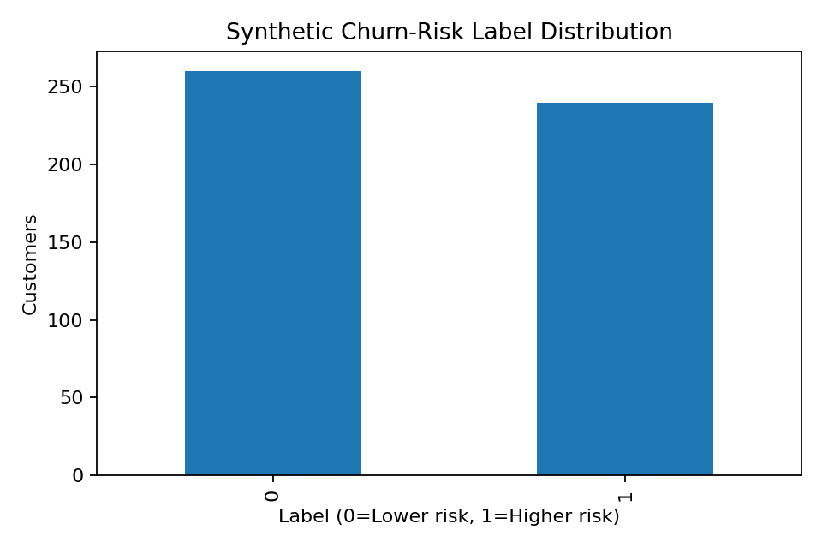
Figure 2. Model performance comparison
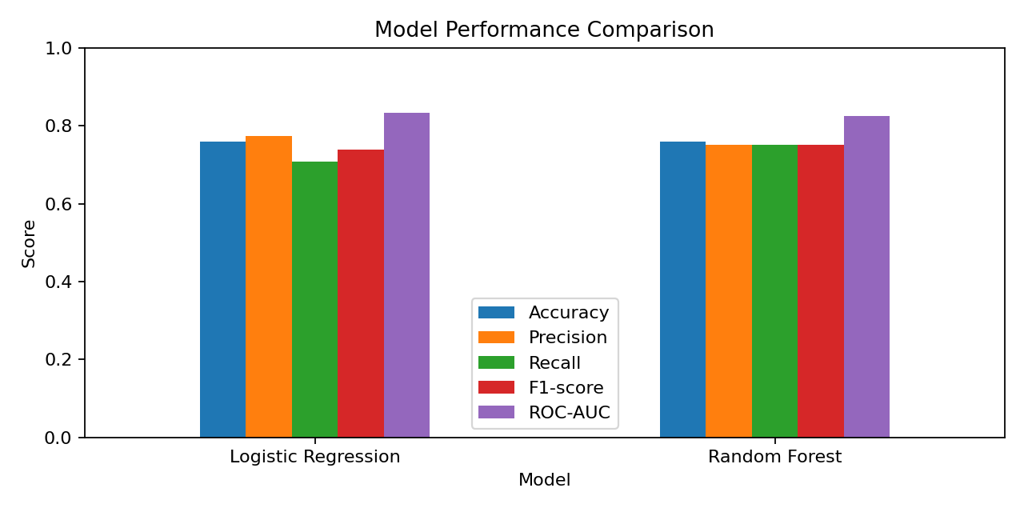
Figure 3. Confusion matrix for selected demonstration model
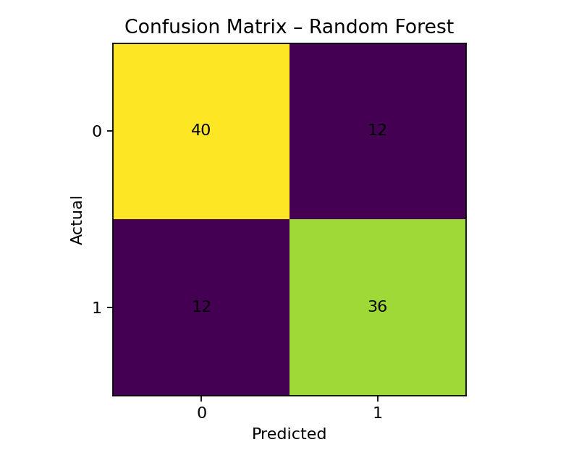
Figure 4. Customer purchase recency distribution
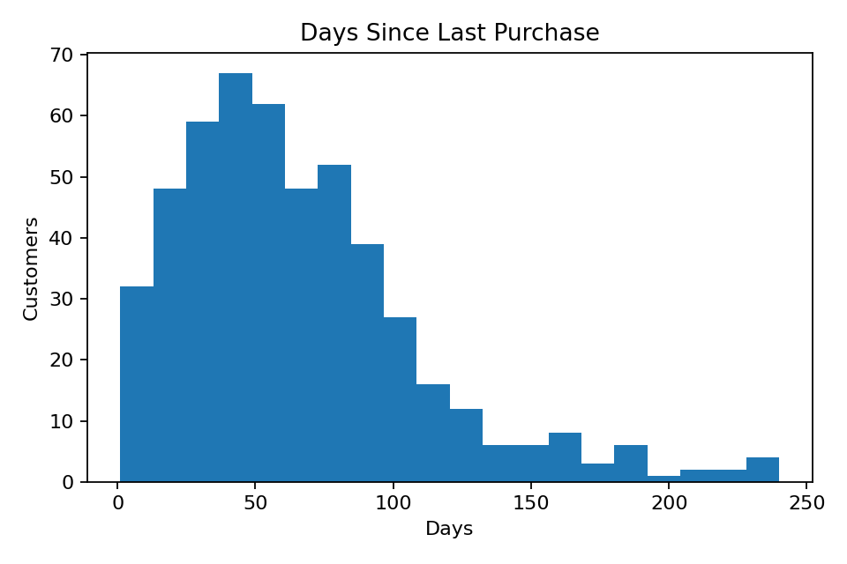

10. Prediction Output
The file outputs/test_predictions.csv contains the held-out test records with actual synthetic labels, predicted labels and predicted risk probabilities for the selected model. These predictions are examples for reviewing the pipeline and are not customer-level recommendations.

11. Limitations and Risk Controls
- The dataset and target are synthetic; the model cannot establish real churn behaviour.
- A simulated label may create an artificially learnable pattern and overstate apparent performance.
- Customer-level data in a public repository must be synthetic or properly anonymized and authorized.
- Churn must be defined using a business-approved inactivity window and a prediction date.
- Features created after the prediction date can cause target leakage and must be excluded.
- Class imbalance, threshold selection, subgroup performance and calibration need review.
- Any retention campaign should be tested with a controlled experiment before claiming business impact.

12. How to Run the Project
1. Install Python 3.10 or later.
2. Open a terminal in the project folder.
3. Run: pip install -r requirements.txt
4. Run: python src/train_models.py
5. Review model_comparison.csv, test_predictions.csv and the PNG charts in outputs/.

13. Future Enhancements
- Replace synthetic data with a permissioned, documented customer dataset.
- Define churn using a clear observation window and prediction horizon.
- Use time-based validation and cross-validation where suitable.
- Add probability calibration, threshold analysis and feature-importance interpretation.
- Develop a separate recommendation module using product metadata and customer preferences.
- Deploy a simple dashboard only after model validation and privacy review.

14. Conclusion
Week 5 demonstrates a complete supervised learning workflow for a beauty and wellness customer-retention use case. It connects Week 4 feature engineering to model training, testing, evaluation, comparison and artifact saving. Logistic Regression provides a baseline and Random Forest provides a non-linear comparison. The package is reproducible and transparent about the synthetic nature of the dataset. The next essential step is validation with approved real data before any operational use.

Appendix: Internship Submission Description
This Week 5 project focuses on Machine Learning Model Development for a Beauty & Wellness AI Personalization and Customer Retention System. It continues the Week 4 exploratory data analysis and feature-engineering workflow by preparing customer-related variables for a supervised classification task. The project uses Python libraries including Pandas, NumPy, Matplotlib and Scikit-learn. The workflow creates features such as age groups, purchase-recency segments, purchase-frequency proxies, discount-spending interactions, rating-review interactions and customer-value indicators. It then separates predictor variables from the target and excludes customer identifiers to reduce leakage. A stratified training and testing split is used for the demonstration experiment. Numeric variables are imputed and standardized, while categorical variables are imputed and one-hot encoded through a Scikit-learn preprocessing pipeline. Two classification algorithms, Logistic Regression and Random Forest, are trained and compared. Evaluation includes accuracy, precision, recall, F1-score, ROC-AUC and a confusion matrix. The project also saves trained model pipelines, test predictions, a model-comparison table and evaluation visualizations. A detailed report and presentation explain the objective, dataset, methodology, results, limitations and future improvements. The included 500-record dataset and churn-risk target are synthetic examples created to demonstrate the technical workflow; therefore, the reported metrics are not real customer performance claims. Further work will require an approved anonymized dataset, a clearly defined churn window, time-aware validation, fairness and privacy checks, and controlled testing before using predictions for retention decisions. This project improves practical understanding of supervised learning, preprocessing pipelines, model evaluation and reproducible data science.

