YUVAINTERN — DATA SCIENCE INTERNSHIP

Week 4: Exploratory Data Analysis
and Feature Engineering
Project: Beauty & Wellness AI Personalization and Retention System
Prepared by: Malini S B | B.Tech Artificial Intelligence and Data Science

Executive Summary
This report presents a reproducible workflow for exploring beauty and wellness customer data and engineering features for future personalization, customer segmentation, and retention analysis. The workflow covers data validation, descriptive statistics, missing-value review, visual analysis, an exploratory statistical test, feature creation, and a preprocessing pipeline. The accompanying Python script produces charts, a text summary, an engineered dataset, and a model-ready feature matrix.
Important: the repository contains a synthetic example dataset created only to demonstrate the workflow. Any chart or statistic generated from it is illustrative and must not be described as a real market finding. The same pipeline can be run on an approved preprocessed dataset by replacing the CSV while retaining the documented column names.

1. Background and Business Problem
Beauty and wellness businesses sell products across categories such as skincare, haircare, makeup, wellness, and fragrance. Customers can differ by age, skin type, purchase frequency, spending, product ratings, discount sensitivity, and time since their last purchase. Looking at each variable separately may miss combinations that explain customer needs or declining engagement.
Business problem: how can customer and purchase attributes be explored and transformed into useful signals for a future AI personalization and retention system? The Week 4 work is analytical preparation, not a deployed recommendation engine or a validated churn predictor.

2. Objectives
- Summarize data structure, data quality, distributions, and category-level patterns.
- Use clear visualizations to explore spending, ratings, missing values, and numeric relationships.
- Form exploratory hypotheses about customer behavior while avoiding unsupported causal claims.
- Create interpretable features that capture recency, frequency, value, customer groups, and interactions.
- Prepare numeric and categorical inputs for downstream machine-learning experiments.
- Document limitations, reproducibility steps, and responsible use of customer data.

3. Dataset and Variables
The demo dataset has 500 synthetic customer records. It includes customer_id, age, skin_type, product_category, average_order_value, product_rating, purchase_count, days_since_last_purchase, discount_percent, review_count, loyalty_tier, estimated_total_spend, and a simulated churn_risk_label. The label is illustrative only and is not used as an input feature.
Variable group | Example fields | Analytical purpose
Customer profile | age, skin_type | Compare preferences across broad groups; avoid sensitive or unfair use.
Product context | product_category, product_rating | Understand category mix and satisfaction patterns.
Purchase behavior | purchase_count, days_since_last_purchase | Explore engagement, recency and repeat purchasing.
Commercial behavior | average_order_value, discount_percent, estimated_total_spend | Explore value and discount response.
Engagement | review_count, loyalty_tier | Explore feedback activity and loyalty differences.

4. Data Validation and Quality Checks
- Schema validation: confirm expected columns exist and each field has a suitable type.
- Row and column counts: record dataset size before and after transformations.
- Missingness: calculate missing counts and percentages; inspect whether missingness is concentrated in particular fields or customer groups.
- Duplicates: check duplicate rows and duplicate customer IDs. Investigate repeated IDs before removing anything because multiple transactions may be legitimate in transaction-level data.
- Range checks: age should be plausible; ratings should be within the survey scale; discounts should be within the business policy range; counts and monetary values should not be negative.
- Outliers: use boxplots and the interquartile range (IQR) as flags. Investigate extreme values rather than automatically deleting them; premium products and high-value customers can be genuine.
- Consistency: check category spelling, whitespace, date logic, currency units, and whether spend totals agree with transaction records.
Recommended missing-value policy: use median imputation for numeric inputs and most-frequent imputation for categorical inputs as a baseline. Preserve missingness indicators when missingness may itself carry information. Fit imputers only on training data in a predictive modeling workflow to prevent leakage.

5. Exploratory Data Analysis Workflow

5.1 Univariate analysis
Use count tables for categorical variables and mean, median, standard deviation, quartiles, minimum, and maximum for numeric variables. Histograms and KDE plots reveal skewness and multiple peaks. Bar charts show category balance. For spending, report median alongside mean because high-value orders may create a right-skewed distribution.

5.2 Bivariate analysis
Use boxplots to compare average order value across product categories and loyalty tiers. Use scatterplots to examine relationships such as purchase_count versus estimated_total_spend, with transparency to reduce overplotting. Use grouped summaries to compare average rating and repeat-purchase indicators by category. Do not interpret correlation as proof of causation.

5.3 Multivariate analysis
A correlation heatmap summarizes linear associations among numeric variables. Pair plots can be added for a small number of numeric features. For larger datasets, use faceting or selected pairs rather than producing unreadable charts. Later, PCA or clustering may help summarize high-dimensional behavior, but these techniques require scaling and careful interpretation.

5.4 Statistical methods
Use the Kruskal–Wallis test as a non-parametric exploratory comparison of rating distributions across product categories when assumptions for a one-way ANOVA are questionable. Report the statistic, p-value, sample sizes, and an effect-size measure where possible. If the test is significant, follow with corrected pairwise comparisons. For a two-group comparison, Mann–Whitney U may be appropriate. For categorical associations, use a chi-square test when expected cell counts are adequate. Statistical significance alone does not establish business importance.

5.5 Visualization plan
Chart | Question answered | Potential business use
Missing-value bar chart | Which fields need attention? | Prioritize data collection and cleaning.
Order-value histogram | Is spending skewed or segmented? | Choose robust summaries and customer-value bands.
Category boxplot | Do order values vary by category? | Review merchandising and bundle opportunities.
Correlation heatmap | Which numeric features move together? | Detect redundancy and guide feature selection.
Category/loyalty bar charts | Which segments are represented? | Plan segment-specific campaigns.

6. Demonstration Outputs
The script creates the following figures from the synthetic dataset. These figures demonstrate the planned analytical workflow; their patterns are not evidence about actual customers.
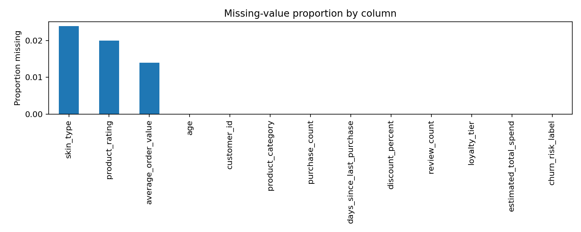
Figure 1. Missing-value proportion by column.

7. Feature Engineering Plan
New feature | Example method | Why it may help
Age group | Bin age into broad bands | Makes broad life-stage comparisons easier; use only when justified.
Recency segment | Recent, at-risk, lapsed, dormant based on days since purchase | Supports lifecycle messaging and retention prioritization.
Purchase-frequency proxy | purchase_count / (days_since_last_purchase / 30) | Provides a rough engagement signal; a true frequency feature needs a defined observation window.
Discount–spend interaction | discount_percent × average_order_value | Explores whether discount exposure relates differently to order value.
Rating–review interaction | product_rating × log(1 + review_count) | Combines rating level with review activity while limiting the scale of review counts.
High-value flag | Spend at or above the training-set median or a business-defined threshold | Supports value-based summaries; threshold must be set using training data or business rules.
Rating band | Low, medium, good, excellent | Makes rating segments easier to communicate.
Category encoding | One-hot encoding for unordered categories | Converts product and profile categories into numeric model inputs.
Numeric scaling | StandardScaler after imputation | Places numeric features on comparable scales for scale-sensitive algorithms.

8. Example Transformations
Recency segment example:
If days_since_last_purchase is 18, the customer is assigned to Recent (0–30d). If it is 65, the customer is assigned to At risk (31–90d). These are initial business rules and should be validated with historical retention outcomes.
One-hot encoding example:
product_category = Skincare becomes indicator columns such as product_category_Skincare, product_category_Haircare, and product_category_Makeup. Exactly one category indicator is typically active for a known category.
Normalization example:
StandardScaler transforms a numeric value using (value − training mean) / training standard deviation. Fit the scaler only on training data and apply the learned transformation to validation/test data.
Interaction feature example:
discount_spend_interaction = discount_percent × average_order_value. This lets a model examine combined patterns, but it does not by itself prove that discounts cause higher spending.

9. Hypothetical Business Scenario
Suppose the EDA later shows that customers with long purchase gaps and low purchase frequency have lower repeat engagement, while certain product categories have higher order values. The business could test a reminder or personalized product bundle for lapsed customers, and tailor product suggestions to stated skin type and prior category interests. A controlled A/B test should compare the campaign with a holdout group and measure incremental repeat purchase, revenue, unsubscribe rate, and customer complaints. These are hypothetical actions, not findings from the synthetic data.

10. Model-readiness and Leakage Prevention
- Define the prediction target and observation window before training any model.
- Exclude customer IDs and any target-derived fields from model inputs.
- Build preprocessing as a scikit-learn Pipeline/ColumnTransformer so imputation, scaling and encoding are fitted on training data only.
- Use a time-based split if predicting future customer behavior from historical events; otherwise use a suitable stratified split for classification.
- Compare a simple baseline with a more complex model and evaluate using metrics appropriate to the target.
- Check fairness, segment-level errors, privacy, consent, and whether features are appropriate for customer decisions.

11. Limitations and Risks
- The included data is synthetic, so no real market conclusion can be drawn.
- The dataset is customer-level and simplified; real transaction data may require aggregation over explicit time windows.
- Correlation and exploratory p-values can be misleading when many comparisons are made.
- Proxy variables may not represent the intended business concept accurately.
- Personalization can create privacy or fairness risks; use only necessary, consented data and review outcomes across customer groups.
- Feature engineering does not guarantee better model accuracy. Improvement must be demonstrated through validation.

12. Tools and Reproducibility
Python is used for reproducible analysis. Pandas handles tabular data; NumPy supports numerical operations; Matplotlib and Seaborn create plots; SciPy provides statistical tests; scikit-learn performs imputation, scaling, encoding and feature transformation. Install dependencies with `pip install -r requirements.txt` and run `python src/eda_feature_engineering.py`. Generated files are saved in the outputs folder.

13. Suggested 30–35 Hour Work Plan
Phase | Estimated hours
Review Week 1–3 scope and confirm dataset | 3
Schema, quality and missingness checks | 4
Univariate and bivariate analysis | 6
Multivariate analysis and statistical testing | 5
Feature design and implementation | 6
Interpret charts and map insights to business questions | 4
Validation, documentation and GitHub packaging | 4
Total | 32

14. Conclusion
This Week 4 workflow connects data exploration with business-oriented feature engineering for a beauty and wellness personalization project. It produces an auditable set of charts and transformed features, while distinguishing hypothetical insights from evidence. The next stage is to apply the pipeline to the approved preprocessed dataset, validate the features, and test whether they improve a downstream model using a leakage-safe evaluation process.

Appendix A: Project Structure
README.md
requirements.txt
data/beauty_wellness_customers.csv
src/eda_feature_engineering.py
outputs/ (generated charts, summary, engineered CSV and model-ready matrix)

Appendix B: Report Description for Submission (200+ words)
This Week 4 project focuses on Exploratory Data Analysis (EDA) and Feature Engineering for a Beauty & Wellness AI Personalization and Retention System. The report explains how customer and product-related data can be examined to understand spending patterns, ratings, product-category differences, purchase recency, repeat purchasing, discount behavior, and customer engagement. It outlines data-quality checks for missing values, duplicate records, inconsistent categories, invalid ranges, and potential outliers. It also describes univariate, bivariate, and multivariate analysis using Pandas, NumPy, Matplotlib, Seaborn, and SciPy. The planned visualizations include missing-value charts, distributions, category-level boxplots, and a numeric correlation heatmap. An exploratory non-parametric statistical test is included to demonstrate how rating distributions may be compared across product categories, with appropriate caution about p-values and business significance. The feature-engineering section introduces age groups, recency segments, a purchase-frequency proxy, discount-spend and rating-review interaction variables, customer-value flags, rating bands, one-hot encoding, missing-value imputation, and numeric standardization. These features may support later customer segmentation, personalization, and retention modeling, but their value must be tested through proper validation. The accompanying Python script creates reproducible charts, a summary report, an engineered dataset, and a model-ready feature matrix. The included data is synthetic and is used only to demonstrate the workflow; no results are presented as real customer or market findings. The report also discusses leakage prevention, privacy, fairness, limitations, and a practical work plan.

Supplementary Figures Generated by the Python Script
These example plots are generated from synthetic demonstration records. Replace the demo data with the approved preprocessed dataset before interpreting results.
Figure 1. Missing-value proportion by column.
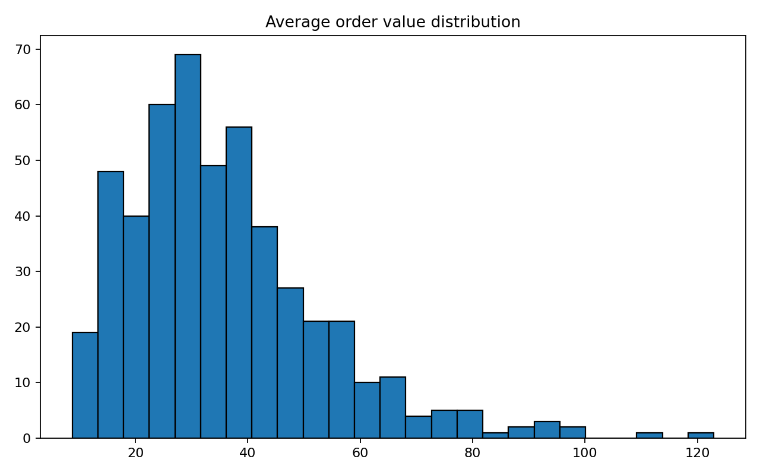
Figure 2. Average order value distribution.
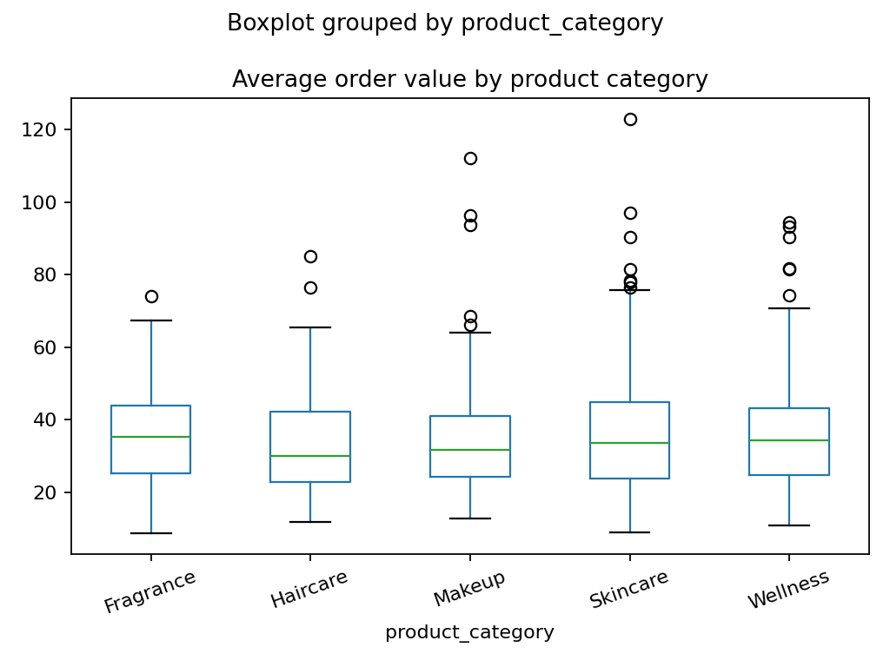
Figure 3. Order value grouped by product category.
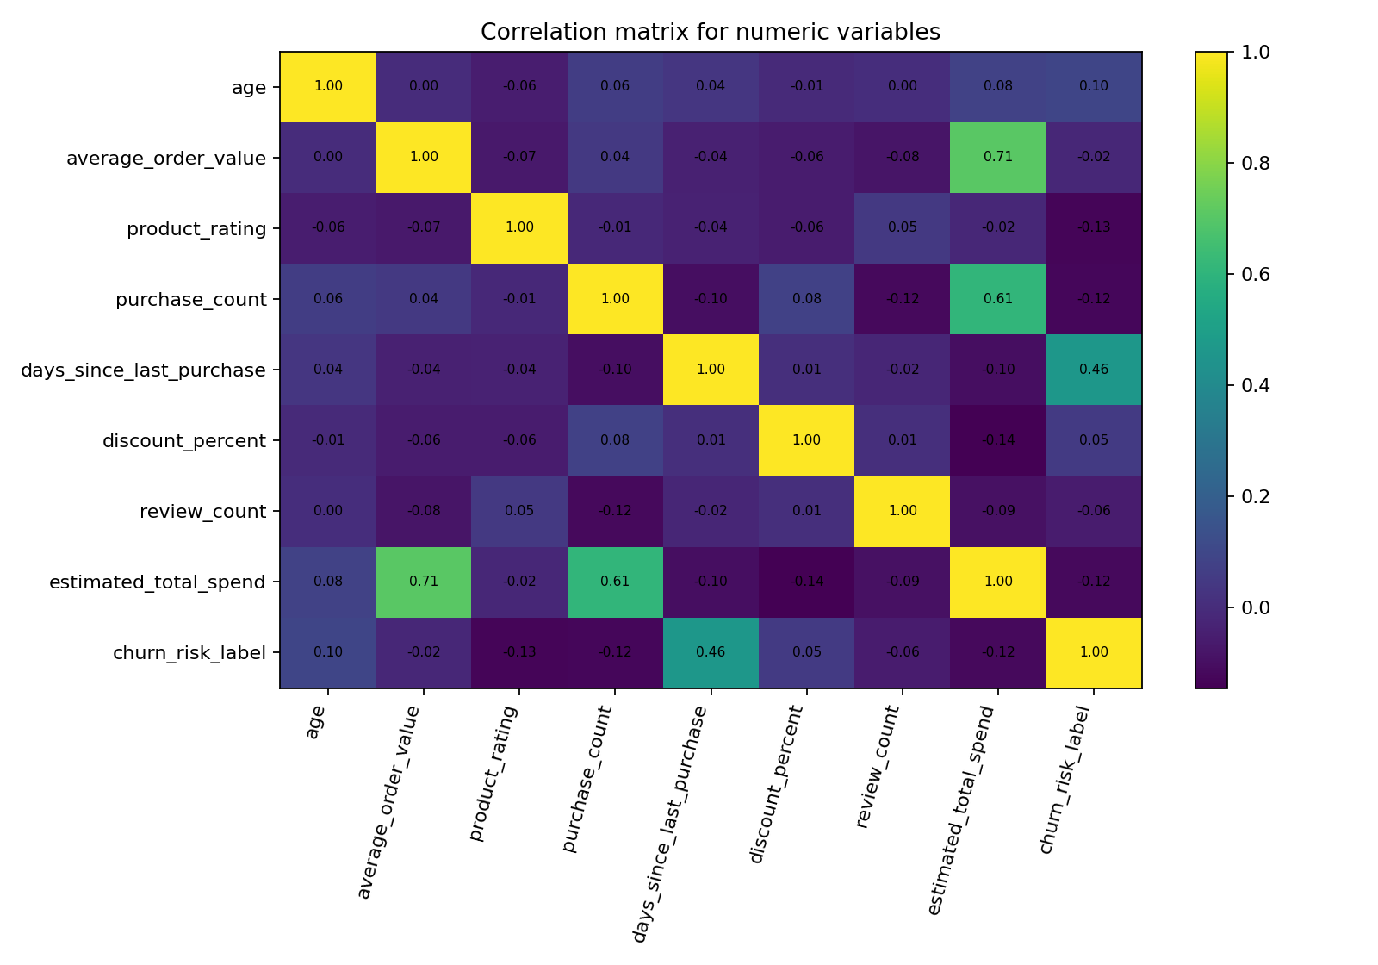
Figure 4. Correlation matrix for numeric variables.

