NAME: - MALLIK THANU NAIK

REG.NO :- 211039038

**STEPPER MOTOR**

#include <LPC213X.h>

void delay();

int i;

unsigned char dir_fl;

int main()

{

IODIR0 = 0XFFFFFFFF;

dir_fl = 0;

while(1)

{

IOSET0 = 0x3;

delay();

IOCLR0 = 0x3;

IOSET0 = 0x6;

delay();

IOCLR0 = 0x6;

IOSET0 = 0xC;

delay();

IOCLR0 = 0xC;

IOSET0 = 0x9;

delay();

IOCLR0 = 0x9;

}

}

void delay()

{

for(i=0; i<=5000;i++)

for(i=0; i<=150000; i++);

}

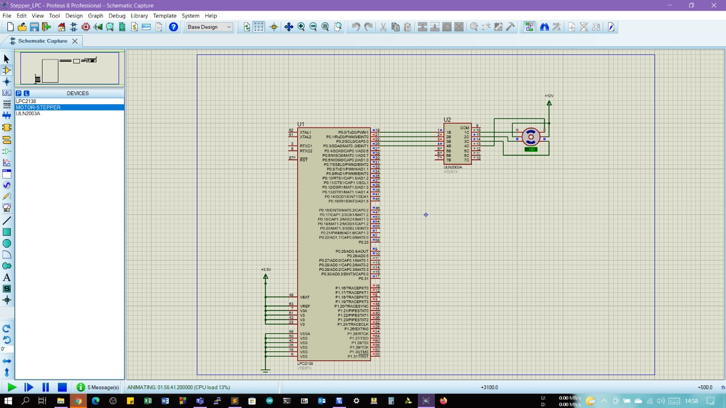

**DC MOTOR**

#include<LPC213x.h>

#define bit(x) (1<<x)

#define delay for(i=0;i<=60000;i++)

unsigned int i;

void main()

{

IO0DIR=0xf; //Declaring as a output

IO0PIN=0; //Clear all IO Pins in P0

VPBDIV=0x01; //PCLK = 60MHz

while(1)

{

/Forward/

IO0SET=bit(0); //IN1 = 1

IO0CLR=bit(1); //IN2 = 0

delay;

delay;

/Off/

IO0CLR=bit(0)|bit(1); //IN1 = IN2 = 0

delay;

delay;

/Reverse/

IO0SET=bit(1); //IN2 = 1

IO0CLR=bit(0); //IN0 = 1

delay;

delay;

/Off/

IO0CLR=bit(0)|bit(1); //IN1 = IN2 = 0

delay;

delay;

}

}

