User interface   
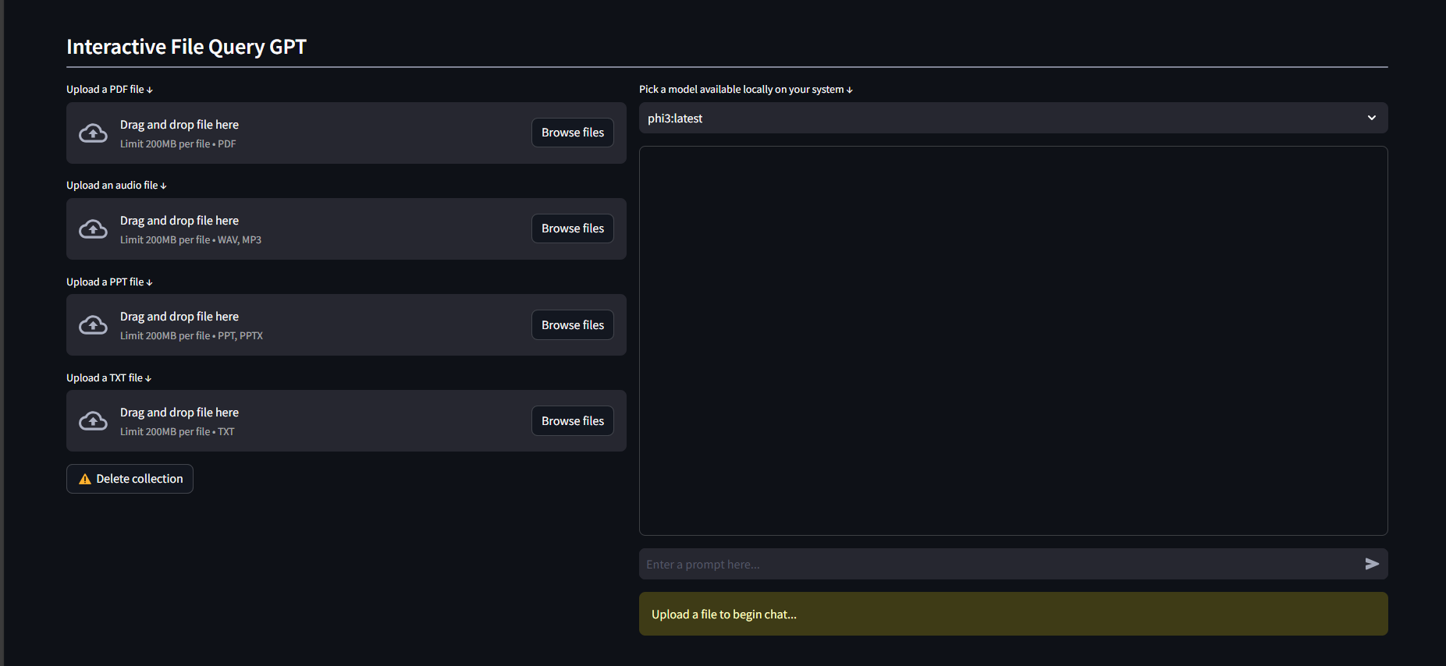

Pdf file

Firstly upload the pdf file and wait until the system processes it

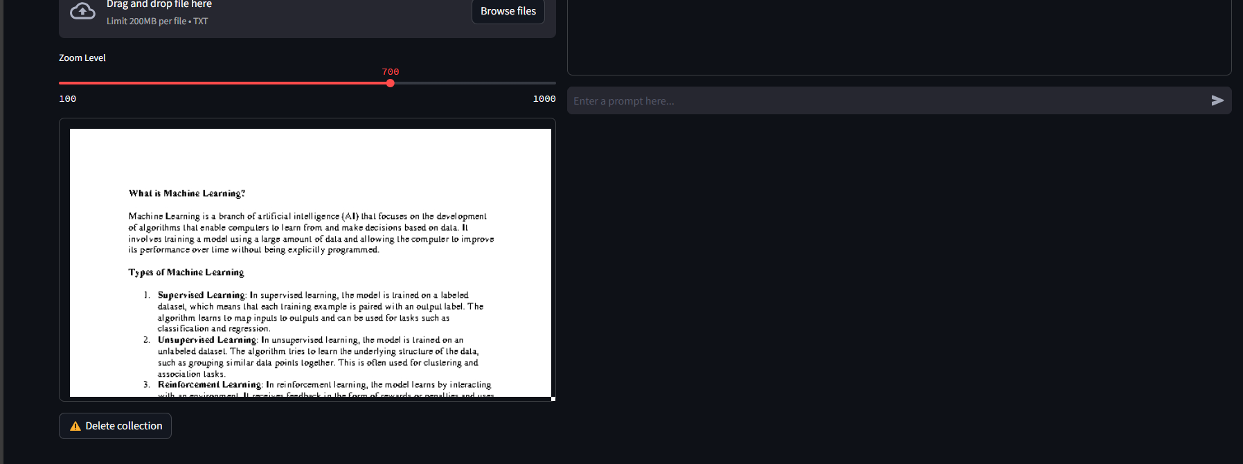

Asking questions using different models  
qwen 0.5 model (light weight 350 mb)

more loss and less accurate  
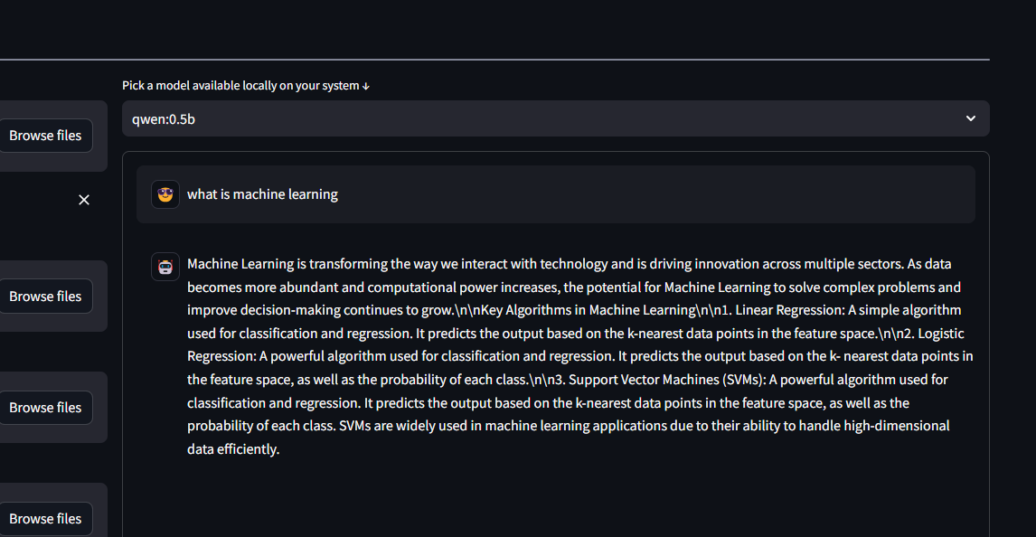

logs

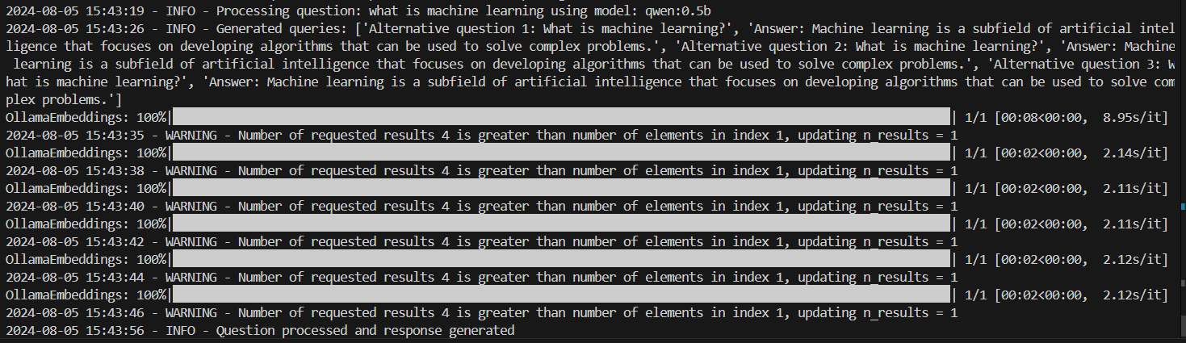

As we can see the model generated 6 questions even though we said 3. So it is not recommended to this model even though it is light weight.

phi3(2.3gb)  
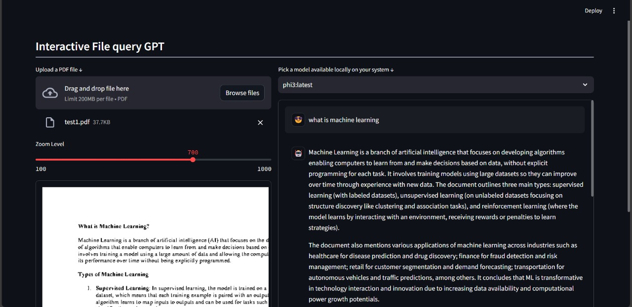

if we ask the question that is not in the context of uploaded pdf. it will not answer the question

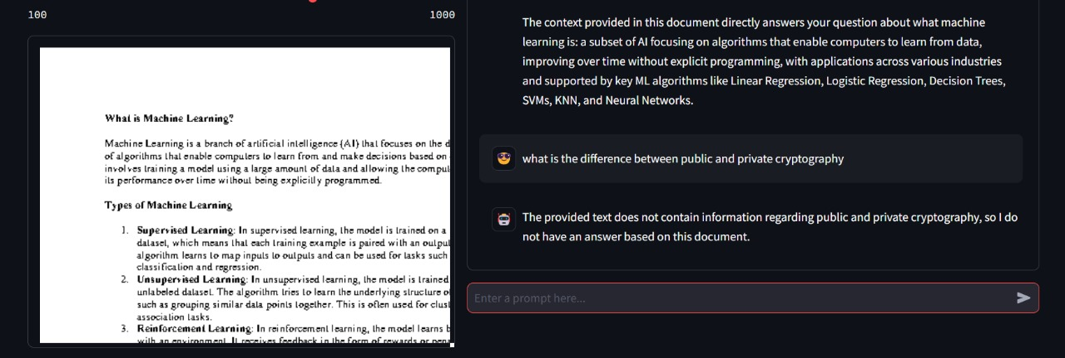

Logs

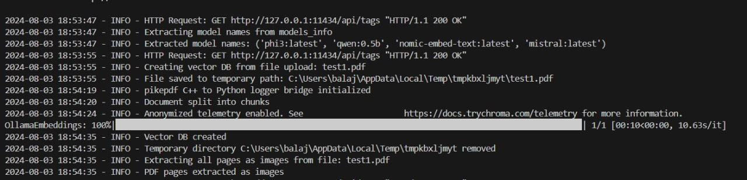

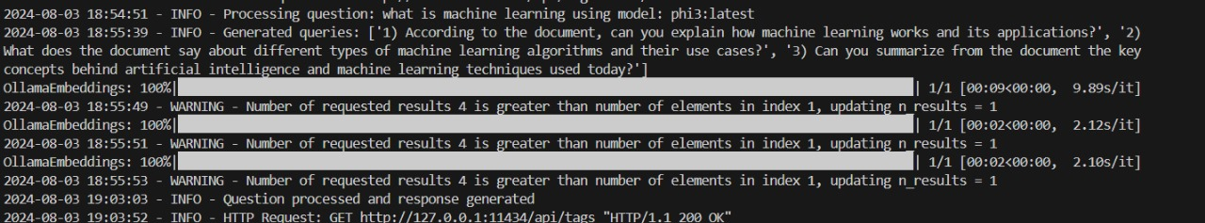

It is recommended because it generates the answer to the questions accurately and is of relatively light weight compared to other models

Audio file

Firstly click on audio upload and upload a file in mp3 or in wav format  
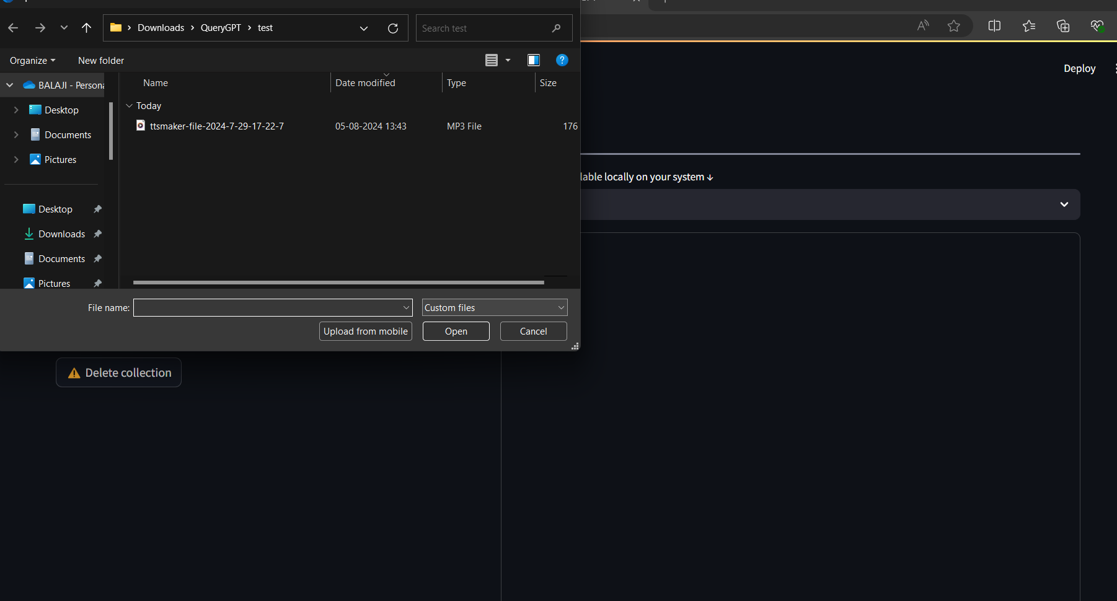

The system will transcribe the audio file and extract the text in it   
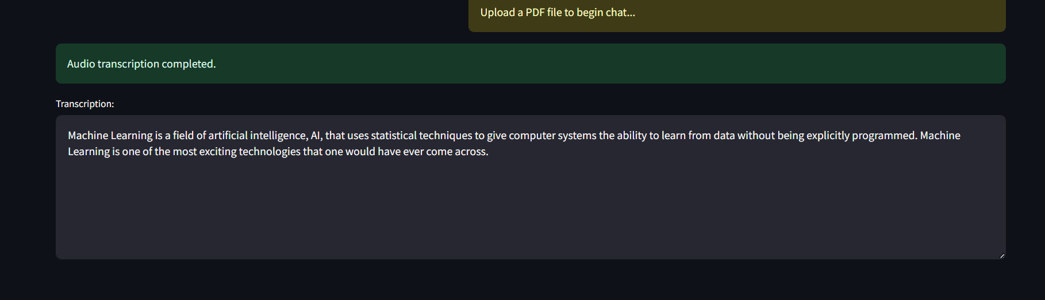

You can ask the questions to the system and the system will answer these questions using only the given audio  


If you ask anything out of the context of the document it will not produce an output  
  
  
  
logs

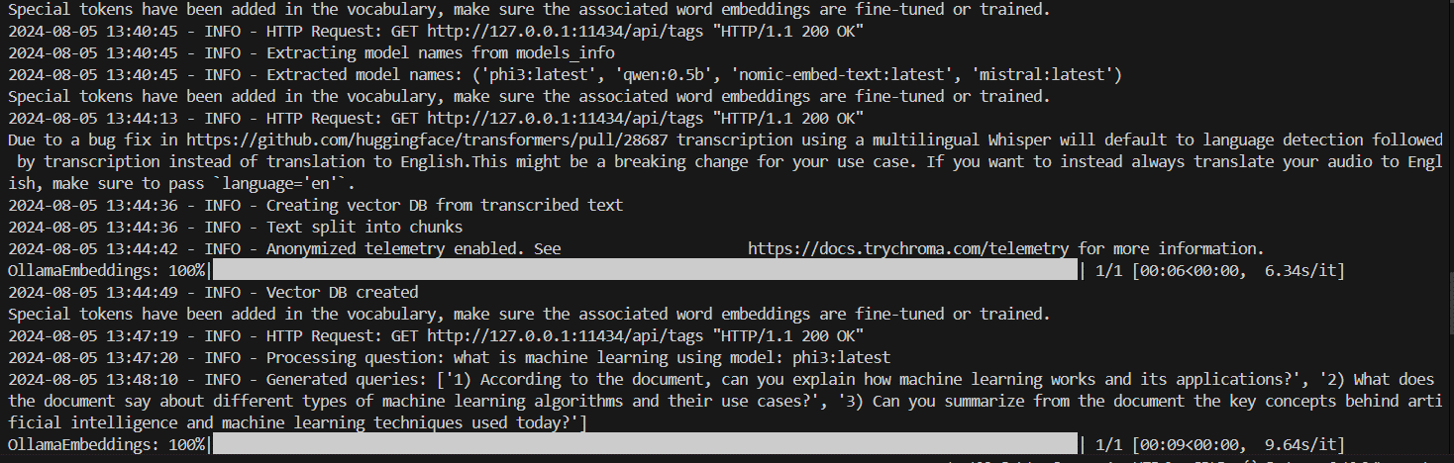

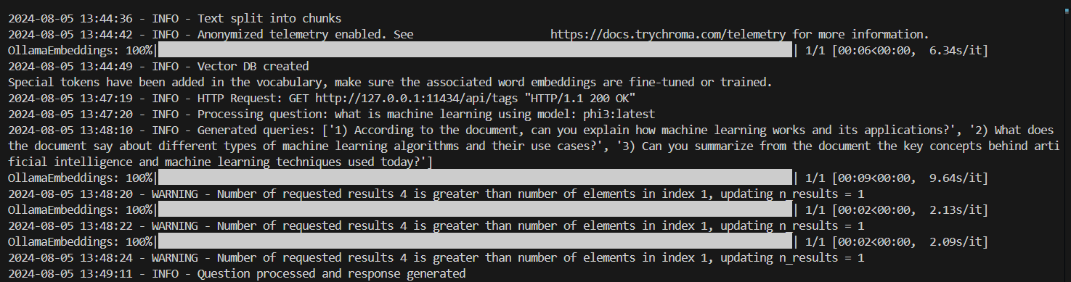

Audio file

Upload a text file the .txt format.

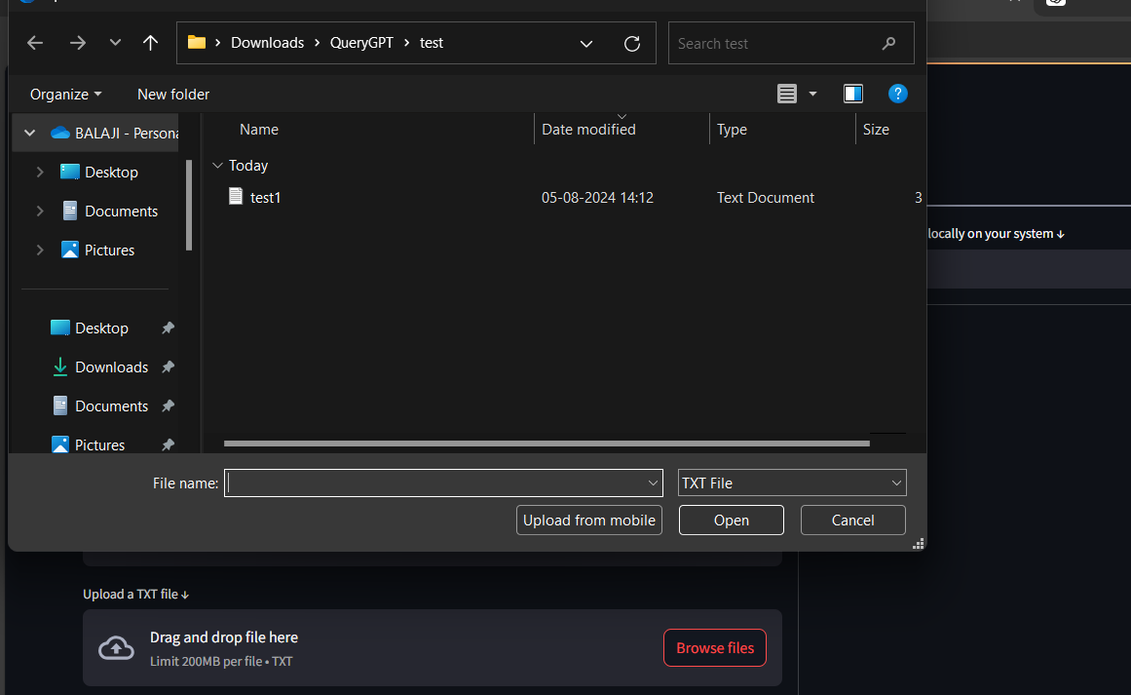

Then the txt file will be processed and the extracted text is stored in a vector database. Once the system shows that the txt processing is complete then you can ask the questions  
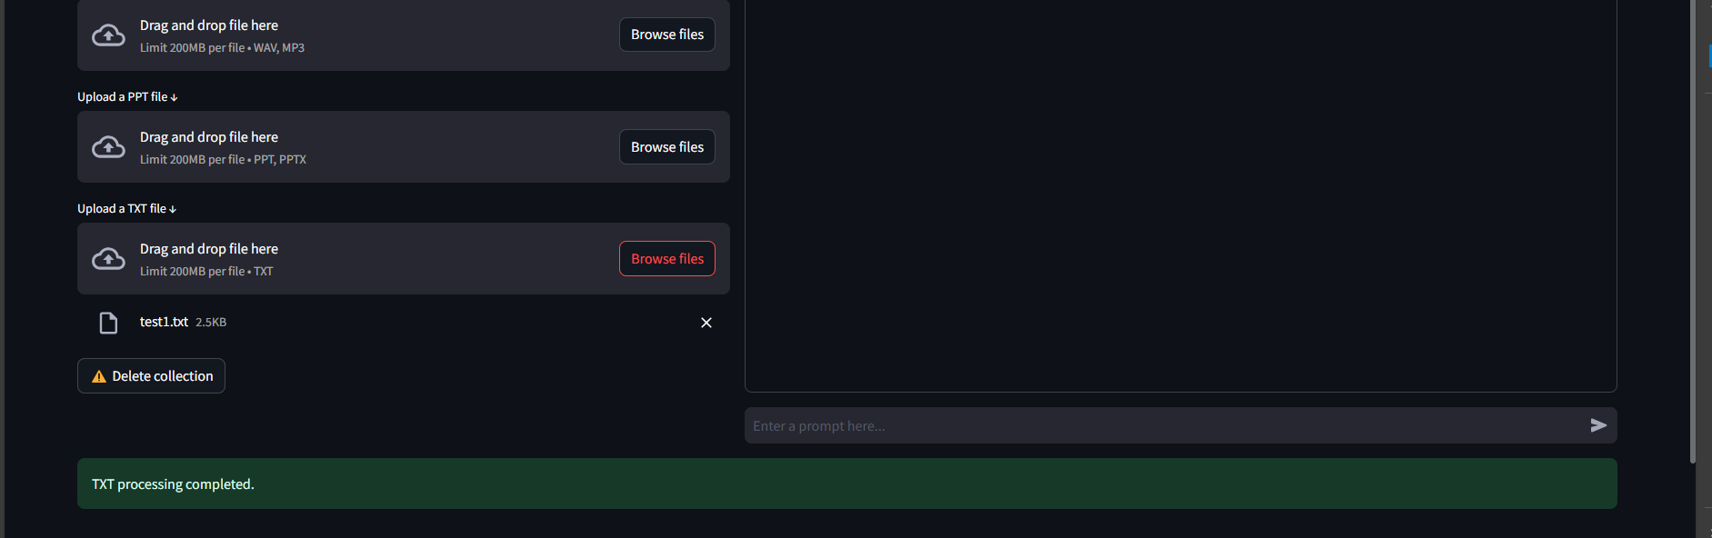

The system will answer the questions based on the txt document provided  
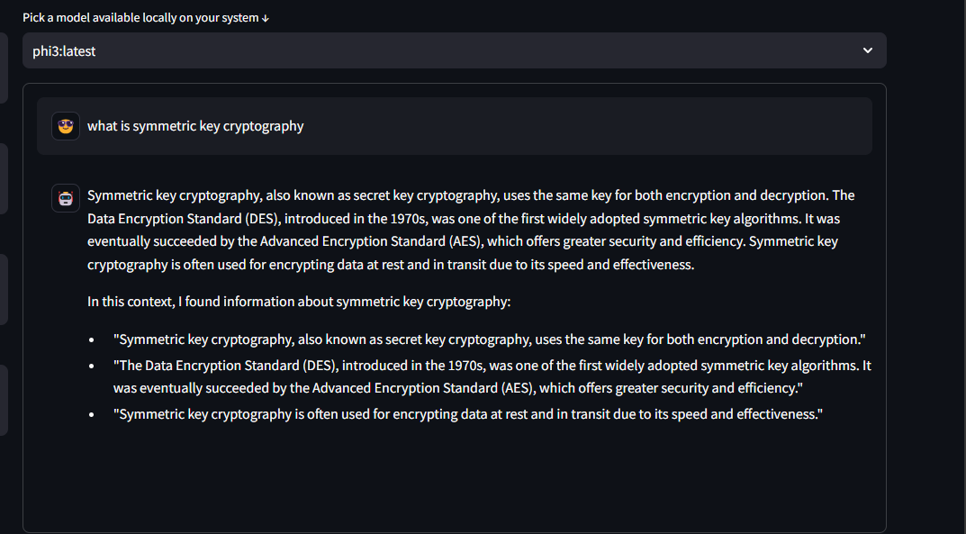

Logs

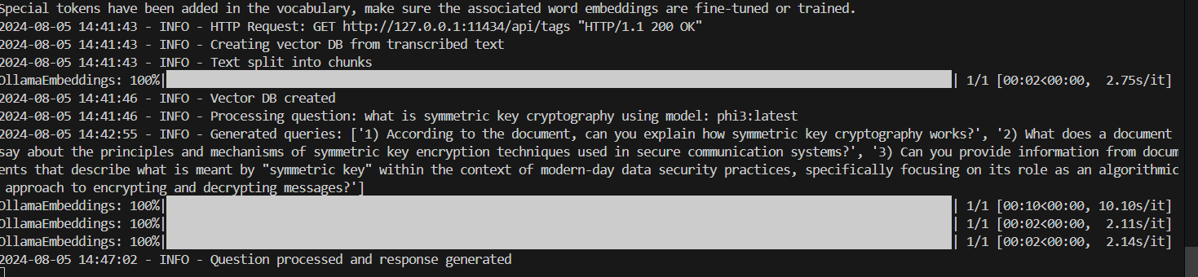

Ppt file

Upload ppt and wait until the system shows the ppt processing is completed as shown in the picture  
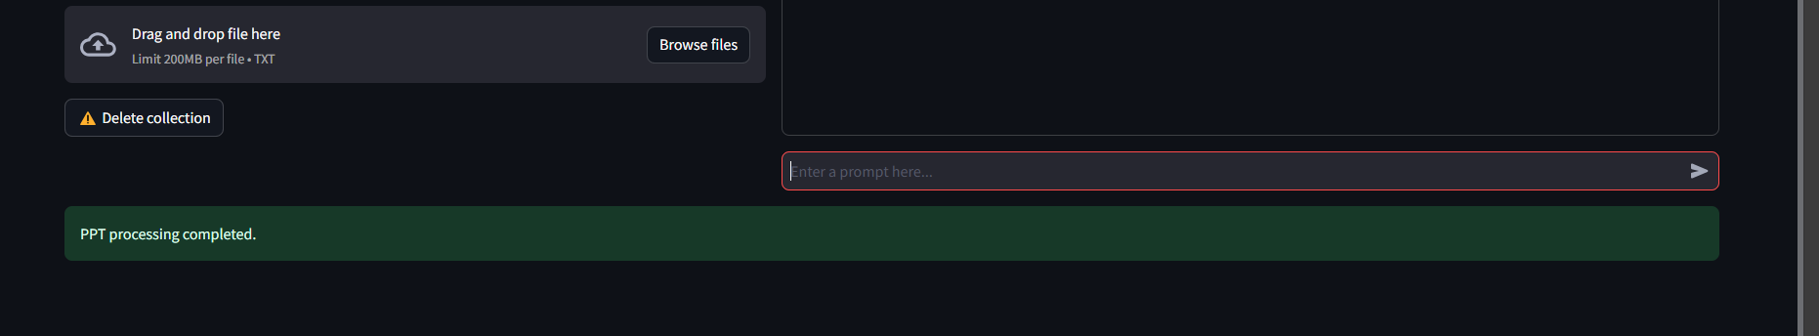

After it shows ppt is processed you can ask questions

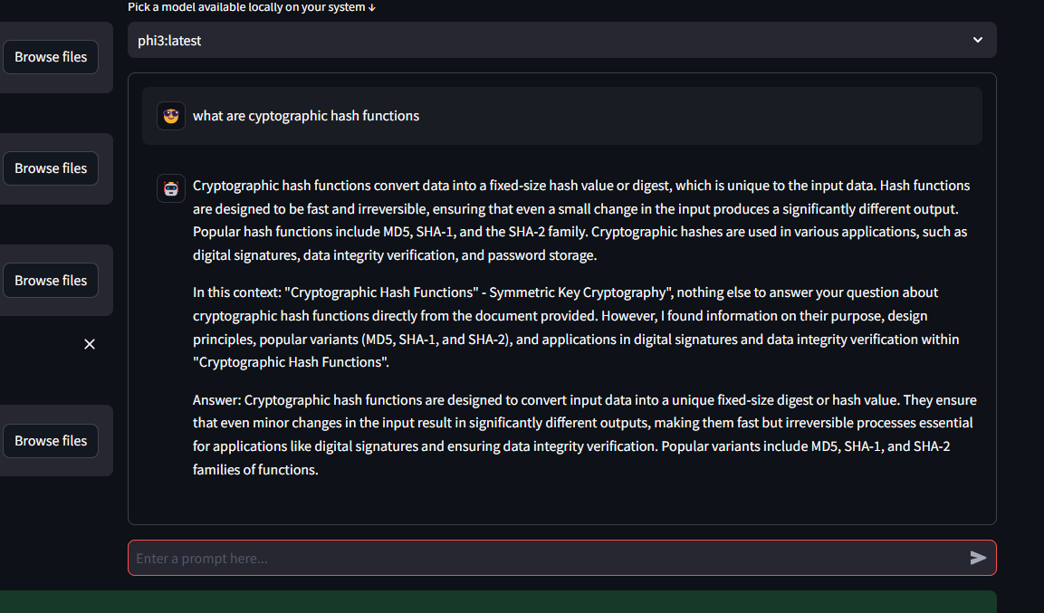

Logs

