Exercise 1 (Mood-board)

* COLORS

I will be using the colors shown above.

* Image examples:

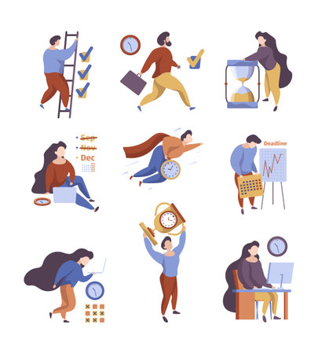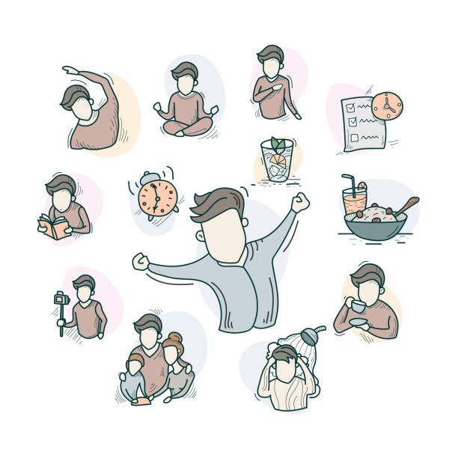

* This will be my font.

( Microsoft JhengHei)

* For my additional components I may use the following:
  + Icons: Utilize 'Font Awesome' icons for various interface elements.
  + Call-to-Action Buttons: Rounded and with a gradient effect to catch attention.
  + Navigation: A clean and simple navigation menu with drop-down options.
  + Social Media Buttons: Icons with hover effects to encourage sharing.
  + Footer: A compact footer with contact information, links, and copyright notice.