CMPG 325 — COMPUTER NETWORKS
INDIVIDUAL PROJECT · MILESTONE 1
Client Design Review — Tshimo Agri Supplies
Student | Maluleke, Kurhula Success
Student Number | 48277444
Project ID | CMPG325-2026-042
Client ID | CLI-042
Assigned Organisation | Tshimo Agri Supplies (Potchefstroom)
Industry | Agriculture
Assigned Addressing Block | 10.23.0.0/16
Assigned Networking Challenge | Network Troubleshooting (fault isolation scenario) — Advanced

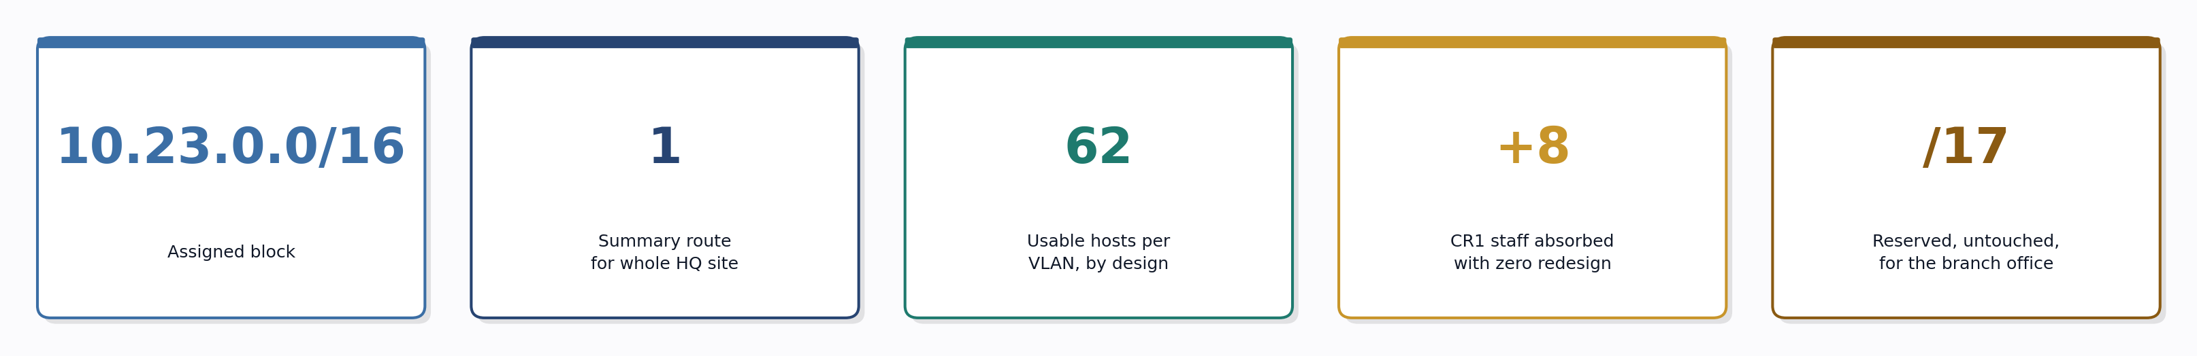

Contents
1. Client Requirements
2. Physical Topology
3. Logical Topology
4. IP Addressing Plan
5. Initial GitHub Repository

Design Philosophy
Every decision in this plan follows one rule: solve the requirement by allocation, not by re-architecture. Uniform subnet sizes, a single summarizable HQ route, and untouched reserved space mean the branch-office constraint and CR1 are both already solved before they happen.

1. Client Requirements

1.1 Stated Requirements (from project brief)
- Assigned organisation: Tshimo Agri Supplies (Potchefstroom); Industry: Agriculture.
- Assigned addressing block: 10.23.0.0/16 — must form the basis of the entire IP addressing plan.
- Provide appropriate connectivity and network services for the assigned scenario.
- Design Constraint: a branch office may be opened within 18 months — the addressing plan must allow for it without redesign.
- Client Change Request (CR1): the client signs 8 additional staff in one department — capacity must be added without redesigning the network.
- Produce a working, testable Cisco Packet Tracer implementation, and demonstrate the assigned challenge: Network Troubleshooting (fault isolation scenario).

1.2 Interpreted Organisational Requirements (design assumption)
The brief does not specify Tshimo Agri Supplies' internal department structure, so the following breakdown was adopted for a small-to-medium agricultural supply business. This assumption drives the topology and addressing plan below.
Department | Function | Current Staff
Administration / Management | HR, finance, general management | 8
Sales | Customer-facing sales & orders | 12
Warehouse / Logistics | Stock, dispatch, delivery (CR1 department) | 12 (+8 via CR1 = 20)
IT / Server Room | DHCP, DNS and File/ERP services | 3 servers

CR1 is applied to the Warehouse / Logistics department, since staffing growth in an agricultural supply business most plausibly occurs in stock handling and dispatch as client volume grows.

2. Physical Topology
The physical topology shows the devices, device roles and cabling for the Tshimo Agri Supplies head office in Potchefstroom. A single edge router provides the WAN connection; a core switch distributes 802.1Q trunks down to one access switch per department, keeping every department electrically and logically separate while sharing a single router for inter-department routing.
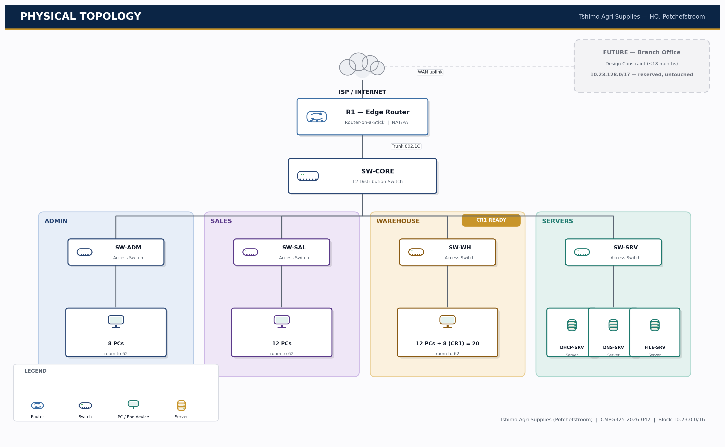
Figure 1 — Physical Topology, Tshimo Agri Supplies HQ (Potchefstroom)
Device | Role | Suggested PT Model | Key Interfaces
R1 | Edge router — WAN uplink, inter-VLAN routing (router-on-a-stick), NAT/PAT | Cisco 4321 / 2911 | Gi0/0 (trunk to SW-CORE), Gi0/1 (WAN to ISP)
SW-CORE | Distribution switch — trunks VLANs between R1 and access layer | Cisco 2960 | Trunk ports to R1 and each access switch
SW-ADM / SW-SAL / SW-WH | Access switches — one per department | Cisco 2960 (24-port) | Access ports to PCs, uplink trunk to core
SW-SRV | Access switch — server segment | Cisco 2960 | Access ports to DHCP/DNS/File servers
End devices | Department PCs + 3 servers | PC-PT / Server-PT | FastEthernet to access switch

Note: access switches are specified as 24-port models even where current headcount is lower (e.g. Admin at 8 PCs), so CR1-style headcount growth is absorbed at the physical layer as well as the addressing layer — see Section 4.

3. Logical Topology
Logically, each department is a separate VLAN. R1 performs inter-VLAN routing using a router-on-a-stick design (one sub-interface per VLAN on Gi0/0), and provides the default route out to the ISP on Gi0/1 with NAT/PAT for internet-bound traffic. DHCP is served from a dedicated DHCP server in the Server VLAN rather than the router, to reflect realistic enterprise practice.
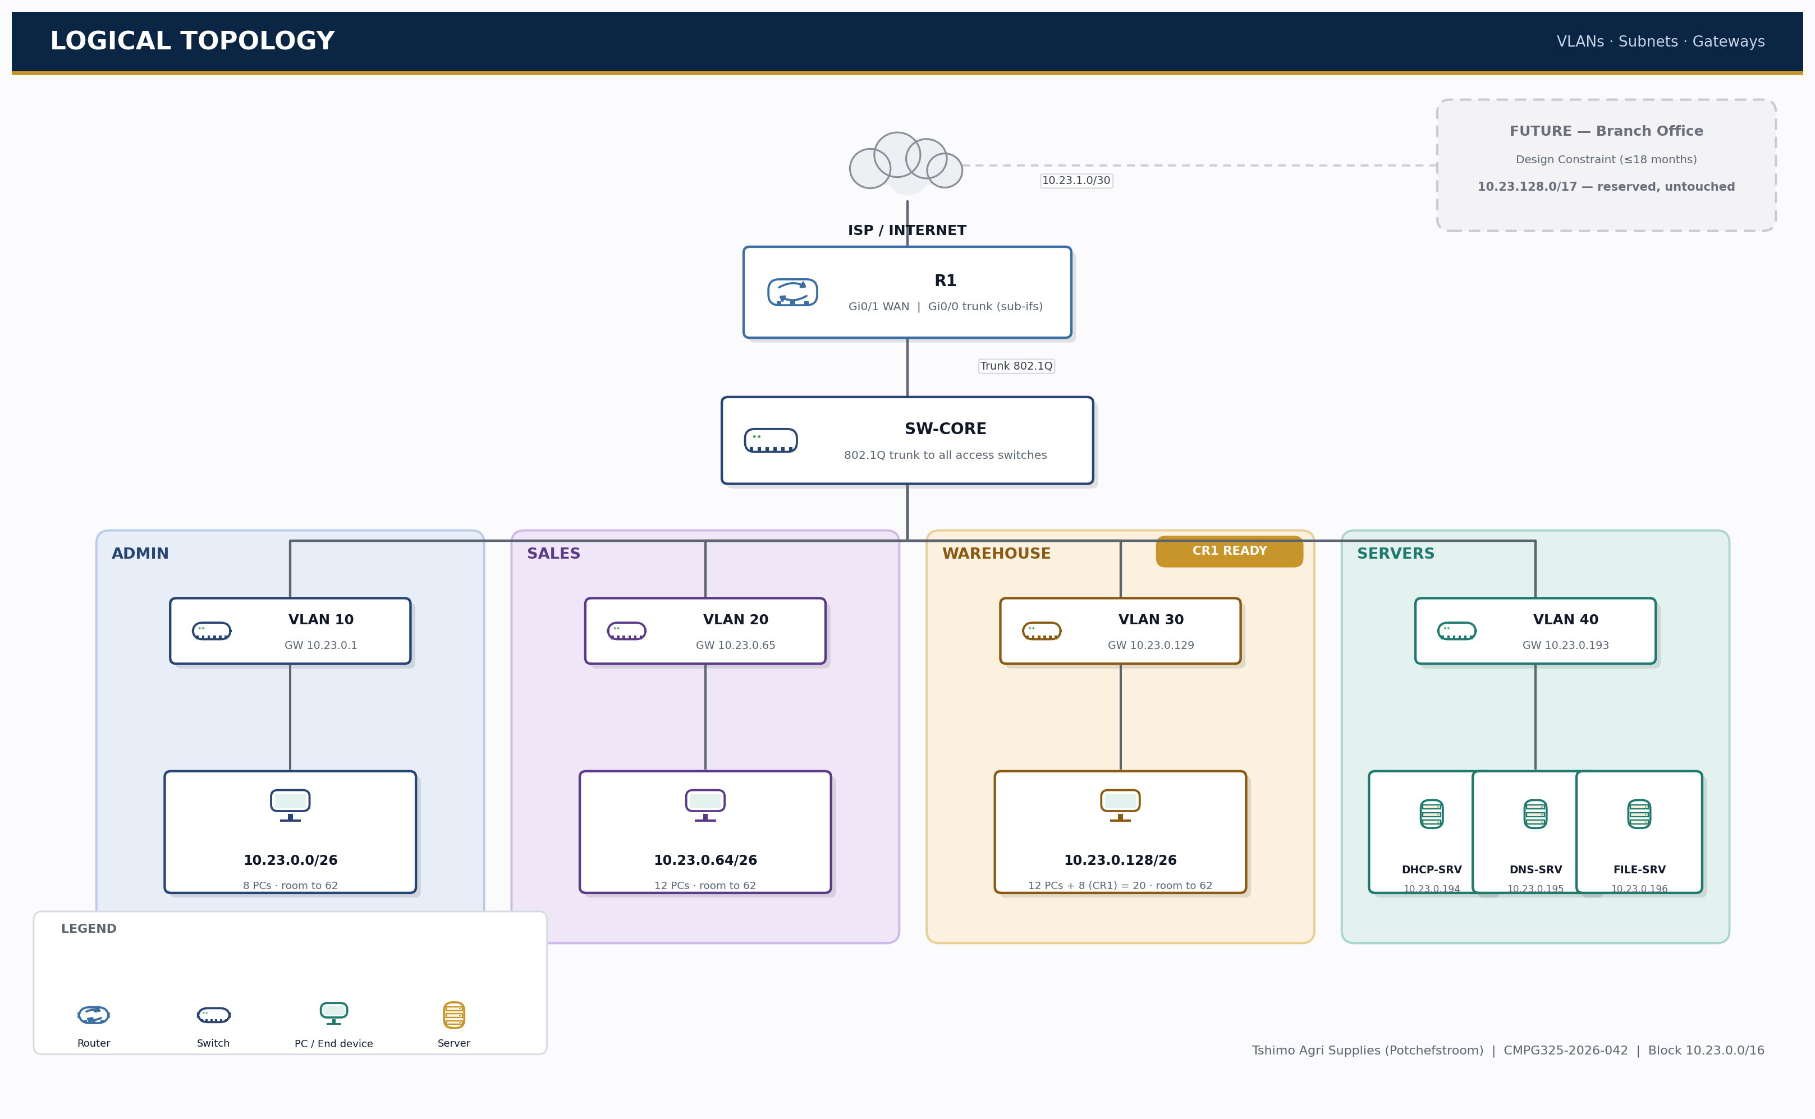
Figure 2 — Logical Topology: VLANs, subnets and default gateways
VLAN | Name | Purpose | Subnet
10 | ADMIN | Administration / Management | 10.23.0.0/26
20 | SALES | Sales | 10.23.0.64/26
30 | WAREHOUSE | Warehouse / Logistics (CR1 department) | 10.23.0.128/26
40 | SERVERS | DHCP, DNS, File/ERP servers | 10.23.0.192/26
99 | MGMT-NATIVE | Switch management / native VLAN (no user traffic) | 10.23.1.16/28

4. IP Addressing Plan
The assigned block 10.23.0.0/16 is split first at the /17 level: the lower half is allocated to the Potchefstroom HQ site now, and the upper half is reserved, untouched, for the branch office constraint. Inside HQ, the plan uses exactly two /24 networks today — one for business VLANs, one for infrastructure — chosen so the whole HQ site collapses into a single summary route upstream.
Why this is the smart solution, not the hard one
1. Uniform block sizing — every department VLAN is the same size (/26 = 62 hosts), so the whole plan fits in one sentence: 'VLAN N lives at offset (N/10 − 1) × 64 in 10.23.0.0/24.' Nothing to memorise per-department.
2. One summary route — 10.23.0.0/24 (business) and 10.23.1.0/24 (infrastructure) are contiguous, so R1 can summarise the entire HQ site as a single 10.23.0.0/23 route upstream instead of advertising every subnet individually.
3. Separation of concerns — user traffic (business VLANs) and infrastructure (WAN, management, guest) live in different /24s, a real enterprise security practice, not just a numbering trick.
4. Growth by allocation, not redesign — CR1 and the branch-office constraint are both solved by handing out already-reserved space, never by re-cabling, re-VLANing or re-IP-addressing anything already deployed.

4.1 Top-level split — Design Constraint (branch office)
Allocation | Block | Status
HQ — Potchefstroom | 10.23.0.0/17 | In use — 2 of 128 possible /24s (see 4.2 / 4.3)
Reserved — future Branch Office | 10.23.128.0/17 | Untouched — available on demand

4.2 Business VLANs — 10.23.0.0/24 (uniform /26 blocks)
Subnet (VLAN) | Network / CIDR | Usable Range | Broadcast | Gateway | Usable Hosts
VLAN 10 — Admin | 10.23.0.0/26 | .1 – .62 | .63 | .1 | 62 (8 used)
VLAN 20 — Sales | 10.23.0.64/26 | .65 – .126 | .127 | .65 | 62 (12 used)
VLAN 30 — Warehouse | 10.23.0.128/26 | .129 – .190 | .191 | .129 | 62 (20 used)
VLAN 40 — Servers | 10.23.0.192/26 | .193 – .254 | .255 | .193 | 62 (3 used)

4.3 Infrastructure — 10.23.1.0/24 (kept separate from user VLANs)
Purpose | Network / CIDR | Usable Range | Broadcast | Gateway | Usable Hosts
R1 – ISP WAN link | 10.23.1.0/30 | .1 – .2 | .3 | n/a | 2 (point-to-point)
VLAN 99 Mgmt/Native | 10.23.1.16/28 | .17 – .30 | .31 | .17 | 14 (switches only)
Guest Wi-Fi (future) | 10.23.1.32/28 | .33 – .46 | .47 | .33 | 14 (reserved)
Free / future infra | 10.23.1.48 – .255 | — | — | — | 208 addresses spare

4.4 How this plan satisfies the constraint and CR1
- Branch office constraint: the entire 10.23.128.0/17 (32,768 addresses) is reserved and untouched. Opening a branch requires only allocating from this pool — no re-addressing of the HQ site.
- CR1 (+8 staff, no redesign): Warehouse/Logistics (VLAN 30) is sized at /26 (62 usable addresses) against a current headcount of 12. Adding 8 staff brings usage to 20/62 — well inside the existing subnet, so no VLSM change, no re-cabling, and no re-IP-addressing is required.
- General headroom: 126 further /24 networks remain free inside the HQ /17 alone, before any branch-office space is touched — this design will not need revisiting for the foreseeable life of the business.

5. Initial GitHub Repository
Repository name: tshimo-agri-network-cmpg325 (suggested — public or private per module instructions)

5.1 Folder structure
- README.md — project overview, client summary, milestone tracker, links to each section below
- docs/01-client-requirements.md
- docs/02-physical-topology.md (+ physical_topology_pro.png)
- docs/03-logical-topology.md (+ logical_topology_pro.png)
- docs/04-ip-addressing-plan.md
- docs/05-change-requests.md
- packet-tracer/ — final .pkt file goes here in later milestones
- screenshots/ — connectivity and configuration evidence
- troubleshooting/ — fault isolation documentation (assigned challenge)

5.2 README skeleton
# Tshimo Agri Supplies — Network Design (CMPG325-2026-042)
Individual semester project for CMPG 325 Computer Networks, NWU. Client: Tshimo Agri Supplies (Potchefstroom, Agriculture). Assigned challenge: Network Troubleshooting (fault isolation scenario).
## Milestones
- Milestone 1 — Client Design Review (28 Aug 2026): requirements, topology, addressing plan — this repository
- Milestone 2 — 2 Oct 2026
- Final submission — 16 Oct 2026
## Contents
- See /docs for the full design documentation.

5.3 Initial commit checklist
- git init in project folder, add README.md and /docs skeleton
- Commit 1: "Add client requirements and project brief summary"
- Commit 2: "Add physical and logical topology diagrams"
- Commit 3: "Add IP addressing / VLSM plan"
- Push to GitHub and paste the repository link into the eFundi text box alongside this document

