5.2 Diagram: -
5.2.1 DFD: -
- 0 Level DFD: -
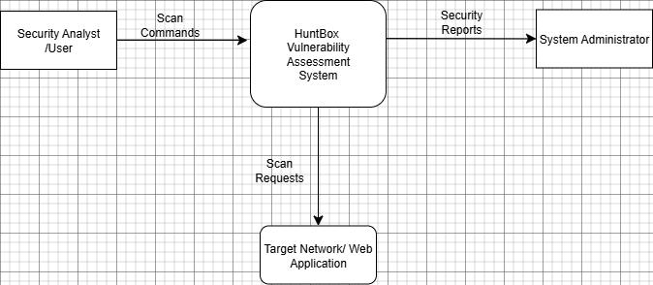
- 1 level DFD: -
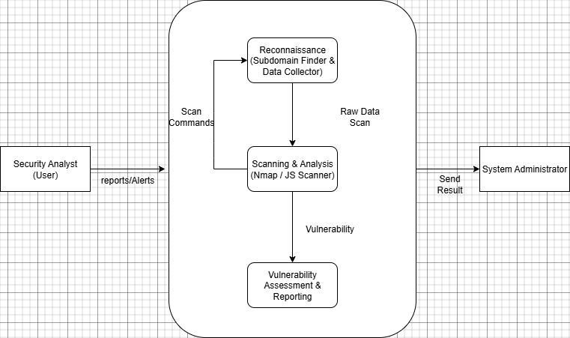

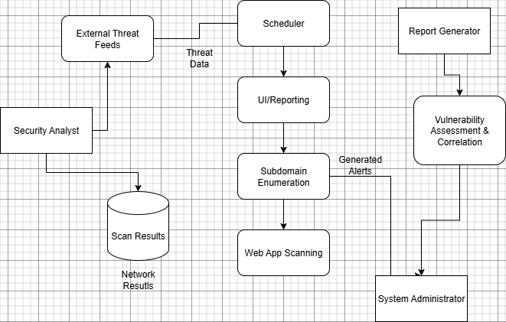
- 2nd Level DFD: -

