A
Project Report
On
HuntBox
Developed By
Malvik Parekh [2205103140018]
Palak Kojani [2205103140008]
Mohit Agarwalla [2205103140010]

as
Partial Fulfillment of VIth Semester of
Integrated Master of Computer Applications
for A.Y. 2024 - 2025

Under The Guidance of
Prof. Tanmay Shah
Submitted To
Department of IMCA
Faculty of IT & Computer Science
PARUL University


Acknowledgement
The success and final outcome of this project required a lot of guidance and assistance from many people and we are extremely privileged to have got this all along the completion of our project. All that we have done is only due to such supervision and assistance and we would not forget to thank them.
I respect and thank Dr. Priya Swaminarayan, Dean, FITCS for providing us an opportunity to do the project work in IMCA and giving us all support and guidance which made us complete the project duly. We are extremely thankful to Mam for providing her support and guidance, although she had a busy schedule managing the academic affairs.
We would not forget to remember Prof. Abhishek Mehta, HOD, BCA department, for her encouragement and more over for her timely support and guidance till the completion of our project work.
We owe our deep gratitude to our project guide Dr./Prof. Tanmay Shah, who took keen interest on our project work and guided us all along, till the completion of our project work by providing all the necessary information for developing a good system.
I am thankful to and fortunate enough to get constant encouragement, support and guidance from our Parents, all Teaching staff of the BCA Department which helped us in successfully completing our project work. Also, we would like to extend our sincere esteems to all staff in the laboratory for their timely support.

Malvik Parekh 2205103140018
Palak Kojani 2205103140008
Mohit Agarwalla 2205103140010


PARUL INSTITUTE OF COMPUTER APPLICATION
CERTIFICATE

This is to certify that _Malvik Parekh, Palak Kojani, Mohit Agarwalla_the student(s) of Parul Institute of Computer Application, has/have satisfactorily completed the project entitled “HuntBox” as a part of course curriculum in IMCA semester- VI for the academic year 2024-2025 under guidance of Prof.Tanmay Shah.
Enrolment Number: Malvik Parekh 2205103140018
Enrolment Number: Palak Kojani 2205103140008
Enrolment Number: Mohit Agarwalla 2205103140010

Quality of work | Grade | Sign of Internal guide
Poor / Average / Good /Excellent | B /B+ / A / A+

Date of submission:
HOD, Principal,

Dr.Abhishek Mehta Dr. Priya Swaminarayan
INDEX
No. | Description | Page No.
1. | About Department of IMCA
2. | Company Profile
3. | Project Profile  3.1 Project Definition  3.2 Project Description  3.3 Existing System / Work Environment  3.4 Problem Statements  3.5 Need for New System  3.6 Proposed System & Features  3.7 Scope  3.8 Outcomes  3.9 Tools & Technology used  3.10 Project Plan | 5
4. | Requirement Analysis  4.1 Feasibility Study  4.2 Users of the System  4.3 Modules  4.4 Process Model  4.5 Hardware & Software Requirements  4.6 Use Cases  4.7 Use Case Diagram | 13
5. | Design  5.1 Use Case Scenarios  5.2 Diagrams  5.2.1 UML / DFD | 20
6. | Implementation  6.1 Form Layouts  6.2 Report Layouts  6.3 Coding Convention | 24
7. | Testing  7.1 Test Strategy  7.2 Test Cases | 28
8. | Future Enhancement | 30
9. | Bibliography | 31

PROJECT PROFILE

3.1 Project Definition: -

- The project aims to develop an Integrated Network and Web Application Security Assessment Toolkit, designed to provide a comprehensive solution for identifying and mitigating security risks across networks and web applications. The toolkit will integrate multiple tools and functionalities, including Nmap network scanning for discovering live hosts, open ports, and services, as well as OS detection and scriptable interactions using the Nmap Scripting Engine (NSE). It will also feature a JavaScript scanner to analyze web applications for client-side vulnerabilities, such as XSS and insecure DOM manipulation, through both static and dynamic analysis.
- Additionally, the toolkit will include a subdomain finder to enumerate subdomains using public datasets and third-party APIs, and a subdomain brute-forcing tool to uncover hidden or less obvious subdomains through wordlist-based attacks. Finally, the toolkit will incorporate a vulnerability assessment module to identify, classify, and prioritize vulnerabilities, providing actionable recommendations for remediation. This integrated approach will empower security professionals, penetration testers, and system administrators to conduct thorough security assessments and enhance the overall security posture of their systems.

3.2 Project Description: -

- Nmap is a powerful and widely-used open-source network scanning tool designed for network discovery, security auditing, and vulnerability assessment. It helps identify active devices, open ports, running services, and even the operating systems of target hosts. Its scripting engine, NSE, allows for advanced tasks like vulnerability detection and brute-forcing, making it a versatile tool for penetration testers and network administrators. For example, a simple Nmap command like nmap -sV -O 192.168.1.1 can reveal open ports, service versions, and OS details of a target IP address.
- JavaScript scanners, on the other hand, are tools or scripts written in JavaScript that focus on scanning web applications and websites for vulnerabilities such as Cross-Site Scripting (XSS) or insecure APIs. These scanners can analyze the Document Object Model (DOM) of web pages or test APIs for security flaws, often running in browsers or Node.js environments. Tools like ZAP (Zed Attack Proxy) and custom Node.js scripts are commonly used for this purpose, enabling automated and continuous security testing of web applications.
- Subfinder is a specialized tool for subdomain enumeration, which is a critical step in reconnaissance during penetration testing or bug bounty hunting. It passively collects subdomains from public sources and can also perform active enumeration through brute-forcing techniques. By using a wordlist, Subfinder systematically guesses subdomains and checks their validity, helping uncover hidden or forgotten subdomains that may expand the attack surface. For instance, the command subfinder -d example.com -w wordlist.txt can brute-force subdomains for a target domain.
- Vulnerability assessment involves identifying, classifying, and prioritizing weaknesses in a system, network, or application. Tools like Nmap, OpenVAS, and Nessus are commonly used for this purpose, alongside JavaScript scanners for web application vulnerabilities. The process typically includes discovery, scanning, analysis, and reporting, ensuring that potential risks are mitigated proactively. By integrating tools like Nmap, Subfinder, and JavaScript scanners, security professionals can perform comprehensive assessments, from discovering subdomains and scanning ports to identifying vulnerabilities in web applications and services.

3.3 Existing System/Work Environment:-

- Cybersecurity Teams and Penetration Testers
- Role: Cybersecurity teams and penetration testers are responsible for identifying and mitigating security risks in an organization's infrastructure.
- Work Environment:
  - They use tools like Nmap for network scanning, Subfinder for subdomain enumeration, and JavaScript scanners for web application testing.
  - These tools are often integrated into a larger workflow that includes reconnaissance, vulnerability scanning, exploitation, and reporting.
  - Teams may work in a controlled lab environment or directly on live systems (with proper authorization).

- Security Operations Center (SOC)
- Role: SOC analysts monitor and respond to security incidents in real-time.
- Work Environment:
  - Tools like Nmap and vulnerability scanners are used to assess the security posture of the network.
  - Hunt box or similar platforms may be used for threat hunting and incident response.
  - Analysts work in a high-pressure environment, often using dashboards and alerts to detect and respond to threats.

- Bug Bounty Hunters
- Role: Bug bounty hunters identify vulnerabilities in web applications and networks for rewards.
- Work Environment:
  - They use tools like Subfinder for subdomain discovery and JavaScript scanners for finding web vulnerabilities.
  - Brute-forcing techniques may be employed to uncover hidden endpoints or credentials.
  - Bug bounty hunters often work independently or as part of a community, testing publicly accessible systems.

3.4 Problem Statement: -

- Incomplete Network Visibility:
  - Tools like Nmap provide network scanning capabilities, but they may miss hidden or non-responsive hosts, leaving blind spots in the network.
  - Subdomains and endpoints that are not publicly known (e.g., discovered through Subfinder or brute-forcing) can serve as entry points for attackers.
- Web Application Vulnerabilities:
  - JavaScript scanners and other web application testing tools may fail to detect complex vulnerabilities like business logic flaws or zero-day exploits.
  - The increasing use of JavaScript frameworks and APIs in modern web applications introduces new attack surfaces that are difficult to secure.
- Inefficient Reconnaissance:
  - Manual reconnaissance processes, such as subdomain enumeration and brute-forcing, are time-consuming and resource-intensive.
  - Lack of integration between tools (e.g., Subfinder, Nmap, vulnerability scanners) leads to fragmented workflows and inefficiencies.
- False Positives and Negatives:
  - Vulnerability assessment tools often generate false positives, requiring manual verification and increasing the workload for security teams.
  - False negatives, where vulnerabilities go undetected, leave systems exposed to potential attacks.
- Scalability and Performance:
  - Scanning large networks or complex web applications can be resource-intensive and may impact system performance.
  - Brute-forcing techniques, while effective, can be slow and may trigger security mechanisms like rate limiting or account lockouts.

3.5 Need for New System:-

1. Incomplete Network Visibility
- Problem: Existing tools like Nmap and Subfinder may miss hidden or non-responsive hosts, subdomains, or endpoints, creating blind spots in the network.
- Need for a New System:
  - A unified platform that combines network scanning, subdomain enumeration, and endpoint discovery to provide complete visibility.
  - Integration of passive and active reconnaissance techniques to identify all potential attack surfaces.

2. Inefficient Web Application Security
- Problem: JavaScript scanners and other web application testing tools struggle to detect complex vulnerabilities, especially in modern frameworks and APIs.
- Need for a New System:
  - Advanced scanning tools that can analyze JavaScript-heavy applications and detect business logic flaws, zero-day vulnerabilities, and API security issues.
  - Real-time monitoring and automated testing capabilities for continuous web application security.

3. Fragmented Workflows
- Problem: Security teams often use multiple tools (e.g., Nmap, Subfinder, vulnerability scanners) in isolation, leading to fragmented workflows and inefficiencies.
- Need for a New System:
  - An integrated platform that combines network scanning, subdomain discovery, brute-forcing, and vulnerability assessment into a single workflow.
  - Automation of repetitive tasks like reconnaissance, scanning, and reporting to save time and resources.

4. High False Positives and Negatives
- Problem: Vulnerability assessment tools generate a high number of false positives, requiring manual verification, while some vulnerabilities go undetected (false negatives).
- Need for a New System:
  - Use of machine learning and AI to improve the accuracy of vulnerability detection and reduce false positives.
  - Prioritization of vulnerabilities based on severity and potential impact to help teams focus on critical issues.

5. Scalability and Performance Issues
- Problem: Scanning large networks or complex applications can be resource-intensive and may impact system performance.
- Need for a New System:
  - Lightweight and scalable tools that can handle large-scale networks and applications without compromising performance.
  - Distributed scanning capabilities to parallelize tasks and reduce processing time.

3.6 Proposed System and Features: -

1. Unified Platform
- Integration of Tools: Combine functionalities of Nmap, Subfinder, JavaScript scanners, and vulnerability assessment tools into a single interface.
- Centralized Dashboard: Provide a unified dashboard for monitoring network security, web application vulnerabilities, and threat intelligence.

2. Advanced Network Scanning
- Comprehensive Discovery: Use Nmap-like capabilities to identify active hosts, open ports, and services, while also detecting hidden or non-responsive devices.
- OS and Service Detection: Automatically detect operating systems and service versions running on target hosts.
- Customizable Scans: Allow users to configure scan types (e.g., TCP, UDP, SYN) and intensity levels.

3. Subdomain Enumeration and Brute-Forcing
- Passive Enumeration: Use Subfinder-like techniques to collect subdomains from public sources.
- Active Enumeration: Perform brute-forcing using customizable wordlists to discover hidden subdomains.
- API Integration: Integrate with DNS databases and threat intelligence feeds for enriched results.

4. Web Application Security Testing
- JavaScript Scanning: Analyze JavaScript-heavy applications for vulnerabilities like XSS, CSRF, and insecure APIs.
- Automated Testing: Perform automated scans for common web vulnerabilities (e.g., SQL injection, broken authentication).
- API Security: Test APIs for insecure endpoints, data leaks, and misconfigurations.

5. Brute-Forcing and Credential Testing
- Password Cracking: Perform brute-forcing attacks to test password strength and identify weak credentials.
- Rate Limiting Bypass: Implement techniques to bypass rate-limiting mechanisms during brute-forcing.
- Custom Wordlists: Allow users to upload or generate custom wordlists for targeted attacks.
.

3.7 Scope:-

- Functional Scope:
  - Network scanning, subdomain enumeration, web application testing, brute-forcing, vulnerability assessment, threat hunting, and compliance reporting.
- Technical Scope:
  - Modular, scalable architecture using Python/Go and user-friendly interfaces.
- Application Scope:
  - Penetration testing, threat hunting, incident response, compliance audits, and bug bounty programs across industries like IT, finance, healthcare, e-commerce, and government.
- Development Scope:
  - Research, design, prototyping, implementation, testing, deployment, and maintenance.

3.8 Outcome:-

1. Improved Network Visibility
- Outcome: Complete visibility into the network, including hidden hosts, subdomains, and endpoints.
- Impact: Reduces blind spots and minimizes the attack surface.

2. Enhanced Web Application Security
- Outcome: Detection of complex vulnerabilities in JavaScript-heavy applications and APIs.
- Impact: Protects web applications from attacks like XSS, SQL injection, and data leaks.

3. Streamlined Workflows
- Outcome: Integration of tools like Nmap, Subfinder, and vulnerability scanners into a unified platform.
- Impact: Saves time and resources by automating repetitive tasks and improving efficiency.

4. Accurate Vulnerability Detection
- Outcome: Reduced false positives and negatives through AI-powered analysis.
- Impact: Enables security teams to focus on critical vulnerabilities and prioritize remediation efforts.

5. Proactive Threat Hunting
- Outcome: Real-time monitoring and detection of emerging threats.
- Impact: Prevents potential breaches by identifying and mitigating risks before they escalate.

6. Compliance and Reporting
- Outcome: Automated compliance monitoring and detailed reporting.
- Impact: Simplifies adherence to regulatory standards (e.g., GDPR, HIPAA, PCI-DSS) and reduces manual effort.

3.9 Tools and Technology Used:-

- Programming Languages
These languages will be used for developing and customizing the system:
- Python: For scripting, automation, and integration of tools.
- Go: For building high-performance, scalable components.

- Frameworks and Libraries
These frameworks and libraries will support the development and functionality of the system:
- Flask/Django (Python): For building web-based interfaces and APIs.
- Python: For creating user-friendly front-end interfaces.
- Scapy (Python): For packet manipulation and network analysis.

- Threat Intelligence Integration
These tools and feeds will enhance threat detection capabilities:
- MISP (Malware Information Sharing Platform): For sharing and correlating threat intelligence.
- AlienVault OTX: For accessing global threat data.
- VirusTotal: For analyzing suspicious files and URLs.
3.10 Project Plan:-
Objectives:
- Build a unified platform for network scanning, subdomain discovery, web app testing, brute-forcing, and vulnerability assessment.
Phases:
- Phase 1: Research & Planning (2 Weeks).
- Study tools, define requirements, finalize tech stack.
- Phase 2: Design & Prototyping (2 Weeks):
- Design architecture, create UI wireframes, build a basic prototype.
- Phase 3: Development (2 Weeks):
- Develop modules, integrate AI/ML, and automate workflows.
- Phase 4: Testing & Debugging (2 Weeks):
- Test functionality, fix bugs, optimize performance.
- Phase 5: Deployment & Documentation (2 Weeks):
- Deploy the platform, create user guides, and provide training.
- Phase 6: Maintenance & Updates (Ongoing):
- Regular updates, feature enhancements, and user support.
Outcome:
- A scalable, user-friendly platform for proactive cybersecurity and compliance..
Date | Task | Tool Used | Status
02-Jan-25 | Install & configure tools | Nmap, Subfinder, JS | ✅ Complete
20-Jan-25 | Subdomain Enumeration | Subfinder | ✅ Complete
03-Feb-25 | Brute Force Subdomains | Subfinder (Brute Mode) | ✅ Complete
27-Feb-25 | Scan open ports & services | Nmap | ✅ Complete
05-Mar-25 | Analyze exposed JavaScript files | JS Scanner | ✅ Complete
15-Mar-25 | Detect vulnerabilities, export report | Manual/Automated Tools | ✅ Complete
04-Apr-25 | Submit final assessment | - | ✅ Complete

REQUIREMENT ANALYSIS

4.1 Feasibility Study: -
- Technical Feasibility:
  - Integration of tools like Nmap, Subfinder, and ZAP is achievable.
  - Python, Go
  - Challenge: Ensuring compatibility and performance.
- Economic Feasibility:
  - Costs: Development, infrastructure, maintenance.
  - Savings: Reduced tool expenses and operational costs.
  - Revenue: Licensing and premium features.
  - Conclusion: Cost-effective with clear ROI.
- Operational Feasibility:
  - Targets cybersecurity professionals and IT admins.
  - User-friendly design and automation.
  - Integrates with existing tools (Nmap,Subfinder).
  - Conclusion: Aligns with user needs and workflows.

- Schedule Feasibility:
  - Estimated 20 weeks for development and deployment.
  - Clear milestones and phases.
  - Risk: Delays due to integration challenges.
  - Conclusion: Realistic timeline with good management.

4.2 Users of the System:-
1. Cybersecurity Professionals
- Role: Identify and mitigate security risks in networks and applications.
- Use Cases:
  - Perform network scans using Nmap.
  - Enumerate subdomains with Subfinder.
  - Test web applications for vulnerabilities using JavaScript scanners.
  - Conduct brute-forcing attacks to test password strength.
  - Perform vulnerability assessments and prioritize remediation.

2. Penetration Testers (Ethical Hackers)
- Role: Simulate attacks to identify vulnerabilities in systems.
- Use Cases:
  - Use Nmap for reconnaissance and network mapping.
  - Discover hidden subdomains and endpoints with Subfinder and brute-forcing.
  - Test web applications for vulnerabilities like XSS, SQL injection, and insecure APIs.
  - Generate reports for clients with detailed findings and recommendations.

3. Security Operations Center (SOC) Analysts
- Role: Monitor and respond to security incidents in real-time.
- Use Cases:
  - Use the platform for continuous network monitoring and threat detection.
  - Investigate alerts and perform root cause analysis.
  - Correlate data with threat intelligence feeds for proactive threat hunting.

4. IT and Network Administrators
- Role: Maintain and secure organizational networks and systems.
- Use Cases:
  - Perform regular network scans to identify open ports and services.
  - Discover and secure unknown subdomains and endpoints.
  - Ensure systems are patched and vulnerabilities are mitigated.

5. Developers and DevOps Teams
- Role: Build and deploy secure applications and infrastructure.
- Use Cases:
  - Test web applications for vulnerabilities during development.
  - Integrate security testing into CI/CD pipelines.
  - Ensure APIs and microservices are secure.

6. Bug Bounty Hunters
- Role: Identify vulnerabilities in web applications and networks for rewards.
- Use Cases:
  - Use Subfinder and brute-forcing to discover hidden subdomains and endpoints.
  - Test web applications for vulnerabilities using JavaScript scanners.
  - Submit detailed reports to bug bounty programs.

4.3 Modules:-

1. Network Scanning Module
- Functionality:
  - Perform comprehensive network scans to identify active hosts, open ports, and services.
  - Detect operating systems and service versions running on target devices.
- Features:
  - Customizable scan types (e.g., TCP, UDP, SYN).
  - OS and service detection.
  - Export scan results in various formats (e.g., XML, JSON).

2. Subdomain Enumeration Module
- Functionality:
  - Discover subdomains using passive and active techniques.
  - Perform brute-forcing to uncover hidden subdomains.
- Features:
  - Integration with DNS databases and threat intelligence feeds.
  - Custom wordlist support for brute-forcing.
  - Export results for further analysis.

3. Web Application Scanning Module
- Functionality:
  - Test web applications for vulnerabilities like XSS, SQL injection, and insecure APIs.
  - Analyze JavaScript-heavy applications for security flaws.
- Features:
  - Automated scanning for common vulnerabilities.
  - API security testing.
  - Detailed vulnerability reports with remediation guidance.

4. Brute-Forcing Module
- Functionality:
  - Perform brute-forcing attacks to test password strength and identify weak credentials.
  - Test for hidden endpoints or directories.
- Features:
  - Support for multiple protocols (e.g., HTTP, FTP, SSH).
  - Custom wordlist support.
  - Rate-limiting bypass techniques.

5. Vulnerability Assessment Module
- Functionality:
  - Identify and prioritize vulnerabilities in networks and applications.
  - Provide actionable recommendations for remediation.
- Features:
  - AI-powered vulnerability prioritization.
  - Integration with threat intelligence feeds.
  - Detailed reports with severity ratings and remediation steps.
.

4.4 Process Model:-

1. Requirement Analysis
- Gather and analyze requirements from stakeholders (e.g., cybersecurity professionals, IT admins).
- Identify key functionalities: network scanning, subdomain enumeration, web app testing, brute-forcing, vulnerability assessment, and compliance.
- Define non-functional requirements (e.g., scalability, performance, usability).

2. Planning
- Create a project plan with timelines, milestones, and deliverables.
- Allocate resources (developers, testers, infrastructure).
- Select the technology stack (Python, Go, React etc.).
- Identify risks and mitigation strategies.

3. System Design
- Design the system architecture (modular and scalable).
- Define data flow and integration between modules (e.g., Nmap, Subfinder, ZAP).
- Create wireframes and UI/UX designs for the user interface.
- Plan database schema and storage for scan results, vulnerabilities, and user data.

4. Prototyping
- Develop a basic prototype to validate core functionalities (e.g., integrating Nmap and Subfinder).
- Test the prototype with a small group of users for feedback.
- Refine requirements and design based on feedback.

5. Development
- Develop individual modules (e.g., network scanning, subdomain enumeration, web app testing).
- Implement AI/ML for vulnerability prioritization and threat detection.
- Build user-friendly interfaces and dashboards.
- Integrate third-party tools and APIs (e.g., MISP, AlienVault OTX).

6. Testing
- Perform unit testing for individual modules.
- Conduct integration testing to ensure seamless interaction between modules.
- Test for scalability, performance, and security vulnerabilities.
- Validate compliance with regulatory standards (e.g., GDPR, HIPAA).

4.5 Hardware and Software Requirements:-

Hardware Requirements
- CPU: Intel i3 / AMD Ryzen 3 (Minimum) | Intel i5/i7 or AMD Ryzen 5/7 (Recommended)
- RAM: 4GB (Minimum) | 8GB+ (Recommended)
- Storage: 20GB HDD (Minimum) | 50GB+ SSD (Recommended)
- Network: 100 Mbps (Minimum) | 1 Gbps (Recommended)
- OS: Linux (Ubuntu/Kali), Windows 10/11, macOS (Linux preferred)

Software Requirements
- Nmap (for network scanning)
- JavaScript Scanner (e.g., ZAP, Burp Suite)
- Subfinder (for subdomain enumeration)

4.6 Use Cases: -
Nmap (Network Mapper) Use Cases
- Network Discovery: Identifying active hosts and devices in a network.
- Port Scanning: Detecting open ports and services running on a target system.
- OS and Service Detection: Identifying operating systems and software versions.
- Firewall Evasion: Testing security defenses and firewall configurations.

2. JavaScript Scanner Use Cases
- Web Application Security: Detecting vulnerabilities in JavaScript code (e.g., XSS, CSRF).
- Automated Security Testing: Scanning for insecure APIs, outdated libraries, and misconfigurations.
- Code Analysis: Identifying malicious scripts and obfuscated code.

3. Subfinder & Subfinder Brute Force Use Cases
- Subdomain Enumeration: Finding hidden or forgotten subdomains of a target website.
- Penetration Testing: Identifying weak entry points for cyberattacks.
- Bug Bounty Hunting: Discovering vulnerable assets of organizations for security testing.

4. Vulnerability Assessment Use Cases
- Security Audits: Evaluating systems for known vulnerabilities.
- Compliance Testing: Ensuring adherence to security standards (e.g., PCI-DSS, GDPR).
- Threat Mitigation: Identifying and fixing potential security risks before exploitation.

4.7 Use Case Diagram: -

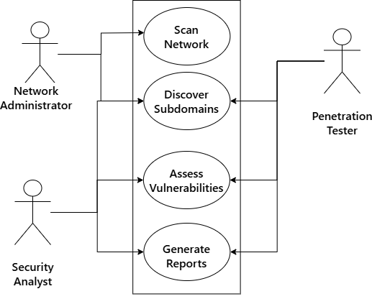
DESIGN
5.1 Use Case Scenarios: -
1. Network Discovery
- Actor: Penetration Tester, Security Analyst, Administrator
- Scenario:
  - The actor initiates a network discovery scan to identify active devices on the network.
  - The system scans the network using Nmap and returns a list of active hosts.
  - The actor reviews the results to map the network topology.

2. Port Scanning
- Actor: Penetration Tester, Security Analyst, Administrator
- Scenario:
  - The actor selects a target IP range and initiates a port scan.
  - The system uses Nmap to identify open ports and services running on the target hosts.
  - The actor analyzes the results to identify potential attack vectors.

3. OS and Service Detection
- Actor: Penetration Tester, Security Analyst, Administrator
- Scenario:
  - The actor requests OS and service detection for a specific host.
  - The system uses Nmap to detect the operating system and service versions.
  - The actor uses this information to assess vulnerabilities associated with the detected OS and services.
4. Firewall Evasion
- Actor: Penetration Tester
- Scenario:
  - The actor configures the system to use advanced Nmap techniques (e.g., fragmentation, decoy scans) to evade firewall detection.
  - The system performs the scan and returns results without triggering firewall alerts.
  - The actor uses the results to identify hidden services.

5. Web Application Security
- Actor: Penetration Tester, Security Analyst
- Scenario:
  - The actor inputs a URL to test a web application for vulnerabilities.
  - The system uses ZAP or Burp Suite to scan for issues like XSS, SQL injection, and insecure APIs.
  - The actor reviews the vulnerability report and recommends fixes.

6. Automated Security Testing
- Actor: Security Analyst, Administrator
- Scenario:
  - The actor schedules automated security tests for the network and web applications.
  - The system runs scans at the specified time and generates a report.
  - The actor reviews the report and takes action on identified vulnerabilities.

5.2 Diagram: -
5.2.1 DFD: -
- 0 Level DFD: -
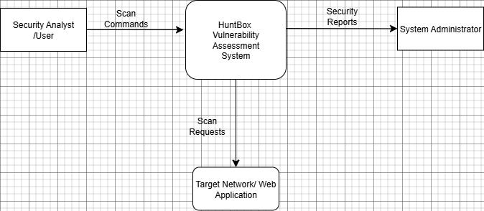
- 1 level DFD: -
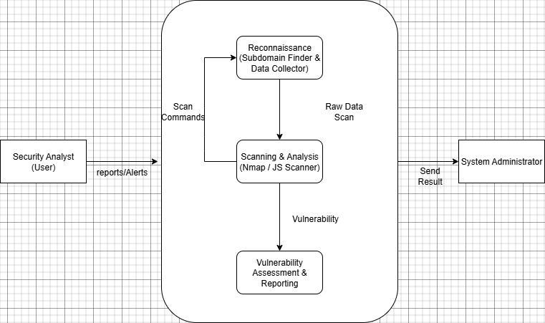

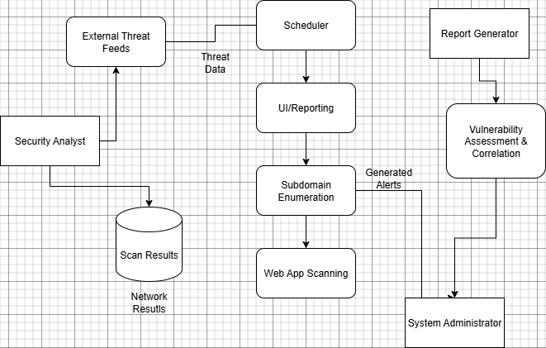
- 2nd Level DFD:-

IMPLEMENTATION
6.1 Form Layouts/Report Layouts: -
JavaScript Extractor
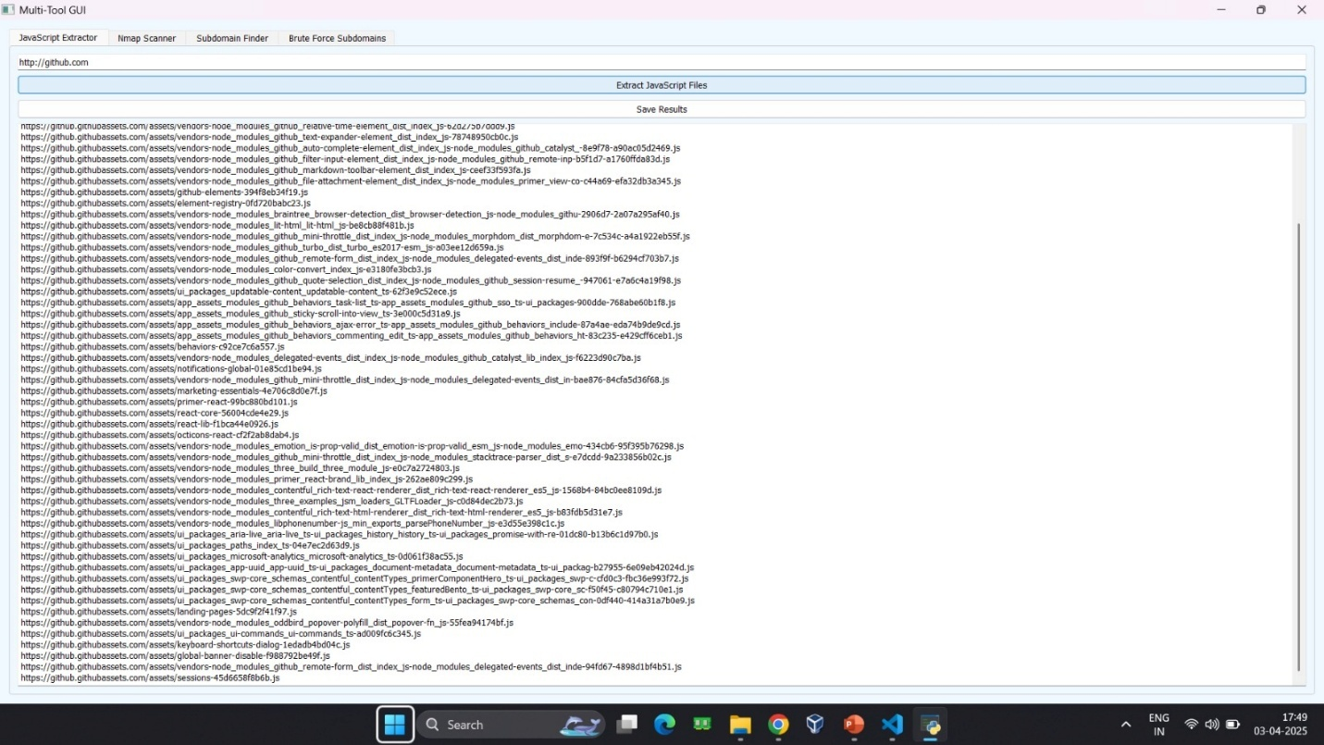
Nmap Scanner
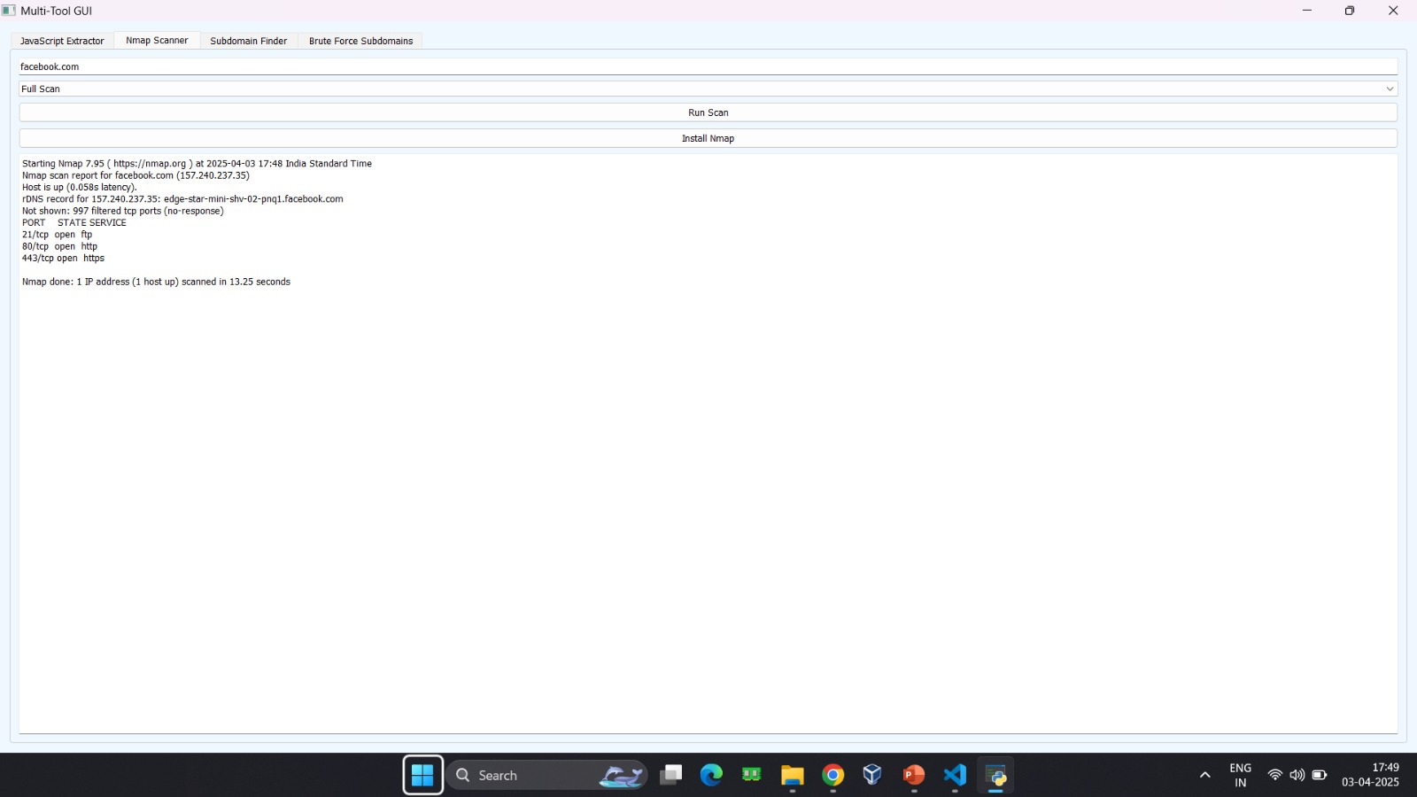
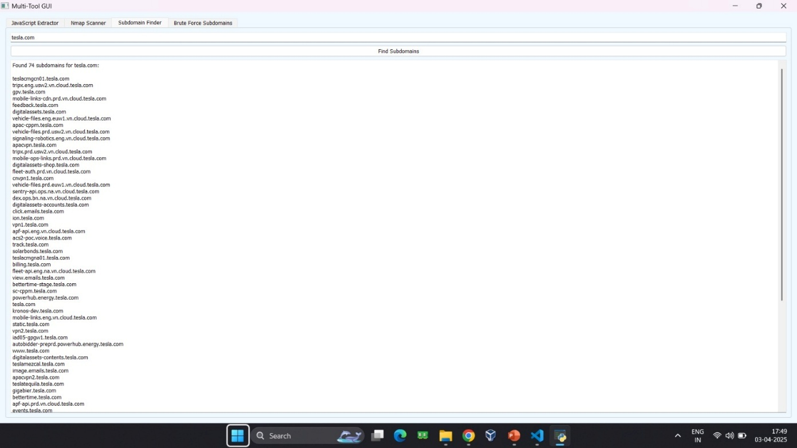
Sub-Domain Finder

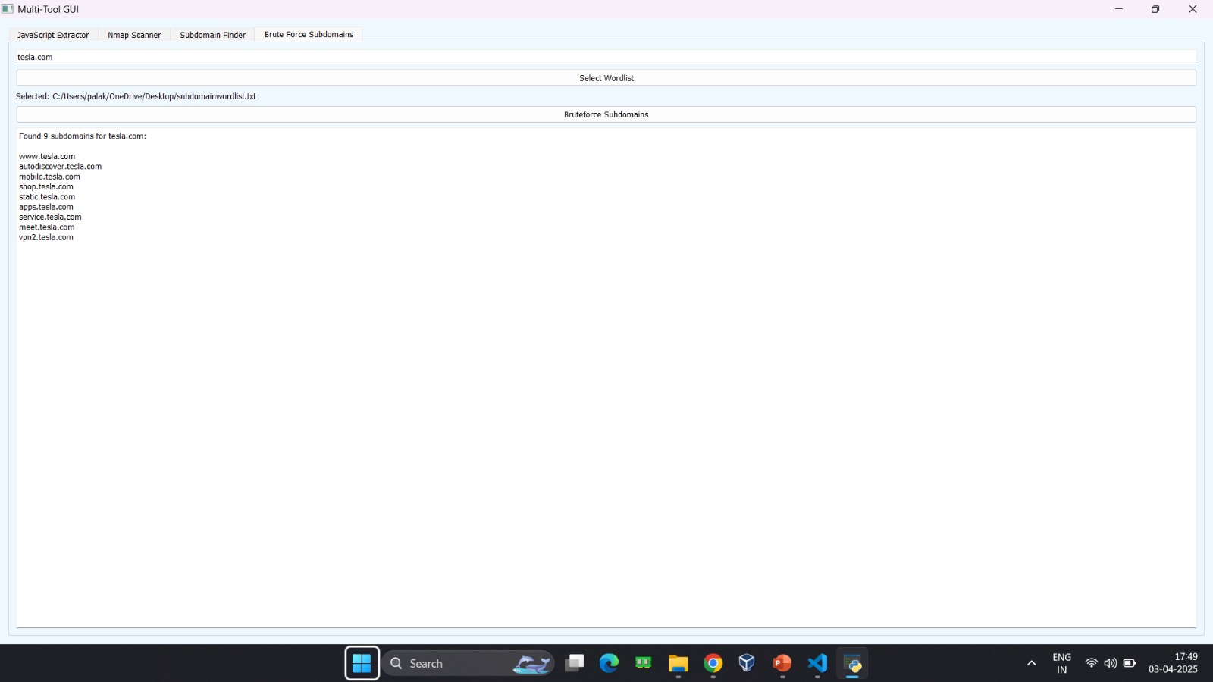
Brute-force Subdomains
6.3 Coding Convention
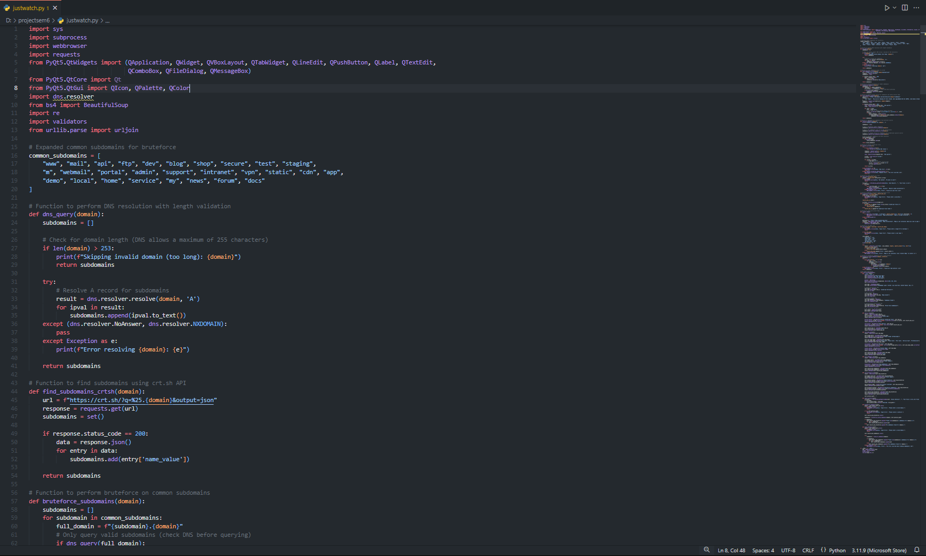
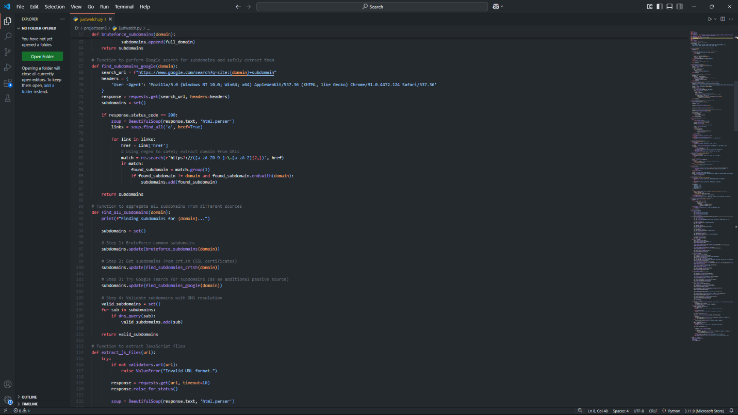

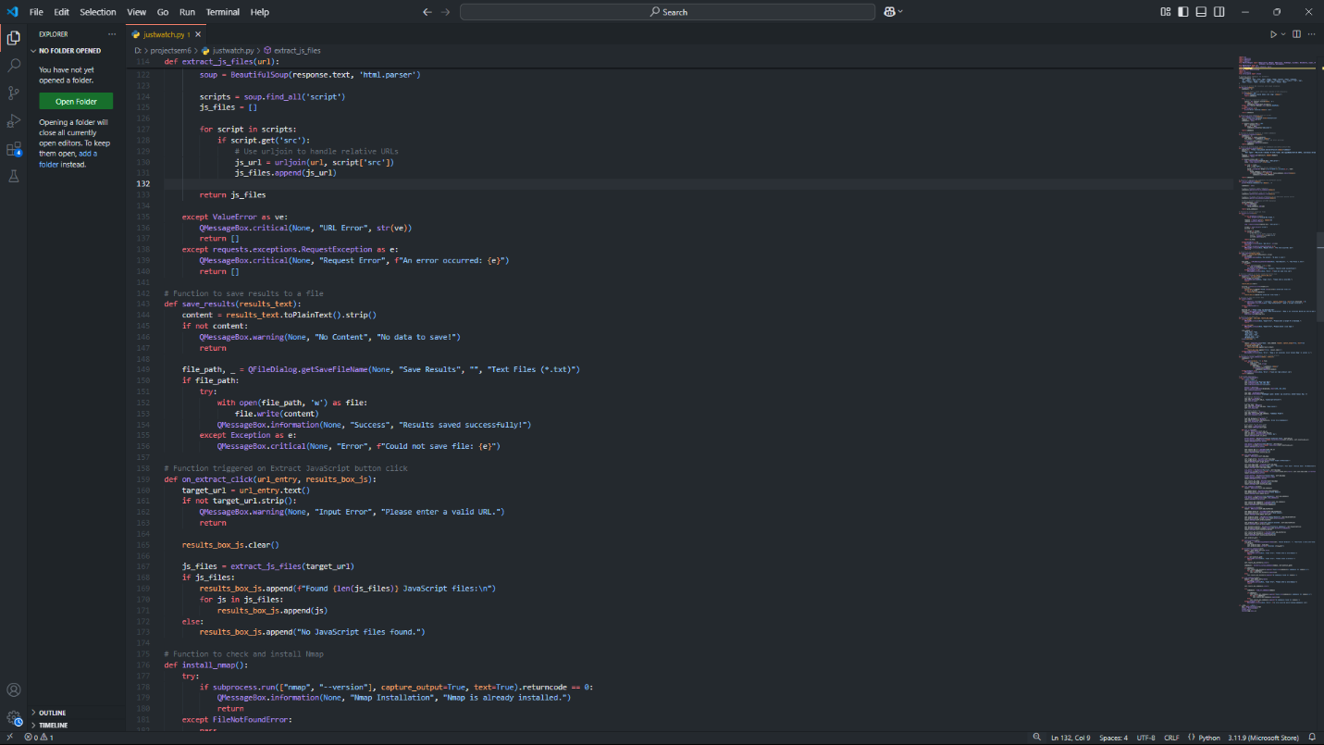
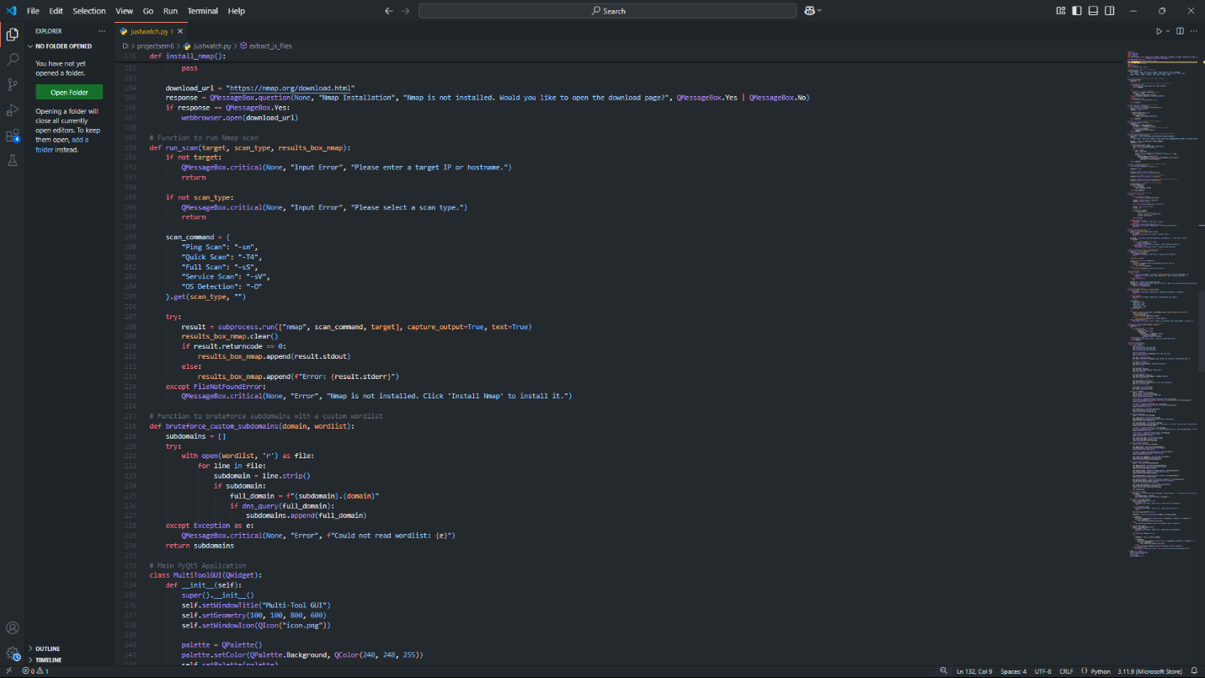

TESTING
7.1 Test Strategy
1. Objectives
- Identify open ports, services, and vulnerabilities.
- Detect JavaScript security flaws (XSS, DOM-based issues).
- Discover subdomains (passive & brute-force).
- Perform vulnerability assessment and prioritize risks.
2. Tools & Methods
Tool | Purpose
Nmap | Network scanning, service detection, OS fingerprinting.
JavaScript Scanner | Finds XSS, insecure functions, DOM vulnerabilities.
Subfinder | Passive subdomain discovery.
Subfinder (Brute Force) | Active subdomain brute-forcing.
Vuln Assessment Tools | Nessus, OpenVAS, Burp Suite for vulnerability detection.
3. Key Tests
✔ Nmap: Scan open ports, services, and OS (nmap -A <target>)
✔ JavaScript Testing: Use OWASP ZAP, Burp Suite for XSS, DOM analysis.
✔ Subfinder: Passive subdomain search (subfinder -d example.com)
✔ Subfinder Brute-Force: Discover hidden subdomains using wordlists.
✔ Vulnerability Scan: Identify CVEs, misconfigurations, security gaps.
4. Reporting & Compliance
- Categorize risks: Critical, High, Medium, Low.
- Provide fixes: Patch recommendations, config updates.
- Ensure ethical testing: Get authorization, avoid disruption.

7.2 Test Case
1. Nmap Network Scanning
Test Case | Steps | Expected Result
Port Scan | nmap -sS -p 1-65535 <target> | List of open ports.
Service Detection | nmap -sV <target> | Identifies running services.
OS Fingerprinting | nmap -O <target> | Detects OS details.
2. JavaScript Security Testing
Test Case | Steps | Expected Result
XSS Detection | Use OWASP ZAP/Burp Suite to inject <script>alert(1)</script> | Alerts or payload execution detected.
DOM-Based Issues | Scan with dynamic JS analysis tools | Finds insecure JavaScript functions.
3. Subdomain Enumeration (Subfinder)
Test Case | Steps | Expected Result
Passive Scan | subfinder -d example.com | List of discovered subdomains.
Brute-Force Scan | subfinder -d example.com -b -w wordlist.txt | Hidden subdomains found.
4. Vulnerability Assessment
Test Case | Steps | Expected Result
Automated Scan | Use Nessus/OpenVAS/Burp Suite | Detects known vulnerabilities.
Exploit Testing (If Allowed) | Validate using Metasploit/manual testing | Confirms exploitability of a vulnerability.

FUTURE ENHANCEMENT
1. AI-Powered Threat Detection
- Integrate machine learning to detect anomalies in network traffic and vulnerabilities.
- Automate pattern recognition for advanced attack prediction.
2. Automated & Continuous Scanning
- Implement CI/CD integration for real-time vulnerability detection.
- Develop automated remediation mechanisms for detected vulnerabilities.
3. Advanced JavaScript Security Analysis
- Use AI-driven JavaScript analyzers to detect complex security flaws.
- Implement behavioral analysis for detecting zero-day JavaScript vulnerabilities.
4. Enhanced Subdomain Enumeration
- Leverage DNS-based AI analysis to predict potential hidden subdomains.
- Combine OSINT techniques for deeper subdomain discovery.
5. Integration with Cloud Security Tools
- Enhance cloud security posture by integrating with AWS, Azure, GCP scanners.
- Automate cloud misconfiguration detection.
6. IoT & API Security Enhancements
- Extend Nmap scanning for IoT devices.
- Implement API security assessments for detecting API-based vulnerabilities.
7. Blockchain-Based Security Logging
- Use blockchain technology for tamper-proof security logging.
- Improve forensic analysis by maintaining immutable security logs.

BIBLIOGRAPHY
Fyodor, G. (2009). Nmap Network Scanning: The Official Nmap Project Guide to Network Discovery and Security Scanning. Insecure.org.
- A comprehensive guide on Nmap’s scanning techniques and security assessment methodologies.
OWASP Foundation. (2023). OWASP JavaScript Security Guide.
- Retrieved from https://owasp.org
- Covers JavaScript security vulnerabilities, XSS detection, and secure coding practices.
Project Discovery. (2024). Subfinder Documentation.
- Retrieved from https://github.com/projectdiscovery/subfinder
- Provides details on passive and brute-force subdomain enumeration using Subfinder.
Scarfone, K., & Mell, P. (2007). Guide to Vulnerability Scanning Tools and Techniques. National Institute of Standards and Technology (NIST).
- Discusses best practices for vulnerability assessment and penetration testing.
Todorov, D. (2020). Cloud and Web Application Security. Apress.
- Covers security assessments of web applications, API security, and cloud-based vulnerability scanning.
Tenable Inc. (2024). Nessus Vulnerability Scanner User Guide.
- Retrieved from https://www.tenable.com
- Provides insights into vulnerability assessment techniques using Nessus.

