🎯 Objective
In this step, we learn how to separate categorical and numerical columns correctly.
Although our dataset contains only numbers, not every number represents a measurable quantity — some represent categories or types.

🧠 Why This Step Is Important
Machine Learning models treat numeric and categorical data differently:
Type | Example | How ML Uses It
Numerical Data | Age = 50, Cholesterol = 230 | Model uses the actual values to detect patterns
Categorical Data | Gender = 1 (Male), 0 (Female) | Model interprets this as a label, not a quantity
If we don’t separate them correctly, the model might think “Male = 1” means greater than “Female = 0”, which is wrong! 😅

📊 Step 1: Check the Data Types
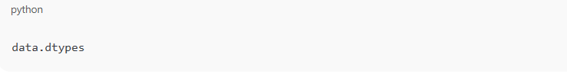

🧩 Step 2: Understand the Meaning of Each Column
These are columns that represent categories or types, not continuous measurements.
Column | Meaning | Category Type | Example
Gender | Biological sex | Binary (0, 1) | 0 = Female, 1 = Male
ChestPainType | Type of chest pain | Multi-class (0–3) | 0 = Typical, 1 = Atypical, 2 = Non-anginal, 3 = Asymptomatic
FastingBS | Blood sugar > 120 mg/dl? | Binary (0, 1) | 1 = True, 0 = False
RestingECG | ECG result type | Multi-class (0–2) | 0 = Normal, 1 = ST-T abnormality, 2 = Hypertrophy
ExerciseAngina | Angina during exercise | Binary (0, 1) | 1 = Yes, 0 = No
ST_Slope | Slope of peak exercise ST segment | Multi-class (0–2) | 0 = Upsloping, 1 = Flat, 2 = Downsloping
MajorVessels | Number of major vessels | Discrete (0–3) | Count
Thalassemia | Type of thalassemia test | Multi-class (1–3) | 1 = Normal, 2 = Fixed defect, 3 = Reversible defect

These columns contain numbers as labels, not measurable quantities.
They require encoding, not scaling.

✅ Numerical Columns
These represent real, continuous, measurable values — where mathematical operations (mean, variance, scaling) make sense.
Column | Meaning | Range | Type
Age | Age of patient | 29–77 | Continuous
RestingBP | Resting blood pressure (mm Hg) | 90–200+ | Continuous
Cholesterol | Serum cholesterol (mg/dl) | 100–560 | Continuous
MaxHR | Maximum heart rate achieved | 70–200 | Continuous
ST_Depression | Depression induced by exercise | 0.0–6.2 | Continuous

📊 Step 2 — Separate Features and Target
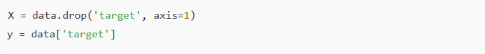
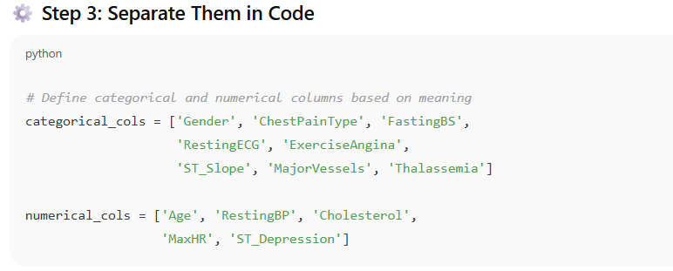

Why Encoding Is Needed
Machine learning models (like Logistic Regression, Random Forest, etc.) cannot understand text or labels — they only understand numbers.
Even though your categorical columns look numeric (like 0, 1, 2, 3), they actually represent categories, not quantities.
For example:
- ChestPainType = 3 doesn’t mean “3× more pain” than ChestPainType = 1.
- It’s just a different type of pain — not an order or magnitude..

🧠 The Two Types of Encoding — Explained Simply
There are two major kinds of categorical data:
Type | Description | Example Columns | Encoding Type
Nominal | Categories with no order | Gender, ChestPainType, Thalassemia | ✅ One-Hot Encoding
Ordinal | Categories with a natural order or ranking | Education Level, ST_Slope (Up, Flat, Down), Severity Level | ✅ Label Encoding

🧩 1️⃣ Nominal Data → One-Hot Encoding
Nominal data means categories that are different, but not ordered.
There’s no “greater than” or “less than” relationship.
Example:
Gender: Male (1), Female (0)
ChestPainType: Typical (0), Atypical (1), Non-Anginal (2), Asymptomatic (3)
So we apply One-Hot Encoding, which creates separate columns for each category.

🧩 What Is One-Hot Encoding?
One-Hot Encoding converts each categorical column into multiple binary columns (0 or 1),
where each column represents one possible category.
Example:
Let’s say we have a column ChestPainType with 4 categories: 0, 1, 2, 3
After One-Hot Encoding, it becomes:
ChestPainType | ChestPainType_1 | ChestPainType_2 | ChestPainType_3
0 | 0 | 0 | 0
1 | 1 | 0 | 0
2 | 0 | 1 | 0
3 | 0 | 0 | 1

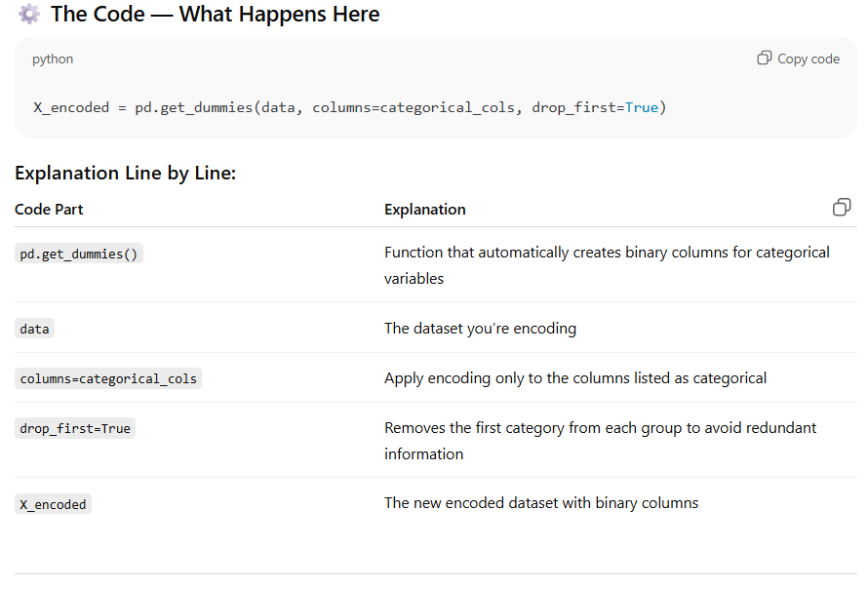

What Is Feature Scaling?
Feature scaling is the process of normalizing the range of independent variables in your dataset — that means, we bring all numerical columns to the same scale or range.
In simple words:
It’s like putting all your features on the same measuring unit —
so that no one dominates others just because of its large numbers.

📊 Why Do We Need Feature Scaling?
Let’s imagine your dataset has two columns:
Feature | Example Range
Age | 20 – 80
Cholesterol | 100 – 600
Now think — both are important to predict heart disease.
But Cholesterol values are much larger (100–600) than Age (20–80).
If we feed this directly to a machine learning model, it’ll assume:
Cholesterol is more important than Age,
because its values are numerically higher.
This happens because most ML models calculate distances or gradients — and big numbers dominate those calculations.

So What Does Feature Scaling Do?
Feature scaling adjusts all numerical values so that:
- Each feature contributes equally to model learning.
- The dataset becomes balanced in numerical magnitude.
- Training becomes faster and more stable.

