* ***MANASH PARASHAR - QA_TEST - 17BCE0031***

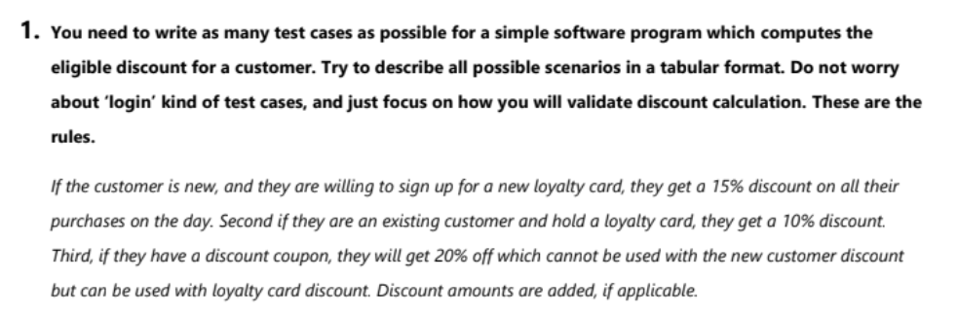

* **(Yes+)** 🡪 Discount added,
* **(New customer discount) 🡪** New customer, Willing to sign up new loyalty card,
* **(2*Yes+)🡪** Add discount two times,

|  |  |  |  |  |
| --- | --- | --- | --- | --- |
| Discount(%):  Type Of  Customers: | 15 | 10 | 20 | No Discount |
| New customer, no coupon |  |  |  | Yes |
| New customer,  with coupon |  |  | Yes |  |
| New customer,  Willing to sign up new loyalty card  (New customer discount) | Yes |  |  |  |
| New customer,  Not Willing to sign up new loyalty card  (New customer discount) |  |  |  | Yes |
| New customer,  With coupon  With new customer discount |  |  |  | Yes |
| New customer,  With coupon  Without new customer discount |  |  | Yes |  |
| New customer,  Without coupon  With new customer discount | Yes |  |  |  |
| New customer,  With coupon  With new customer discount | Yes |  |  |  |
| New customer,  With loyalty card discount |  |  | Yes |  |
| New customer,  With coupon  With loyalty card |  |  | 2*Yes+ |  |
| New customer,  Willing to sign up new loyalty card + having loyalty card | Yes + |  | Yes+ |  |
| Existing customer with loyalty card |  | Yes |  |  |
| Existing customer with loyalty card and no coupon |  | Yes |  |  |
| Existing customer with loyalty card and with coupon |  | Yes+ | Yes+ |  |
| Existing customer without loyalty card and no coupon |  |  |  | Yes |
| Existing customer without loyalty card and with coupon |  |  | Yes |  |

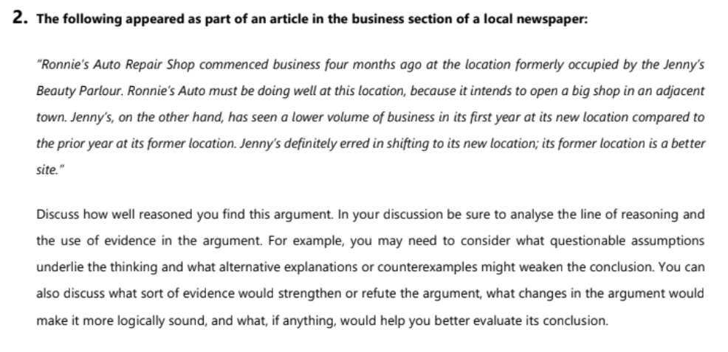

The argument states that “Ronnie’s Auto Repair Shop” commenced business four months ago at the same location which was occupied by “jenny’s beauty parlour” and Ronnie’s auto shop is doing good as compared to jenny’s shop as auto shop intends to open a big shop in an adjacent town. The conclusion that jenny definitely erred in shifting to its new location and its former location is a better site is based on the premise that she has seen a lower volume of business in its first year at its new location. However, there are several assumptions that may not necessarily apply or considered to this argument. For example,

Firstly, cost to repair vehicles at repair shop could be more than beauty treatment at beauty shop, This comparison is illogical, however, as it fails to consider the fact that both shops might be of the different sizes and, clearly, do not have the same market share.

Secondly, as it is new location for both jenny’s and Ronnie’s shops, it would take good amount of time to customers, to get accompanied with the shops or Ronnie’s shop could be more established as compared to jenny’s shop. Hence, jenny’s shop might face several difficulties to gain customers, who are not familiar with the shop at its new location.

Thirdly, the cost of selling the former shop owned by jenny may compensate the amount of loss made by jenny in its first year of new shop, or Ronnie may have had good additional investment to open a new shop in another town.

Finally, the author doesn't take into account the possibility that, it is completely possible that demand for repairing vehicles is more than that of beauty shop as frequency of vehicle repairs is quite more than that of beauty customers. so, these factors may impact widely on the argument so the conclusion may not necessarily be accurate.

So, if the author would have discussed more factors defined above like cost to repair a vehicle as compared to taking a beauty treatment, or comparison of profits earned by both the shops in a particular year rather than taking four months for repair shop and one year for beauty shop, or defining population coming to repair shop and beauty shop, also the author could have given a strong reasoning why Ronnie’s repair shop is doing well instead of just saying “it intends to open a big shop in an adjacent town” as there could be many other reasons why he is able to open another big shop in an adjacent town.

In summary, the presented argument is neither persuasive nor sound, It leans on questionable assumptions about jenny’s shop and makes controversial comparisons. In addition, the author fails to take into account the fact that do not have the same market share.



* **In the case of wireless mouse,**
* check the range up to which the mouse remains operational.
* check the battery requirement of the mouse.
* Check if there is an option to switch on or mouse.
* Check if the mouse is an optical mouse or not.
* Verify that left-click and right-click buttons are working fine.
* Check if the double click is working fine.
* Check if the scroller is present at the top or not.
* Verify the speed of the mouse pointer.
* Verify the time duration between two left clicks, in order to consider it as a double click.
* Check the pressure required for clicking the mouse buttons.
* Verify the acceleration of the mouse pointer.
* Verify that clicking the button and dragging the mouse operation is working fine (drag and drop functionality).
* Check the dimension of the mouse, if it’s suitable to grip and work.
* Verify that the mouse works in all the allowed surfaces.
* Check if the mouse is a wireless mouse or corded mouse.