Unit2
polymorphism in Java (and in object-oriented programming) means "many forms". It allows objects to behave differently based on the context in which they are used. In simpler terms, a single interface or method can represent multiple forms or behaviors.
There are two main types of polymorphism in Java:

1. Compile-Time Polymorphism (Static Binding)
This type of polymorphism is determined during compile time.
When a object is bound with its functionality at compile time is called compile-time polymor
It is achieved using method overloading.
Method Overloading:
When multiple methods in the same class have the same name but differ in their parameter list (number, type, or order of parameters), it is called method overloading.
2. Runtime Polymorphism (Dynamic Binding)
This type of polymorphism is determined during runtime.
When a object is bound with its functionality at runtime.
It is achieved using method overriding.
Method Overriding:
When a subclass provides its own implementation for a method that is already defined in the parent class, it is called method overriding.
- The method in the child class must have the same name, return type, and parameters as in the parent class.
- The overridden method is called based on the actual object type at runtime, not the reference type.

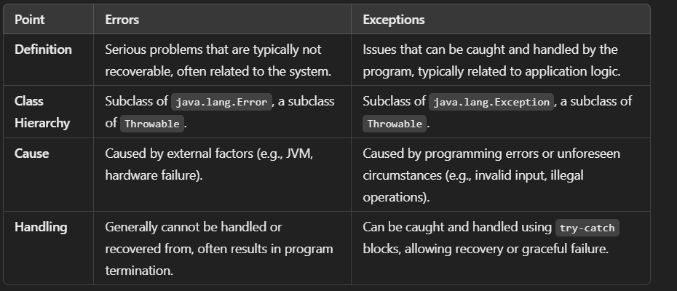

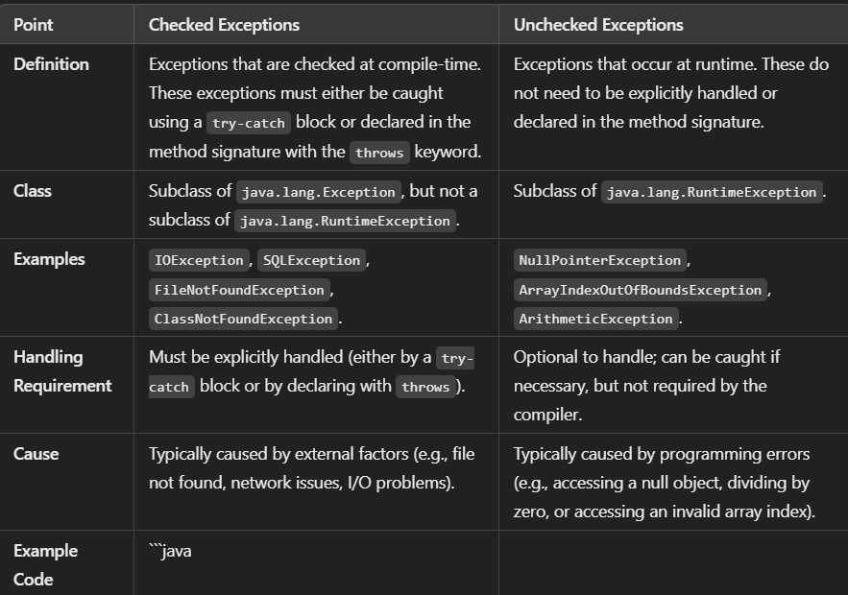

COLLECTIONS IN JAVA:
A Collection in Java is a framework that provides a set of classes and interfaces to store and manipulate groups of objects as a single unit. It is a part of the java.util package and helps in handling dynamic data structures such as lists, sets, queues, and maps efficiently.
Key Points About Collections:
- Purpose:
  - Collections are used to group objects and perform operations like searching, sorting, insertion, deletion, and manipulation on them.
- Interfaces:
  - The core interfaces of the Collections Framework include:
    - Collection (parent interface)
    - List (ordered collection, allows duplicates)
    - Set (unordered collection, no duplicates)
    - Queue (FIFO structure)
    - Map (key-value pairs, not technically part of Collection but part of the framework)
- Advantages:
  - Provides ready-made data structures.
  - Supports algorithms like sorting, searching, and more.
  - Reduces development time and effort.

LISTS:
- Arraylist
- Linked list
- Vecor
SETS:
- Hashset
- Treeset
- Linkedhashset
Queues:
- priorityQueue
- linked list

java8-coldstamp
java-dampprods
oop-

