A.Manideep CB.SC.U4CSE24462
SHEETHALRAJ CB.SC.U4CSE24446

GIVEN TWO SENTENCES WHERE ONE IS A POSITIVE SENTENCE AND OTHER IS A NEGITIVE SENTENCE CALCULATE THE PROB SCORE USING N-GRAM(1-GRAM),(2-GRAM),…AND WRITE THE CODE FOR THE SAME USING NLTK

1)<S>GATED COMMUNITIES HAVE A NICE ENVIRONMENT</S>
2)<S>GATED COMMUNITIES ARE VERY COSTLYB</S>

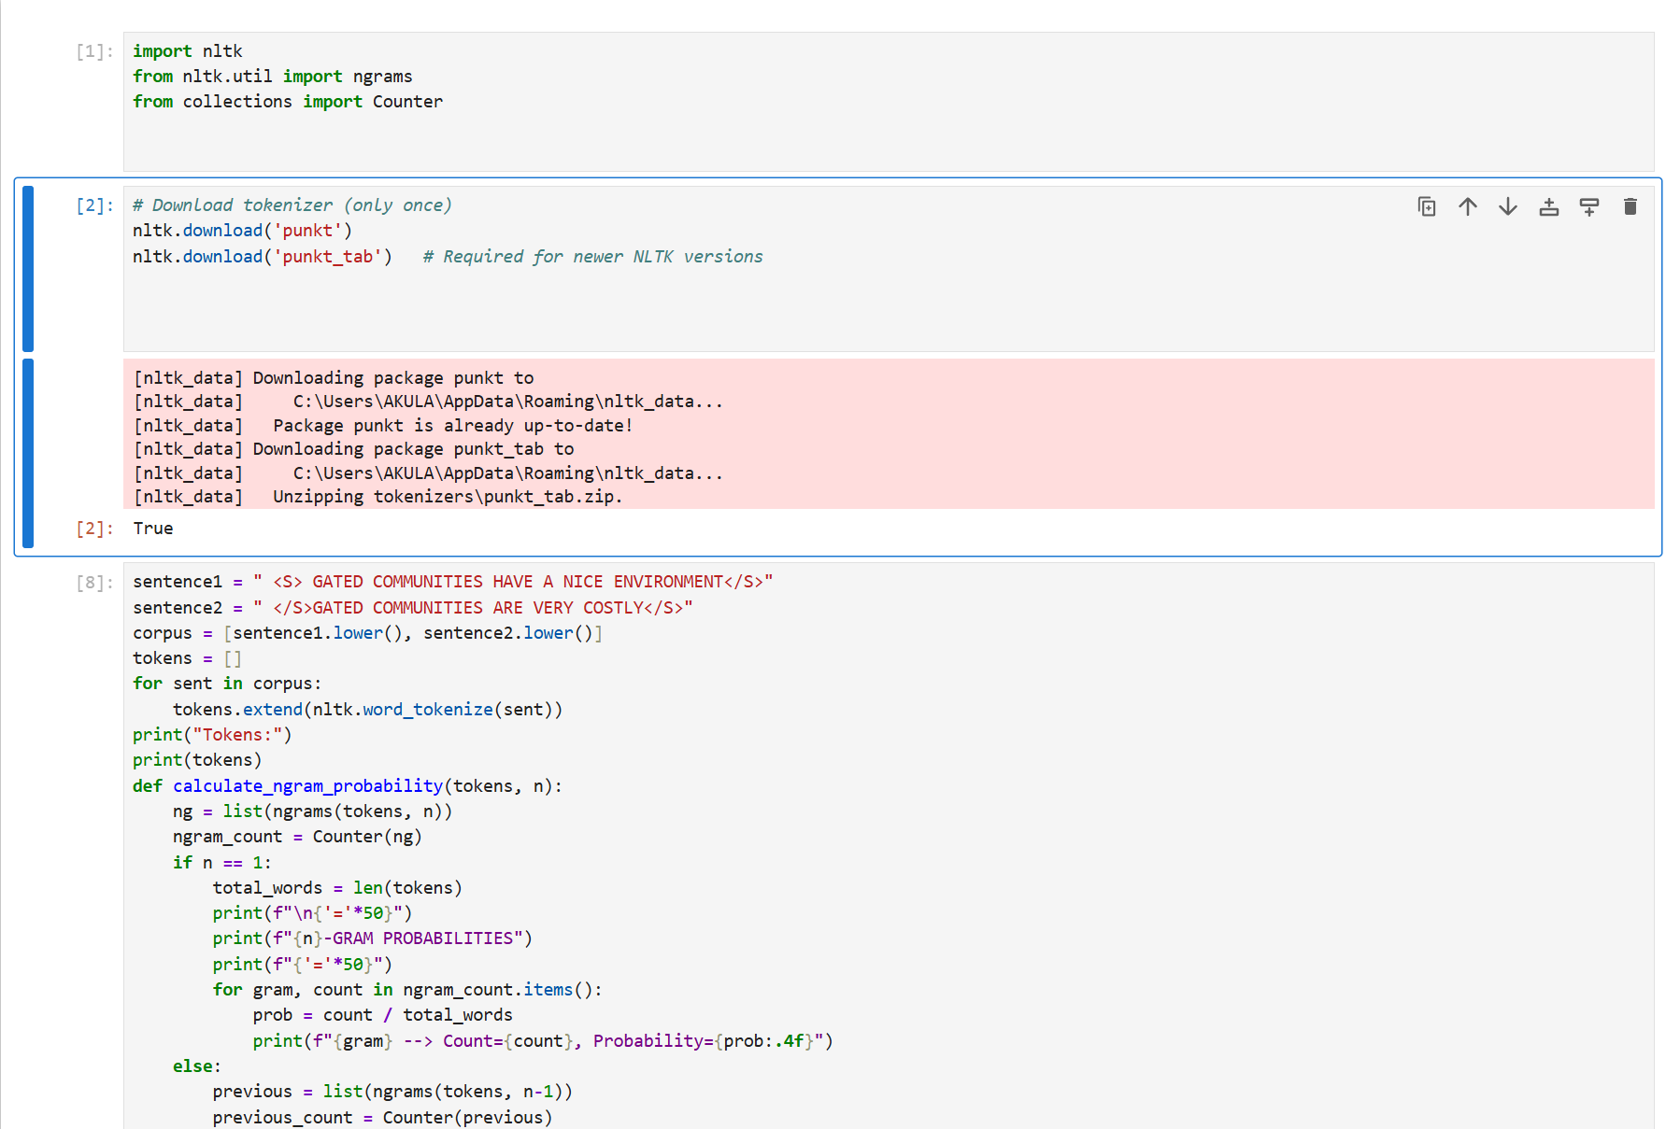

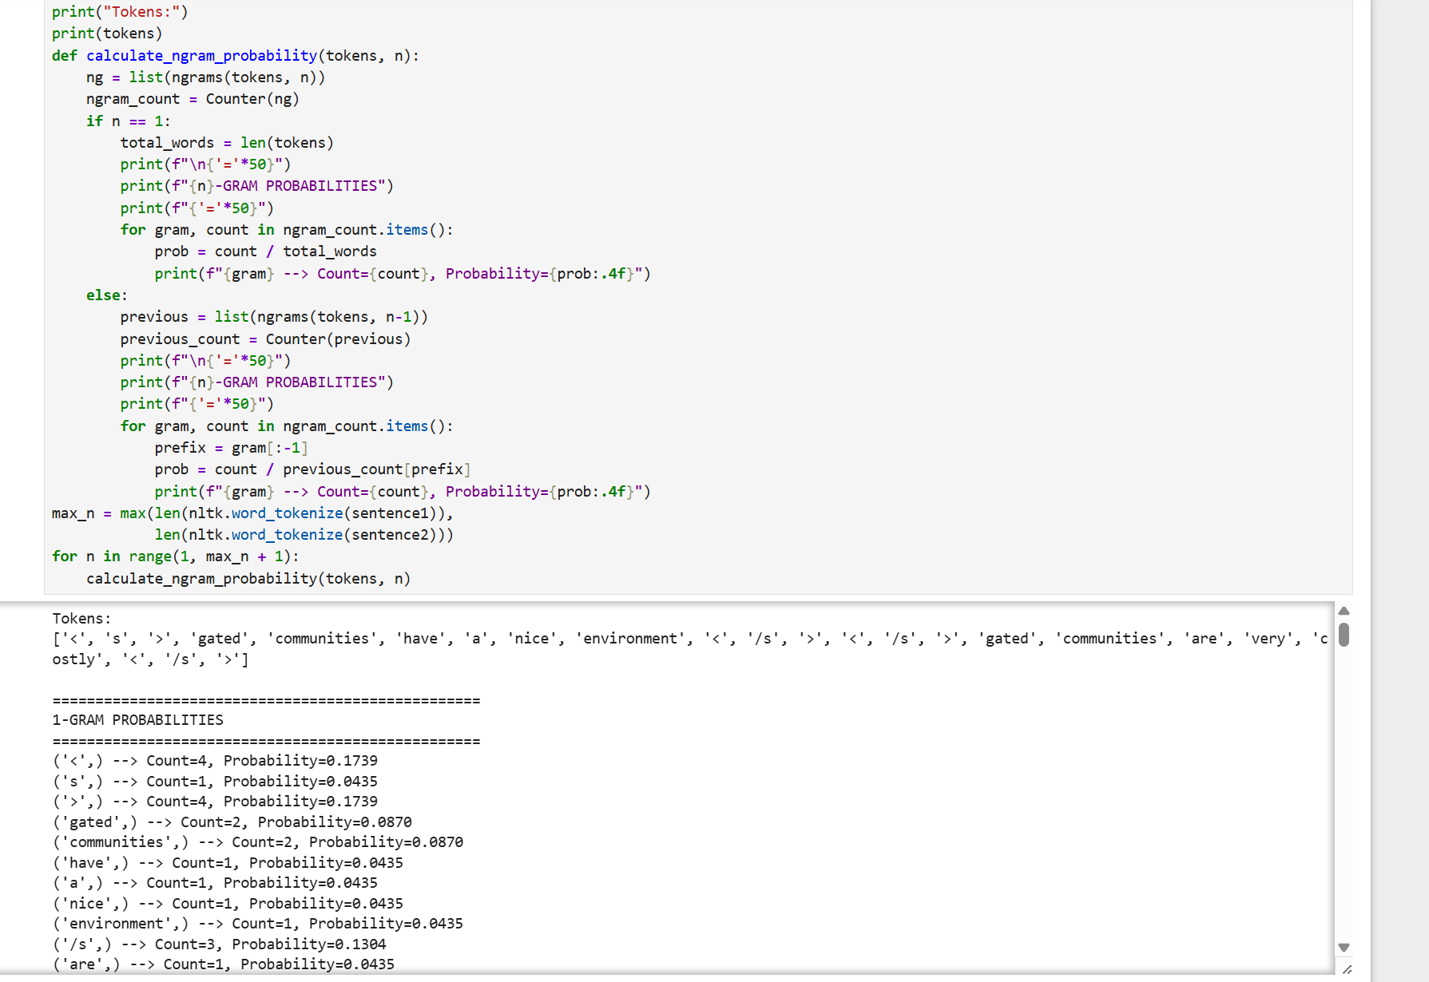

==================================================
2-GRAM PROBABILITIES
==================================================
('<', 's') --> Count=1, Probability=0.2500
('s', '>') --> Count=1, Probability=1.0000
('>', 'gated') --> Count=2, Probability=0.5000
('gated', 'communities') --> Count=2, Probability=1.0000
('communities', 'have') --> Count=1, Probability=0.5000
('have', 'a') --> Count=1, Probability=1.0000
('a', 'nice') --> Count=1, Probability=1.0000
('nice', 'environment') --> Count=1, Probability=1.0000
('environment', '<') --> Count=1, Probability=1.0000
('<', '/s') --> Count=3, Probability=0.7500
('/s', '>') --> Count=3, Probability=1.0000
('>', '<') --> Count=1, Probability=0.2500
('communities', 'are') --> Count=1, Probability=0.5000
('are', 'very') --> Count=1, Probability=1.0000
('very', 'costly') --> Count=1, Probability=1.0000
('costly', '<') --> Count=1, Probability=1.0000

==================================================
3-GRAM PROBABILITIES
==================================================
('<', 's', '>') --> Count=1, Probability=1.0000
('s', '>', 'gated') --> Count=1, Probability=1.0000
('>', 'gated', 'communities') --> Count=2, Probability=1.0000
('gated', 'communities', 'have') --> Count=1, Probability=0.5000
('communities', 'have', 'a') --> Count=1, Probability=1.0000
('have', 'a', 'nice') --> Count=1, Probability=1.0000
('a', 'nice', 'environment') --> Count=1, Probability=1.0000
('nice', 'environment', '<') --> Count=1, Probability=1.0000
('environment', '<', '/s') --> Count=1, Probability=1.0000
('<', '/s', '>') --> Count=3, Probability=1.0000
('/s', '>', '<') --> Count=1, Probability=0.3333
('>', '<', '/s') --> Count=1, Probability=1.0000
('/s', '>', 'gated') --> Count=1, Probability=0.3333
('gated', 'communities', 'are') --> Count=1, Probability=0.5000
('communities', 'are', 'very') --> Count=1, Probability=1.0000
('are', 'very', 'costly') --> Count=1, Probability=1.0000
('very', 'costly', '<') --> Count=1, Probability=1.0000
('costly', '<', '/s') --> Count=1, Probability=1.0000

==================================================
4-GRAM PROBABILITIES
==================================================
('<', 's', '>', 'gated') --> Count=1, Probability=1.0000
('s', '>', 'gated', 'communities') --> Count=1, Probability=1.0000
('>', 'gated', 'communities', 'have') --> Count=1, Probability=0.5000
('gated', 'communities', 'have', 'a') --> Count=1, Probability=1.0000
('communities', 'have', 'a', 'nice') --> Count=1, Probability=1.0000
('have', 'a', 'nice', 'environment') --> Count=1, Probability=1.0000
('a', 'nice', 'environment', '<') --> Count=1, Probability=1.0000
('nice', 'environment', '<', '/s') --> Count=1, Probability=1.0000
('environment', '<', '/s', '>') --> Count=1, Probability=1.0000
('<', '/s', '>', '<') --> Count=1, Probability=0.3333
('/s', '>', '<', '/s') --> Count=1, Probability=1.0000
('>', '<', '/s', '>') --> Count=1, Probability=1.0000
('<', '/s', '>', 'gated') --> Count=1, Probability=0.3333
('/s', '>', 'gated', 'communities') --> Count=1, Probability=1.0000
('>', 'gated', 'communities', 'are') --> Count=1, Probability=0.5000
('gated', 'communities', 'are', 'very') --> Count=1, Probability=1.0000
('communities', 'are', 'very', 'costly') --> Count=1, Probability=1.0000
('are', 'very', 'costly', '<') --> Count=1, Probability=1.0000
('very', 'costly', '<', '/s') --> Count=1, Probability=1.0000
('costly', '<', '/s', '>') --> Count=1, Probability=1.0000

==================================================
5-GRAM PROBABILITIES
==================================================
('<', 's', '>', 'gated', 'communities') --> Count=1, Probability=1.0000
('s', '>', 'gated', 'communities', 'have') --> Count=1, Probability=1.0000
('>', 'gated', 'communities', 'have', 'a') --> Count=1, Probability=1.0000
('gated', 'communities', 'have', 'a', 'nice') --> Count=1, Probability=1.0000
('communities', 'have', 'a', 'nice', 'environment') --> Count=1, Probability=1.0000
('have', 'a', 'nice', 'environment', '<') --> Count=1, Probability=1.0000
('a', 'nice', 'environment', '<', '/s') --> Count=1, Probability=1.0000
('nice', 'environment', '<', '/s', '>') --> Count=1, Probability=1.0000
('environment', '<', '/s', '>', '<') --> Count=1, Probability=1.0000
('<', '/s', '>', '<', '/s') --> Count=1, Probability=1.0000
('/s', '>', '<', '/s', '>') --> Count=1, Probability=1.0000
('>', '<', '/s', '>', 'gated') --> Count=1, Probability=1.0000
('<', '/s', '>', 'gated', 'communities') --> Count=1, Probability=1.0000
('/s', '>', 'gated', 'communities', 'are') --> Count=1, Probability=1.0000
('>', 'gated', 'communities', 'are', 'very') --> Count=1, Probability=1.0000
('gated', 'communities', 'are', 'very', 'costly') --> Count=1, Probability=1.0000
('communities', 'are', 'very', 'costly', '<') --> Count=1, Probability=1.0000
('are', 'very', 'costly', '<', '/s') --> Count=1, Probability=1.0000
('very', 'costly', '<', '/s', '>') --> Count=1, Probability=1.0000

==================================================
6-GRAM PROBABILITIES
==================================================
('<', 's', '>', 'gated', 'communities', 'have') --> Count=1, Probability=1.0000
('s', '>', 'gated', 'communities', 'have', 'a') --> Count=1, Probability=1.0000
('>', 'gated', 'communities', 'have', 'a', 'nice') --> Count=1, Probability=1.0000
('gated', 'communities', 'have', 'a', 'nice', 'environment') --> Count=1, Probability=1.0000
('communities', 'have', 'a', 'nice', 'environment', '<') --> Count=1, Probability=1.0000
('have', 'a', 'nice', 'environment', '<', '/s') --> Count=1, Probability=1.0000
('a', 'nice', 'environment', '<', '/s', '>') --> Count=1, Probability=1.0000
('nice', 'environment', '<', '/s', '>', '<') --> Count=1, Probability=1.0000
('environment', '<', '/s', '>', '<', '/s') --> Count=1, Probability=1.0000
('<', '/s', '>', '<', '/s', '>') --> Count=1, Probability=1.0000
('/s', '>', '<', '/s', '>', 'gated') --> Count=1, Probability=1.0000
('>', '<', '/s', '>', 'gated', 'communities') --> Count=1, Probability=1.0000
('<', '/s', '>', 'gated', 'communities', 'are') --> Count=1, Probability=1.0000
('/s', '>', 'gated', 'communities', 'are', 'very') --> Count=1, Probability=1.0000
('>', 'gated', 'communities', 'are', 'very', 'costly') --> Count=1, Probability=1.0000
('gated', 'communities', 'are', 'very', 'costly', '<') --> Count=1, Probability=1.0000
('communities', 'are', 'very', 'costly', '<', '/s') --> Count=1, Probability=1.0000
('are', 'very', 'costly', '<', '/s', '>') --> Count=1, Probability=1.0000

==================================================
7-GRAM PROBABILITIES
==================================================
('<', 's', '>', 'gated', 'communities', 'have', 'a') --> Count=1, Probability=1.0000
('s', '>', 'gated', 'communities', 'have', 'a', 'nice') --> Count=1, Probability=1.0000
('>', 'gated', 'communities', 'have', 'a', 'nice', 'environment') --> Count=1, Probability=1.0000
('gated', 'communities', 'have', 'a', 'nice', 'environment', '<') --> Count=1, Probability=1.0000
('communities', 'have', 'a', 'nice', 'environment', '<', '/s') --> Count=1, Probability=1.0000
('have', 'a', 'nice', 'environment', '<', '/s', '>') --> Count=1, Probability=1.0000
('a', 'nice', 'environment', '<', '/s', '>', '<') --> Count=1, Probability=1.0000
('nice', 'environment', '<', '/s', '>', '<', '/s') --> Count=1, Probability=1.0000
('environment', '<', '/s', '>', '<', '/s', '>') --> Count=1, Probability=1.0000
('<', '/s', '>', '<', '/s', '>', 'gated') --> Count=1, Probability=1.0000
('/s', '>', '<', '/s', '>', 'gated', 'communities') --> Count=1, Probability=1.0000
('>', '<', '/s', '>', 'gated', 'communities', 'are') --> Count=1, Probability=1.0000
('<', '/s', '>', 'gated', 'communities', 'are', 'very') --> Count=1, Probability=1.0000
('/s', '>', 'gated', 'communities', 'are', 'very', 'costly') --> Count=1, Probability=1.0000
('>', 'gated', 'communities', 'are', 'very', 'costly', '<') --> Count=1, Probability=1.0000
('gated', 'communities', 'are', 'very', 'costly', '<', '/s') --> Count=1, Probability=1.0000
('communities', 'are', 'very', 'costly', '<', '/s', '>') --> Count=1, Probability=1.0000

==================================================
8-GRAM PROBABILITIES
==================================================
('<', 's', '>', 'gated', 'communities', 'have', 'a', 'nice') --> Count=1, Probability=1.0000
('s', '>', 'gated', 'communities', 'have', 'a', 'nice', 'environment') --> Count=1, Probability=1.0000
('>', 'gated', 'communities', 'have', 'a', 'nice', 'environment', '<') --> Count=1, Probability=1.0000
('gated', 'communities', 'have', 'a', 'nice', 'environment', '<', '/s') --> Count=1, Probability=1.0000
('communities', 'have', 'a', 'nice', 'environment', '<', '/s', '>') --> Count=1, Probability=1.0000
('have', 'a', 'nice', 'environment', '<', '/s', '>', '<') --> Count=1, Probability=1.0000
('a', 'nice', 'environment', '<', '/s', '>', '<', '/s') --> Count=1, Probability=1.0000
('nice', 'environment', '<', '/s', '>', '<', '/s', '>') --> Count=1, Probability=1.0000
('environment', '<', '/s', '>', '<', '/s', '>', 'gated') --> Count=1, Probability=1.0000
('<', '/s', '>', '<', '/s', '>', 'gated', 'communities') --> Count=1, Probability=1.0000
('/s', '>', '<', '/s', '>', 'gated', 'communities', 'are') --> Count=1, Probability=1.0000
('>', '<', '/s', '>', 'gated', 'communities', 'are', 'very') --> Count=1, Probability=1.0000
('<', '/s', '>', 'gated', 'communities', 'are', 'very', 'costly') --> Count=1, Probability=1.0000
('/s', '>', 'gated', 'communities', 'are', 'very', 'costly', '<') --> Count=1, Probability=1.0000
('>', 'gated', 'communities', 'are', 'very', 'costly', '<', '/s') --> Count=1, Probability=1.0000
('gated', 'communities', 'are', 'very', 'costly', '<', '/s', '>') --> Count=1, Probability=1.0000

==================================================
9-GRAM PROBABILITIES
==================================================
('<', 's', '>', 'gated', 'communities', 'have', 'a', 'nice', 'environment') --> Count=1, Probability=1.0000
('s', '>', 'gated', 'communities', 'have', 'a', 'nice', 'environment', '<') --> Count=1, Probability=1.0000
('>', 'gated', 'communities', 'have', 'a', 'nice', 'environment', '<', '/s') --> Count=1, Probability=1.0000
('gated', 'communities', 'have', 'a', 'nice', 'environment', '<', '/s', '>') --> Count=1, Probability=1.0000
('communities', 'have', 'a', 'nice', 'environment', '<', '/s', '>', '<') --> Count=1, Probability=1.0000
('have', 'a', 'nice', 'environment', '<', '/s', '>', '<', '/s') --> Count=1, Probability=1.0000
('a', 'nice', 'environment', '<', '/s', '>', '<', '/s', '>') --> Count=1, Probability=1.0000
('nice', 'environment', '<', '/s', '>', '<', '/s', '>', 'gated') --> Count=1, Probability=1.0000
('environment', '<', '/s', '>', '<', '/s', '>', 'gated', 'communities') --> Count=1, Probability=1.0000
('<', '/s', '>', '<', '/s', '>', 'gated', 'communities', 'are') --> Count=1, Probability=1.0000
('/s', '>', '<', '/s', '>', 'gated', 'communities', 'are', 'very') --> Count=1, Probability=1.0000
('>', '<', '/s', '>', 'gated', 'communities', 'are', 'very', 'costly') --> Count=1, Probability=1.0000
('<', '/s', '>', 'gated', 'communities', 'are', 'very', 'costly', '<') --> Count=1, Probability=1.0000
('/s', '>', 'gated', 'communities', 'are', 'very', 'costly', '<', '/s') --> Count=1, Probability=1.0000
('>', 'gated', 'communities', 'are', 'very', 'costly', '<', '/s', '>') --> Count=1, Probability=1.0000

==================================================
10-GRAM PROBABILITIES
==================================================
('<', 's', '>', 'gated', 'communities', 'have', 'a', 'nice', 'environment', '<') --> Count=1, Probability=1.0000
('s', '>', 'gated', 'communities', 'have', 'a', 'nice', 'environment', '<', '/s') --> Count=1, Probability=1.0000
('>', 'gated', 'communities', 'have', 'a', 'nice', 'environment', '<', '/s', '>') --> Count=1, Probability=1.0000
('gated', 'communities', 'have', 'a', 'nice', 'environment', '<', '/s', '>', '<') --> Count=1, Probability=1.0000
('communities', 'have', 'a', 'nice', 'environment', '<', '/s', '>', '<', '/s') --> Count=1, Probability=1.0000
('have', 'a', 'nice', 'environment', '<', '/s', '>', '<', '/s', '>') --> Count=1, Probability=1.0000
('a', 'nice', 'environment', '<', '/s', '>', '<', '/s', '>', 'gated') --> Count=1, Probability=1.0000
('nice', 'environment', '<', '/s', '>', '<', '/s', '>', 'gated', 'communities') --> Count=1, Probability=1.0000
('environment', '<', '/s', '>', '<', '/s', '>', 'gated', 'communities', 'are') --> Count=1, Probability=1.0000
('<', '/s', '>', '<', '/s', '>', 'gated', 'communities', 'are', 'very') --> Count=1, Probability=1.0000
('/s', '>', '<', '/s', '>', 'gated', 'communities', 'are', 'very', 'costly') --> Count=1, Probability=1.0000
('>', '<', '/s', '>', 'gated', 'communities', 'are', 'very', 'costly', '<') --> Count=1, Probability=1.0000
('<', '/s', '>', 'gated', 'communities', 'are', 'very', 'costly', '<', '/s') --> Count=1, Probability=1.0000
('/s', '>', 'gated', 'communities', 'are', 'very', 'costly', '<', '/s', '>') --> Count=1, Probability=1.0000

==================================================
11-GRAM PROBABILITIES
==================================================
('<', 's', '>', 'gated', 'communities', 'have', 'a', 'nice', 'environment', '<', '/s') --> Count=1, Probability=1.0000
('s', '>', 'gated', 'communities', 'have', 'a', 'nice', 'environment', '<', '/s', '>') --> Count=1, Probability=1.0000
('>', 'gated', 'communities', 'have', 'a', 'nice', 'environment', '<', '/s', '>', '<') --> Count=1, Probability=1.0000
('gated', 'communities', 'have', 'a', 'nice', 'environment', '<', '/s', '>', '<', '/s') --> Count=1, Probability=1.0000
('communities', 'have', 'a', 'nice', 'environment', '<', '/s', '>', '<', '/s', '>') --> Count=1, Probability=1.0000
('have', 'a', 'nice', 'environment', '<', '/s', '>', '<', '/s', '>', 'gated') --> Count=1, Probability=1.0000
('a', 'nice', 'environment', '<', '/s', '>', '<', '/s', '>', 'gated', 'communities') --> Count=1, Probability=1.0000
('nice', 'environment', '<', '/s', '>', '<', '/s', '>', 'gated', 'communities', 'are') --> Count=1, Probability=1.0000
('environment', '<', '/s', '>', '<', '/s', '>', 'gated', 'communities', 'are', 'very') --> Count=1, Probability=1.0000
('<', '/s', '>', '<', '/s', '>', 'gated', 'communities', 'are', 'very', 'costly') --> Count=1, Probability=1.0000
('/s', '>', '<', '/s', '>', 'gated', 'communities', 'are', 'very', 'costly', '<') --> Count=1, Probability=1.0000
('>', '<', '/s', '>', 'gated', 'communities', 'are', 'very', 'costly', '<', '/s') --> Count=1, Probability=1.0000
('<', '/s', '>', 'gated', 'communities', 'are', 'very', 'costly', '<', '/s', '>') --> Count=1, Probability=1.0000

==================================================
12-GRAM PROBABILITIES
==================================================
('<', 's', '>', 'gated', 'communities', 'have', 'a', 'nice', 'environment', '<', '/s', '>') --> Count=1, Probability=1.0000
('s', '>', 'gated', 'communities', 'have', 'a', 'nice', 'environment', '<', '/s', '>', '<') --> Count=1, Probability=1.0000
('>', 'gated', 'communities', 'have', 'a', 'nice', 'environment', '<', '/s', '>', '<', '/s') --> Count=1, Probability=1.0000
('gated', 'communities', 'have', 'a', 'nice', 'environment', '<', '/s', '>', '<', '/s', '>') --> Count=1, Probability=1.0000
('communities', 'have', 'a', 'nice', 'environment', '<', '/s', '>', '<', '/s', '>', 'gated') --> Count=1, Probability=1.0000
('have', 'a', 'nice', 'environment', '<', '/s', '>', '<', '/s', '>', 'gated', 'communities') --> Count=1, Probability=1.0000
('a', 'nice', 'environment', '<', '/s', '>', '<', '/s', '>', 'gated', 'communities', 'are') --> Count=1, Probability=1.0000
('nice', 'environment', '<', '/s', '>', '<', '/s', '>', 'gated', 'communities', 'are', 'very') --> Count=1, Probability=1.0000
('environment', '<', '/s', '>', '<', '/s', '>', 'gated', 'communities', 'are', 'very', 'costly') --> Count=1, Probability=1.0000
('<', '/s', '>', '<', '/s', '>', 'gated', 'communities', 'are', 'very', 'costly', '<') --> Count=1, Probability=1.0000
('/s', '>', '<', '/s', '>', 'gated', 'communities', 'are', 'very', 'costly', '<', '/s') --> Count=1, Probability=1.0000
('>', '<', '/s', '>', 'gated', 'communities', 'are', 'very', 'costly', '<', '/s', '>') --> Count=1, Probability=1.0000

OBSERVATION
1. Sentence markers change the token count.
Adding <s> and </s> gives 8 tokens in S1 and 7 in S2, but only 11 are counted for the unigram model since the markers are excluded from N. The markers are kept for the bigram model — without them, P(gated|<s>) and P(</s>|environment) cannot be estimated, and the model would have no way to score how a sentence begins or ends.
2. Unigram model ignores word order.
P(w) depends only on frequency, so gated and communities score highest (2/11 = 0.1818) simply because they appear in both sentences. The model would assign the exact same probability to "environment nice a have communities gated", which is meaningless English. This confirms the unigram model captures no context.
3. Unigram probabilities shrink rapidly with sentence length.
P(S1) = 2.26 × 10⁻⁶ against P(S2) = 2.48 × 10⁻⁵ — S2 scores about 11× higher purely because it has one word fewer, not because it is a better sentence. Multiplying many fractions below 1 causes underflow for long sentences, which is why real implementations sum log probabilities instead.
4. Bigram model captures local context.
The bigram matrix is extremely sparse — only 11 non-zero cells out of 11 × 11 = 121, i.e. about 9% filled. Almost every row has a single entry with probability 1.0, because the corpus is tiny and each word is followed by only one word.

