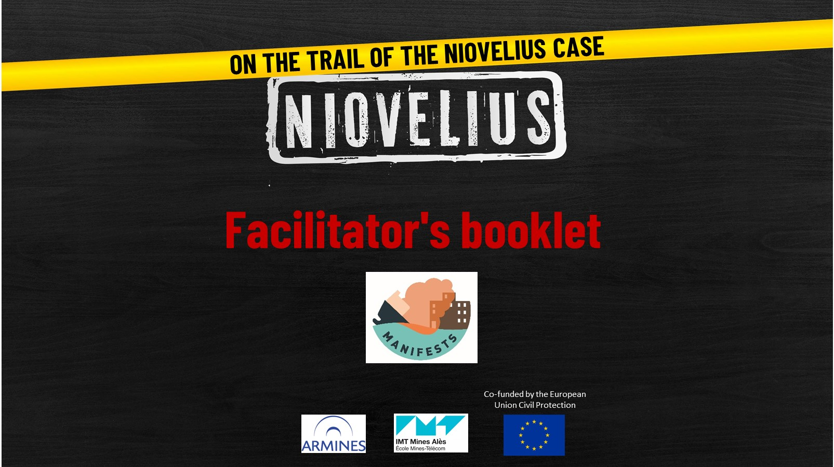

Contents

Genesis of the game 5

Objectives of the game 5

Duration 5

Number of players and facilitators 6

Space and play materials 6

Space required for a group of 4 players 6

Play material for a group of 4 players 6

Installation of the game 9

Checking before a simulation: 9

Storing the material in the kit bag before the start of the game 9

Installation of the NIOVELIUS application 9

Recommended arrangement of materials in the room: 9

Debriefing 10

Code solutions 11

# Genesis of the game

Accidental release of volatile Hazard Noxious Substances (HNS) at sea can lead to the formation of toxic, flammable or even explosive gas clouds potentially hazardous for nearby population, first responders or the environment. The objective of MANIFESTS project (https://manifests-project.eu/) is to address the lack in response guidance on dealing with such airborne releases and with decisions over sheltering or evacuation of the crew, responders and the coastal population. The project seeks to improve response capacities of marine pollution field operators’ through the development of innovative decision support tools and operational guidelines and by facilitating access to relevant knowledge and databases, particularly on volatile HNS spills.

Among the tools developed within the project, it was proposed to create a serious game for the training of emergency responders and planners: the NIOVELIUS game.

# Objectives of the game

The objectives of the game are:

* Discover the phases of marine pollution management and its actors;
* Develop knowledge on the behaviour of products accidentally spilled at sea.
* Discover the first feedbacks from accidents

# Duration

The total duration of the game is 3 hours, which is divided as follows:

* ¼ h for introduction/briefing ;
* 2h to 2h¼ of play;
* ½ h to ¾ h for debriefing.

# Number of players and facilitators

* Players

The game is played in groups of 4 people.

It is possible to have several teams playing in parallel, but this requires as many game kits as there are teams.

Under these conditions, the facilitator brings the different groups together for the briefing and debriefing phases.

* Facilitators

1 facilitator for the briefing/debriefing phases.

The play phase does not require the presence of a facilitator.

# Space and play materials

## Space required for a group of 4 players

* 1 large table (4 people dimension)
* 1 large table (2 people dimension)
* 1 projection screen if possible

For several groups, if possible have the groups play in different rooms (to listen in good conditions to the audio messages that punctuate the game).

This space must be duplicated by the number of groups playing in parallel.

## Play material for a group of 4 players

#### Non-paper material :

* The NIOVELIUS digital application
* A computer with a monitor
* A mouse
* 1 briefcase with at least 3 pockets, at least 2 of which can store A4 documents and can be closed with padlocks
* 2 3-digit code locks
* 1 UV lamp
* 1 Bluetooth speaker
* 1 storage roll for the Timeline
* Small office equipment: notepads, pens, fixing paste

#### Material in paper format :

The cited slides come from the file Printable materials NIOVELIUS

* Mission #1 ‘Profiling Kit’ is composed of a main folder (A4 format) with slide 1 as cover in the first pocket, which contains:
  + Challenge 1 (A5 folder with slide 2 as cover) and contains the cut-out elements of slide 3 3 ("Testimonial" cards + 4 photographs of product behaviour).
  + Challenge 2 (two A5 folders with slide 4 or 5 as cover) which contain respectively:
    - For team 1: cut-out elements from slide 6 to 9 (5 strips,5 pollu-criminal behaviour cards, 5 labels consisting of 1 to 3 letters, 1 code entry card.)
    - For team 2: cut-out elements from slide 10 to 13 (5 strips,5 pollu-criminal behaviour cards, 5 labels consisting of 1 to 3 letters, 1 code entry card.).
  + Challenge 3 (A5 folder with slide 14 as cover) which contains cut-out elements from the slide 15 to 25 (2 extracts from crime scenes, 2 criminal records, 6 scenes of pollu-crime, 8 hazard cards, 10 impact cards, 1 printed newspaper).
  + document pictogram of hazards
  + 1 "ESCB" diagram
* Mission #2 ‘Cold Case’ is composed of a folder (A4 format) with slide 26 as cover accessible with the padlock code in the second pocket, which contains:
  + the 4 investigator badges
  + the slides 27 and 28. For the slide 27, you must write the following codes in invisible ink:
    - 49°18N-003°52W
    - 49°23N-003°34W
* The Timeline (A1 format) and a black folder accessible with the padlock code in the third pocket which contains cut-out elements from slide 29 to 31 (16 drawings in Polaroid format).

# Installation of the game

## Checking before a simulation:

* Check that the equipment is complete and in the right place in the kit bag
* Check that the locks are locked
* Check that the application is installed on the computer (if not, see § Installing the NIOVELIUS application)

## Storing the material in the kit bag before the start of the game

* Place in a lockable storage area the photo of the shipwreck and the investigator badges
* Lock this storage area with the padlock code **715**.
* Place the Mission 2 A4 pocket in the other lockable storage area
* Lock this second storage area with the padlock code **542**.
* Place the UV lamp in the third storage area

## Installation of the NIOVELIUS application

To install the application, unzip the file, then double-click on practice or test.html.

## Recommended arrangement of materials in the room:

* Place the computer on the largest table (table 1)
* Near the computer, install the audio speaker (table 1).
* Place the Mission 1 folder on table 1.
* If projection is possible, set up the video projection system
* Place the briefcase near table 1.
* Place the storage roll with the Timeline on the table 2.

# Debriefing

The debriefing is an important step as it accompanies the learning process by helping the players to look back on their experience of the simulation, to understand and analyse the actions taken in order to reinvest the learning in a similar situation, and to discuss the emotions felt during the simulation.

It will also be an opportunity for the players and the facilitator to go deeper into the central event of the NIEVOLIUS case, the IEVOLI SUN accident, in order to be open to other accidents that could feed the discussions and reflections.

For this reason, it is proposed that the time devoted to debriefing should not be less than ½ hour.

A longer duration could be considered when several groups have run the simulation in parallel.

In general, the facilitator will prefer to ask questions to refocus the discussion on the participants' experiences and learning.

# Code solutions

The solutions to the riddles can be found in the Solution Booklet file.

**!**

On some slides, it is necessary to position the cursor correctly to continue the game.

For example, to listen to the welcome speech to the recruits, you have to find the symbol on the character’s face (at her throat).

