**PHASE – 4**

**DATA ANALYTICS WITH COGNOS**

**TOPIC: DATA MODELING AND VISUALIZATION**

1. Data Integration: Obtain air quality data from reliable sources. This data may include

measurements of pollutants like PM2.5, PM10, NO2, CO, O3, etc., as well as meteorological data. this data is structured and accessible for analysis.

2. Data Preparation: Clean and preprocess the data if necessary. This may involve handling missing values, outliers, or converting data into a format suitable for analysis.

3. Create Reports and dashboard : Use Cognos Analytics' reporting and dashboard creation tools to design visualizations that display air quality data. You can create various charts, tables, and maps to represent different aspects of air quality.

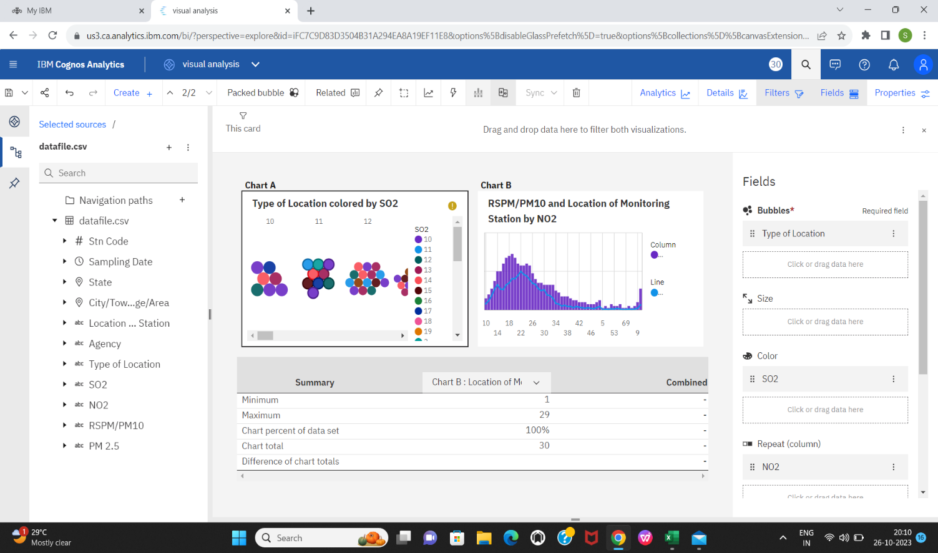

Steps to be done for Air Quality Analysis with Cognos:

Project for air analysis of tamilnadu using IBM cognos

Data Collection:

Gather air quality data for various locations in Tamil Nadu. This data might include PM2.5, PM10, CO2, NO2, SO2, and other relevant pollutants.

Collect meteorological data like temperature, humidity, wind speed, and direction, as these factors can influence air quality.

Data Integration:

Clean and integrate the collected data. Ensure that data from different sources can be combined for analysis.

IBM Cognos Setup:

Install and configure IBM Cognos in your environment.

Data Modeling:

Create a data model in Cognos to represent the integrated air quality data.

Data Analysis:

Design and build reports and dashboards that analyze air quality trends, pollution levels, and meteorological data.

Use Cognos tools like Cognos Report Studio or Cognos Analytics to create these reports.

Visualization:

Create visualizations that make it easier to understand the data. Use charts, graphs, and maps to display air quality information.

Alerting:

Implement alerting mechanisms to notify relevant authorities or the public when air quality reaches dangerous levels.

Geospatial Analysis:

Utilize geospatial capabilities in IBM Cognos to create maps that show air quality variations across Tamil Nadu.

Predictive Modeling (optional):

Use machine learning and predictive modeling to forecast air quality trends based on historical data.

User Access and Sharing:

Configure user access rights and sharing settings to ensure that the right people have access to the data and reports.

Data Collection: Collect the necessary data for your analysis. This may involve data extraction from various sources and formats.

Data Preprocessing: Clean and prepare the data. Handle missing values, outliers, and perform data transformations as needed.

Exploratory Data Analysis (EDA): Use IBM Cognos to explore the data visually and statistically. Create charts, graphs, and tables to gain insights into the data.

Data Modeling: Depending on the project requirements, build predictive or descriptive models. This could include regression, classification, clustering, or other techniques. IBM Cognos provides modeling tools for this purpose.

Model Training: Split your data into training and testing sets. Train your models on the training data.

Model Evaluation: Use various evaluation metrics (e.g., accuracy, F1-score, RMSE) to assess the model's performance on the test data.

Visualization: Create visualizations to communicate your findings and model results effectively. IBM Cognos offers a range of visualization options.

Report Generation: Generate reports summarizing the analysis, modeling process, and results. IBM Cognos can help you design and distribute these reports.

Iterate and Optimize: Review the results and, if necessary, refine your models and analyses based on feedback or new insights.

Deployment: If the project requires it, deploy your models and analysis into a production environment.

**Here the data model and visualization of air quality analysis which was done in IBM cognos analytics with given data set.**

**SUBMITTED BY:**

* **Meena S**
* **Kiruthika S**
* **Manimegalai N**
* **Prithivi raj S -Apollo engineering college**