EXP.NO: 9 | Develop an Android Calculator Application using Android Studio
DATE:26/03/2025

AIM:
To develop an Android application that performs basic arithmetic operations such as addition, subtraction, multiplication, and division using Android Studio.
ALGORITHM:
1. Initialize the Android Application:
- Open Android Studio
- Create a new project
- Select Empty Activity
- Name the application (e.g., CalculatorApp)
- Choose language: Java / Kotlin

2. Design the User Interface (UI):
- Open activity_main.xml file
- Add UI components:
  - TextView / EditText for input display
  - Buttons for numbers (0–9)
  - Buttons for operators (+, −, ×, ÷)
  - Equal (=) button
  - Clear (C) button

3. Design XML Layout:
- Use layouts like:
  - LinearLayout / GridLayout
- Arrange buttons in rows and columns
- Set properties:
  - Text
  - ID
  - Layout width/height

4. Get User Input:
- In MainActivity.java:
  - Initialize UI elements using:
findViewById()
  - Capture button clicks using listeners

5. Implement Button Click Handling:
- Set OnClickListener for all buttons
- On number click:
  - Append number to display
- On operator click:
  - Store first number
  - Store operator
- On equal (=):
  - Perform calculation
- On clear (C):
  - Reset value

6. Perform Arithmetic Operations:
- Use conditional statements:
  - Addition → +
  - Subtraction → -
  - Multiplication → *
  - Division → /
- Store result and display it

7. Handle Edge Cases:
- Division by zero → show error
- Empty input → prevent calculation
- Invalid operations → display message

8. Display the Result:
- Show result in TextView / EditText
- Allow continuous calculations

9. Run the Application:
- Connect emulator or real device
- Click Run in Android Studio
- Test all operations
Code:
activity_main.xml:
<?xml version="1.0" encoding="utf-8"?>
<LinearLayout xmlns:android="http://schemas.android.com/apk/res/android"
android:orientation="vertical"
android:layout_width="match_parent"
android:layout_height="match_parent">

<EditText
android:id="@+id/display"
android:layout_width="match_parent"
android:layout_height="wrap_content"
android:textSize="24sp"
android:gravity="right" />

<Button android:text="1"/>
<Button android:text="2"/>
<Button android:text="3"/>
<Button android:text="+"/>
<Button android:text="="/>
<Button android:text="C"/>

</LinearLayout>

MainActivity.java:
package com.example.calculator;

import android.os.Bundle;
import android.view.View;
import android.widget.Button;
import android.widget.EditText;
import androidx.appcompat.app.AppCompatActivity;

public class MainActivity extends AppCompatActivity {

EditText display;
double num1, num2;
String operator;

@Override
protected void onCreate(Bundle savedInstanceState) {
super.onCreate(savedInstanceState);
setContentView(R.layout.activity_main);

display = findViewById(R.id.display);
}

public void onNumberClick(View view) {
Button b = (Button) view;
display.append(b.getText().toString());
}

public void onOperatorClick(View view) {
Button b = (Button) view;
num1 = Double.parseDouble(display.getText().toString());
operator = b.getText().toString();
display.setText("");
}

public void onEqualClick(View view) {
num2 = Double.parseDouble(display.getText().toString());
double result = 0;

if (operator.equals("+"))
result = num1 + num2;
else if (operator.equals("-"))
result = num1 - num2;
else if (operator.equals("*"))
result = num1 * num2;
else if (operator.equals("/"))
result = num1 / num2;

display.setText(String.valueOf(result));
}

public void onClearClick(View view) {
display.setText("");
}
}

Output:
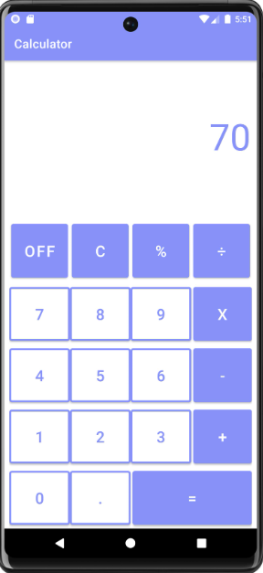

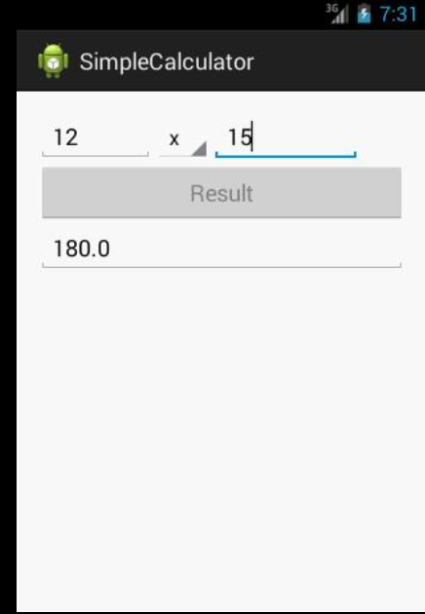

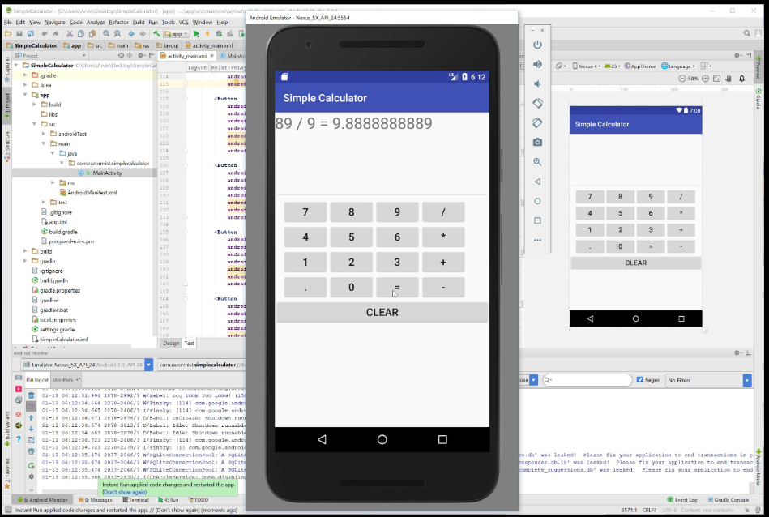

RESULT:
An Android Calculator Application is successfully developed using Android Studio, which performs basic arithmetic operations and displays accurate results

