EXP.NO: 7 | Develop a Java Servlet-based application that integrates with a Library Management System and allows users to borrow and return books.
DATE:26/03/2025

AIM:
To design a client-side validation system using JavaScript for forms in a Library Management System and ensure proper data handling before sending it to the backend.
ALGORITHM:
- 1. Input:
- The user inputs data in various form fields:
- Book ID (for borrowing)
- User ID / Membership ID
- Dates (Issue Date, Return Date)

- 2. Steps to Perform Validation Using JavaScript:
- 1. Identify Forms and Fields:
- Registration Form:
- Name, Email, Phone Number, Membership ID
- Book Form:
- Book ID, Title, Author, ISBN
- Issue Form:
- User ID, Book ID, Issue Date, Return Date

- 2. Apply Validation Rules:
- Name: Should not be empty, only alphabets allowed
- Email: Must follow standard email format
- Phone Number: Must be exactly 10 digits
- Membership ID / Book ID: Should not be empty and must follow a specific format
- ISBN: Must be numeric and valid length

- 3. Implement JavaScript Validation Scripts:
- Write functions to check:
- Required fields are not empty
- Email format correctness
- Phone number length and digits
- Use:
- alert() for error messages
- return false to prevent form submission

- 4. Validate on Form Submission:
- When the user submits a form:
- JavaScript checks all fields
- If invalid → show error messages and stop submission
- If valid → allow form submission

- 5. Provide User Feedback:
- Display error messages near the fields
- Highlight incorrect inputs
- Allow correction before submission

- 6. Integration with Servlet Backend:
- Form Submission:
- After successful validation, form data is sent to Servlet using HTTP
- Server-Side Processing:
- Servlet receives request parameters
- Performs additional validation (security layer)
- Interaction with Database:
- Store user records
- Manage book borrowing
- Update book availability

- 7. Database Access:
- Use JDBC in Servlet:
- Insert records (Registration, Book Entry)
- Update records (Borrow/Return status)

- 8. Generate Response:
- Display:
- Success message (e.g., "Book Issued Successfully")
- Error message (if validation fails)

- 3. Assumptions (Business Logic):
- Each user has a unique Membership ID
- A user can borrow a limited number of books at a time
- A return date is based on issue date
- Books are marked available/unavailable based on status
- Admin manages book inventory

- 4. Output:
- Valid inputs → data stored successfully
- Invalid inputs → appropriate error messages displayed

- 5. Observations:
- JavaScript validation reduces invalid data submission
- Server-side validation ensures security and consistency
- Integration improves overall system performance

Code:
Html code:
<!DOCTYPE html>
<html>
<head>
<title>Courier Login</title>

<style>
* {
margin: 0;
padding: 0;
box-sizing: border-box;
font-family: Arial, sans-serif;
}

body {
height: 100vh;
background: linear-gradient(135deg, #667eea, #764ba2);
display: flex;
justify-content: center;
align-items: center;
}

.login-container {
width: 350px;
background: white;
padding: 30px;
border-radius: 12px;
box-shadow: 0 10px 25px rgba(0,0,0,0.2);
animation: fadeIn 0.8s ease-in-out;
}

@keyframes fadeIn {
from { opacity: 0; transform: translateY(20px); }
to { opacity: 1; transform: translateY(0); }
}

.login-container h2 {
text-align: center;
margin-bottom: 20px;
color: #333;
}

.input-group {
margin-bottom: 15px;
}

.input-group label {
display: block;
margin-bottom: 5px;
color: #555;
}

.input-group input {
width: 100%;
padding: 10px;
border-radius: 6px;
border: 1px solid #ccc;
transition: 0.3s;
}

.input-group input:focus {
border-color: #667eea;
box-shadow: 0 0 5px rgba(102,126,234,0.5);
outline: none;
}

.login-btn {
width: 100%;
padding: 10px;
background: #667eea;
color: white;
border: none;
border-radius: 6px;
font-size: 16px;
cursor: pointer;
transition: 0.3s;
}

.login-btn:hover {
background: #5a67d8;
}

.extra {
text-align: center;
margin-top: 10px;
}

.extra a {
text-decoration: none;
color: #667eea;
font-size: 14px;
}

</style>
</head>

<body>

<div class="login-container">
<h2>Courier Login</h2>

<form action="LoginServlet" method="post">

<div class="input-group">
<label>Username</label>
<input type="text" name="username" required>
</div>

<div class="input-group">
<label>Password</label>
<input type="password" name="password" required>
</div>

<button class="login-btn" type="submit">Login</button>

</form>

<div class="extra">
<a href="#">Forgot Password?</a>
</div>

</div>

</body>
</html>

loginservlet:

import java.io.*;
import jakarta.servlet.*;
import jakarta.servlet.http.*;
import jakarta.servlet.annotation.WebServlet;

@WebServlet("/LoginServlet")
public class LoginServlet extends HttpServlet {

protected void doPost(HttpServletRequest request, HttpServletResponse response)
throws ServletException, IOException {

String user = request.getParameter("username");
String pass = request.getParameter("password");

if(user.equals("admin") && pass.equals("1234")) {

HttpSession session = request.getSession();
session.setAttribute("user", user);

response.sendRedirect("DashboardServlet");

} else {
response.setContentType("text/html");
PrintWriter out = response.getWriter();
out.println("<h3 style='color:red;text-align:center;'>Invalid Login</h3>");
out.println("<center><a href='index.html'>Try Again</a></center>");
}
}
}

dashboardservlet:

import java.io.*;
import jakarta.servlet.*;
import jakarta.servlet.http.*;
import jakarta.servlet.annotation.WebServlet;

@WebServlet("/DashboardServlet")
public class DashboardServlet extends HttpServlet {

protected void doGet(HttpServletRequest request, HttpServletResponse response)
throws ServletException, IOException {

// Get session
HttpSession session = request.getSession(false);

// If not logged in → redirect
if (session == null) {
response.sendRedirect("index.html");
return;
}

String user = (String) session.getAttribute("user");

response.setContentType("text/html");
PrintWriter out = response.getWriter();

// HTML START
out.println("<html><head><title>Dashboard</title>");

// CSS
out.println("<style>");
out.println("*{margin:0;padding:0;box-sizing:border-box;font-family:Arial;}");

out.println("body{display:flex;background:#f4f6f9;}");

// Sidebar
out.println(".sidebar{width:220px;height:100vh;background:#2c3e50;color:white;padding:20px;position:fixed;}");
out.println(".sidebar h2{text-align:center;margin-bottom:20px;}");
out.println(".sidebar a{display:block;color:white;padding:10px;margin:5px 0;text-decoration:none;border-radius:5px;}");
out.println(".sidebar a:hover{background:#34495e;}");

// Main
out.println(".main{margin-left:220px;width:100%;padding:20px;}");

// Header
out.println(".header{background:white;padding:15px;border-radius:10px;box-shadow:0 2px 10px rgba(0,0,0,0.1);margin-bottom:20px;}");

// Cards
out.println(".cards{display:flex;gap:20px;}");
out.println(".card{flex:1;background:white;padding:20px;border-radius:10px;text-align:center;box-shadow:0 4px 10px rgba(0,0,0,0.1);}");

// Sections
out.println(".section{margin-top:20px;background:white;padding:20px;border-radius:10px;}");
out.println("input,button{width:100%;padding:10px;margin:10px 0;}");
out.println("button{background:#2980b9;color:white;border:none;border-radius:5px;}");

out.println("</style></head><body>");

// Sidebar
out.println("<div class='sidebar'>");
out.println("<h2>Courier</h2>");
out.println("<a href='#'>Dashboard</a>");
out.println("<a href='#track'>Track</a>");
out.println("<a href='#book'>Book</a>");
out.println("<a href='LogoutServlet'>Logout</a>");
out.println("</div>");

// Main content
out.println("<div class='main'>");

// Header
out.println("<div class='header'><h2>Welcome " + user + "</h2></div>");

// Cards
out.println("<div class='cards'>");
out.println("<div class='card'><h3>Total Orders</h3><p>25</p></div>");
out.println("<div class='card'><h3>Delivered</h3><p>18</p></div>");
out.println("<div class='card'><h3>Pending</h3><p>7</p></div>");
out.println("</div>");

// Track Section
out.println("<div id='track' class='section'>");
out.println("<h3>Track Courier</h3>");
out.println("<input type='text' placeholder='Enter Tracking ID'>");
out.println("<button>Track</button>");
out.println("</div>");

// Book Section
out.println("<div id='book' class='section'>");
out.println("<h3>Book Courier</h3>");
out.println("<input type='text' placeholder='Sender Name'>");
out.println("<input type='text' placeholder='Receiver Name'>");
out.println("<input type='text' placeholder='Address'>");
out.println("<button>Book Now</button>");
out.println("</div>");

out.println("</div></body></html>");
}
}

logoutservlet:

import java.io.*;
import jakarta.servlet.*;
import jakarta.servlet.http.*;
import jakarta.servlet.annotation.WebServlet;

@WebServlet("/LogoutServlet")
public class LogoutServlet extends HttpServlet {

protected void doGet(HttpServletRequest request, HttpServletResponse response)
throws ServletException, IOException {

HttpSession session = request.getSession(false);

if(session != null){
session.invalidate();
}

response.sendRedirect("index.html");
}
}
Output:
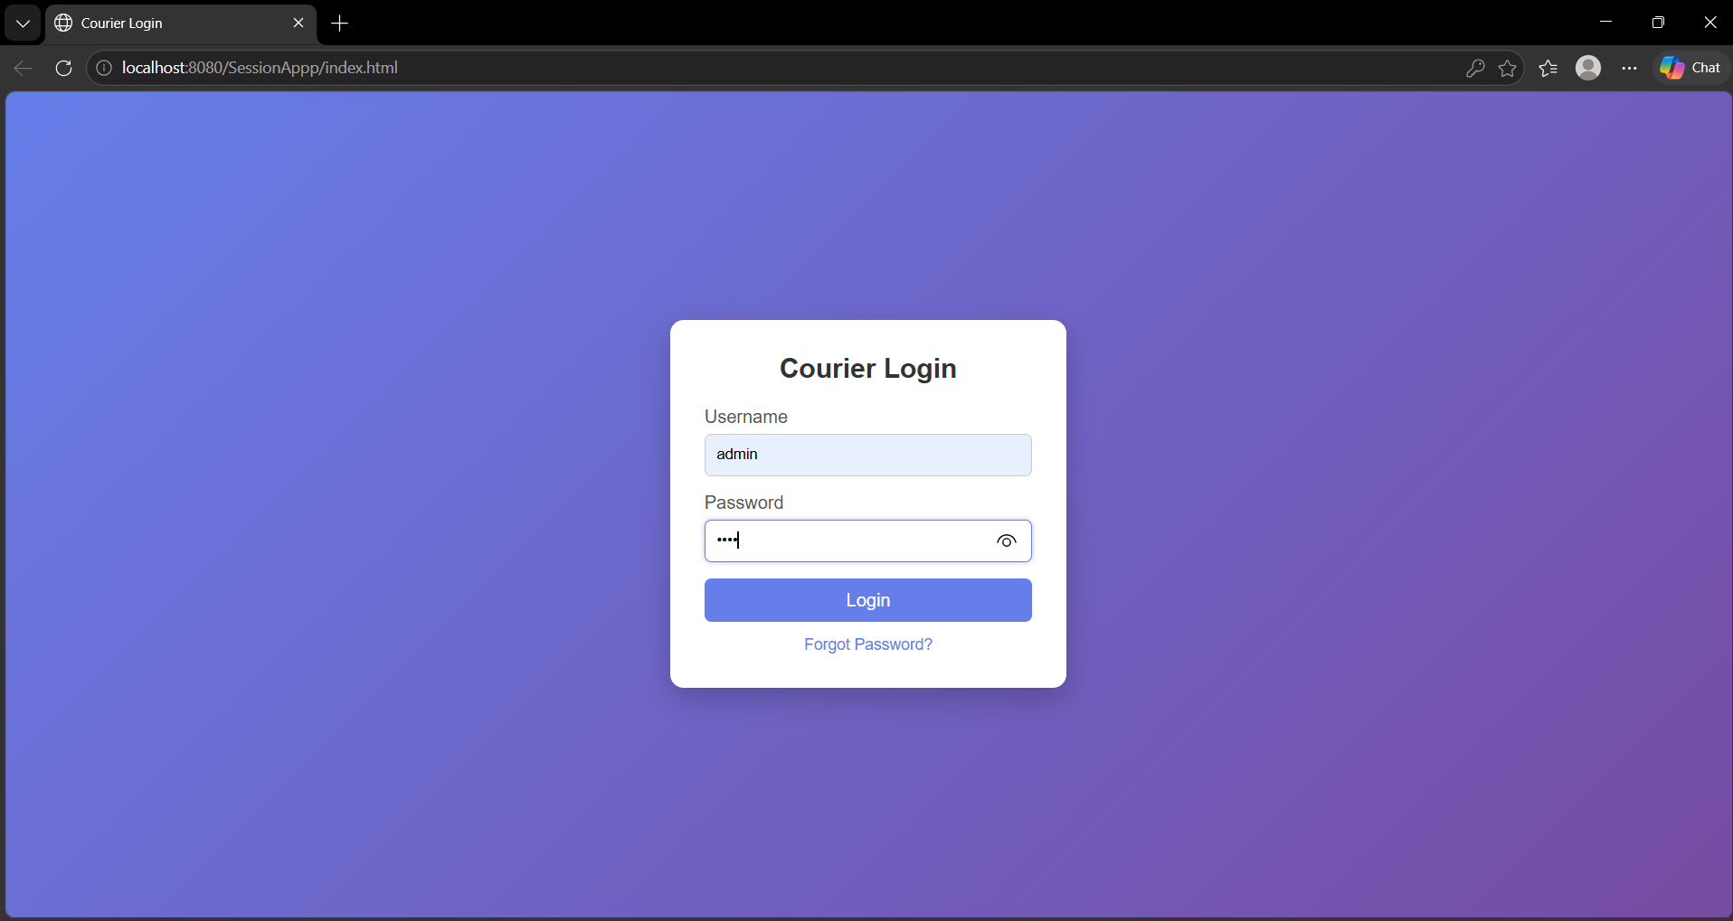

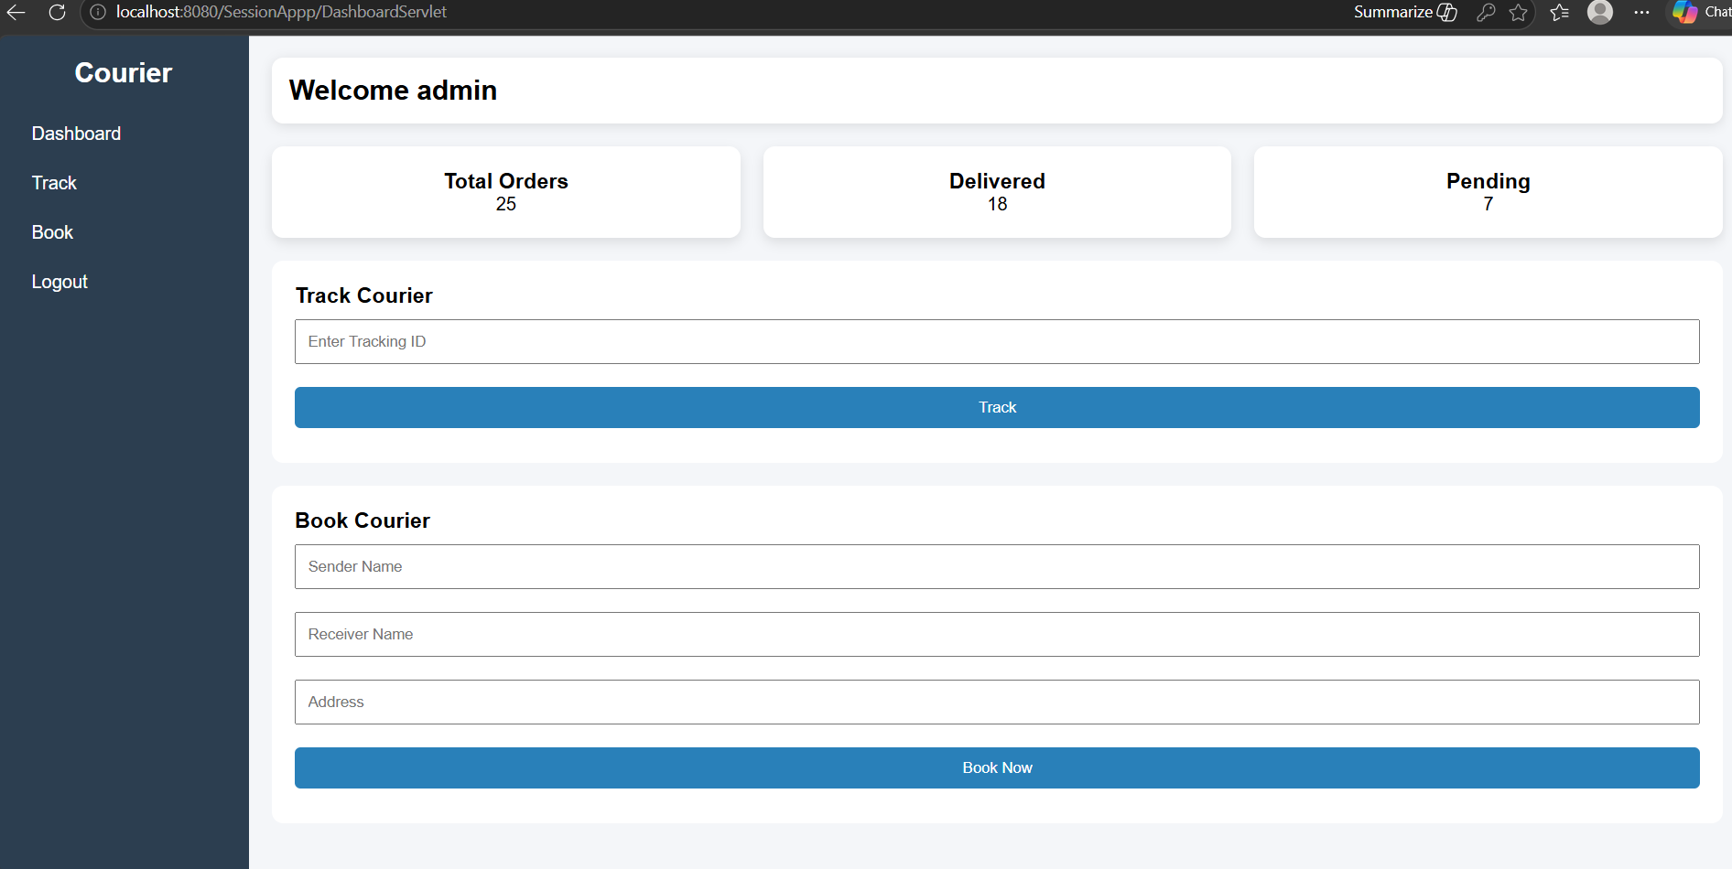

RESULT:
A Java Servlet-based validation system is successfully implemented for a Library Management System, ensuring correct user input and efficient handling of book borrowing and returning operations.

