EXP.NO: 6 | Write a Servlet to demonstrate session tracking using HttpSession.
DATE:26/03/2025

AIM:
To demonstrate session tracking using HttpSession in a Servlet-based web application. The exercise involves implementing a simple login system where a user can log in with their username and password, and their session will be tracked throughout their interaction with the web application.
ALGORITHM:
1. Input:
- The user will enter their username and password in a login form.
- The servlet will validate the credentials and create an HTTP session for the user if authentication is successful.

2. Steps for Implementing Session Tracking with HttpSession:
- Create the Login Form (HTML):
  - Create an HTML form with two input fields for username and password.
  - Provide a submit button to send the data to the servlet for authentication.
- Create the Login Servlet:
  - Write a Java servlet class to handle login requests.
  - The servlet will:
    - Retrieve the username and password from the form.
    - Authenticate the user by comparing the credentials to a stored value (e.g., hardcoded or from a database).
    - Create a new HTTP session for the user if the credentials are valid.
    - Set session attributes such as the user's username to track the session.
- Validate User Credentials:
  - In the servlet, check if the username and password match the expected values.
  - If valid, create a session and store the username in the session.
  - If invalid, redirect the user back to the login page with an error message.
- Create and Track User Session:
  - Upon successful login, use the HttpSession object to store the session data.
  - Use the session.setAttribute("username", username) method to save the username.
  - Optionally, set session timeout using session.setMaxInactiveInterval(time_in_seconds) to manage session expiration.
- Redirect to a Protected Page:
  - After a successful login, the user will be redirected to a protected page (e.g., a dashboard or home page).
  - The protected page should check if the user is authenticated by checking the session attribute.
- Logout and Session Invalidation:
  - Provide a logout feature that invalidates the session using session.invalidate() when the user logs out.
  - After logout, redirect the user back to the login page.
- Session Expiration:
  - If the session expires or the user manually logs out, the session will be invalidated, and the user will be redirected to the login page.
Code:
LoginServlet.java:
package com.example;

import java.io.*;
import jakarta.servlet.*;
import jakarta.servlet.http.*;

public class LoginServlet extends HttpServlet {

protected void doPost(HttpServletRequest request, HttpServletResponse response)
throws ServletException, IOException {

String user = request.getParameter("username");
String pass = request.getParameter("password");

if(user.equals("admin") && pass.equals("1234")) {

HttpSession session = request.getSession();
session.setAttribute("user", user);

response.sendRedirect("DashboardServlet");

} else {
response.getWriter().println("Invalid Login");
}
}
}

LogoutServlet.java:
package com.example;

import java.io.*;
import jakarta.servlet.*;
import jakarta.servlet.http.*;

public class LogoutServlet extends HttpServlet {

protected void doGet(HttpServletRequest request, HttpServletResponse response)
throws ServletException, IOException {

HttpSession session = request.getSession(false);

if(session != null) {
session.invalidate();
}

response.sendRedirect("login.html");
}
}

DASHBOARDservlet:
package com.example;

import java.io.*;
import jakarta.servlet.*;
import jakarta.servlet.http.*;

public class DashboardServlet extends HttpServlet {

protected void doGet(HttpServletRequest request, HttpServletResponse response)
throws ServletException, IOException {

response.setContentType("text/html");

HttpSession session = request.getSession(false);

if(session != null && session.getAttribute("user") != null) {

String user = (String) session.getAttribute("user");

PrintWriter out = response.getWriter();

out.println("<html>");
out.println("<head>");
out.println("<title>Dashboard</title>");
out.println("<style>");
out.println("body { font-family: Arial; background: #f4f4f4; text-align:center; }");
out.println(".box { margin-top:100px; background:white; padding:30px; display:inline-block; border-radius:10px; }");
out.println("a { text-decoration:none; color:white; background:red; padding:10px; border-radius:5px; }");
out.println("</style>");
out.println("</head>");

out.println("<body>");
out.println("<div class='box'>");
out.println("<h2>Welcome " + user + "</h2>");
out.println("<p>Courier Management Dashboard</p>");
out.println("<a href='LogoutServlet'>Logout</a>");
out.println("</div>");
out.println("</body>");
out.println("</html>");

} else {
response.sendRedirect("login.html");
}
}
}

Login.html:
<!DOCTYPE html>
<html>
<head>
<meta charset="UTF-8">
<title>Courier System</title>

<style>
body {
margin: 0;
font-family: 'Segoe UI';
background: linear-gradient(135deg, #1e3c72, #2a5298);
color: white;
}

/* Center box */
.box {
width: 320px;
margin: 100px auto;
background: rgba(255,255,255,0.1);
padding: 25px;
border-radius: 10px;
text-align: center;
}

/* Dashboard layout */
.dashboard {
display: none;
}

.navbar {
display: flex;
justify-content: space-between;
padding: 15px;
background: rgba(0,0,0,0.4);
}

.container {
display: flex;
gap: 20px;
padding: 20px;
}

.card {
flex: 1;
background: rgba(255,255,255,0.1);
padding: 20px;
border-radius: 10px;
}

/* Inputs */
input {
width: 90%;
padding: 10px;
margin: 10px;
border: none;
border-radius: 5px;
}

/* Buttons */
button {
padding: 10px;
width: 95%;
background: #00c6ff;
border: none;
color: white;
cursor: pointer;
}

button:hover {
background: #0072ff;
}

.result {
margin-top: 10px;
background: rgba(0,0,0,0.3);
padding: 10px;
}
</style>

<script>
let trackingDB = {};

// LOGIN
function login() {
let user = document.getElementById("username").value;
let pass = document.getElementById("password").value;

if(user === "admin" && pass === "1234") {
document.getElementById("loginPage").style.display = "none";
document.getElementById("dashboard").style.display = "block";
} else {
alert("Invalid Login");
}
}

// LOGOUT
function logout() {
document.getElementById("loginPage").style.display = "block";
document.getElementById("dashboard").style.display = "none";
}

// BOOK COURIER
function bookCourier() {
let sender = document.getElementById("sender").value;
let receiver = document.getElementById("receiver").value;

if(sender === "" || receiver === "") {
alert("Fill all fields!");
return;
}

let id = "TRK" + Math.floor(Math.random()*1000);
trackingDB[id] = "In Transit";

document.getElementById("bookResult").innerHTML =
"Booked! ID: " + id;
}

// TRACK
function trackCourier() {
let id = document.getElementById("trackId").value;

if(trackingDB[id]) {
document.getElementById("trackResult").innerHTML =
"Status: " + trackingDB[id];
} else {
document.getElementById("trackResult").innerHTML =
"Invalid ID";
}
}
</script>

</head>

<body>

<!-- LOGIN PAGE -->
<div id="loginPage" class="box">
<h2>Login</h2>
<input type="text" id="username" placeholder="Username"><br>
<input type="password" id="password" placeholder="Password"><br>
<button onclick="login()">Login</button>
</div>

<!-- DASHBOARD -->
<div id="dashboard" class="dashboard">

<div class="navbar">
<h2>Courier Dashboard</h2>
<button onclick="logout()">Logout</button>
</div>

<div class="container">

<!-- BOOK -->
<div class="card">
<h3>Book Courier</h3>
<input type="text" id="sender" placeholder="Sender">
<input type="text" id="receiver" placeholder="Receiver">
<button onclick="bookCourier()">Book</button>
<div id="bookResult" class="result"></div>
</div>

<!-- TRACK -->
<div class="card">
<h3>Track Courier</h3>
<input type="text" id="trackId" placeholder="Tracking ID">
<button onclick="trackCourier()">Track</button>
<div id="trackResult" class="result"></div>
</div>

</div>

</div>

</body>
</html>

Output:

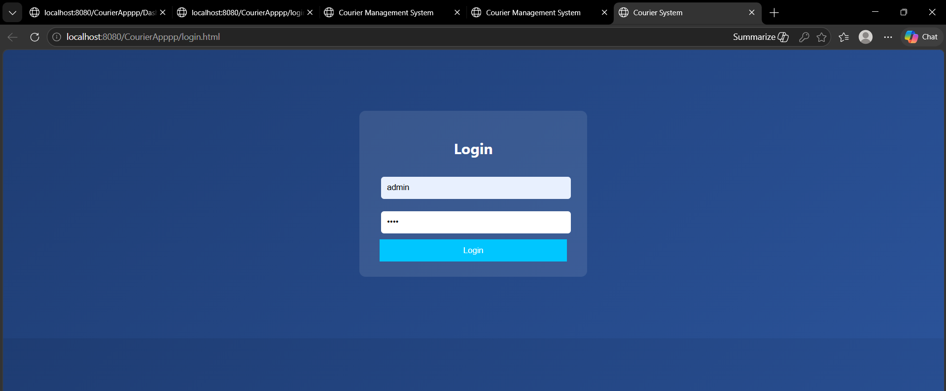

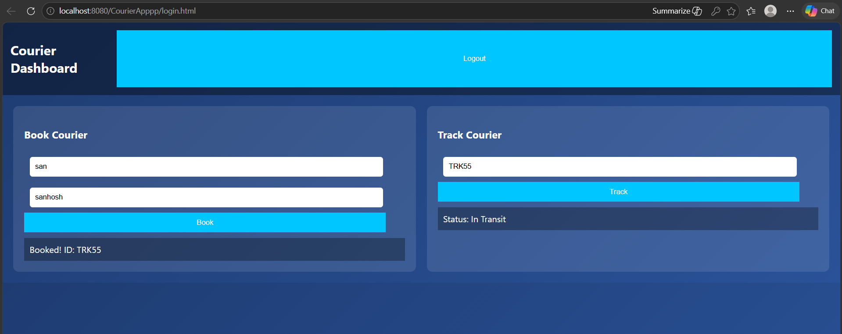

RESULT:
A simple login system is created where the user's session is tracked by a servlet to demonstrate session tracking using HttpSession.

