EXP.NO: 2 | Write JavaScript Programme to validate the following fields of the HTML Registration page.
DATE: 06/02/2025

AIM:
To write JavaScript code to validate user input in a registration form. The validation will ensure that the data entered by the user meets specific criteria for each field. This will help in maintaining data integrity and prevent invalid submissions.
ALGORITHM:
1. Input:
- The user fills in the following fields: First Name, Password, E-mail, Mobile Number, Last Name, and Address.
2. Validation Steps:
- Validate First Name:
  - Check if the first name contains only alphabets.
  - Ensure the length of the First Name is at least 6 characters.
  - If any of these conditions fail, display an error message indicating the required input.
- Validate Password:
  - Check if the password is at least 6 characters long.
  - If it is less than 6 characters, display an error message.
- Validate E-mail:
  - Use a regular expression to check if the email follows the standard pattern: name@domain.com.
  - Ensure that the email contains no invalid characters and matches the required pattern.
  - If it doesn't match, display an error message indicating an invalid email format.
- Validate Mobile Number:
  - Check if the mobile number contains exactly 10 digits.
  - Ensure there are no alphabets or special characters.
  - If the number is invalid, display an error message indicating the correct format.
- Validate Last Name:
  - Ensure the Last Name field is not empty.
  - If it is empty, display an error message.
- Validate Address:
  - Ensure the Address field is not empty.
  - If it is empty, display an error message.
Code:
<!DOCTYPE html>
<html>
<head>
<title>Courier Validation</title>

<style>
body {
font-family: 'Segoe UI';
background: linear-gradient(135deg,#1e293b,#0f172a);
display: flex;
justify-content: center;
align-items: center;
height: 100vh;
}

/* Form box */
.container {
background: rgba(255,255,255,0.1);
backdrop-filter: blur(15px);
padding: 25px;
border-radius: 15px;
width: 350px;
color: white;
text-align: center;
}

/* Inputs */
input, select {
width: 90%;
padding: 10px;
margin: 8px;
border-radius: 8px;
border: none;
outline: none;
transition: 0.3s;
}

/* Focus animation */
input:focus, select:focus {
transform: scale(1.05);
box-shadow: 0 0 10px cyan;
}

/* Button */
button {
padding: 10px;
width: 95%;
background: cyan;
border: none;
cursor: pointer;
}
button:hover {
background: #22d3ee;
}

/* Error */
.error {
color: red;
font-size: 12px;
}

/* Shake animation */
@keyframes shake {
0% {transform: translateX(0);}
25% {transform: translateX(-5px);}
50% {transform: translateX(5px);}
75% {transform: translateX(-5px);}
100% {transform: translateX(0);}
}

.shake {
animation: shake 0.3s;
}

/* Popup */
.popup {
position: fixed;
top: 50%;
left: 50%;
transform: translate(-50%,-50%) scale(0);
background: white;
color: black;
padding: 20px;
border-radius: 10px;
text-align: center;
transition: 0.3s;
}

.popup.show {
transform: translate(-50%,-50%) scale(1);
}
</style>

</head>

<body>

<div class="container">

<h2>📦 Book Courier</h2>

<form onsubmit="return validateForm()">

<input type="text" id="name" placeholder="Sender Name">
<span id="nameError" class="error"></span>

<input type="text" id="mobile" placeholder="Mobile Number">
<span id="mobileError" class="error"></span>

<input type="text" id="address" placeholder="Pickup Address">
<span id="addressError" class="error"></span>

<input type="text" id="destination" placeholder="Delivery Address">
<span id="destError" class="error"></span>

<select id="type">
<option value="">Select Parcel Type</option>
<option>Document</option>
<option>Electronics</option>
</select>
<span id="typeError" class="error"></span>

<br>
<button type="submit">Submit</button>

</form>

</div>

<!-- POPUP -->
<div id="popup" class="popup">
<h3>✅ Booking Successful!</h3>
<p>Your courier has been booked.</p>
<button onclick="closePopup()">OK</button>
</div>

<script>

function validateForm(){

let name = document.getElementById("name");
let mobile = document.getElementById("mobile");
let address = document.getElementById("address");
let destination = document.getElementById("destination");
let type = document.getElementById("type");

let valid = true;

/* Name */
if(name.value === "" || !/^[A-Za-z ]+$/.test(name.value)){
document.getElementById("nameError").innerHTML = "Enter valid name";
name.classList.add("shake");
valid = false;
} else {
document.getElementById("nameError").innerHTML = "";
}

/* Mobile */
if(!/^[0-9]{10}$/.test(mobile.value)){
document.getElementById("mobileError").innerHTML = "Enter 10 digit number";
mobile.classList.add("shake");
valid = false;
} else {
document.getElementById("mobileError").innerHTML = "";
}

/* Address */
if(address.value === ""){
document.getElementById("addressError").innerHTML = "Required";
address.classList.add("shake");
valid = false;
} else {
document.getElementById("addressError").innerHTML = "";
}

/* Destination */
if(destination.value === ""){
document.getElementById("destError").innerHTML = "Required";
destination.classList.add("shake");
valid = false;
} else {
document.getElementById("destError").innerHTML = "";
}

/* Type */
if(type.value === ""){
document.getElementById("typeError").innerHTML = "Select type";
type.classList.add("shake");
valid = false;
} else {
document.getElementById("typeError").innerHTML = "";
}

/* If valid → show popup */
if(valid){
document.getElementById("popup").classList.add("show");
}

/* Remove shake after animation */
setTimeout(() => {
name.classList.remove("shake");
mobile.classList.remove("shake");
address.classList.remove("shake");
destination.classList.remove("shake");
type.classList.remove("shake");
}, 300);

return false;
}

/* Close popup */
function closePopup(){
document.getElementById("popup").classList.remove("show");
}
</script>

</body>
</html>
Output:
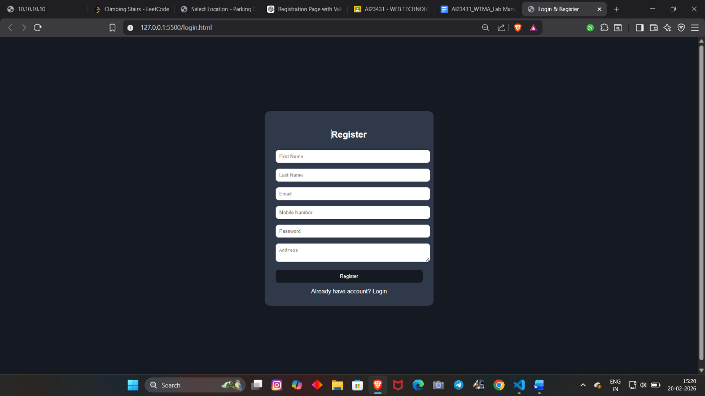
RESULT:
HTML page with Form is created and is validated using Javascript

