EXP.NO: 10 | Develop an application to change the font and color of the text used in Android application and display it using different views.
DATE:26/03/2026

AIM:
To develop an Android application that allows users to change the font style and color of text dynamically using different UI components and display the updated text using various views.
ALGORITHM:
1. Initialize the Android Application:
- Open Android Studio
- Create a new project
- Select Empty Activity

2. Design the User Interface (UI):
- Open activity_main.xml
- Add the following UI components:
  - TextView → to display the text
  - Buttons / RadioButtons → to select font styles
  - Spinner / Dropdown → to select colors
  - Apply button → to apply changes

3. Implement Font and Color Selection:
- Use RadioButtons for font styles:
  - Bold
  - Italic
  - Normal
- Use Spinner / Dropdown Menu for color selection:
  - Red
  - Green
  - Blue
  - Black

4. Detect User Input:
- When the user selects a font style:
  - Apply selected font style to TextView
- When the user selects a color:
  - Apply selected color to TextView

5. Set Local Storage (Optional):
- Store selected preferences using:
  - SharedPreferences
- Retrieve preferences when app restarts

6. Implement Event Handling:
- Use OnClickListener for buttons
- Use OnItemSelectedListener for Spinner
- Update TextView dynamically

7. Show Result:
- TextView displays updated text with:
  - Selected font style
  - Selected color

8. Handle Errors:
- If no option is selected:
  - Display message to user
- Ensure default values are set
Code:
activity_main.xml:
<?xml version="1.0" encoding="utf-8"?>
<ScrollView xmlns:android="http://schemas.android.com/apk/res/android"
android:layout_width="match_parent"
android:layout_height="match_parent"
android:background="#F4F6F8">

<LinearLayout
android:layout_width="match_parent"
android:layout_height="wrap_content"
android:orientation="vertical"
android:padding="20dp">

<TextView
android:id="@+id/txtDisplay"
android:layout_width="match_parent"
android:layout_height="wrap_content"
android:text="Welcome to Android"
android:textSize="28sp"
android:textStyle="bold"
android:gravity="center"
android:padding="25dp"
android:background="#FFFFFF" />

<TextView
android:layout_width="wrap_content"
android:layout_height="wrap_content"
android:text="Select Font Style"
android:textSize="18sp"
android:layout_marginTop="25dp" />

<RadioGroup
android:id="@+id/radioGroupFont"
android:layout_width="match_parent"
android:layout_height="wrap_content">

<RadioButton
android:id="@+id/rbNormal"
android:layout_width="wrap_content"
android:layout_height="wrap_content"
android:text="Normal" />

<RadioButton
android:id="@+id/rbBold"
android:layout_width="wrap_content"
android:layout_height="wrap_content"
android:text="Bold" />

<RadioButton
android:id="@+id/rbItalic"
android:layout_width="wrap_content"
android:layout_height="wrap_content"
android:text="Italic" />

<RadioButton
android:id="@+id/rbBoldItalic"
android:layout_width="wrap_content"
android:layout_height="wrap_content"
android:text="Bold Italic" />
</RadioGroup>

<TextView
android:layout_width="wrap_content"
android:layout_height="wrap_content"
android:text="Select Text Color"
android:textSize="18sp"
android:layout_marginTop="20dp" />

<Spinner
android:id="@+id/spinnerColor"
android:layout_width="match_parent"
android:layout_height="wrap_content" />

<Button
android:id="@+id/btnApply"
android:layout_width="match_parent"
android:layout_height="wrap_content"
android:text="Apply Changes"
android:layout_marginTop="25dp" />

<Button
android:id="@+id/btnReset"
android:layout_width="match_parent"
android:layout_height="wrap_content"
android:text="Reset"
android:layout_marginTop="10dp" />

</LinearLayout>
</ScrollView>

MainActivity.java:

package com.example.fontcolorapp;

import android.graphics.Color;
import android.graphics.Typeface;
import android.os.Bundle;
import android.widget.ArrayAdapter;
import android.widget.Button;
import android.widget.RadioButton;
import android.widget.RadioGroup;
import android.widget.Spinner;
import android.widget.TextView;
import android.widget.Toast;

import androidx.appcompat.app.AppCompatActivity;

public class MainActivity extends AppCompatActivity {

TextView txtDisplay;
RadioGroup radioGroupFont;
RadioButton rbNormal, rbBold, rbItalic, rbBoldItalic;
Spinner spinnerColor;
Button btnApply, btnReset;

@Override
protected void onCreate(Bundle savedInstanceState) {
super.onCreate(savedInstanceState);
setContentView(R.layout.activity_main);

txtDisplay = findViewById(R.id.txtDisplay);
radioGroupFont = findViewById(R.id.radioGroupFont);
rbNormal = findViewById(R.id.rbNormal);
rbBold = findViewById(R.id.rbBold);
rbItalic = findViewById(R.id.rbItalic);
rbBoldItalic = findViewById(R.id.rbBoldItalic);
spinnerColor = findViewById(R.id.spinnerColor);
btnApply = findViewById(R.id.btnApply);
btnReset = findViewById(R.id.btnReset);

String[] colors = {"Black", "Red", "Green", "Blue", "Magenta"};
ArrayAdapter<String> adapter = new ArrayAdapter<>(
this,
android.R.layout.simple_spinner_dropdown_item,
colors
);
spinnerColor.setAdapter(adapter);

rbNormal.setChecked(true);

btnApply.setOnClickListener(v -> {
int selectedId = radioGroupFont.getCheckedRadioButtonId();

if (selectedId == R.id.rbNormal) {
txtDisplay.setTypeface(null, Typeface.NORMAL);
} else if (selectedId == R.id.rbBold) {
txtDisplay.setTypeface(null, Typeface.BOLD);
} else if (selectedId == R.id.rbItalic) {
txtDisplay.setTypeface(null, Typeface.ITALIC);
} else if (selectedId == R.id.rbBoldItalic) {
txtDisplay.setTypeface(null, Typeface.BOLD_ITALIC);
}

String selectedColor = spinnerColor.getSelectedItem().toString();

if (selectedColor.equals("Black")) {
txtDisplay.setTextColor(Color.BLACK);
} else if (selectedColor.equals("Red")) {
txtDisplay.setTextColor(Color.RED);
} else if (selectedColor.equals("Green")) {
txtDisplay.setTextColor(Color.GREEN);
} else if (selectedColor.equals("Blue")) {
txtDisplay.setTextColor(Color.BLUE);
} else if (selectedColor.equals("Magenta")) {
txtDisplay.setTextColor(Color.MAGENTA);
}

Toast.makeText(this, "Font and Color Changed", Toast.LENGTH_SHORT).show();
});

btnReset.setOnClickListener(v -> {
txtDisplay.setText("Welcome to Android");
txtDisplay.setTextColor(Color.BLACK);
txtDisplay.setTypeface(null, Typeface.BOLD);
rbNormal.setChecked(true);
spinnerColor.setSelection(0);
});
}
}

Output:

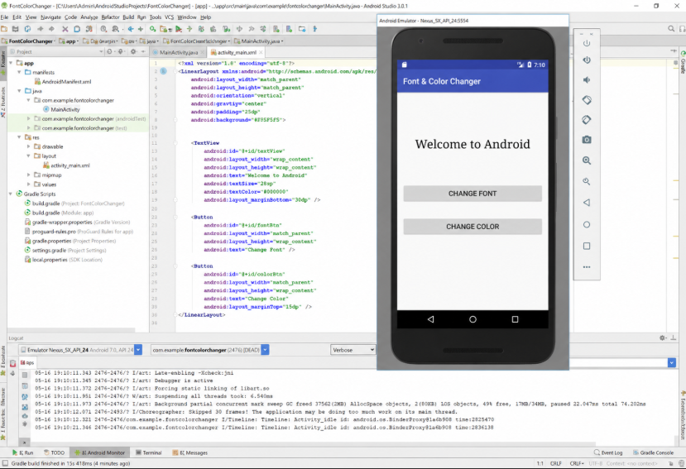

RESULT:
An Android application is successfully developed to change the font style and color of text dynamically and display it using different views.

