EXP.NO: 12 | Develop a mobile application to send an email
DATE:26/03/2026

AIM:
To develop a mobile application that enables the user to send an email using an intent. The application should allow the user to enter the recipient’s email address, subject, and message body, and trigger the email client.
ALGORITHM:
- Start:
  - The user launches the application.
  - The main screen (UI) of the app is displayed.
- Design the User Interface (UI):
  - Add EditText fields for:
    - Recipient Email Address
    - Subject of Email
    - Message Content
  - Add a Button → “Send Email”
- Initialize UI Components:
  - Define variables and link UI components using findViewById()
- Define Button Click Event:
  - Set OnClickListener to the Send Email button
- Create Email Intent:
  - Use Intent with action: Intent.ACTION_SEND
  - Set MIME type: "message/rfc822"
- Add Email Details to Intent:
  - Put Extra values:
    - Intent.EXTRA_EMAIL → recipient email
    - Intent.EXTRA_SUBJECT → subject
    - Intent.EXTRA_TEXT → message body
- Launch Email Client:
  - Use startActivity(Intent.createChooser())
  - Let user choose email app (Gmail, Outlook, etc.)
- Handle Exceptions:
  - If no email app installed → show Toast message
- Stop:
  - Email app opens and user can send email

ADVANTAGES:
- Easy way to send emails directly from app
- Uses existing email apps (no need to build mail server)
- Simple and efficient communication method
APPLICATIONS:
- Sending feedback from users
- Contact forms in apps
- Sharing information via email

Code:
activity_main.xml
<?xml version="1.0" encoding="utf-8"?>
<LinearLayout xmlns:android="http://schemas.android.com/apk/res/android"
android:layout_width="match_parent"
android:layout_height="match_parent"
android:orientation="vertical"
android:padding="20dp"
android:gravity="center">

<EditText
android:id="@+id/email"
android:layout_width="match_parent"
android:layout_height="wrap_content"
android:hint="Enter Recipient Email"
android:inputType="textEmailAddress" />

<EditText
android:id="@+id/subject"
android:layout_width="match_parent"
android:layout_height="wrap_content"
android:hint="Enter Subject"
android:layout_marginTop="15dp" />

<EditText
android:id="@+id/message"
android:layout_width="match_parent"
android:layout_height="wrap_content"
android:hint="Enter Message"
android:minLines="4"
android:gravity="top"
android:layout_marginTop="15dp" />

<Button
android:id="@+id/sendBtn"
android:layout_width="match_parent"
android:layout_height="wrap_content"
android:text="Send Email"
android:layout_marginTop="20dp" />

</LinearLayout>

MainActivity.java
package com.example.experiment12;

import android.content.Intent;
import android.os.Bundle;
import android.widget.Button;
import android.widget.EditText;
import android.widget.Toast;
import androidx.appcompat.app.AppCompatActivity;

public class MainActivity extends AppCompatActivity {

EditText email, subject, message;
Button sendBtn;

@Override
protected void onCreate(Bundle savedInstanceState) {
super.onCreate(savedInstanceState);
setContentView(R.layout.activity_main);

email = findViewById(R.id.email);
subject = findViewById(R.id.subject);
message = findViewById(R.id.message);
sendBtn = findViewById(R.id.sendBtn);

sendBtn.setOnClickListener(v -> {
String to = email.getText().toString();
String sub = subject.getText().toString();
String msg = message.getText().toString();

Intent intent = new Intent(Intent.ACTION_SEND);
intent.setType("message/rfc822");

intent.putExtra(Intent.EXTRA_EMAIL, new String[]{to});
intent.putExtra(Intent.EXTRA_SUBJECT, sub);
intent.putExtra(Intent.EXTRA_TEXT, msg);

try {
startActivity(Intent.createChooser(intent, "Choose Email App"));
} catch (Exception e) {
Toast.makeText(this, "No Email App Found", Toast.LENGTH_SHORT).show();
}
});
}
}
AndroidManifest.xml
<manifest xmlns:android="http://schemas.android.com/apk/res/android"
package="com.example.experiment12">

<application
android:allowBackup="true"
android:label="Send Email App"
android:supportsRtl="true">

<activity android:name=".MainActivity"
android:exported="true">

<intent-filter>
<action android:name="android.intent.action.MAIN" />
<category android:name="android.intent.category.LAUNCHER" />
</intent-filter>

</activity>
</application>

</manifest>

Output:

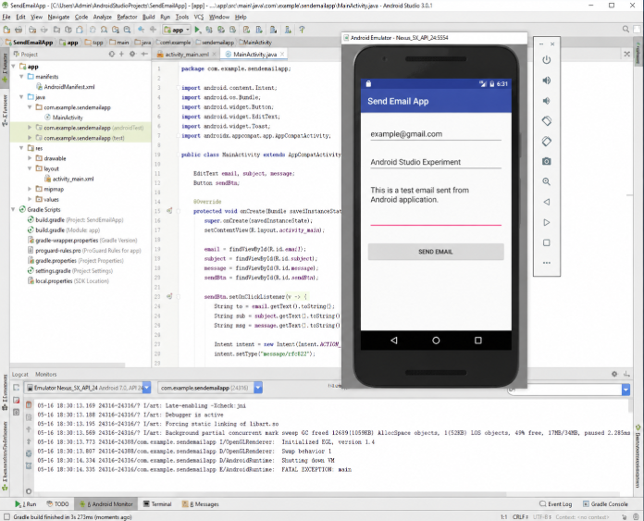

RESULT:
The email app opens with recipient, subject, and message filled.

