EXP.NO: 2 Create a web form that accepts a user’s name and age. Write a Servlet to process Date :6/2/2025 the form data and display it back on the browser
Aim:
To write a basic Servlet program that demonstrates the use of Java Servlets by printing
“Hello, World!” when accessed through a browser.
ALGORITHM:
1. Input:
• The user fills out a web form with their name and age and submits it.
2. Form Handling and Servlet Processing:
1. Create the Web Form:
o Create an HTML form with two input fields: one for the user&#39;s name and one
for the user&#39;s age.
o Add a submit button to the form.
o Set the form&#39;s action attribute to the URL of the Servlet and the method to
POST (or GET).
2. Create the Servlet Class:
o Write a Servlet that processes the form data submitted by the user.
o The Servlet will override the doPost() (or doGet() depending on the form
method) to handle form submissions.
o The Servlet will retrieve the name and age parameters from the request
object using request.getParameter(&quot;name&quot;) and request.getParameter(&quot;age&quot;).

3. Process the Data in the Servlet:
o Extract the name and age values submitted from the form.
o Validate the input (e.g., check if the age is a valid number).
o Prepare a response that will display the user&#39;s name and age back on the
browser.

4. Send Response to the Browser:
o The Servlet will send a response to the browser containing a message like:
▪ &quot;Hello, [name]! You are [age] years old.&quot;
o The response will be displayed to the user in the browser.
5. Deploy the Servlet:
o Compile the Servlet and deploy it to a Servlet container (like Apache
Tomcat).
o Ensure the web.xml file or Servlet annotations are used to map the Servlet to
the URL defined in the form&#39;s action attribute.

6. Test the Application:
o Open the web browser, fill in the form with the name and age, and submit it.
o The Servlet will process the data and display the message back to the user in
the browser.
Code:
Index.html:
<!DOCTYPE html>
<html>
<head>
<title>Courier Booking</title>
<style>
body {
margin: 0;
font-family: Arial;
background: linear-gradient(to right, #4facfe, #00f2fe);
}

.container {
width: 400px;
margin: 80px auto;
background: white;
padding: 25px;
border-radius: 10px;
box-shadow: 0 0 15px rgba(0,0,0,0.2);
}

h1 {
text-align: center;
}

label {
font-weight: bold;
}

input {
width: 100%;
padding: 10px;
margin: 8px 0 15px;
border-radius: 5px;
border: 1px solid #ccc;
}

button {
width: 100%;
padding: 12px;
background: #4facfe;
border: none;
color: white;
font-size: 16px;
border-radius: 5px;
cursor: pointer;
}

button:hover {
background: #007bff;
}

.title {
text-align: center;
color: white;
margin-top: 30px;
font-size: 28px;
}
</style>
</head>

<body>

<div class="title">🚚 Online Courier Management System</div>

<div class="container">
<h1>Book Courier</h1>

<form action="process" method="post">
<label>Sender Name</label>
<input type="text" name="name" required>

<label>Parcel Weight (kg)</label>
<input type="number" name="age" required>

<button type="submit">Submit</button>
</form>
</div>

</body>
</html>
BookingServlet.java:
import java.io.*;
import jakarta.servlet.*;
import jakarta.servlet.http.*;
import jakarta.servlet.annotation.WebServlet;

@WebServlet("/process")
public class ProcessServlet extends HttpServlet {

protected void doPost(HttpServletRequest request, HttpServletResponse response)
throws ServletException, IOException {

String name = request.getParameter("name");
String age = request.getParameter("age");

response.setContentType("text/html");
PrintWriter out = response.getWriter();

out.println("<html><body style='text-align:center;'>");
out.println("<h1>Courier Booking Successful</h1>");
out.println("<h2>Name: " + name + "</h2>");
out.println("<h2>Weight: " + age + " kg</h2>");
out.println("</body></html>");
}
}

OUTPUT:

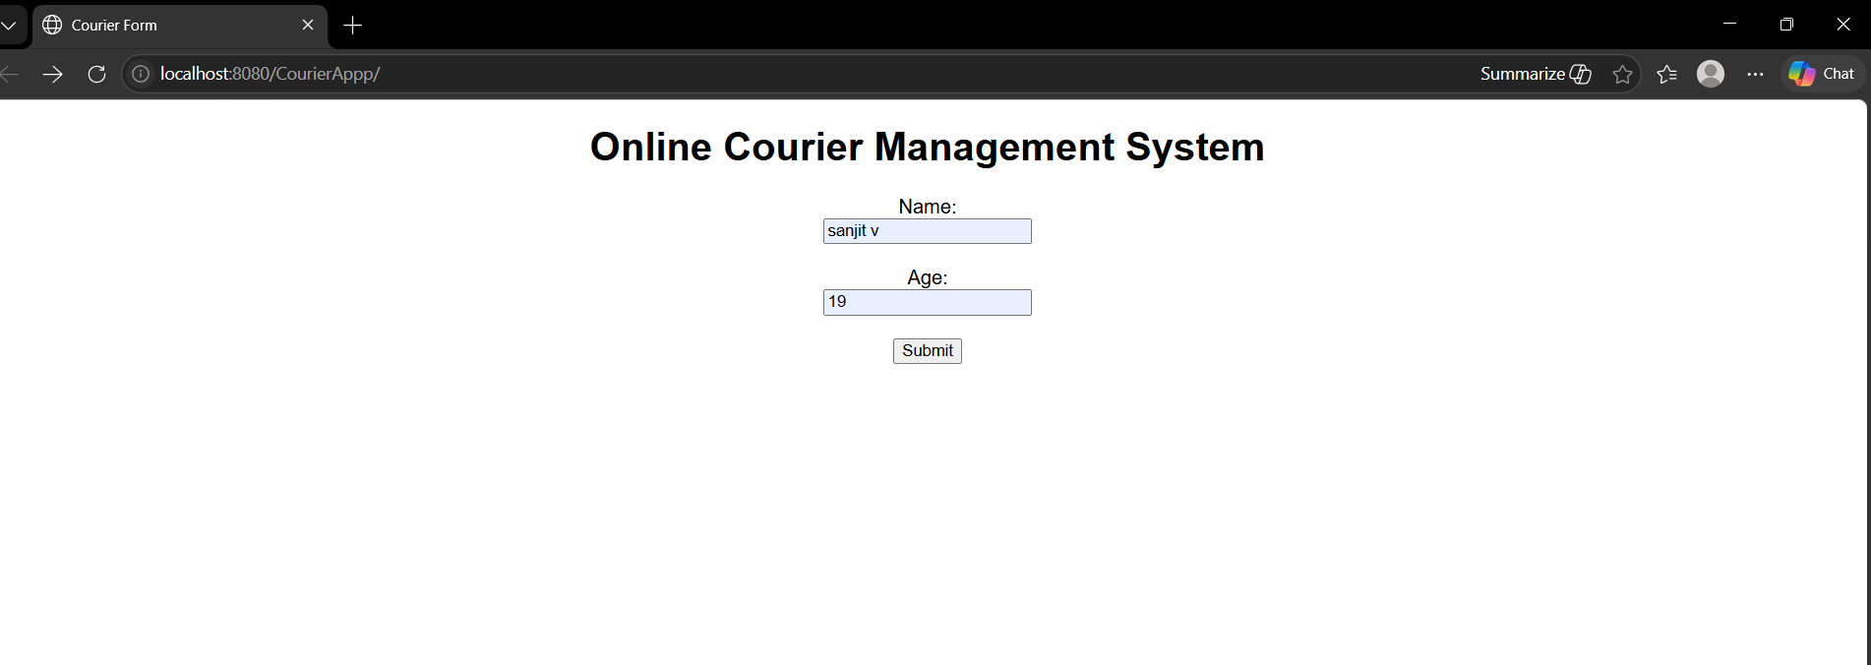

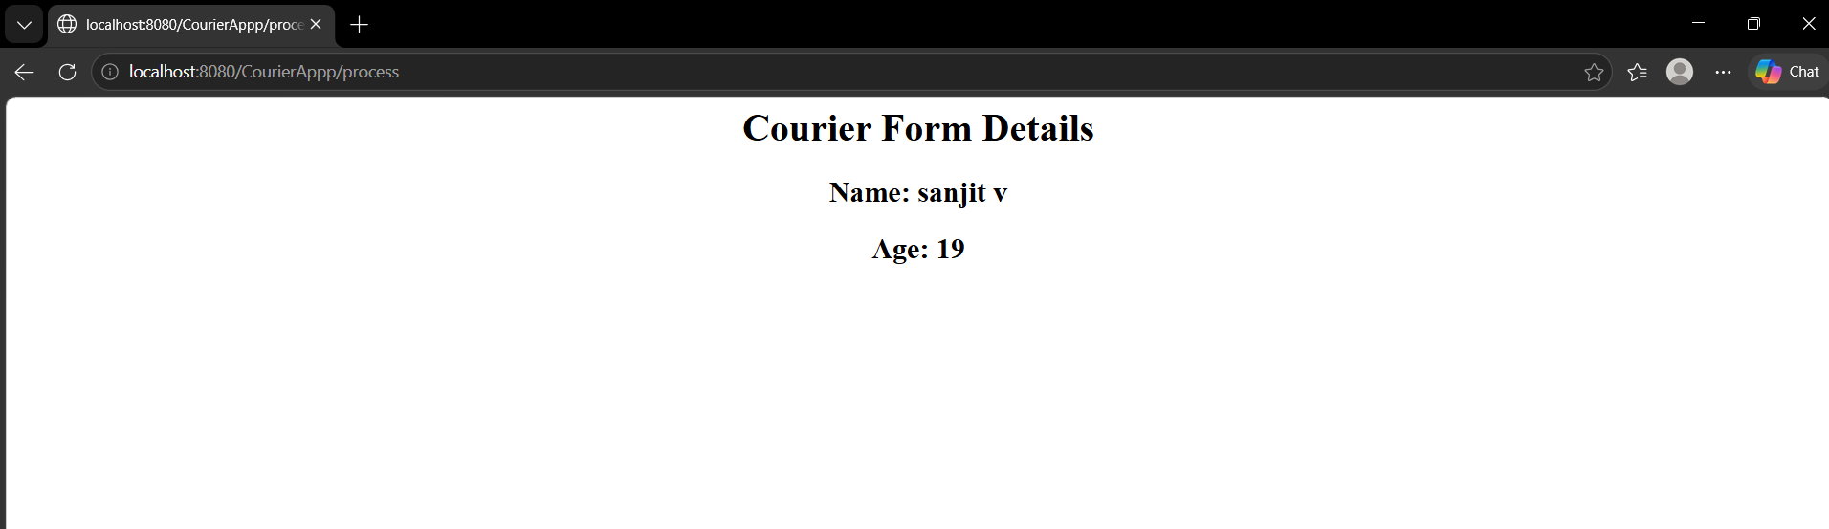

RESULT:
A Servlet is created to process the HTML form data and display it back on the browser.

