EXP.NO: 5 | Write a Servlet to demonstrate the difference between HTTP GET and POST methods by creating a form and handling requests accordingly.
DATE:05/03/2025

AIM:
To demonstrate the difference between the HTTP GET and POST methods by creating a form in an HTML page and handling the form submissions using two different HTTP methods in a Java Servlet.
ALGORITHM:
1. Input:
- The user fills out a web form with their name and email.
- The form will use both GET and POST methods for data submission.

2. Steps for Creating and Handling the HTTP GET and POST Requests:
- Create an HTML Form:
  - Design an HTML form with two input fields: one for the name and one for the email.
  - Create two buttons to allow the user to submit the form using GET or POST methods.
  - Use the action attribute to define the Servlet URL and specify the form method (either GET or POST).
- Create the Servlet to Handle GET and POST Requests:
  - Write a Java Servlet class that will handle both GET and POST requests.
  - The servlet will have two methods:
    - doGet() to handle the GET requests.
    - doPost() to handle the POST requests.
  - In both methods, retrieve the form data using request.getParameter().
  - In the doGet() method, process and display the data in the URL.
  - In the doPost() method, process and display the data in the HTTP request body.
- Handle GET Requests in the Servlet:
  - In the doGet() method, use request.getParameter() to retrieve the name and email submitted via GET.
  - Output the data as a response, including the name and email in the URL (visible to the user).
- Handle POST Requests in the Servlet:
  - In the doPost() method, use request.getParameter() to retrieve the name and email submitted via POST.
  - Output the data as a response, displaying the name and email without exposing them in the URL (more secure).
- Return the Output:
  - The Servlet should return an HTML page displaying the name and email entered by the user.
  - For the GET method, the output should be visible in the URL.
  - For the POST method, the output should be visible in the response body, not the URL.
- Deploy and Test the Servlet:
  - Compile the Servlet class and deploy it to a Servlet container (like Apache Tomcat).
  - Test the form using GET and POST methods to see the difference in data submission.
- Observe and Compare GET and POST Results:
  - Test the GET method: The form data is sent in the URL.
  - Test the POST method: The form data is sent in the HTTP request body, not visible in the URL.
Code:
ParkingServlet.java
package com.example;

import java.io.IOException;
import java.io.PrintWriter;
import java.time.LocalDateTime;

import jakarta.servlet.ServletException;
import jakarta.servlet.annotation.WebServlet;
import jakarta.servlet.http.*;

@WebServlet("/MethodServlet")
public class MethodServlet extends HttpServlet {

// Handle GET request
protected void doGet(HttpServletRequest request, HttpServletResponse response)
throws ServletException, IOException {
processRequest(request, response, "GET");
}

// Handle POST request
protected void doPost(HttpServletRequest request, HttpServletResponse response)
throws ServletException, IOException {
processRequest(request, response, "POST");
}

// Common method (advanced)
private void processRequest(HttpServletRequest request, HttpServletResponse response, String method)
throws IOException {

// Encoding (best practice)
request.setCharacterEncoding("UTF-8");
response.setContentType("text/html;charset=UTF-8");

PrintWriter out = response.getWriter();

// Get parameters
String name = request.getParameter("name");
String age = request.getParameter("age");

// Validation
if (name == null || name.trim().isEmpty()) {
name = "Not Provided";
}

if (age == null || age.trim().isEmpty()) {
age = "Not Provided";
}

// Current time (advanced feature)
String time = LocalDateTime.now().toString();

// HTML Response
out.println("<!DOCTYPE html>");
out.println("<html>");
out.println("<head>");
out.println("<title>Submission Result</title>");

// CSS Styling
out.println("<style>");
out.println("body { font-family: 'Segoe UI'; background: linear-gradient(135deg,#667eea,#764ba2); display:flex; justify-content:center; align-items:center; height:100vh; margin:0; }");
out.println(".card { background:white; padding:30px; border-radius:15px; width:350px; text-align:center; box-shadow:0 10px 30px rgba(0,0,0,0.3);}");
out.println("h2 { color:#333; }");
out.println("p { font-size:16px; margin:8px 0; }");
out.println(".get { color:red; font-weight:bold; }");
out.println(".post { color:green; font-weight:bold; }");
out.println(".btn { display:inline-block; margin-top:20px; padding:10px 20px; background:#333; color:white; text-decoration:none; border-radius:8px; }");
out.println("</style>");

out.println("</head>");
out.println("<body>");

out.println("<div class='card'>");

out.println("<h2>🎉 Form Submitted</h2>");
out.println("<p><b>Name:</b> " + name + "</p>");
out.println("<p><b>Age:</b> " + age + "</p>");
out.println("<p><b>Method:</b> " + method + "</p>");
out.println("<p><b>Time:</b> " + time + "</p>");

// GET vs POST message
if (method.equals("GET")) {
out.println("<p class='get'>⚠ GET: Data visible in URL (Less Secure)</p>");
} else {
out.println("<p class='post'>✔ POST: Data hidden in request body (More Secure)</p>");
}

out.println("<a class='btn' href='index.html'>⬅ Go Back</a>");

out.println("</div>");
out.println("</body>");
out.println("</html>");

out.close();
}
}

Bookingform.html
<!DOCTYPE html>
<html>
<head>
<title>GET vs POST Advanced</title>

<style>
body {
font-family: 'Segoe UI';
background: linear-gradient(135deg, #667eea, #764ba2);
margin: 0;
height: 100vh;
display: flex;
justify-content: center;
align-items: center;
}

.container {
display: flex;
gap: 40px;
}

.card {
background: white;
padding: 25px;
border-radius: 15px;
width: 300px;
box-shadow: 0px 10px 25px rgba(0,0,0,0.2);
transition: transform 0.3s;
}

.card:hover {
transform: scale(1.05);
}

h2 {
text-align: center;
}

input {
width: 100%;
padding: 10px;
margin: 10px 0;
border-radius: 8px;
border: 1px solid #ccc;
}

button {
width: 100%;
padding: 10px;
border: none;
border-radius: 8px;
color: white;
font-weight: bold;
cursor: pointer;
}

.get-btn {
background: #ff6b6b;
}

.post-btn {
background: #1dd1a1;
}

button:hover {
opacity: 0.9;
}

.title {
position: absolute;
top: 20px;
color: white;
font-size: 26px;
font-weight: bold;
}

</style>

<script>
function validateForm(form) {
let name = form.name.value;
let age = form.age.value;

if(name === "" || age === "") {
alert("All fields are required!");
return false;
}

if(age <= 0) {
alert("Enter valid age!");
return false;
}

return true;
}
</script>

</head>

<body>

<div class="title">GET vs POST - Advanced Demo</div>

<div class="container">

<!-- GET FORM -->
<div class="card">
<h2>GET Method</h2>
<form action="MethodServlet" method="get" onsubmit="return validateForm(this)">
<input type="text" name="name" placeholder="Enter Name">
<input type="number" name="age" placeholder="Enter Age">
<button class="get-btn">Submit via GET</button>
</form>
<p style="color:red; font-size:12px;">Data visible in URL</p>
</div>

<!-- POST FORM -->
<div class="card">
<h2>POST Method</h2>
<form action="MethodServlet" method="post" onsubmit="return validateForm(this)">
<input type="text" name="name" placeholder="Enter Name">
<input type="number" name="age" placeholder="Enter Age">
<button class="post-btn">Submit via POST</button>
</form>
<p style="color:green; font-size:12px;">Data hidden (secure)</p>
</div>

</div>

</body>
</html>

Output:
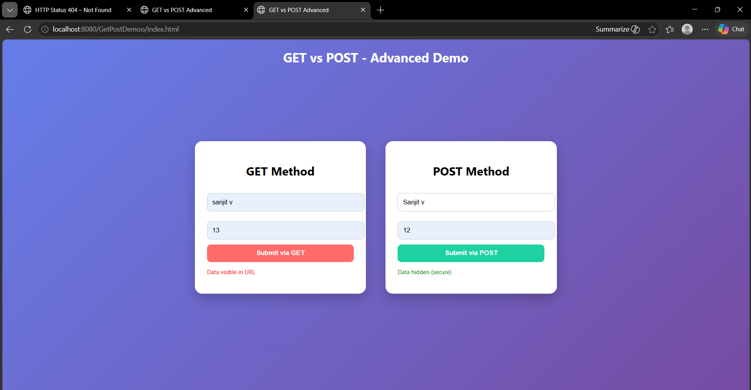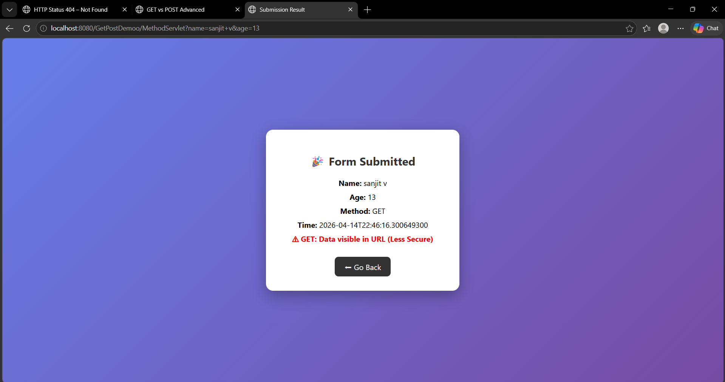

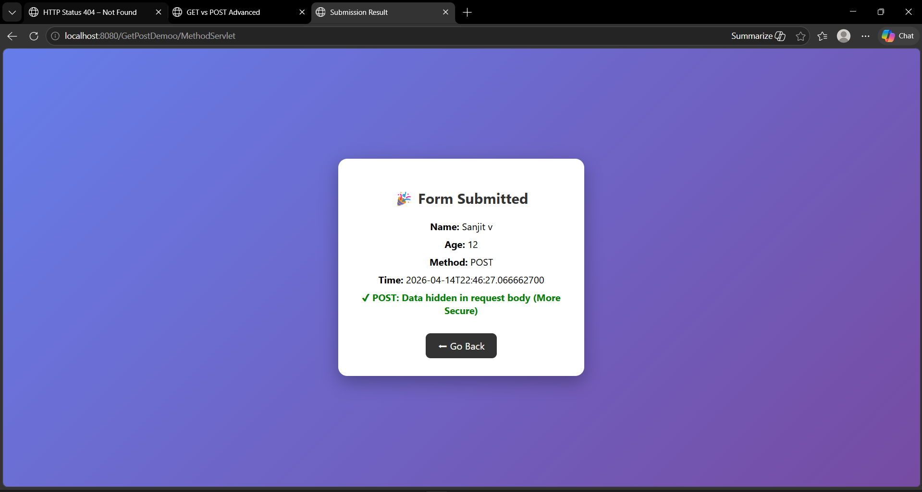
RESULT:
A Servlet is created to demonstrate the difference between HTTP GET and POST methods by creating a form and handling requests accordingly.

