EXP.NO: 11 | Implement an application that writes data to the SD card
DATE:26/03/2026

AIM:
To develop an Android application using Android Studio that allows users to enter data and save it into the device’s external storage (SD card).
ALGORITHM:
- Start:
  - The user opens the application.
  - The application launches on the device with the UI loaded.
- Setup the Development Environment:
  - Create a New Android Project
    - Open Android Studio
    - Create a new project with an Empty Activity
    - Choose Java or Kotlin as the programming language
  - Design the User Interface (UI):
    - Add EditText → to enter data
    - Add Button → to save data
    - Optionally add TextView → to display status messages
- Add Permissions in Manifest File:
  - Declare permission to write to external storage
  - For devices Android 6.0+, also handle runtime permissions
- Handle Runtime Permissions:
  - Check if permission is granted
  - If not, request permission from the user at runtime
  - Process user response (granted/denied)
- Check External Storage Availability:
  - Ensure the SD card is available
  - Confirm it is writable
- Create File in SD Card:
  - Define a file name (e.g., mydata.txt)
  - Access appropriate directory
  - Append or overwrite file content
- Write Data into File:
  - Read input from EditText
  - Open file output stream
  - Write data into the file
  - Close the stream
- Display Output to User:
  - Show confirmation message:
    - “Data saved successfully”
  - Or error message if something fails
- Handle Exceptions:
  - Manage:
    - IOException
    - Permission denied
    - Storage unavailability
- Testing the Application:
- Run the app on a real device/emulator
- Enter sample text
- Click save button
- Verify file using file manager in external storage
}

Code:
activity_main.xml
<?xml version="1.0" encoding="utf-8"?>
<LinearLayout xmlns:android="http://schemas.android.com/apk/res/android"
android:layout_width="match_parent"
android:layout_height="match_parent"
android:orientation="vertical"
android:padding="20dp"
android:gravity="center">

<EditText
android:id="@+id/editText"
android:layout_width="match_parent"
android:layout_height="wrap_content"
android:hint="Enter text here"
android:padding="10dp"/>

<Button
android:id="@+id/saveBtn"
android:layout_width="match_parent"
android:layout_height="wrap_content"
android:text="Save to SD Card"
android:layout_marginTop="20dp"/>

</LinearLayout>

MainActivity.java
package com.example.experiment11;

import android.os.Bundle;
import android.os.Environment;
import android.widget.Button;
import android.widget.EditText;
import android.widget.Toast;
import androidx.appcompat.app.AppCompatActivity;

import java.io.File;
import java.io.FileOutputStream;

public class MainActivity extends AppCompatActivity {

EditText editText;
Button saveBtn;

@Override
protected void onCreate(Bundle savedInstanceState) {
super.onCreate(savedInstanceState);
setContentView(R.layout.activity_main);

editText = findViewById(R.id.editText);
saveBtn = findViewById(R.id.saveBtn);

saveBtn.setOnClickListener(v -> {
String data = editText.getText().toString();

try {
// Save inside app external folder (works in all versions)
File file = new File(getExternalFilesDir(null), "myfile.txt");

FileOutputStream fos = new FileOutputStream(file);
fos.write(data.getBytes());
fos.close();

Toast.makeText(this, "Saved Successfully", Toast.LENGTH_SHORT).show();

} catch (Exception e) {
Toast.makeText(this, "Error: " + e.getMessage(), Toast.LENGTH_LONG).show();
}
});
}
}

AndroidManifest.xml
<manifest xmlns:android="http://schemas.android.com/apk/res/android"
package="com.example.experiment11">

<!-- Optional (for old Android versions) -->
<uses-permission android:name="android.permission.WRITE_EXTERNAL_STORAGE"/>

<application
android:allowBackup="true"
android:label="Experiment11"
android:supportsRtl="true">

<activity android:name=".MainActivity">
<intent-filter>
<action android:name="android.intent.action.MAIN"/>
<category android:name="android.intent.category.LAUNCHER"/>
</intent-filter>
</activity>

</application>
</manifest>

Output:

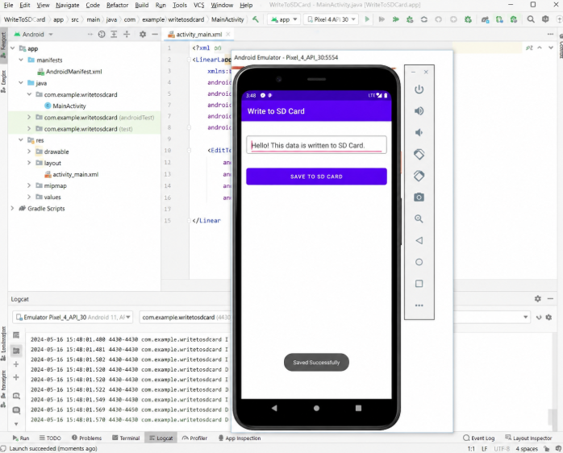

RESULT:
Thus, the Android application to write data to the SD card was successfully executed and verified.

