**Scenario 1:**

**Deployment your First Docker Container :**

**\***Redis, a popular KV Store.

* This scenario discusses how she will complete her task and deploy Redis as a Docker Container.

*Jane's development environment has access to latest version of the Docker Engine via a machine called *docker*.

**DOCKER:**

**\*** Docker is an open source platform.

*It can be used for the deployment of the applications in container so this applications can work efficiently in different environment.

**Command :**docker Search redis

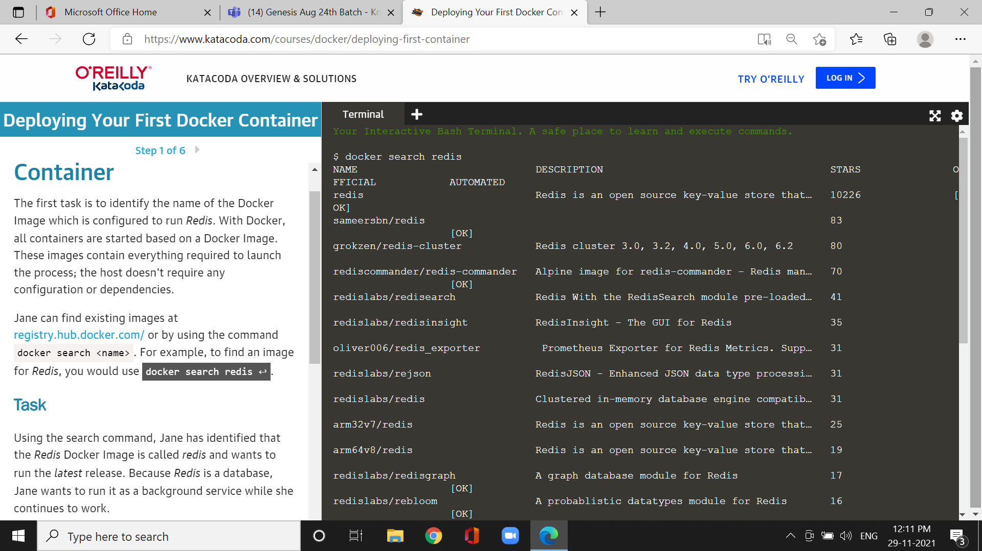

Docker will run a command in the foreground :

Command : docker run -d redis

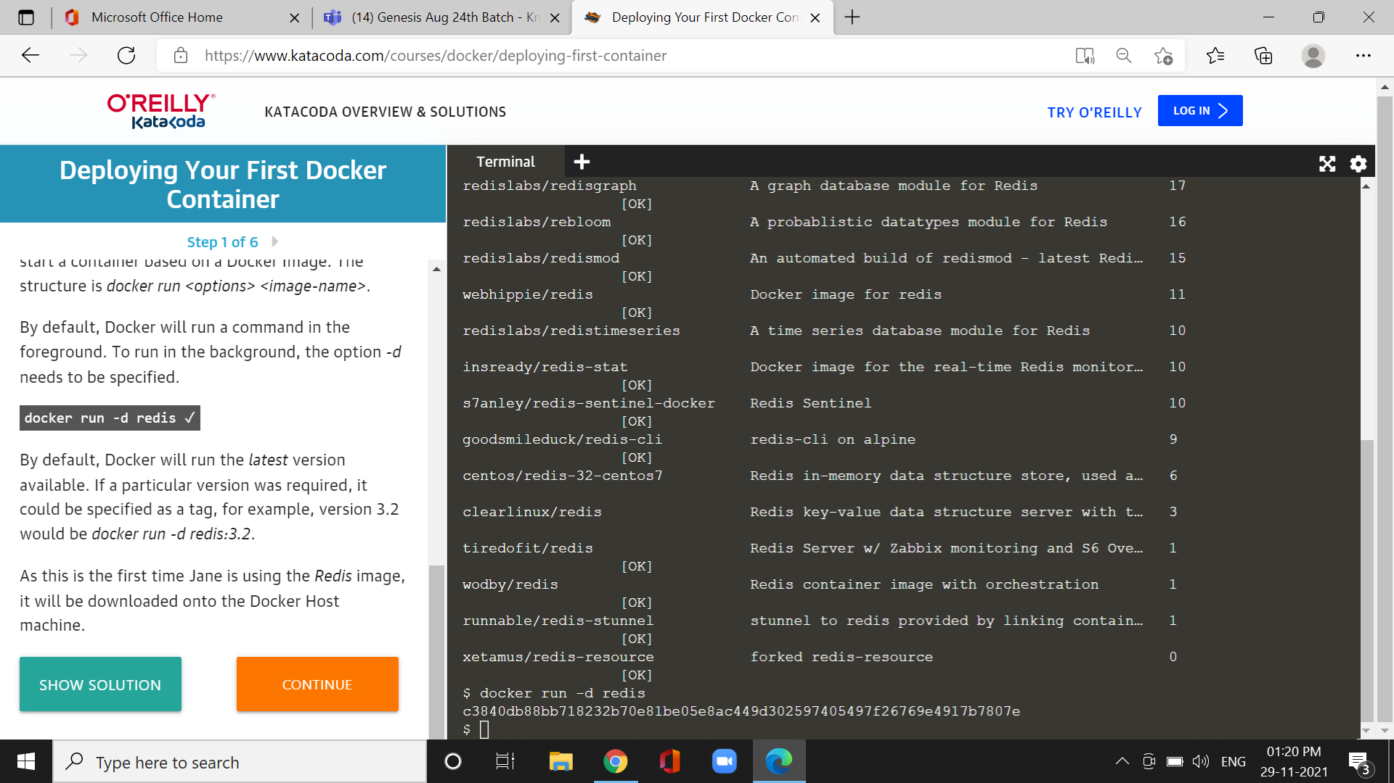

*The docker run command function is to build and run the container.

*To run the container in the foreground is -d.

**Step 2 : Finding Running containers :**

Cmd:docker ps:

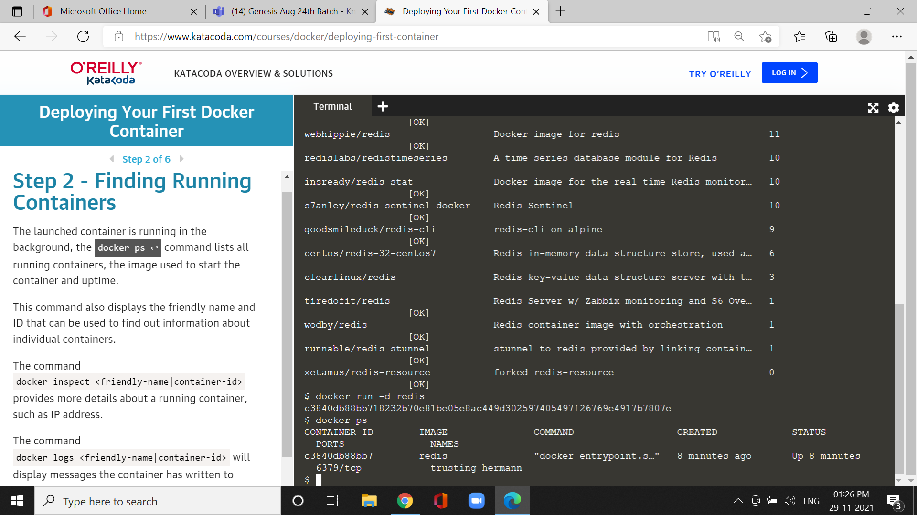

* It can be used for command lists all running containers, the image used to start the container and uptime.

*The command also displays friendly name and ID

*The command docker inspect <friendly-name|container-id>provides more details about a running container, such as IP address.

*The command docker logs <friendly-name|container-id> will display messages the container has written to standard error.

**Step3 Acessing Redis :**

**\***Redis runs on port 6379.

cmd : docker run --d --name redisHostport -p 6379:6379 redis:latest

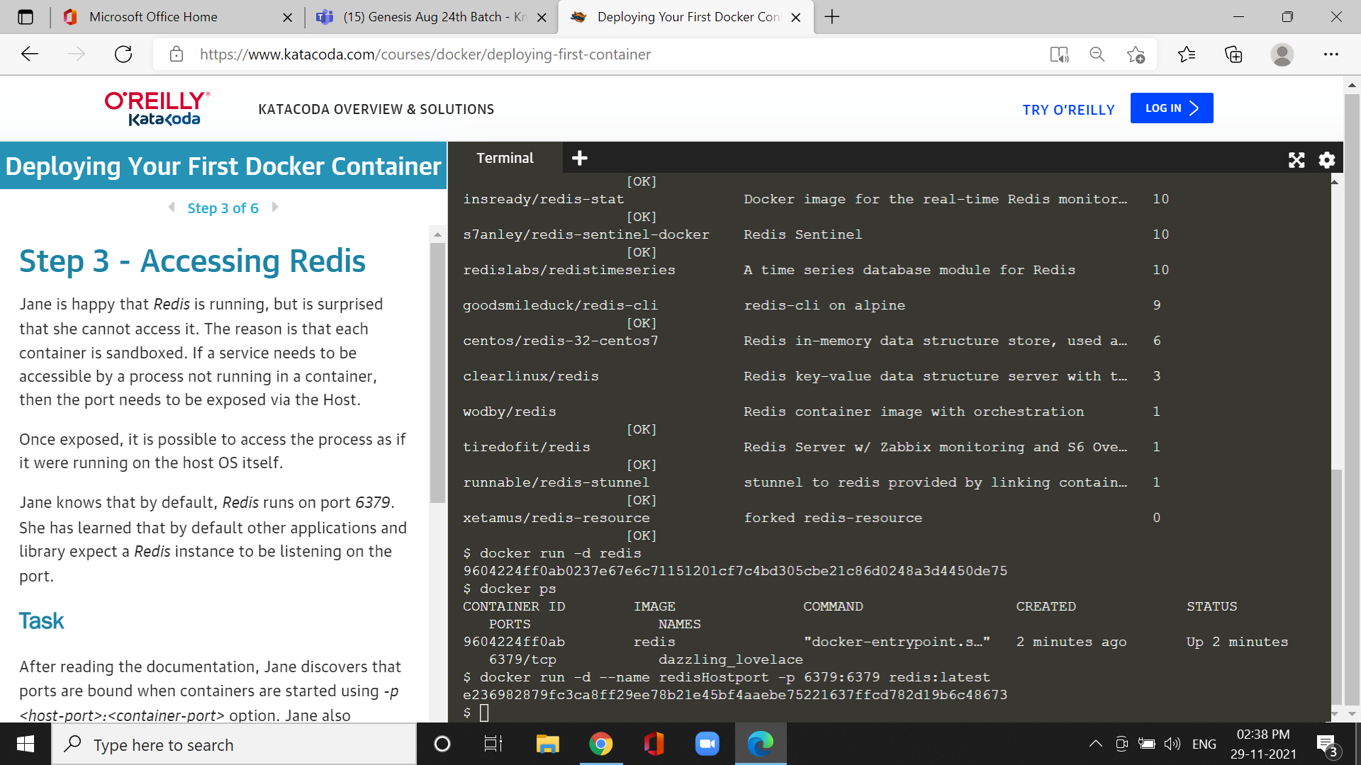

*This command is used for the name of the redis in the background of redis Hostport.

**Step4:**

Cmd :docker run -d --name redisDynamic -p 6379 redis:latest

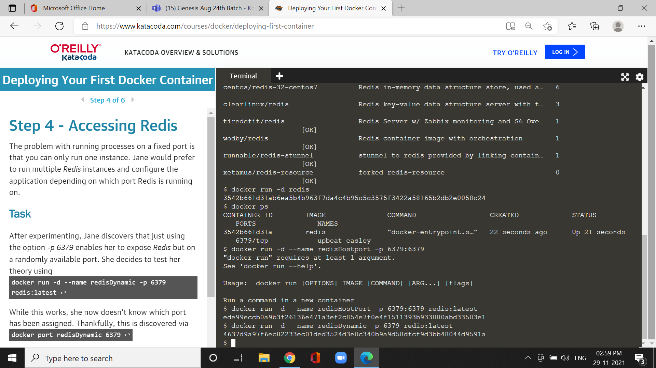

*it can be used for multiple redis instances and application depends on this port.

Cmd:docker port redisDynamic 6379 & cmd: docker ps

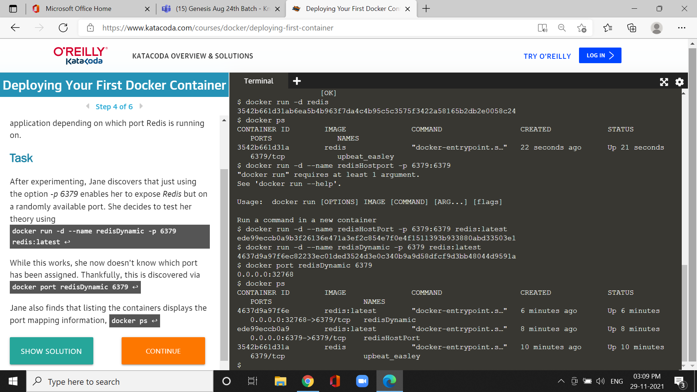

* it can be used for the port can be assigned.

* docker ps used for finding the listing containers displays the mapping port information.

**Step5 : Persisting Data**

**\***Containers are designed stateless.

*Binding directories also known as volumes option -v

Cmd : docker run -d --name redisMapped -v /opt/docker/data/redis:/data redis

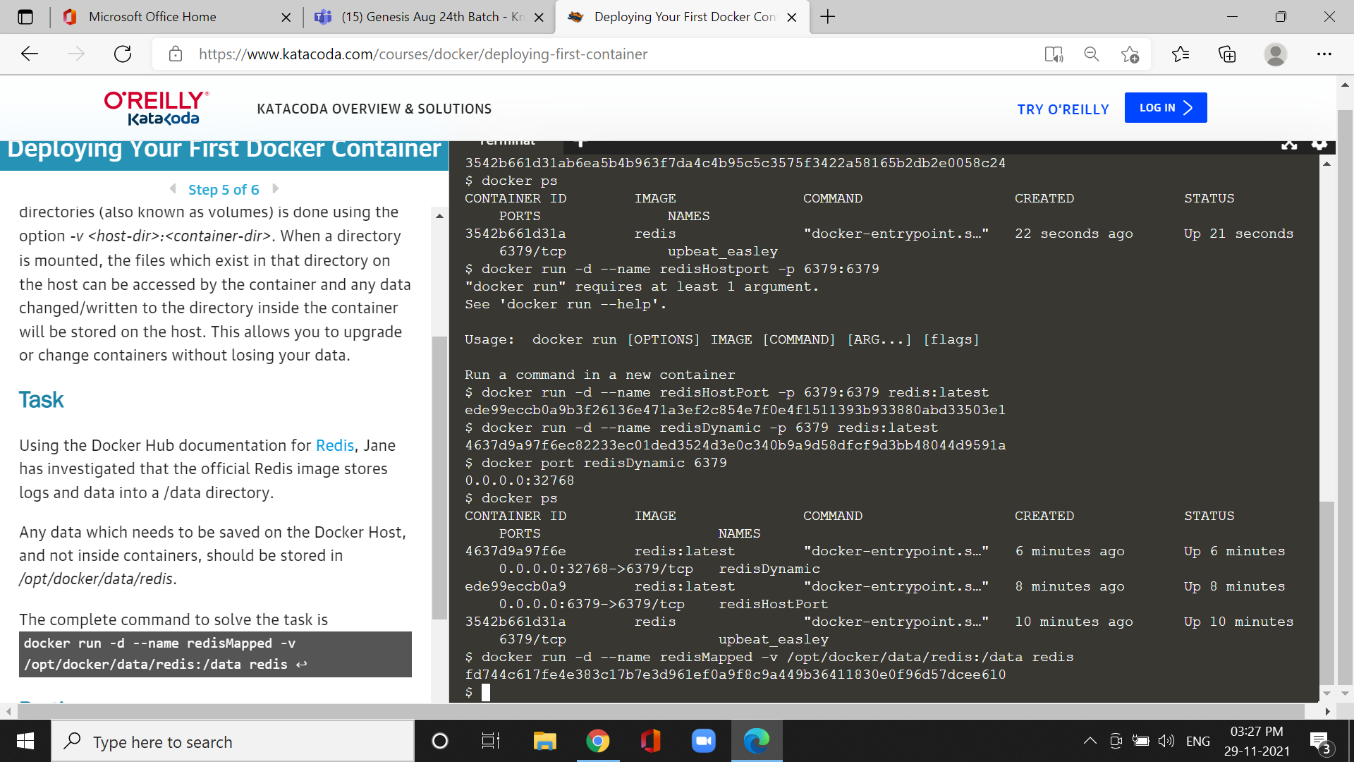

*It can be used for image store logs and data into a directory.

*Any data which needs to be saved on the Docker Host, and not inside containers, should be stored in */opt/docker/data/redis*.

**Step6 : Running a container in the foreground**

*containers work with foreground ps or bash

\**-d* to execute the container in a detached, background, state.

* Example: The Ubuntu image can either run OS commands or run an interactive bash prompt using */bin/bash*

Cmd : docker run ubuntu ps

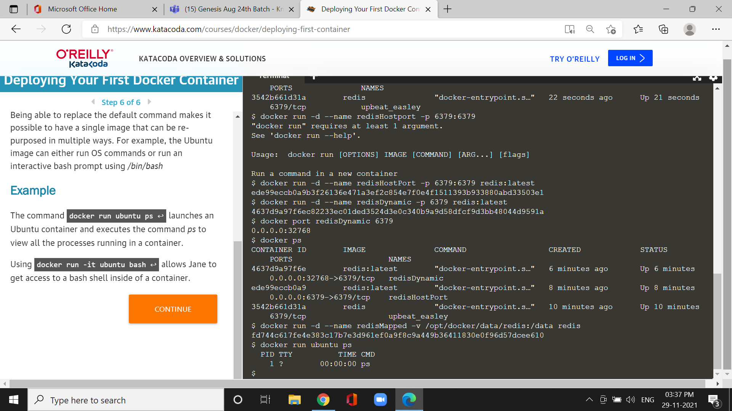

*It can be used for ubuntu container and executes the command *ps* to view all the processes running in a container.

Cmd :docker run -it ubuntu bash

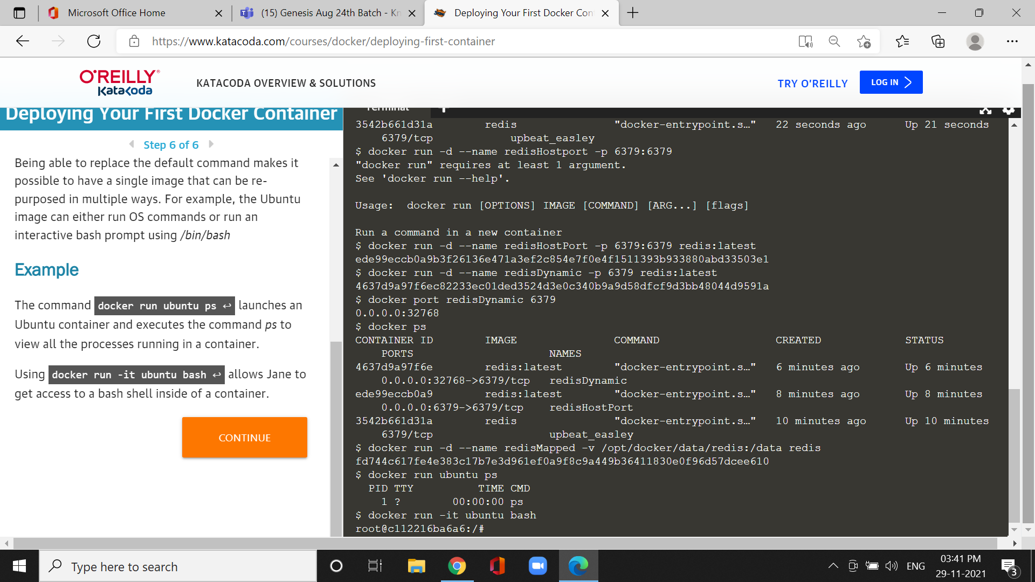

*it can used to get access to a bash shell inside of a container.