Scenario10:

**Persisting Data using volumes**

**\***Docker Volumes allows you to upgrade containers, restart machines and share data without data loss.

step1:Data volumes

*Data Volumes allow you to map a host directory to a container for sharing data.

*It allows data stored on the host to be accessed from within the container.

cmd:Docker run -v/docker/redis-data:/data\

--name r1 -d redis\

Redis -server--appendonly yes

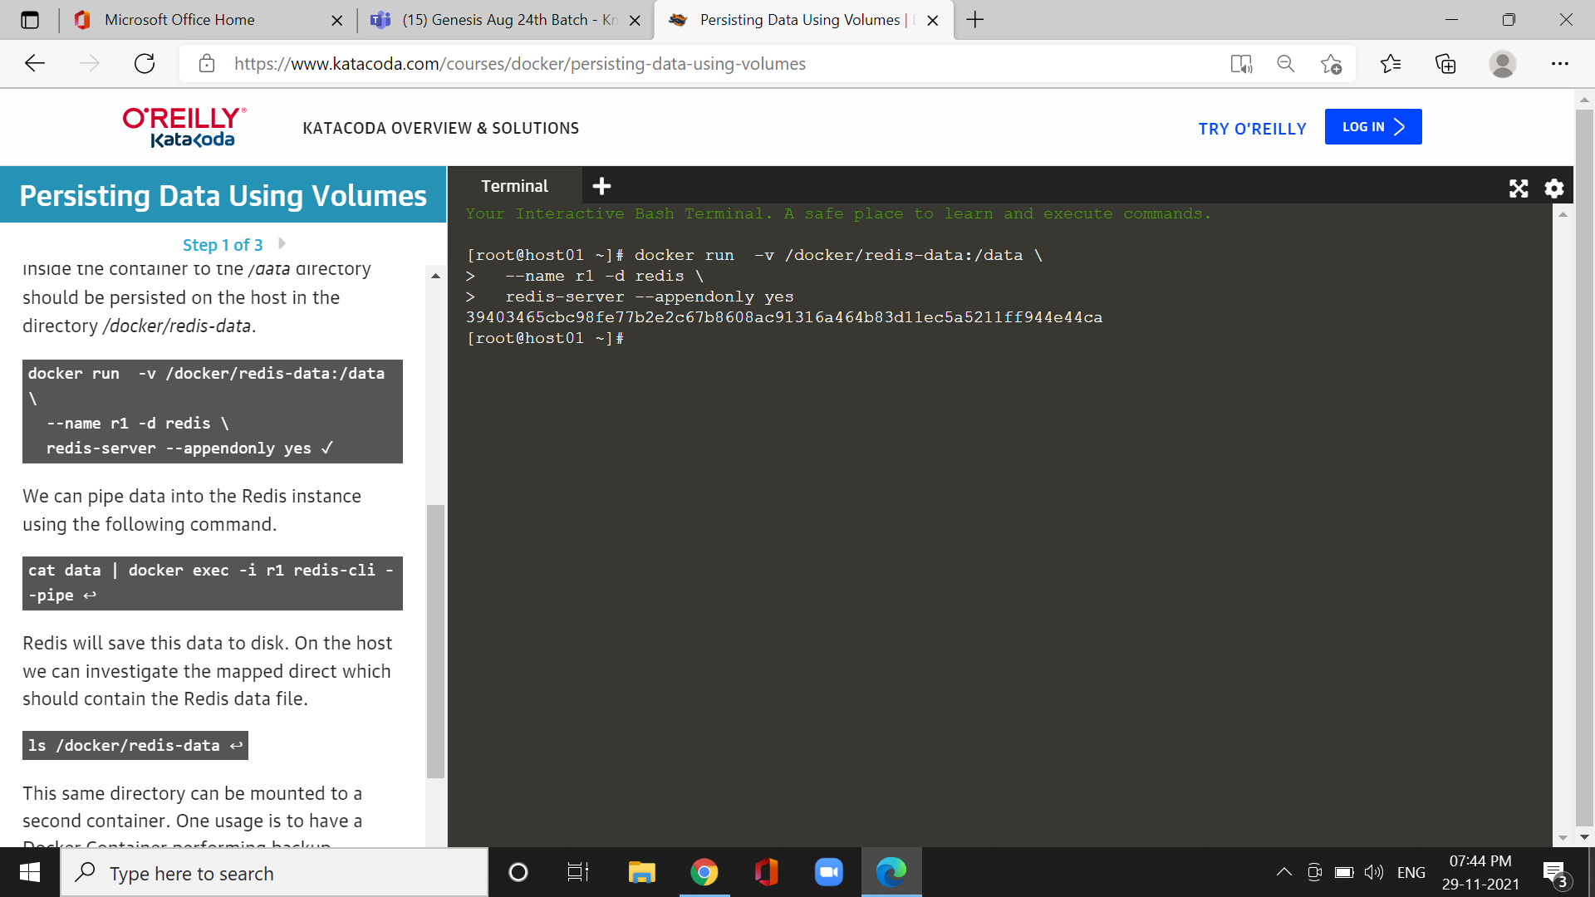

Step2:shared volumes:

*The */data* directory only exists within our Redis container, however, because of *-volumes-from* our Ubuntu container can access the data.

Cmd:docker run --volumes-from r1 -it ubuntu ls/data

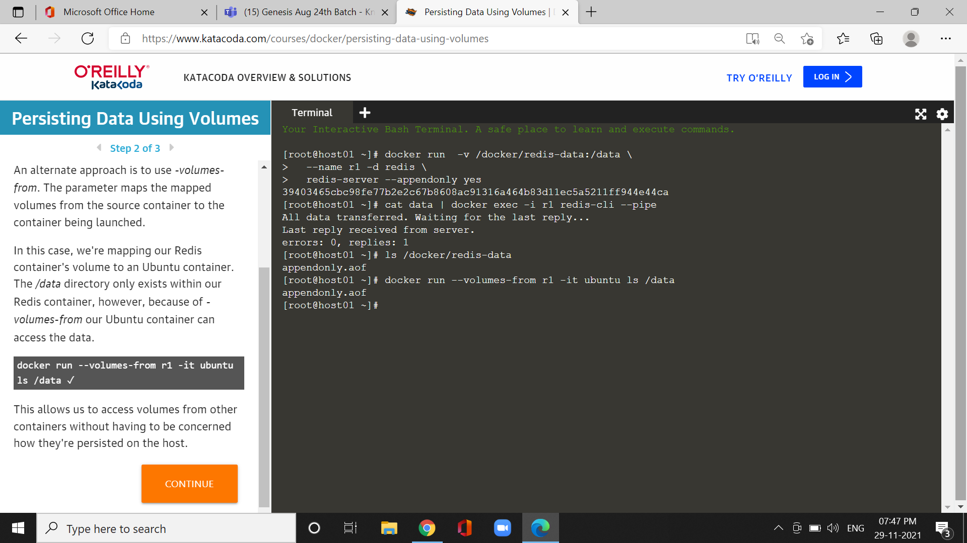

step3:Read only volumes

*Mounting Volumes gives the container full read and write access to the directory.

*read-only permissions on the directory by adding the permissions *:ro* to the mount.

Cmd:docker run -v /docker/redis-

data:/data:ro -it ubuntu rm -rf /data

