Scenario 4:

**Dockerizing node.js application**

**cmd:**FROM node:10-alpine

RUN mkdir -p /src/app

WORKDIR /src/app

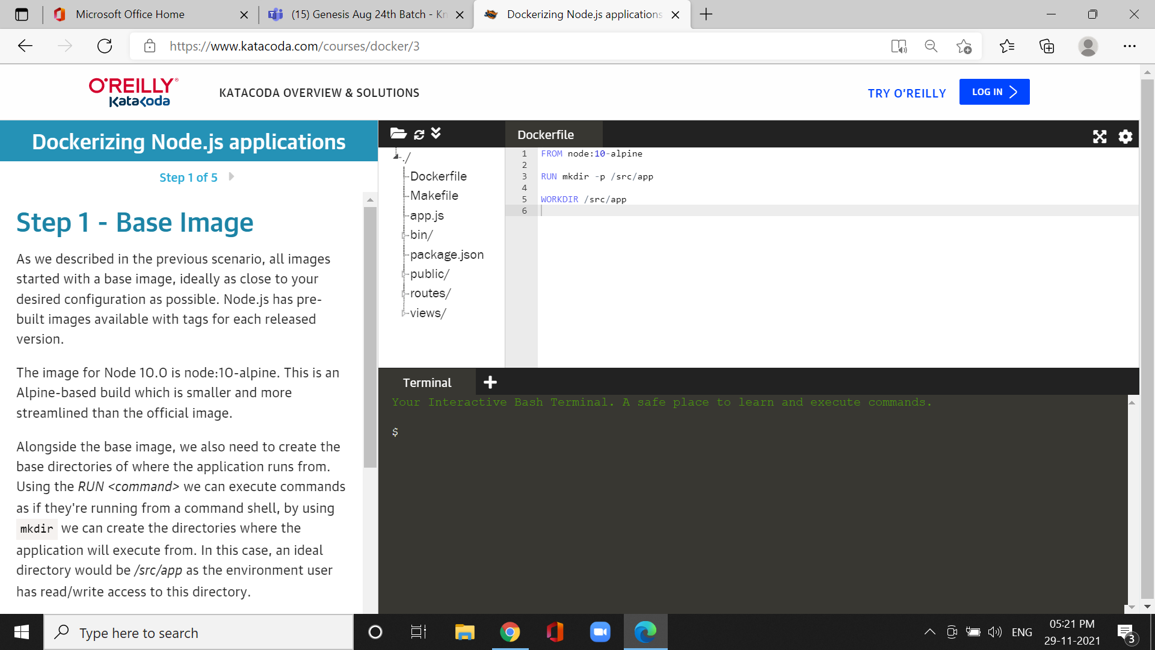

*\*WORKDIR <directory>* to ensure that all future commands are executed from the directory relative to our application.

cmd:COPY package.json /src/app/package.json

RUN npm install

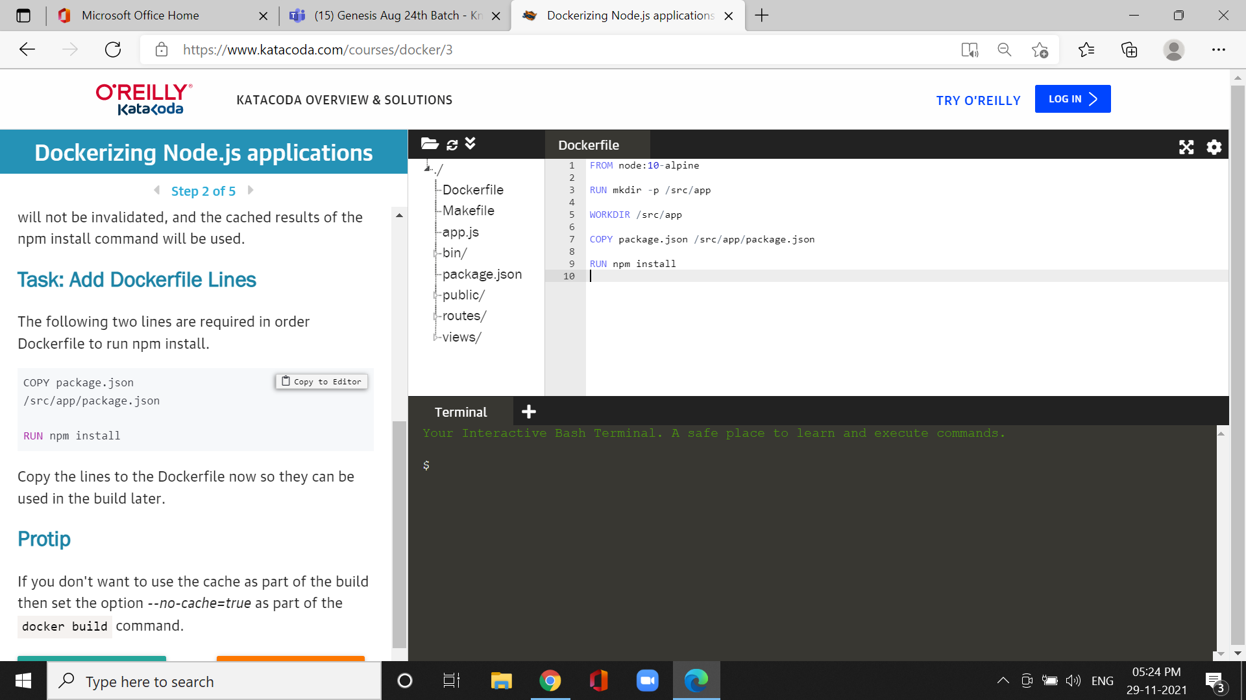

*The copy the lines to the Dockerfile now so they can be used in the build late.

Cmd:docker build -t my-nodejs-app

