Scenario5:

**Optimising dockerfile with onbuild**

**FROM node:7**

**RUN mkdir -p /usr/src/app**

**WORKDIR /usr/src/app**

**ONBUILD COPY package.json /usr/src/app/**

**ONBUILD RUN npm install**

**ONBUILD COPY . /usr/src/app**

**CMD [ "npm", "start" ]**

**\***The advantage of creating OnBuild images is that our Dockerfile is now much simpler and can be easily re-used across multiple projects without having to re-run the same steps improving build times.

Expose 3000

Cmd:docker build -t my -nodejs.-app

* Building the images based on the OnBuild docker file is the same .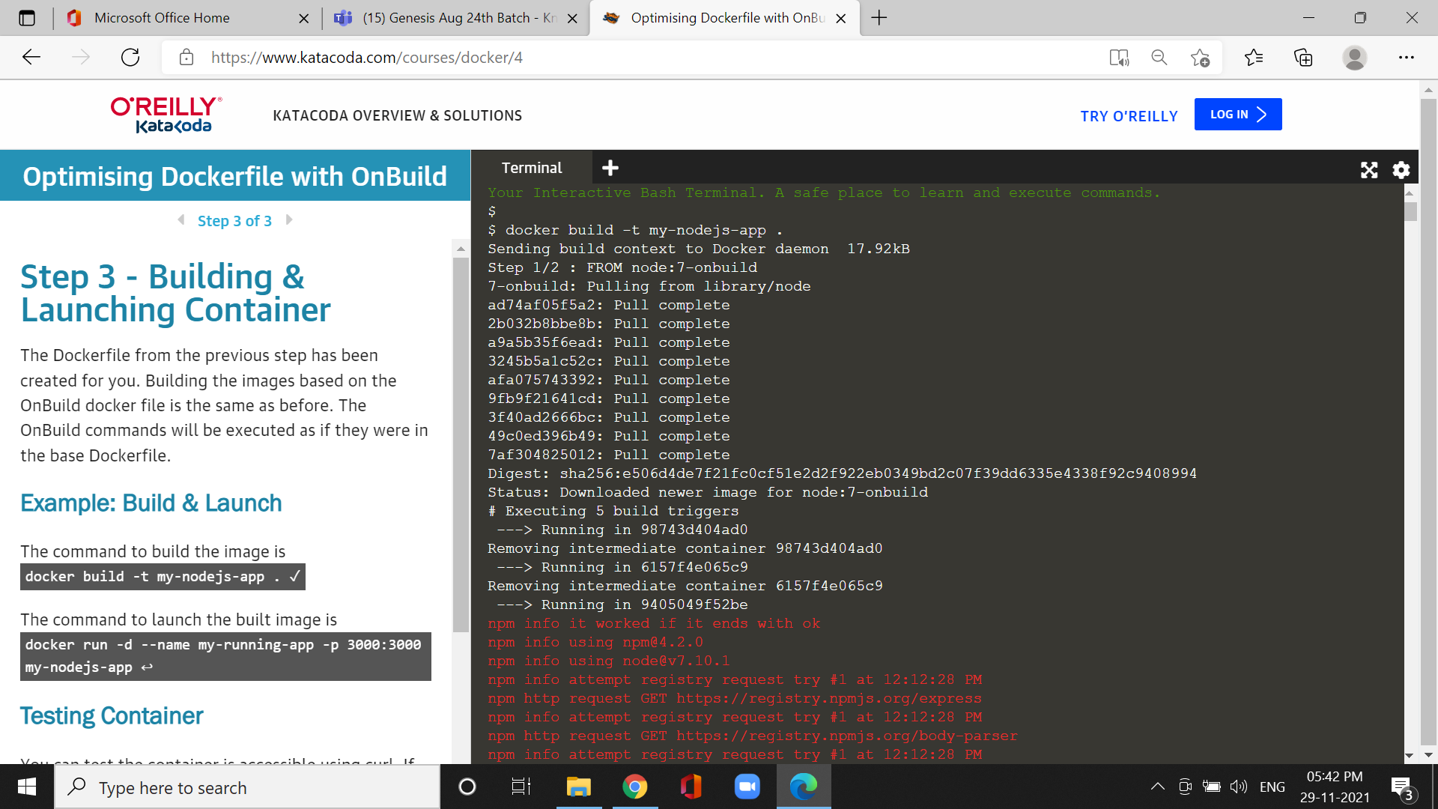

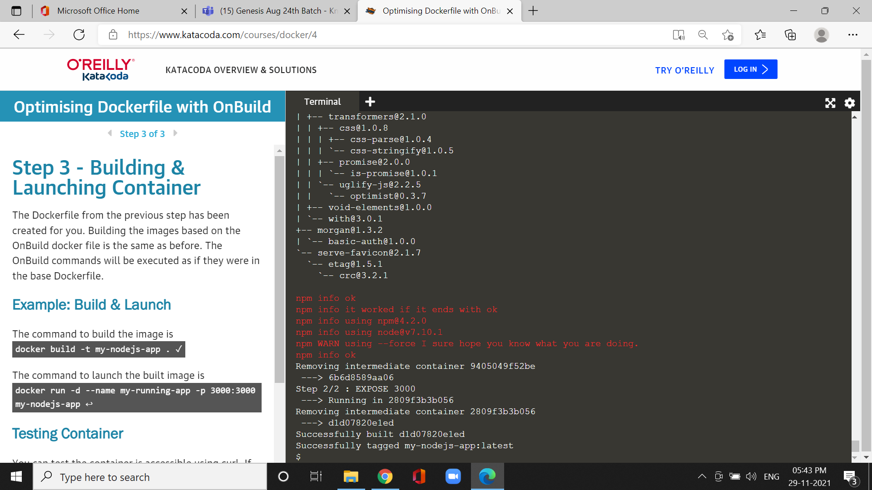

cmd:Curl <https://docker:3000>

