Scanerio7:

**Data containers:**

*It can be used in two ways of stateful containers.

*containers are store.

*persistent data for future use.

*One approach we've discussed is using the *-v <host-dir>:<container-dir>* option to map directories.

*The other approach is to use Data Containers.

**Step1:Create Container**

* Data Containers are containers whose sole responsibility is to be a place to store/manage data.

*When creating the container, we also provide a *-v* option to define where other containers will be reading/saving data.

Cmd:docker create -v/config --name dataContainer busybox

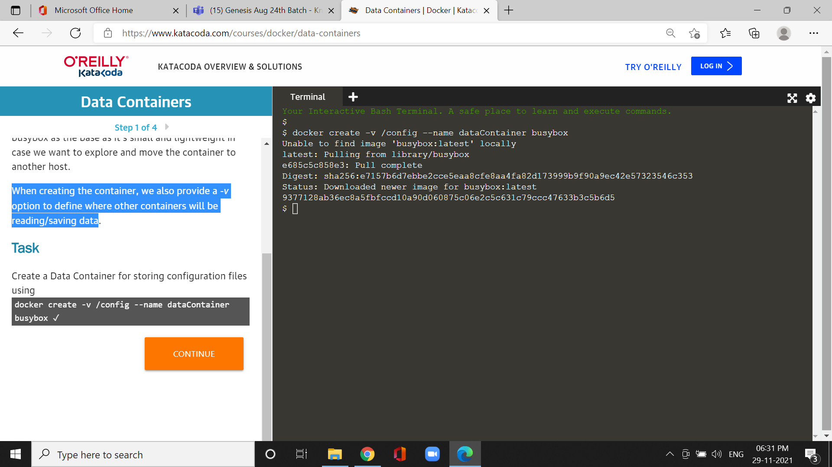

*Create a Data Container for storing configuration files.

**Step2:Copy files**

*To copy files into a container you use the command *docker cp.*

Cmd:docker cp config.conf dataContainer:/config/

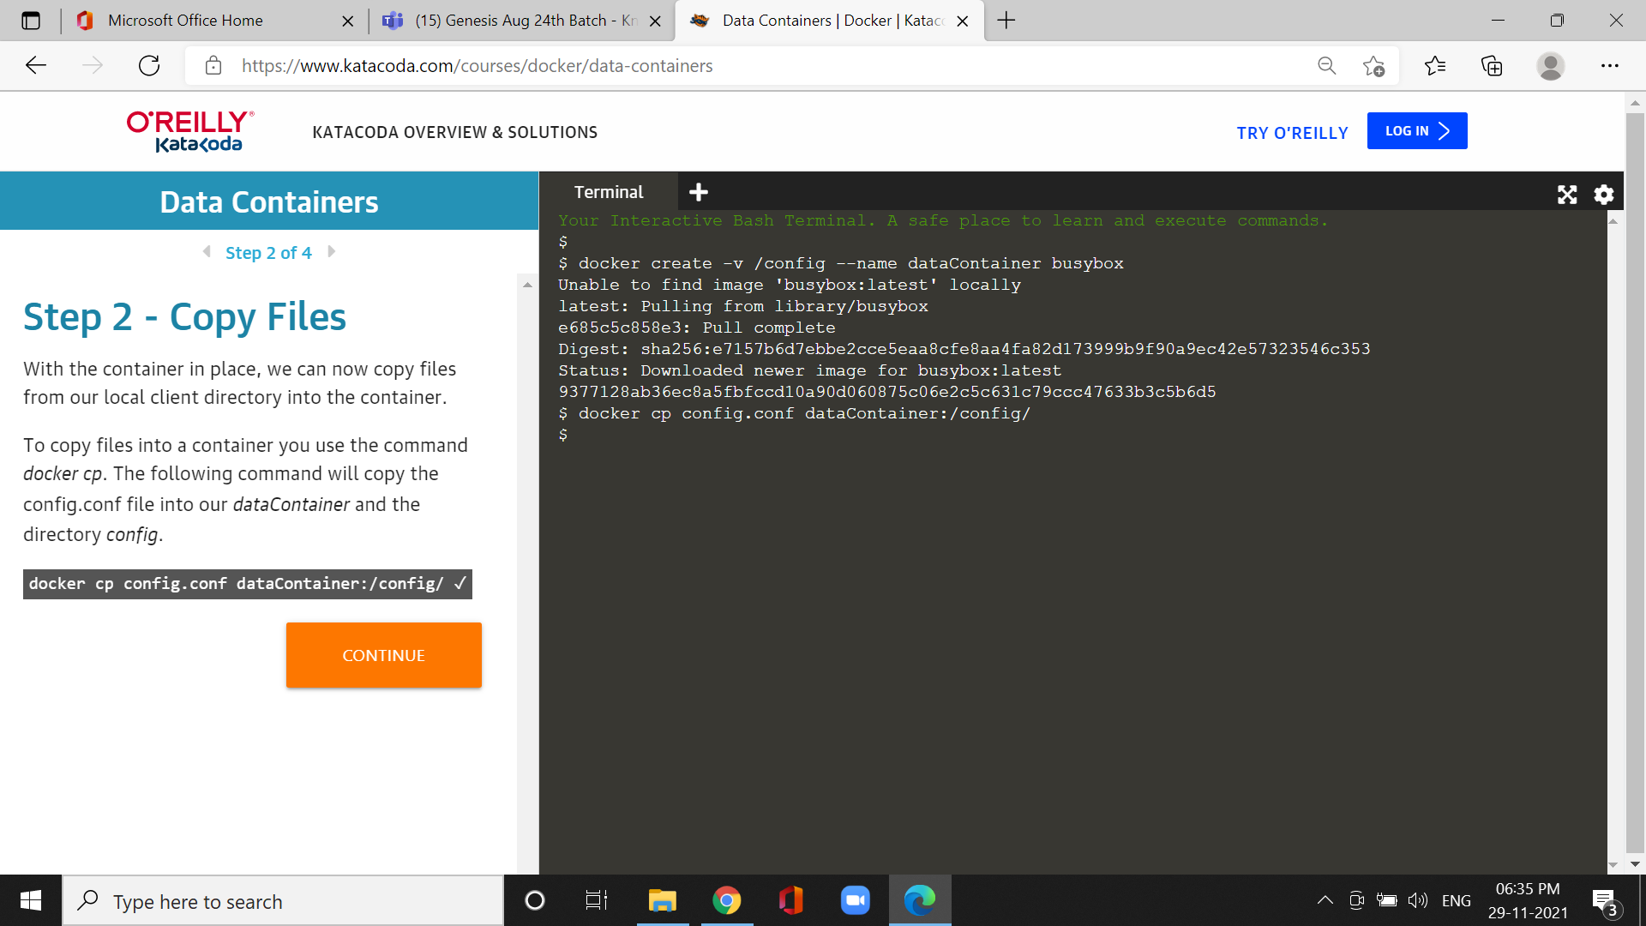

**Step3:Mount volumes from**

**\*T**he *--volumes-from <container>* option we can use the mount volumes from other containers inside the Container being launched.

Cmd :docker run --volumes-from dataContainer ubuntu ls/config

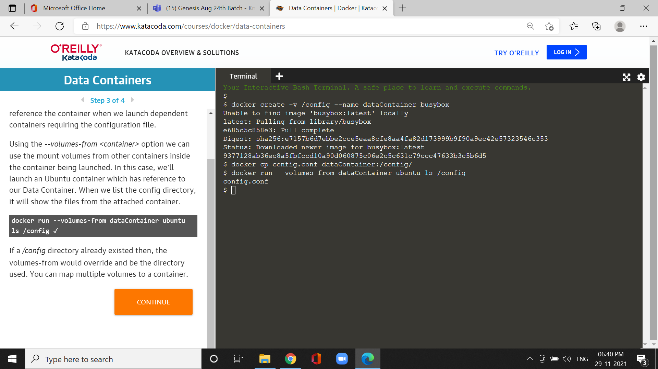

**Step4:Export/Import Containers:**

**\***To move the Data Container to another machine then we can export it to a .tar file.

Cmd:docker export dataContainer >dataContainer.tar.

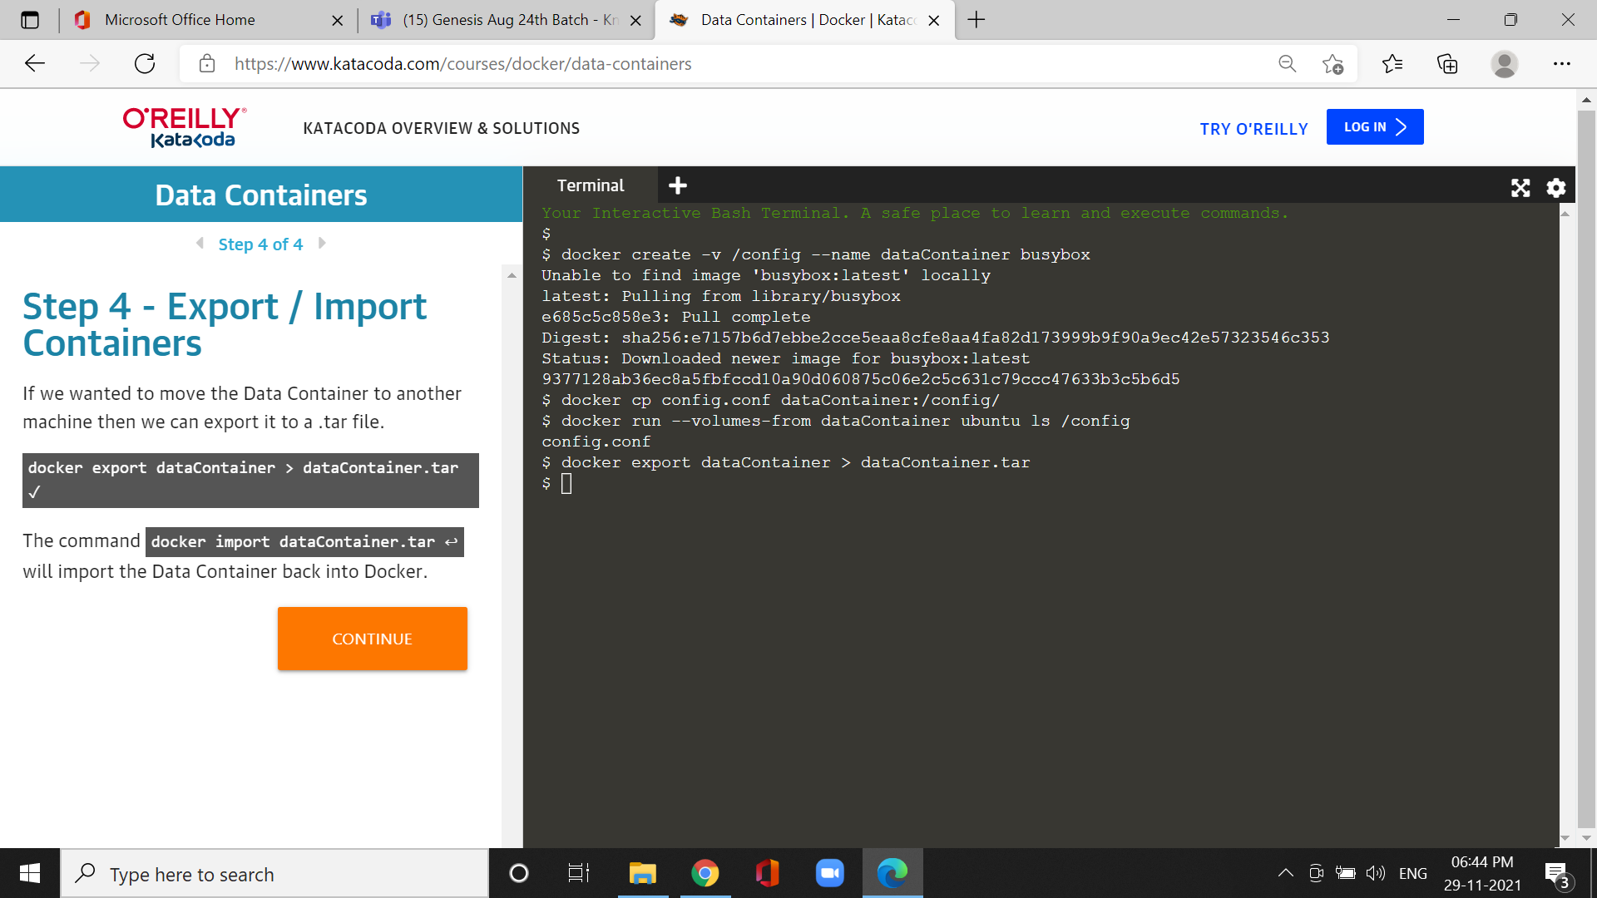

Cmd:docker import dataContainer.tar

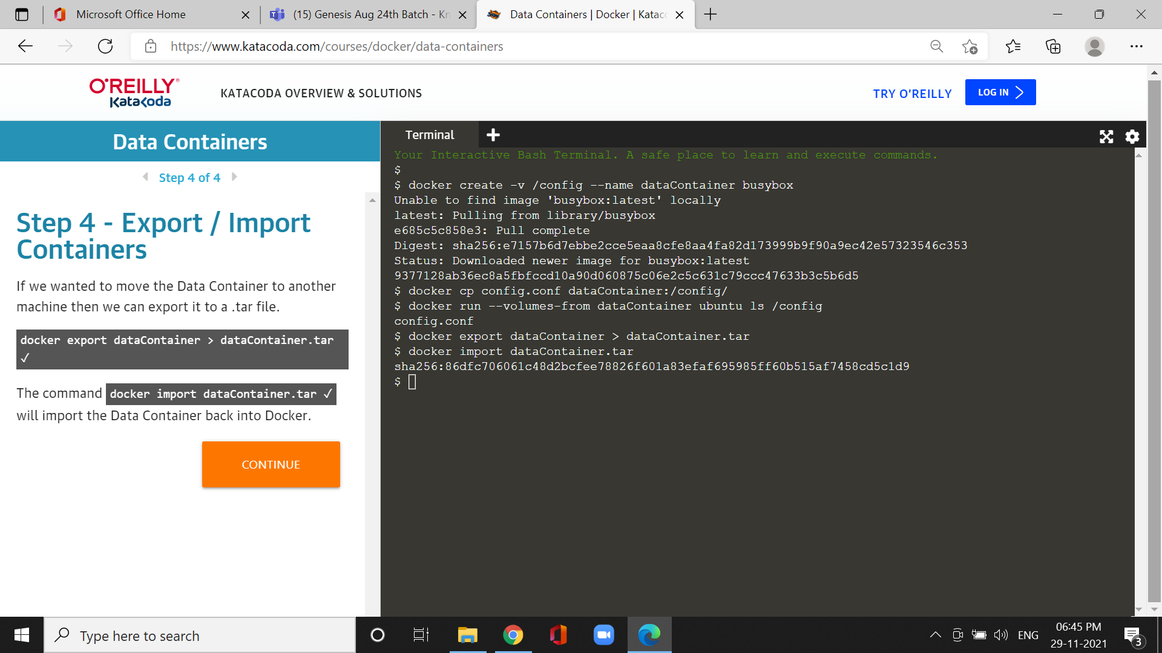

*it will import the Data Container back into Docker.