Scenario8:

**Communicating between Containers:**

**\*** To allow multiple containers to communicate with each other.

**Step1: Start Redis**

Cmd:docker run -d --name redis server redis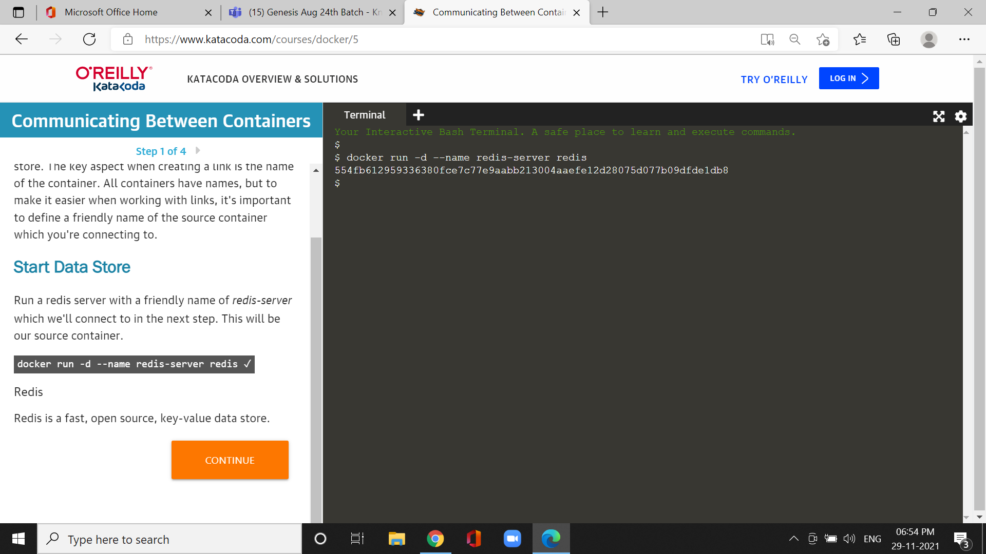

*Redis server with a friendly name of *redis-server* which we'll connect to in the next step.

Step2 :Create Link

*To connect to a source container you use the *--link <container-name|id>:<alias>* option when launching a new container.

*When a link is created, Docker will do two things.

*First, Docker will set some environment variables based on the linked to the container.

*These environment variables give you a way to reference information such as Ports and IP addresses via known names.

Cmd:docker run --link redis server:redis alpine env

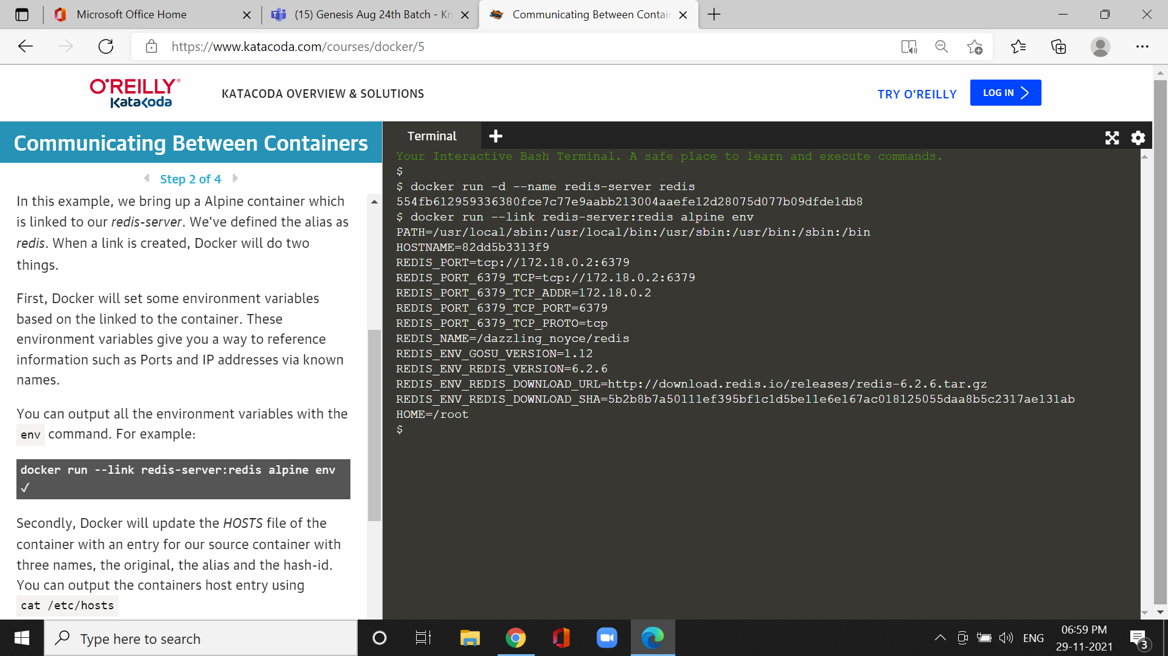

*Secondly, Docker will update the *HOSTS* file of the container with an entry for our source container with three names, the original, the alias and the hash-id.

Cmd:docker run --link redis server:redis alpine ping -c 1 redis

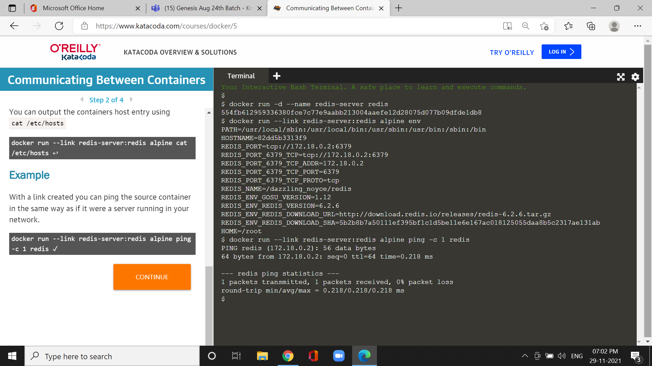

Step3: connect to redis CLI

*Redis-cli tool and connect to the redis server via its alias.

Cmd :docker run -it --link redis-server:redis redis redis -cli -h redis

