Scenerio9:

**Docker Networks**

**\***Docker has two approaches to networking.

*The first defines a link between two containers. This link updates */etc/hosts* and environment variables to allow containers to discover and communicate.

*The alternate approach is to create a *docker network* that containers are connected to.

*The network has similar attributes to a physical network, allowing containers to come and go more freely than when using links.

Cmd:docker network create backend-network

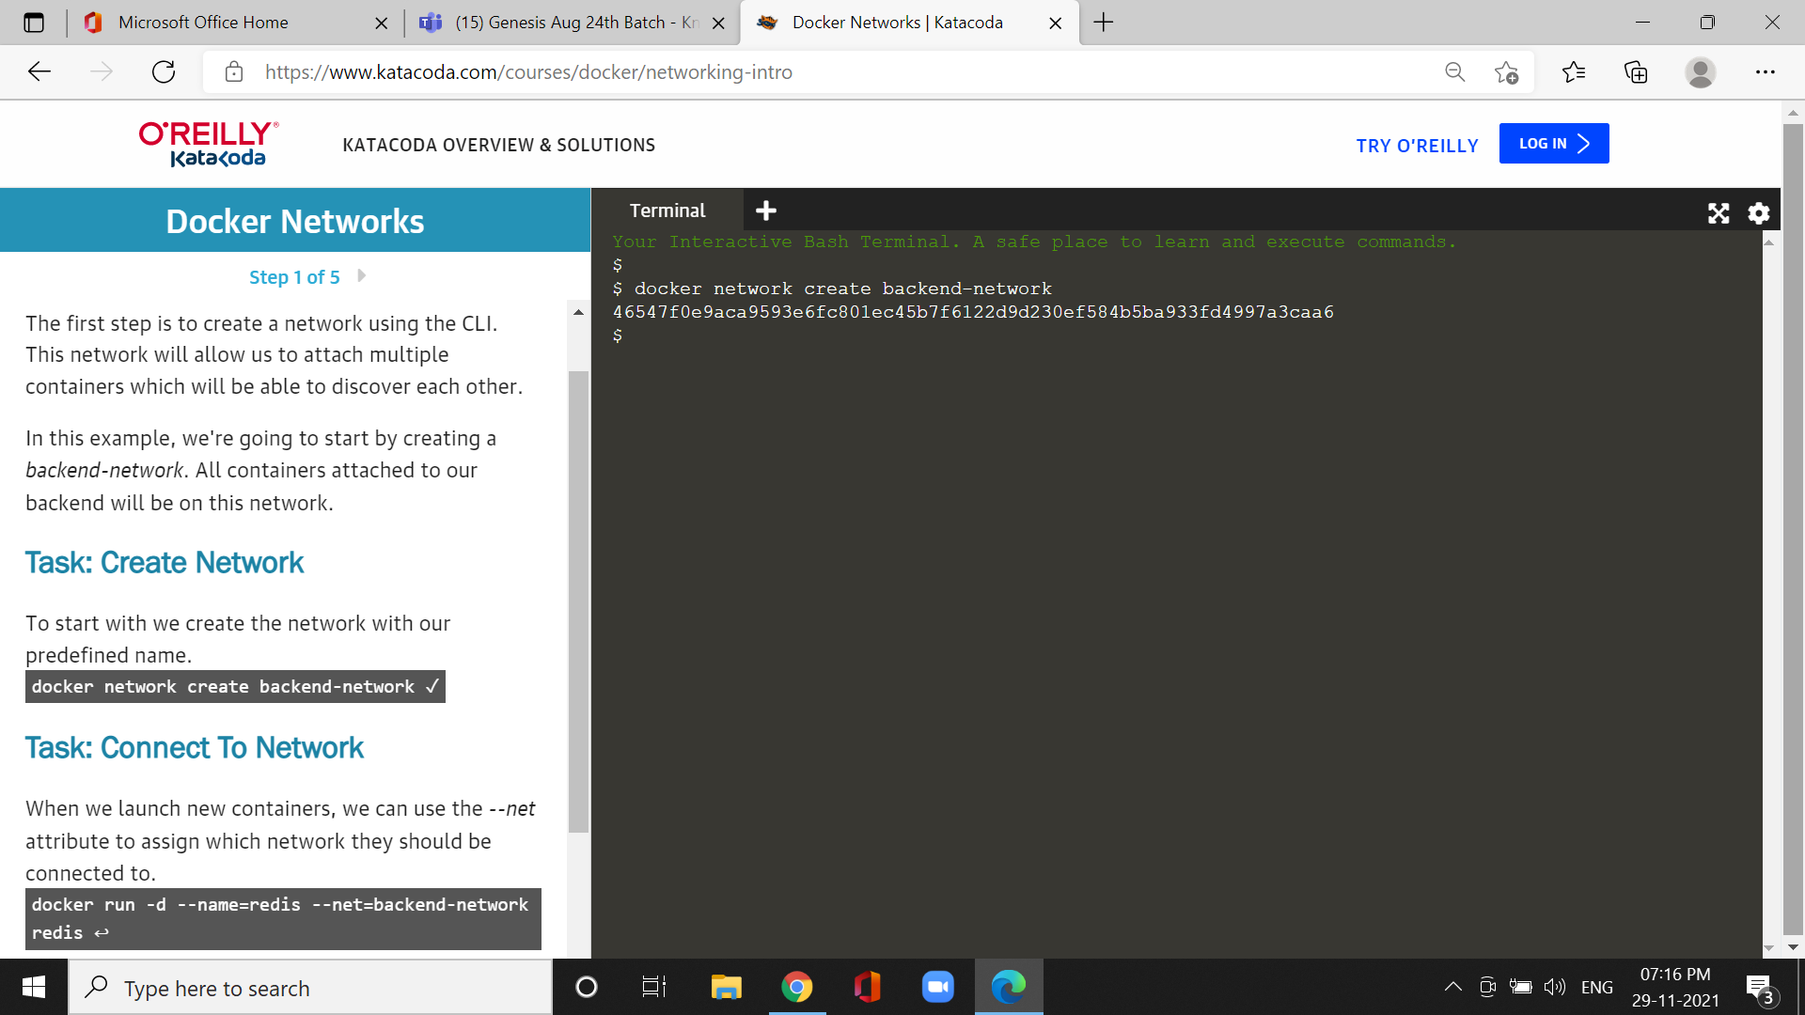

*Explore using the following two commands

Cmd:docker run --net=backend-network alpine env

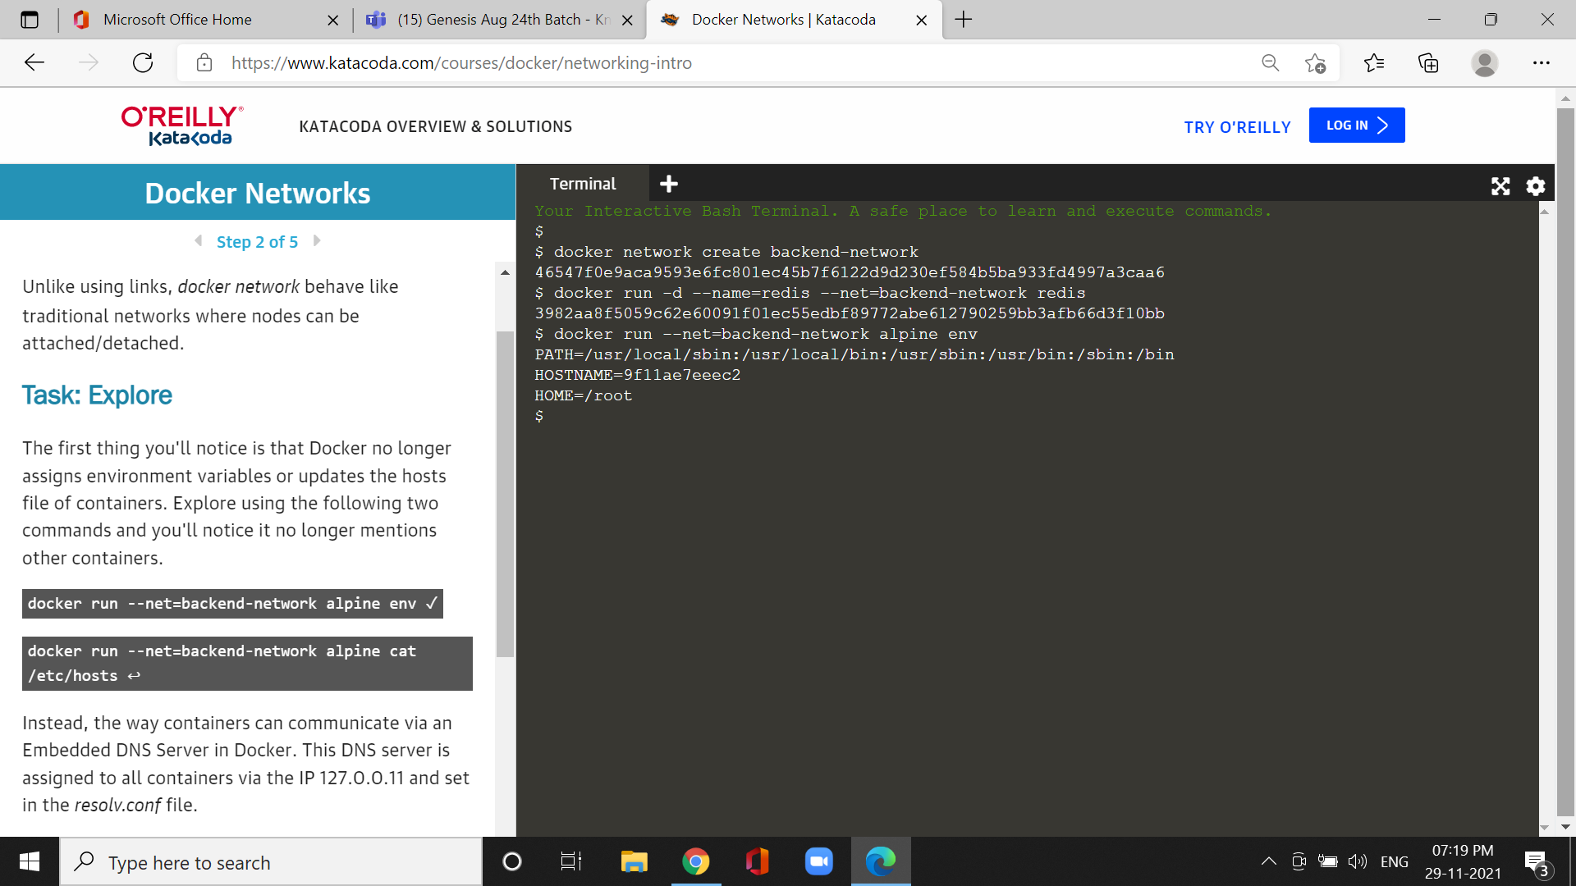

Cmd:docker run --net=backend-network alpine cat/etc/hosts

*This DNS server is assigned to all containers via the IP 127.0.0.11 and set in the *resolv.conf* file.

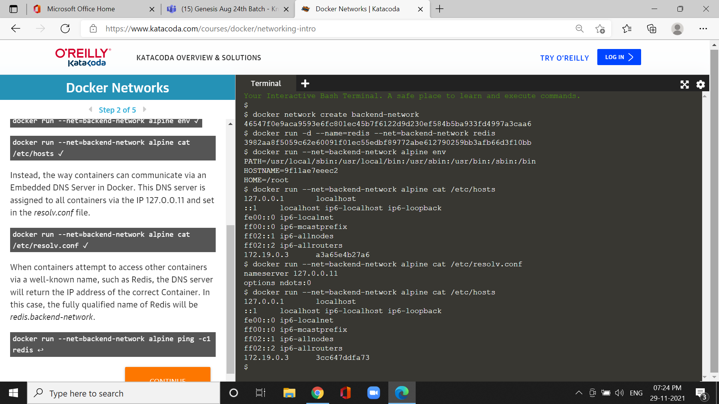

Cmd:docker network create frontend -network

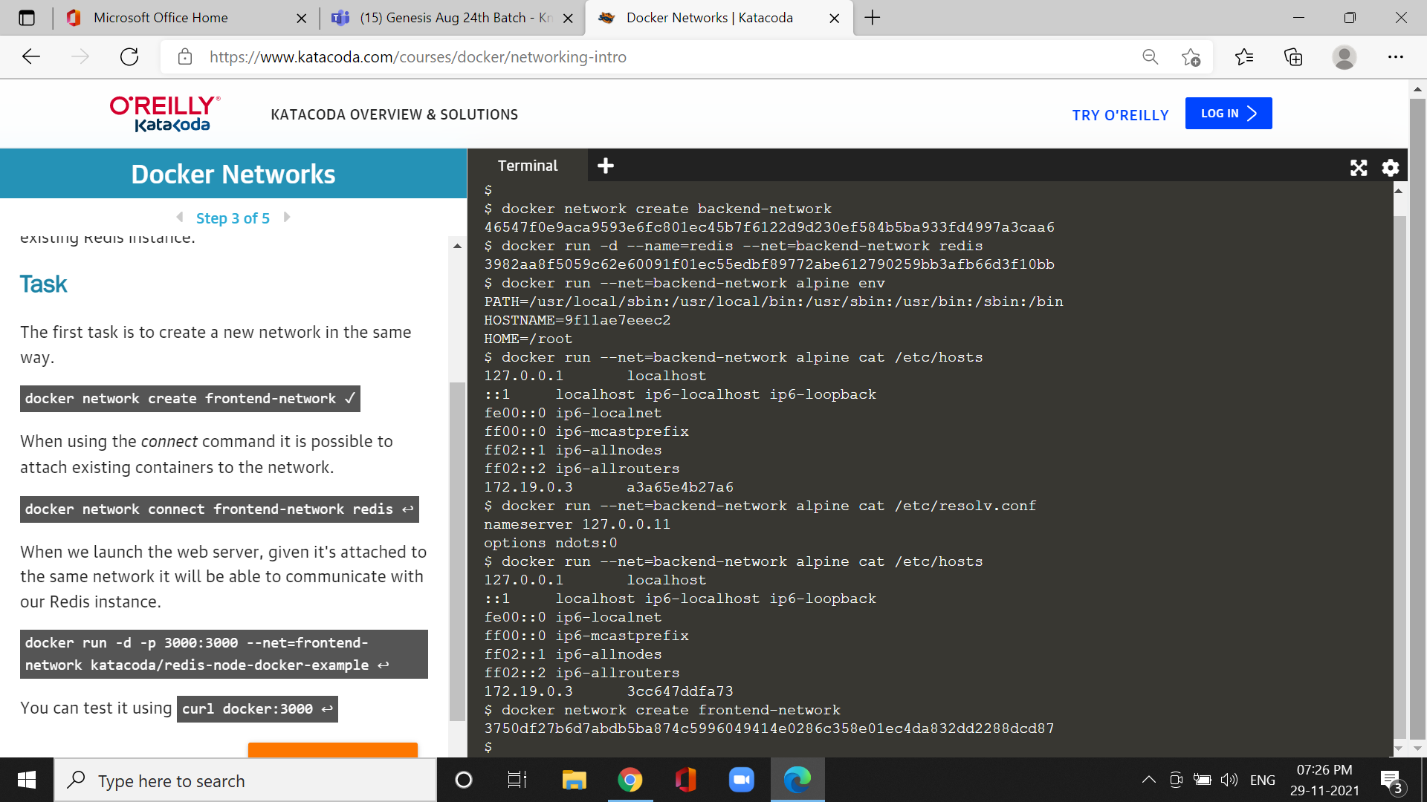

cmd:docker network create frontend -network2

docker network connect --alias db frontend -network2 redis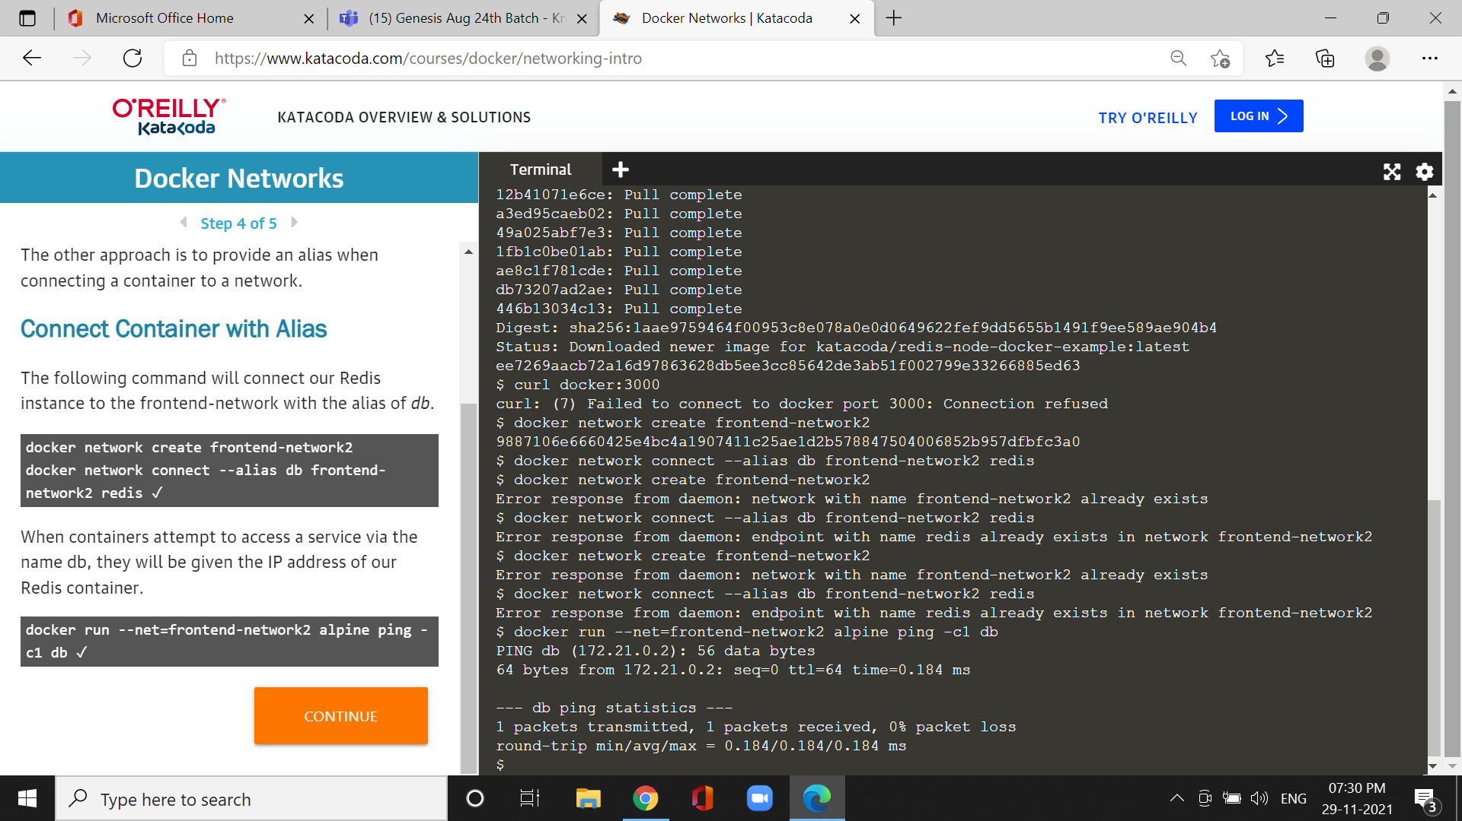

Cmd :docker network ls

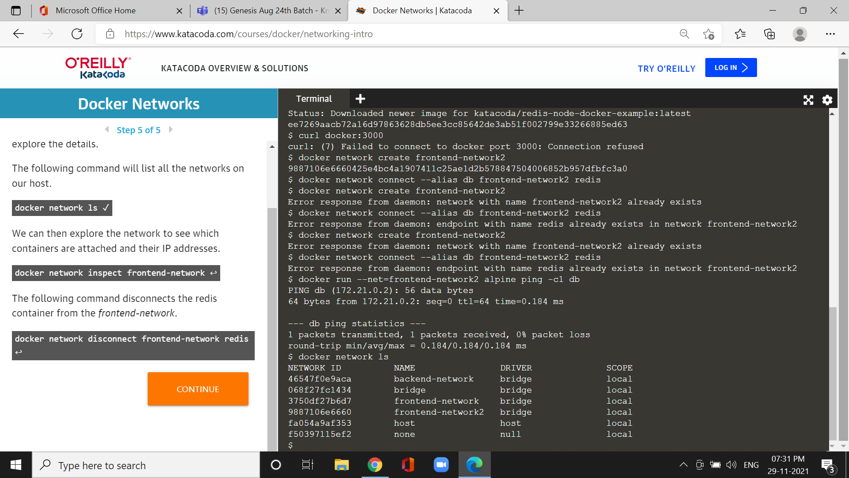

cmd:docker network inspect frontend -network 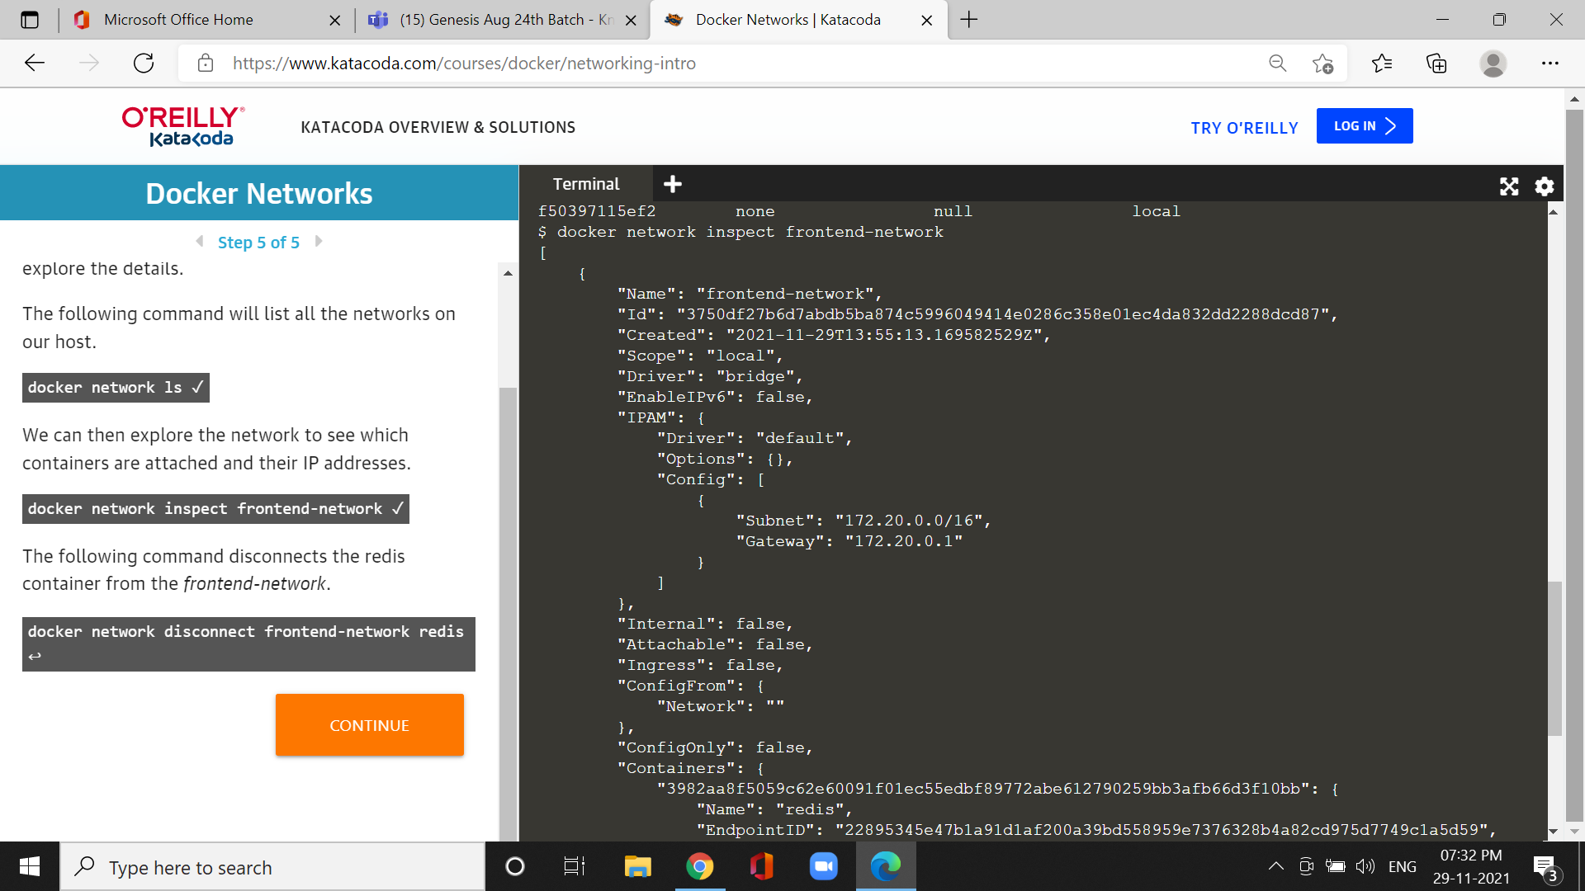

cmd:docker network disconnect frontend -network redis

