Name: Manorath Sunil Ital
Class:D20A
Roll No:25
Batch:B

Aim: To implement a Private Ethereum Blockchain using Geth.

Theory:

Ethereum is an open-source, decentralized blockchain platform that enables developers to build and deploy smart contracts and decentralized applications (DApps). Unlike public blockchains such as the Ethereum mainnet, a Private Ethereum Blockchain is restricted to specific participants, making it ideal for development, testing, and enterprise applications where confidentiality, control, and performance are essential.
Geth (Go-Ethereum) is one of the most widely used Ethereum clients, written in the Go programming language. It allows users to run an Ethereum node, mine Ether, and interact with the blockchain through JSON-RPC, command-line, or JavaScript consoles.
Setting up a Private Ethereum Network involves creating a customized blockchain environment isolated from the public Ethereum network. It enables developers to test smart contracts, consensus mechanisms, and network behavior without incurring gas costs or depending on public validators.

Steps Involved:
- Choosing a Network ID:
- Each private blockchain must have a unique network ID to differentiate it from public or other private networks.
- Choosing a Consensus Algorithm:
- Ethereum supports different consensus mechanisms such as Proof of Work (PoW) and Proof of Authority (PoA). In private networks, Clique (PoA) is often used for faster block confirmation.
- Creating a Genesis Block:
- The genesis block is the first block of the blockchain, defining network parameters such as difficulty, gas limit, initial account balances, and consensus settings.
- Initializing the Geth Database:
- The geth init command initializes the blockchain using the genesis.json file, preparing the data directory for node operation.
- Setting up Networking:
- Nodes communicate using enodes (Ethereum Node URLs) that contain IP addresses and public keys for peer discovery and connection.
- Running the Member Nodes:
- Each participant runs a Geth node that connects to the private network and participates in block validation and transaction processing.
- Running a Signer (in Clique):
- In the Clique consensus, designated signers validate and sign blocks. These accounts are pre-configured in the genesis file to ensure trusted block production.
Note: Download the genesis file and edit the account details, including the public keys of all participating peers in the network.

Step 1: Installing Geth on Ubuntu
sudo apt update
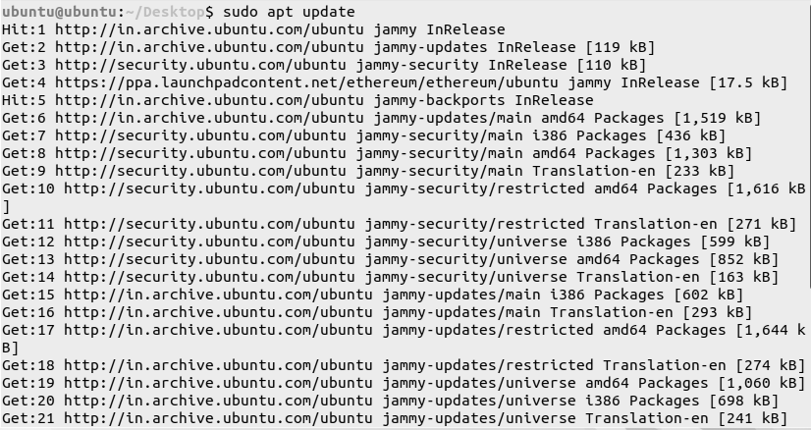
Sudo dpkg –configure -a
sudo apt install software-properties-common
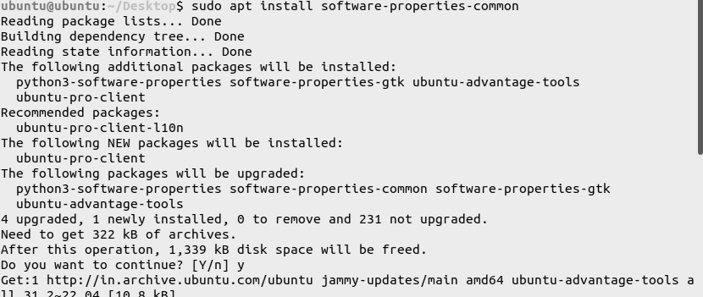

sudo add-apt-repository -y ppa:ethereum/ethereum
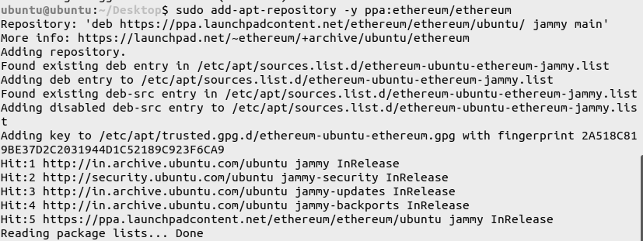
sudo apt update
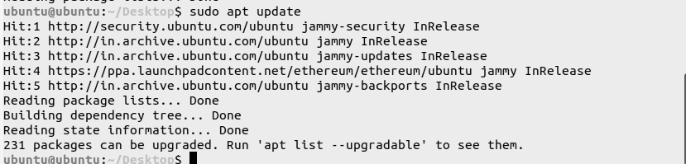
sudo apt install geth
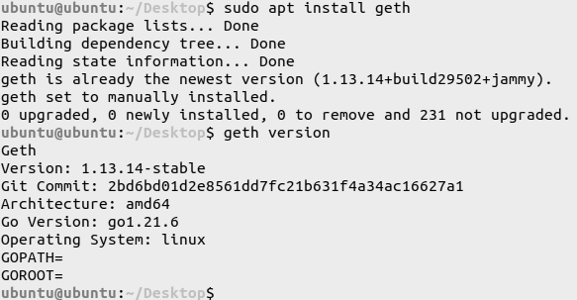

Step 2: Check the version of Geth on the Terminal
geth version

3. Step - 3: Create a Private Ethereum Network
1. Create a folder named, private_ethereum_setup
2. Create 2 subfolders named node1 and node2 in the folder private_ethereum_setup
3. Create 2 accounts in the folder corresponding to node1 and node2
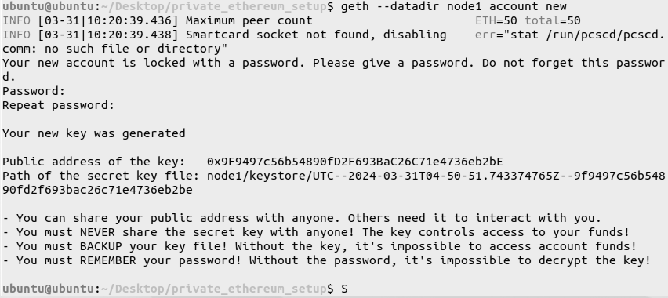
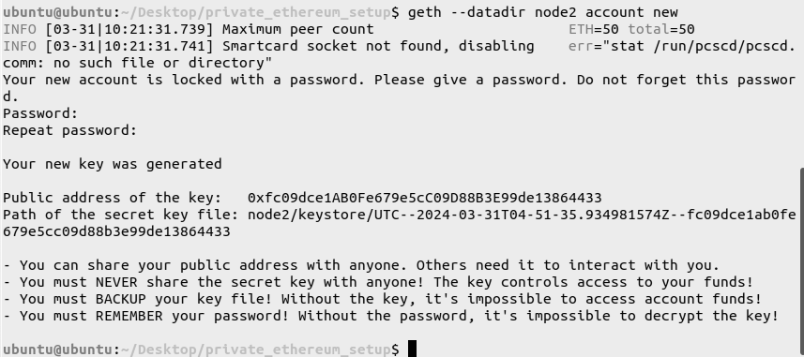
4. Create a genesis.json file in the folder, private_ethereum_setup
nano genesis.json
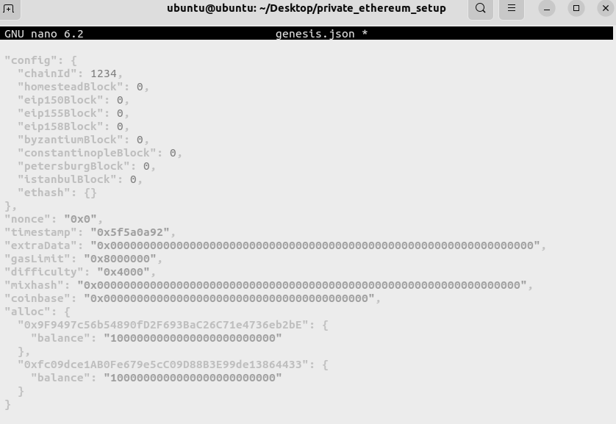

5. Initialize the nodes with the genesis file
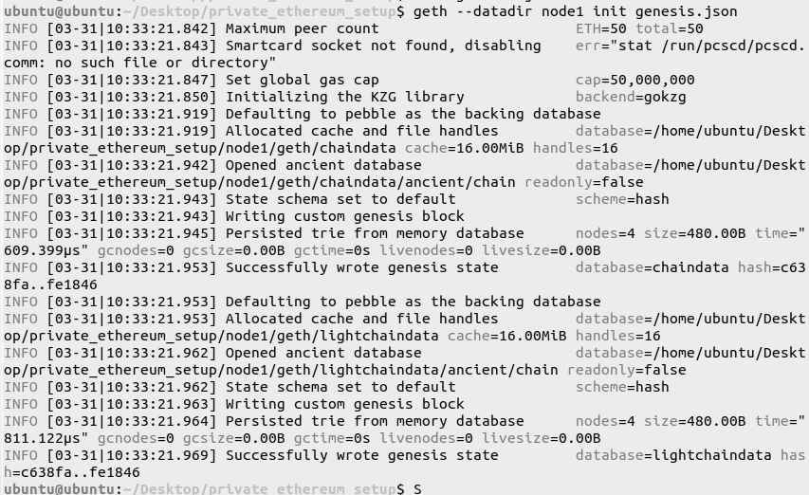
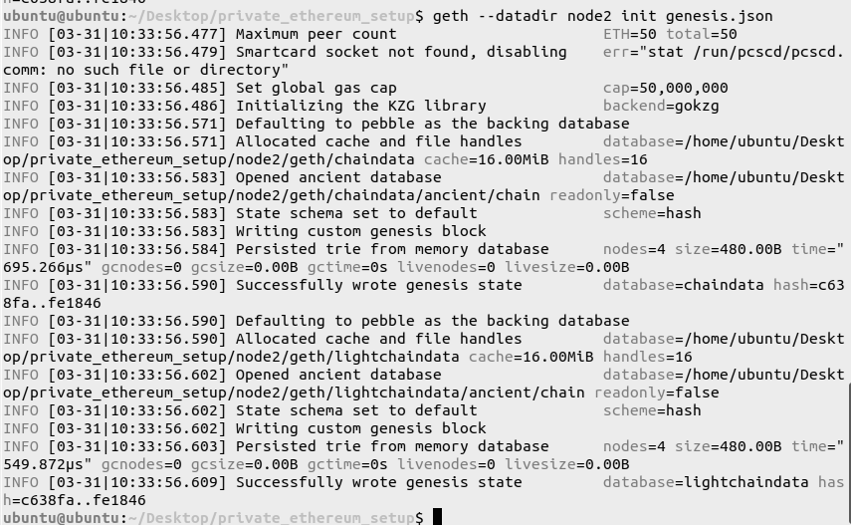

6. For configuring the boot node
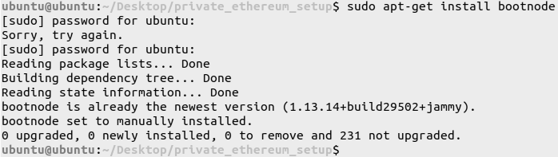
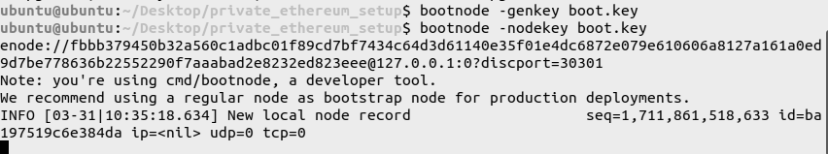

4. Step - 4: Establish a Peer-Peer Connection between the nodes along with the bootnode
1. On the first Terminal, Use boot.key to run the boot node
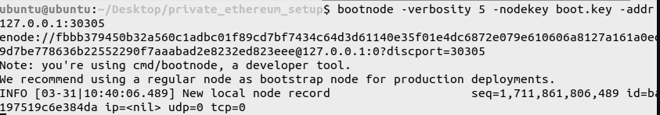

2. On the second Terminal, Run Node 1
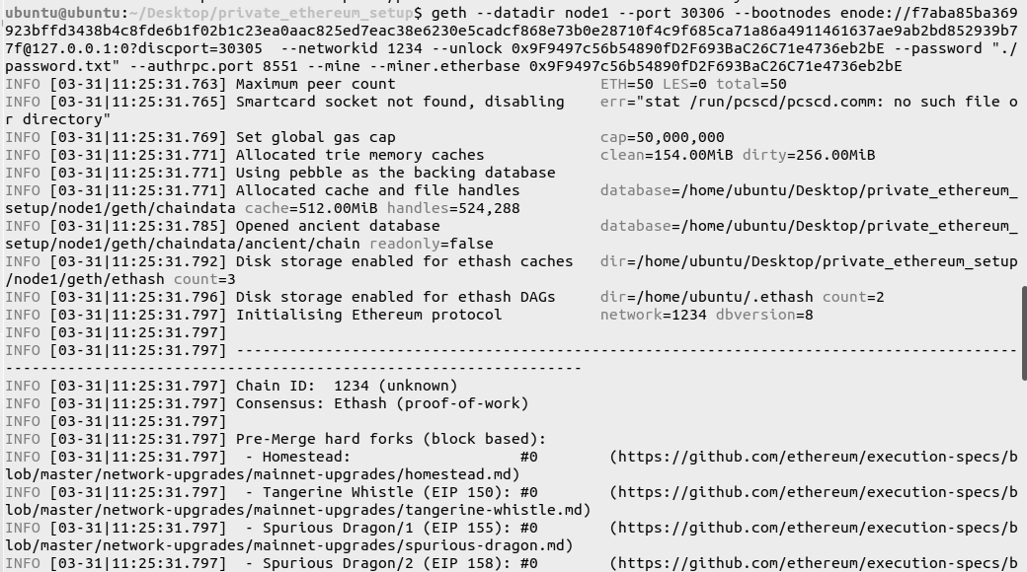
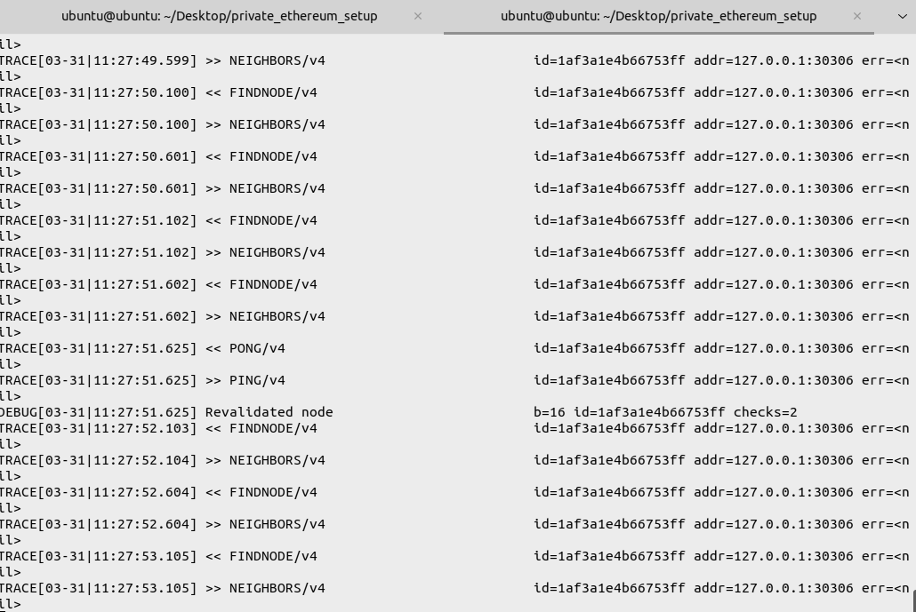

3. On the third Terminal, Run Node 2
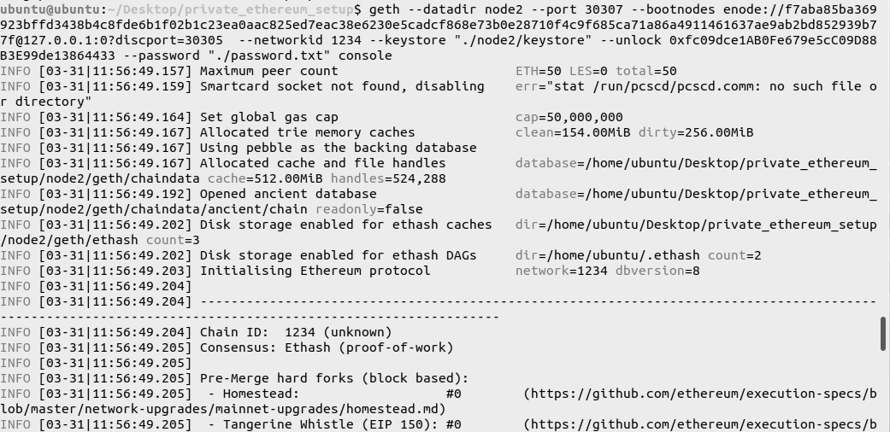


5. Step - 5 : Exploring the network by attaching JavaScript console to Node 1
1. Fetch network status
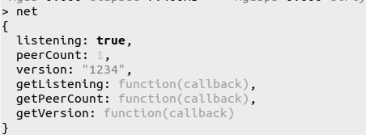
2. To fetch the number of blocks mined
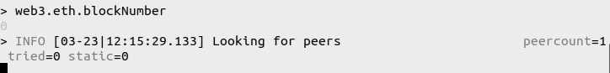
3. To check the balance of the accounts
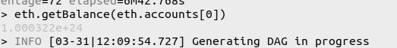

4. To fetch the details of the latest mined block

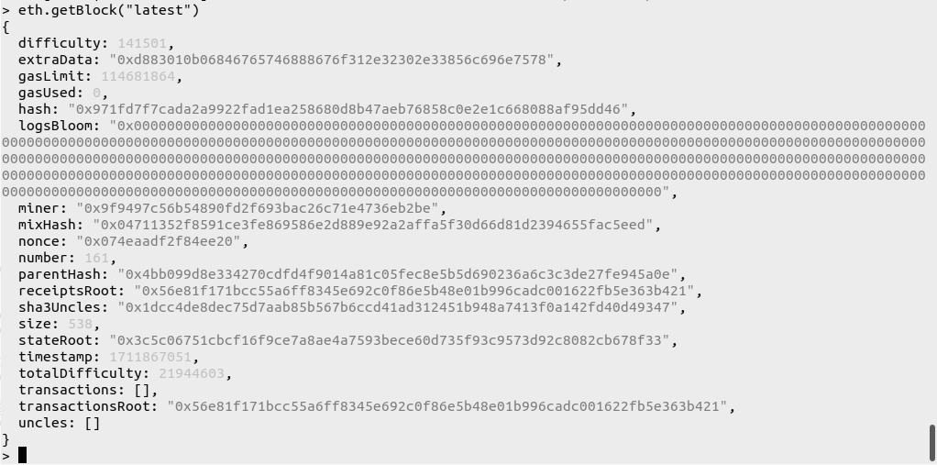

5. To fetch the details of a specific block
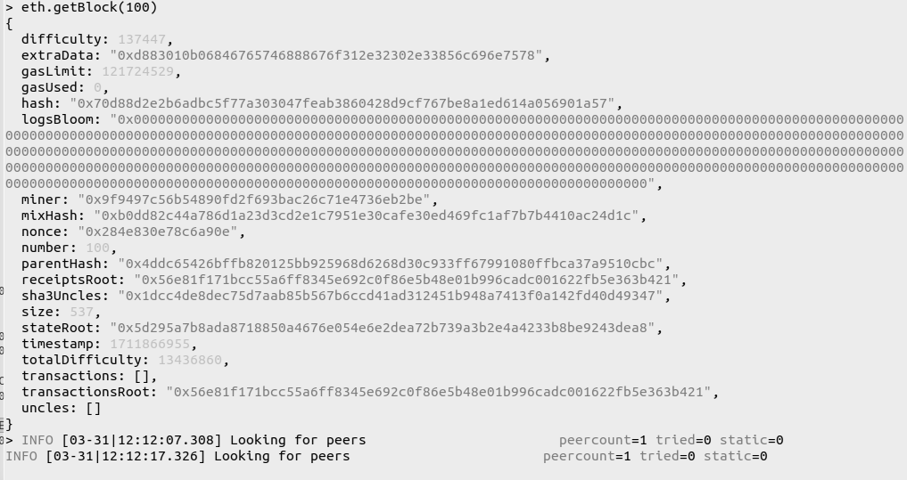
6. To check the account balance of the peer machine, provide their Public Key

7. Fetch the details of the peers in the network
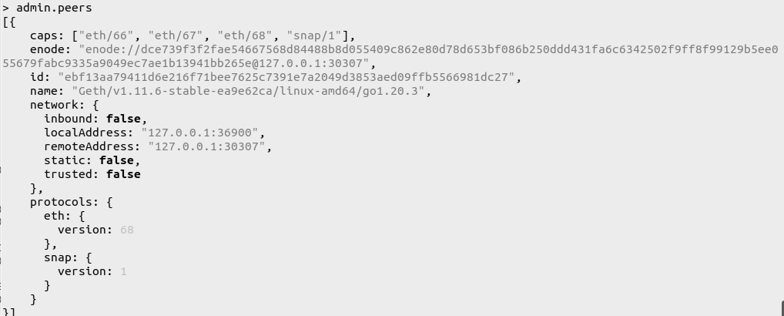
8. Perform Transactions between peers in the network
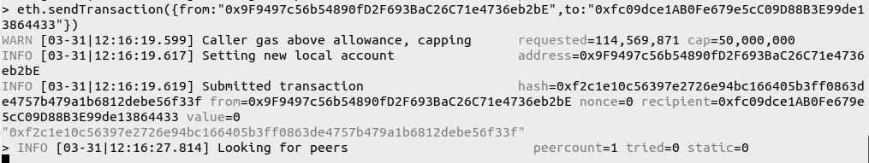
9. Check the balances of sender and receiver 2
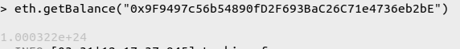
10. To check the details of the transaction on Node 1 Terminal
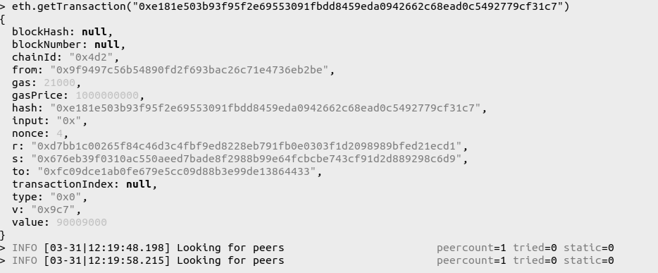

11. To check the contents in the Mempool - Transaction Pool
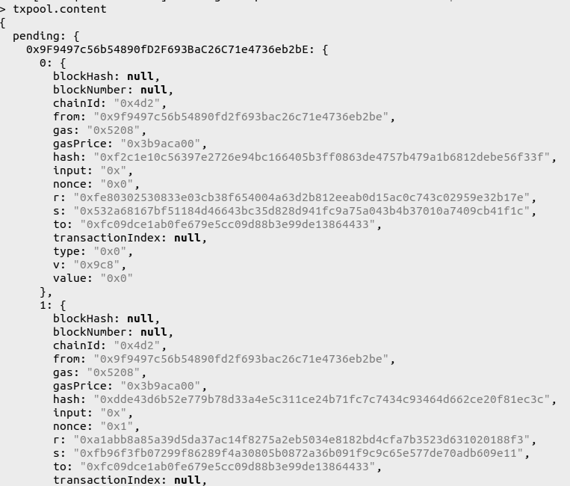
12. To check the status of the Mempool - Transaction Pool
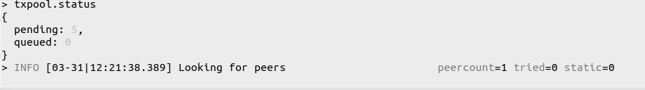

Conclusion:-
The experiment successfully implemented a Private Ethereum Blockchain using Geth and Clique (PoA) consensus. By initializing a custom genesis block, an isolated network was established for zero-cost testing. This setup proved that authorized signers can effectively validate transactions without the computational overhead of public networks, providing a secure environment for enterprise DApp development.

