Name: Manorath Sunil Ital
Class:D20A
Roll No:25
Batch:B

Aim: Explore the Cryptocurrency Landscape

Theory:
This experiment explores the cryptocurrency landscape by combining real-world market data analysis with blockchain technology research. The focus asset for this analysis is Chainlink (LINK), and data was collected from three reputable sources as per the lab requirement:
- Financial Data (APIs) – Services like CoinGecko and CoinMarketCap provided structured data on market capitalization, circulating supply, and historical 24-hour trading volumes, which are essential for calculating liquidity and asset dominance.
- News & Social Platforms – Platforms such as CryptoPanic (news aggregator) and LunarCrush (social sentiment) were used to track how public perception and breaking news correlate with price volatility.
- Regulatory & Institutional Portals – Websites like The Block Pro or official government portals (e.g., SEC, EU MiCA updates) provided data on legal frameworks and institutional entry.

Cryptocurrency Landscape
- Definition – Cryptocurrencies are decentralized digital assets built on blockchain networks, enabling secure, transparent, and immutable transactions without central authority.
- Market Diversity – Thousands of cryptocurrencies exist, each serving unique roles:
  - Store of Value (SoV) – Bitcoin (BTC), characterized by digital scarcity.
  - Utility Tokens – Chainlink (LINK), Ether (ETH), used to pay for network services.
  - Stablecoins – USDT, USDC, pegged to fiat (USD) to provide price stability.
  - Governance Tokens – UNI, AAVE, granting holders voting rights over protocols.
- Volatility – Prices are highly sensitive to market sentiment, technological developments, and "macro" regulatory drivers.
- Data Analysis Importance – Integrating financial, social, and regulatory data is essential for a holistic understanding of asset performance and market health.

Data Collection Process
The program used the CoinGecko API to automate historical data fetching for Chainlink. The retrieved data was processed with Pandas to compute:
- Daily Returns – Percentage change between consecutive days to measure volatility.
- Moving Averages (MA7, MA30) – Short-term and long-term trend indicators.
- Cumulative Returns – Growth factor over time.
- Rolling Volatility – Short-term risk measurement based on daily return fluctuations.

Visualization & Dashboard
Using Matplotlib, a six-panel dashboard was created to display:
- Price Trend – Daily price movement over the selected period.
- Price vs Volume – Correlation between trading activity and price changes.
- Daily Returns Distribution – Statistical spread of daily gains/losses.
- Moving Averages – Technical analysis trend lines for price movement.
- Cumulative Returns – Overall growth performance.
- Rolling Volatility – Market risk trends over time.

Technological Analysis
Beyond market data, the study covered advancements in blockchain technology, including:
- Consensus Mechanisms – The shift toward Proof of Stake (PoS) for sustainability and Proof of History (PoH) for faster processing.
- Scalability Solutions – Implementation of Layer-2 Rollups (Optimistic and ZK-Rollups) and Sharding to solve the "Blockchain Trilemma."
- Interoperability Protocols – Tools like Chainlink CCIP and Polkadot’s Relay Chain enabling seamless cross-chain data and value exchange.
- Privacy Features – Zero-Knowledge Proofs (ZKP) allowing verifiable transactions without revealing sensitive underlying data.
- Technical Roadmaps – Ethereum’s focus on "The Surge" (100k+ TPS) and Solana’s "Firedancer" client for institutional-grade reliability.

Market Trends & Adoption
- Merchant Acceptance – Significant surge in interest with major processors like Stripe and Shopify integrating stablecoins for global settlement.
- Wallet Growth – Increasing downloads of non-custodial wallets (MetaMask, Phantom), indicating a shift toward direct on-chain interaction.
- Network Activity – Analysis of transaction volumes vs. active addresses to distinguish between "whale" activity and organic retail growth.
- Integration with Traditional Finance – The rise of Real-World Asset (RWA) Tokenization, bringing traditional assets like bonds and real estate on-chain.
- Regulatory Developments – The implementation of frameworks like the EU’s MiCA and U.S. FIT21 Act, providing a clear licensing roadmap for the industry

Utilizing Api for analysis and visualization :
Code:
import requests
import matplotlib.pyplot as plt
import pandas as pd
import datetime

# ---------- CONFIGURATION ----------
# Replace 'YOUR_API_KEY' with the key you got from CryptoCompare
API_KEY = 'YOUR_API_KEY'
SYMBOL = 'LINK'
COMPARISON_SYMBOL = 'USD'
LIMIT = 180 # Number of days

# ---------- Fetch Data Function ----------
def fetch_cryptocompare_data(symbol, comparison_symbol, limit, api_key):
url = f"https://min-api.cryptocompare.com/data/v2/histoday"
params = {
"fsym": symbol,
"tsym": comparison_symbol,
"limit": limit,
"api_key": api_key
}

response = requests.get(url, params=params)
data = response.json()

if data['Response'] == 'Success':
# CryptoCompare returns OHLCV data in 'Data' -> 'Data'
return data['Data']['Data']
else:
print(f"Error fetching data: {data.get('Message')}")
return None

# ---------- Dashboard Function ----------
def cryptocompare_dashboard(symbol, comparison_symbol, limit, api_key):
raw_data = fetch_cryptocompare_data(symbol, comparison_symbol, limit, api_key)
if not raw_data: return

# Create DataFrame
df = pd.DataFrame(raw_data)

# Convert 'time' (unix timestamp) to datetime
df['timestamp'] = pd.to_datetime(df['time'], unit='s')
df.set_index('timestamp', inplace=True)

# Standardize column names to match your previous logic
# 'close' is used as the daily price
df['price'] = df['close']
df['volume'] = df['volumeto'] # Total volume in USD (volumeto)

# Calculate metrics
df['returns'] = df['price'].pct_change()
df['MA7'] = df['price'].rolling(window=7).mean()
df['MA30'] = df['price'].rolling(window=30).mean()
df['cumulative'] = (1 + df['returns']).cumprod()
df['volatility'] = df['returns'].rolling(window=7).std() * 100

# ---------- Plotting ----------
fig, axes = plt.subplots(3, 2, figsize=(16, 12))
fig.suptitle(f'CryptoCompare: {symbol} Analysis Dashboard', fontsize=16, fontweight='bold')

# 1. Price Trend
axes[0, 0].plot(df.index, df['price'], color='tab:blue', linewidth=2)
axes[0, 0].set_title('Historical Price Trend (USD)')
axes[0, 0].grid(True, linestyle='--', alpha=0.7)

# 2. Price vs Volume
axes[0, 1].plot(df.index, df['price'], color='tab:blue', label='Price')
axes[0, 1].bar(df.index, df['volume'], color='gray', alpha=0.3, label='Volume (USD)')
axes[0, 1].set_title('Price vs Trading Volume')
axes[0, 1].legend()

# 3. Daily Returns Distribution
axes[1, 0].hist(df['returns'].dropna(), bins=40, color='tab:purple', edgecolor='white')
axes[1, 0].set_title('Daily Returns Distribution')

# 4. Moving Averages
axes[1, 1].plot(df.index, df['price'], color='lightgray', alpha=0.5, label='Price')
axes[1, 1].plot(df.index, df['MA7'], color='tab:orange', label='7-Day MA')
axes[1, 1].plot(df.index, df['MA30'], color='tab:red', label='30-Day MA')
axes[1, 1].set_title('Trend Analysis (Moving Averages)')
axes[1, 1].legend()

# 5. Cumulative Returns
axes[2, 0].fill_between(df.index, df['cumulative'], color='tab:green', alpha=0.2)
axes[2, 0].plot(df.index, df['cumulative'], color='tab:green')
axes[2, 0].set_title('Cumulative Growth')

# 6. Volatility
axes[2, 1].plot(df.index, df['volatility'], color='tab:red')
axes[2, 1].set_title('7-Day Rolling Volatility (%)')

plt.tight_layout(rect=[0, 0.03, 1, 0.95])
plt.show()

# ---------- Run ----------
cryptocompare_dashboard(SYMBOL, COMPARISON_SYMBOL, LIMIT, API_KEY)

Output:-
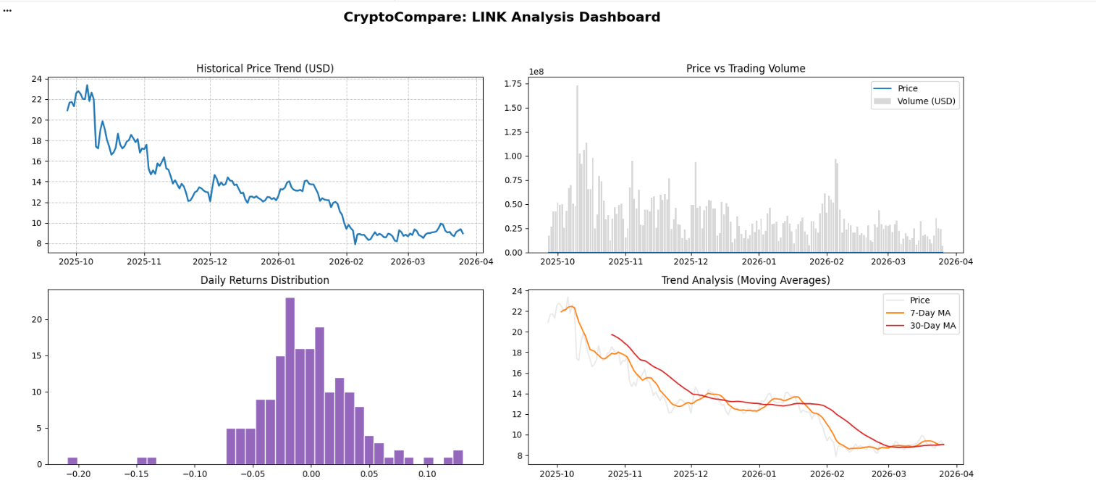
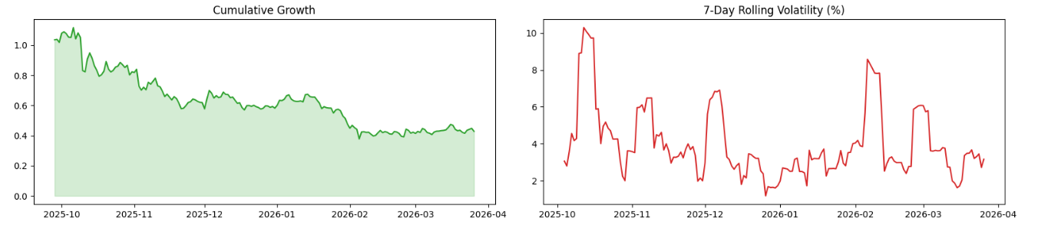

Coingecko Website
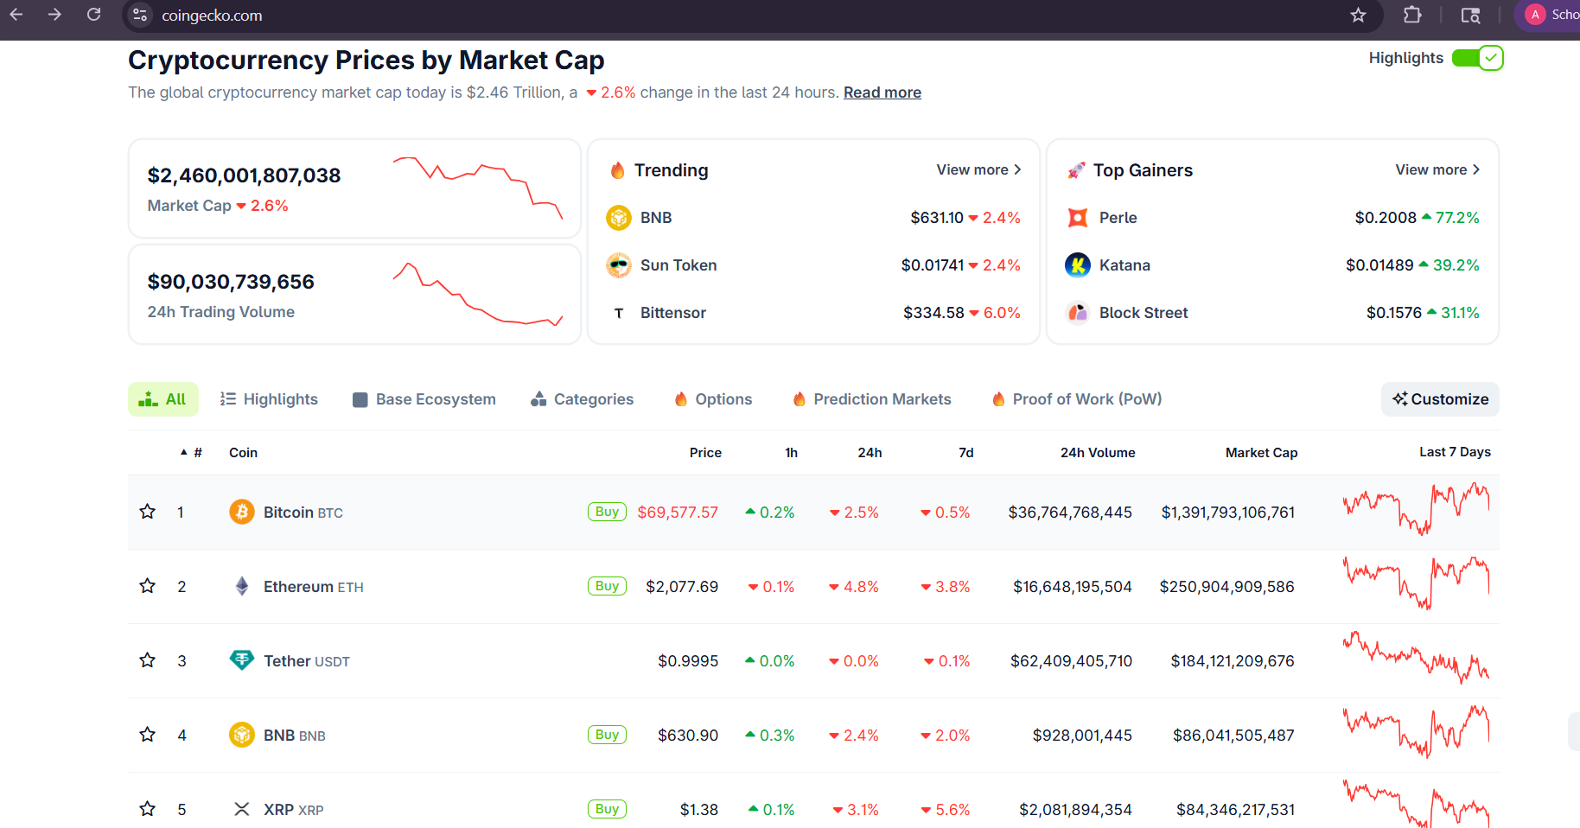
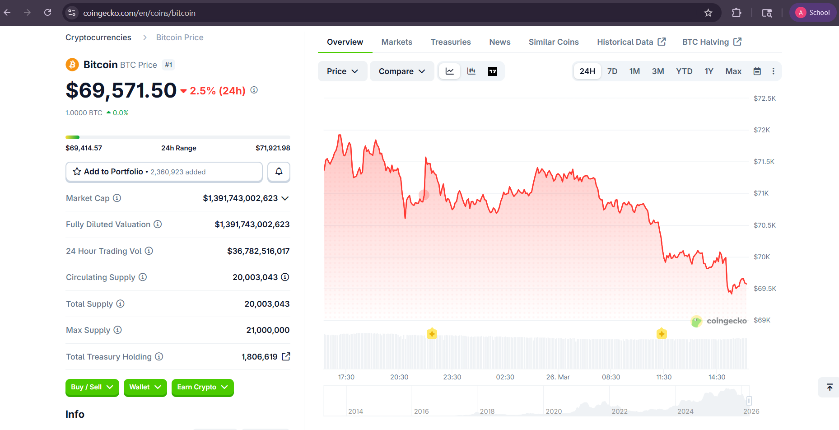

CoinMarketCap website
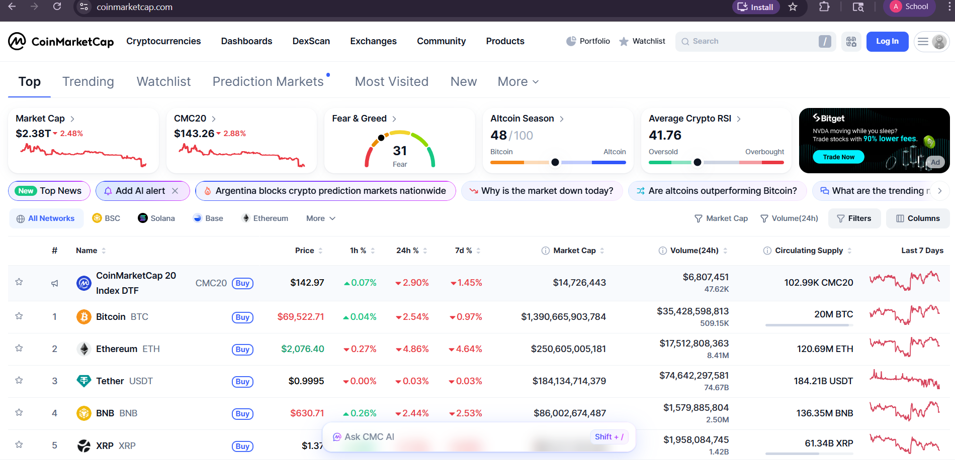

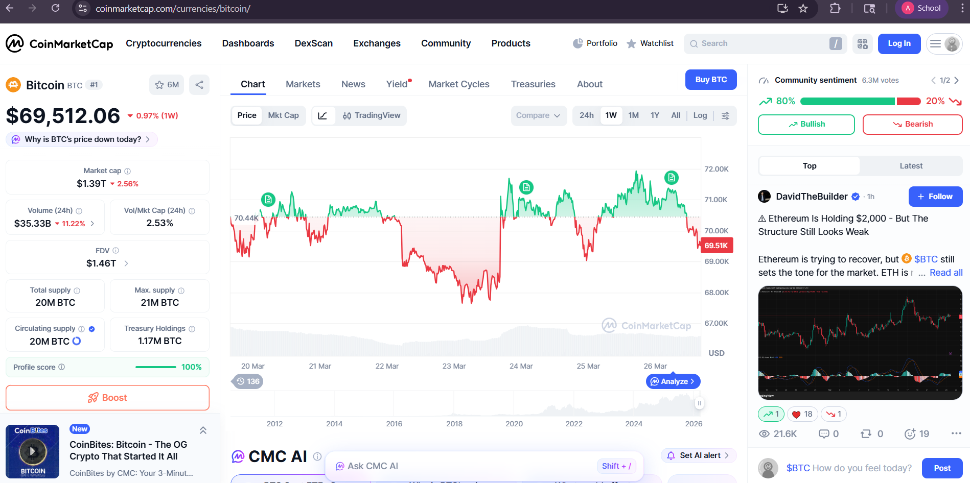

Conclusion:-

By combining automated market data processing, visual trend analysis, blockchain technology evaluation, and adoption metrics, this experiment presents a holistic view of the cryptocurrency ecosystem. It demonstrates how blockchain’s technical foundations connect with real-world market behavior, providing insights into both current trends and future advancements in the digital asset industry.

