Name: Manorath Sunil Ital
Class:D20A
Roll No:25
Batch: B

Aim: Implement the embedding wallet (Metamask) and transaction using Solidity

Theory:

1. What is MetaMask?
MetaMask is a software cryptocurrency wallet used to interact with the Ethereum blockchain and other EVM-compatible networks (like Polygon, BSC, and Avalanche).
It is primarily known as a "bridge" because it allows users to access Decentralized Applications (dApps) directly through a regular web browser (like Chrome or Firefox) without having to run a full Ethereum node.

Core Theoretical Functions:
- Identity Management: It generates and manages your private keys locally on your device (not on a central server), giving you full ownership of your digital identity.
- Web3 Injection: It injects a JavaScript library called web3.js or ethers.js into the websites you visit. This allows the website to "talk" to the blockchain.
- Transaction Signing: When you want to perform an action on a dApp (like buying an NFT), MetaMask "pops up" to let you review and digitally sign the transaction before it is sent to the network.
- Network Switching: It allows users to switch between the "Mainnet" (real money) and various "Testnets" (fake money).

2. What is a Testnet?
A Testnet (Test Network) is an alternative blockchain that acts as an exact replica of the main blockchain (Mainnet) but is used specifically for experimenting, testing, and debugging.
In blockchain theory, deploying code directly to the Mainnet is risky and expensive because every transaction costs real money (Gas fees) and bugs can lead to permanent financial loss. Testnets solve this by providing a "sandbox" environment.

Key Characteristics:
- No Real Value: The tokens used on a testnet (e.g., Sepolia ETH) have zero real-world market value. You can get them for free from "Faucets."
- Identical Environment: It uses the same rules, consensus mechanisms (like Proof of Stake), and smart contract logic as the Mainnet.
- Safe Playground: If a developer’s smart contract has a bug that crashes the system or "leaks" funds, no real money is lost.
- Public Access: Most testnets are public, meaning anyone can join and test their applications before the official launch.

Implementation:

Step 1: Install Metamask
Follow this link to install the Metamask Google Chrome Extension, and also create the wallet

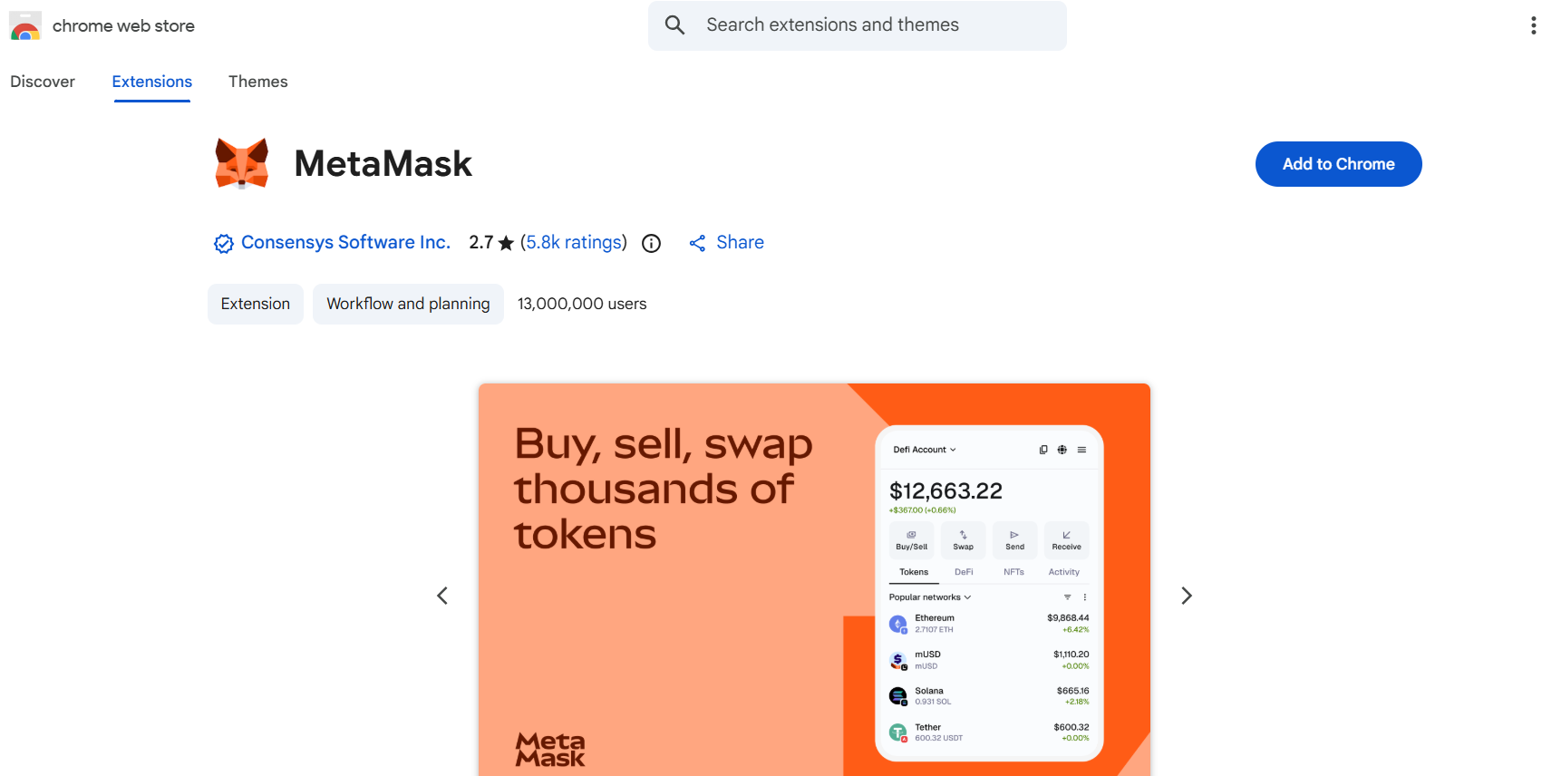 | 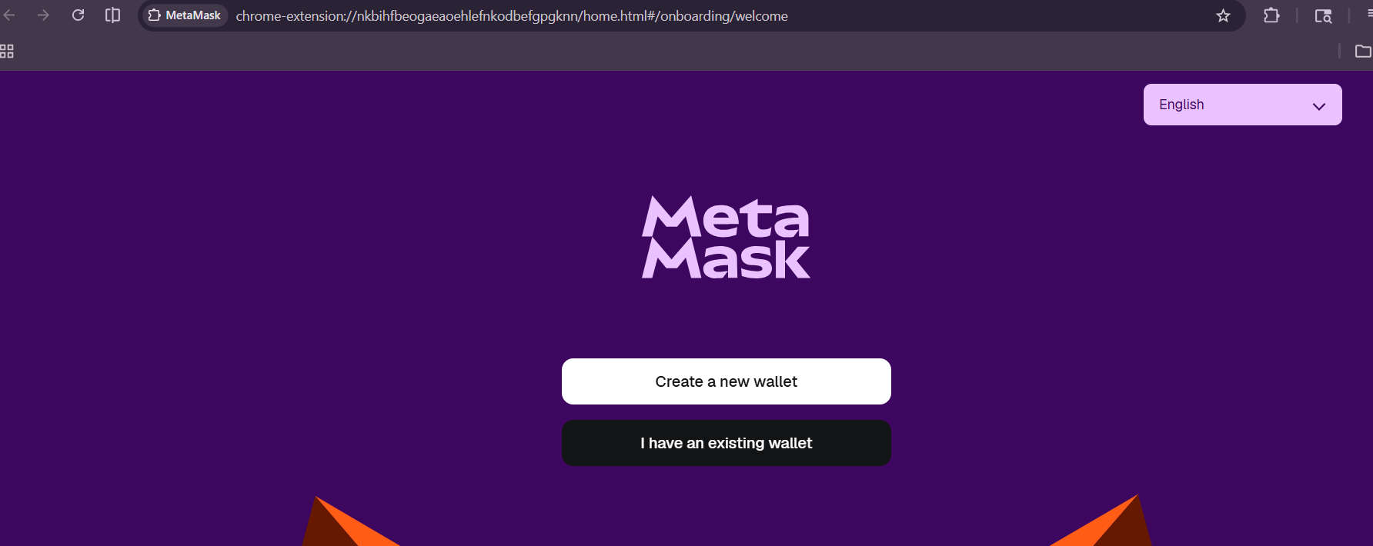

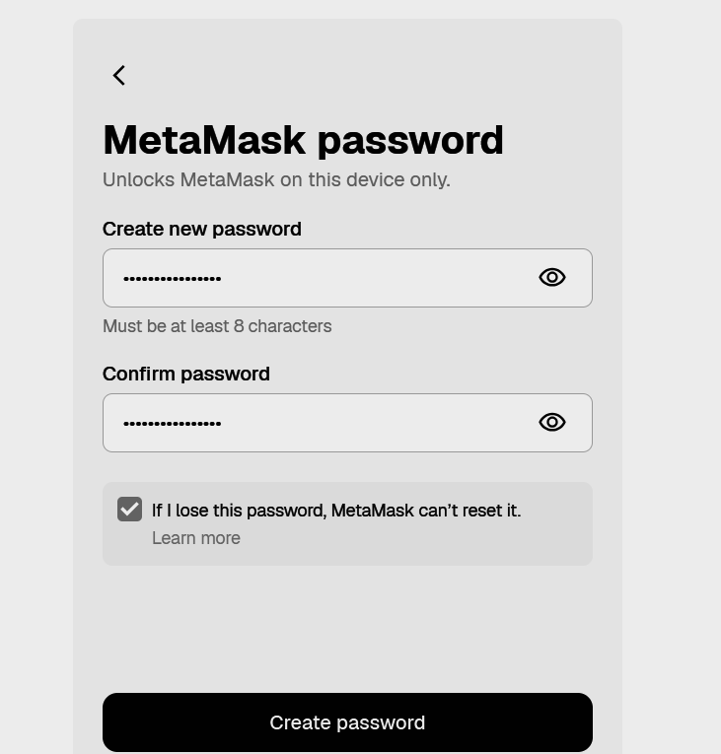 | 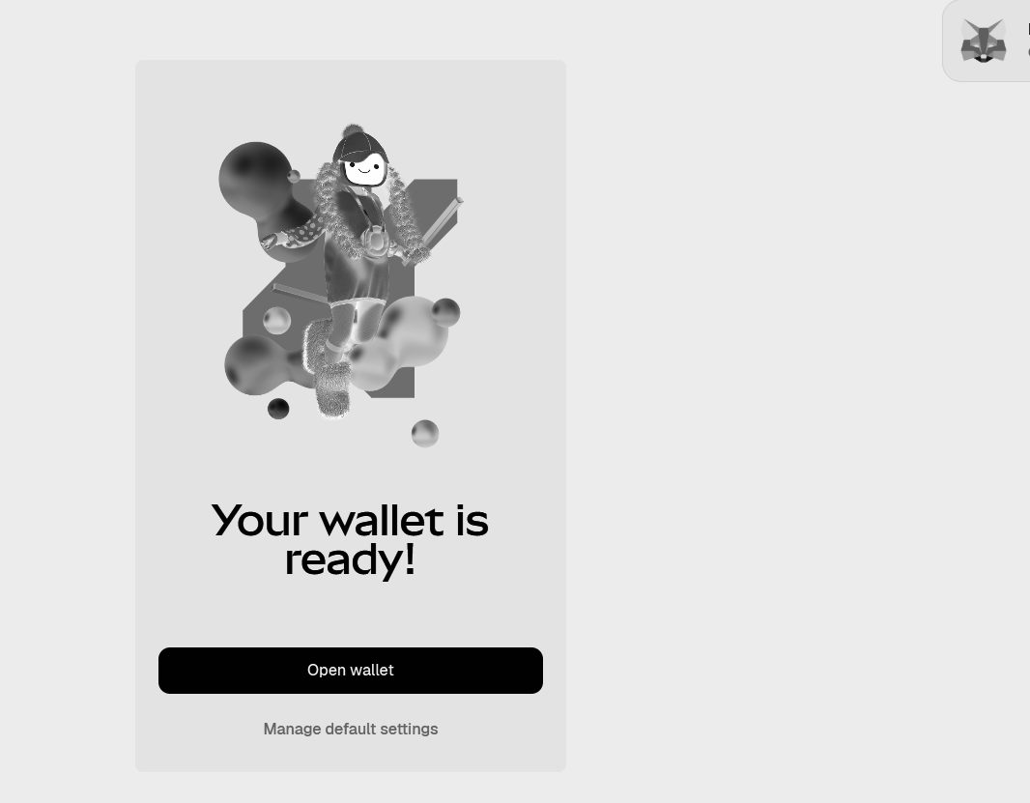
Note :
- While creation of the Metamask Wallet, you will be asked to select 12 pass phrase
- Keep the passphrase safley
- It becomes handy to recover your password

Step 2: Enable Test Networks
- By default, MetaMask shows the "Ethereum Mainnet" (real money).
- Click the network dropdown (top left) and toggle Show test networks.
- Select Sepolia.

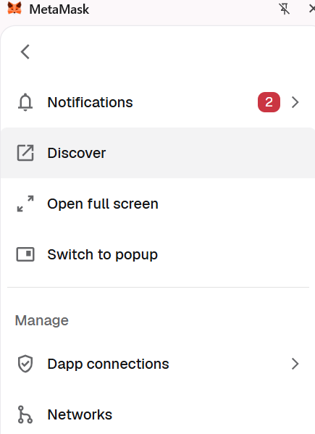 | 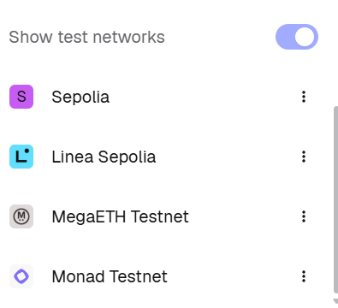

Step 3: Configuring the Sepolia Test network
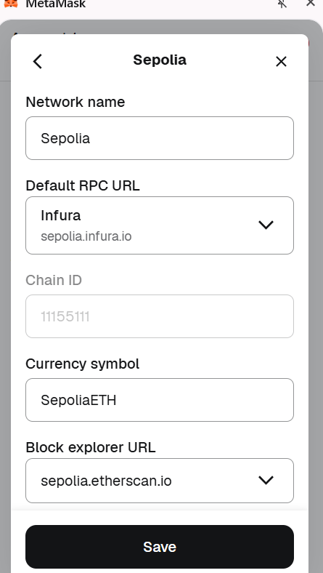

Step 4: Funding the Wallet
Every action on the blockchain requires a fee called Gas. On the Sepolia network, we use "Test ETH" which is free.
- Copy Your Address: Click your account name at the top of MetaMask (it starts with 0x...) to copy your public address.
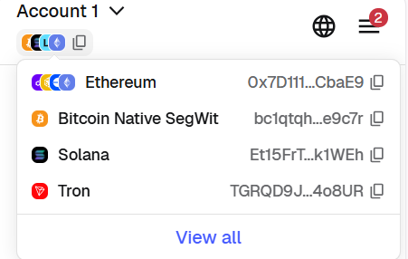

2. Visit a Faucet: Use the Google Cloud Sepolia Faucet to procure SepoliaETH
by pasting the wallet address as shown

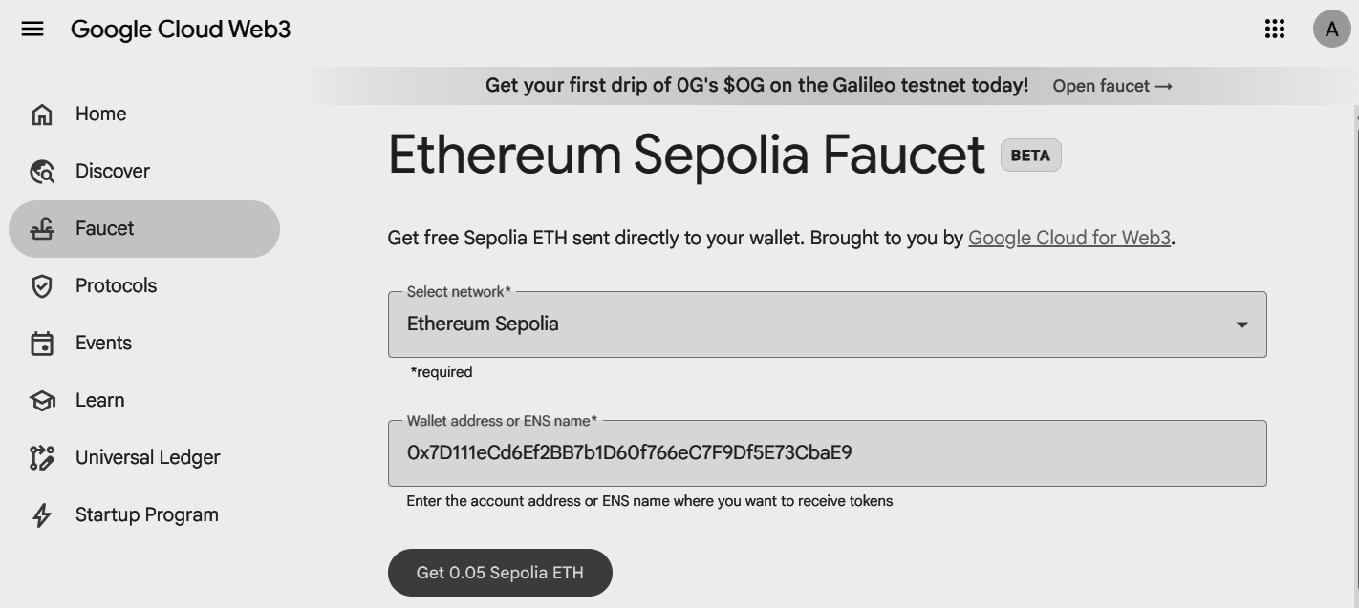
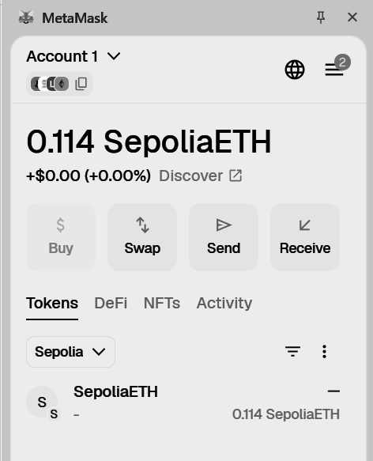 | 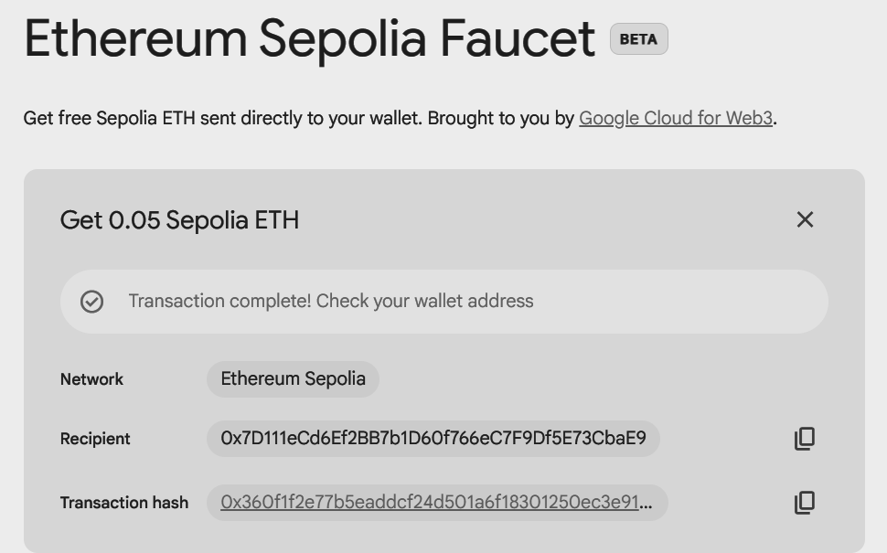

3.Verify: Your MetaMask balance should update within 30 seconds.
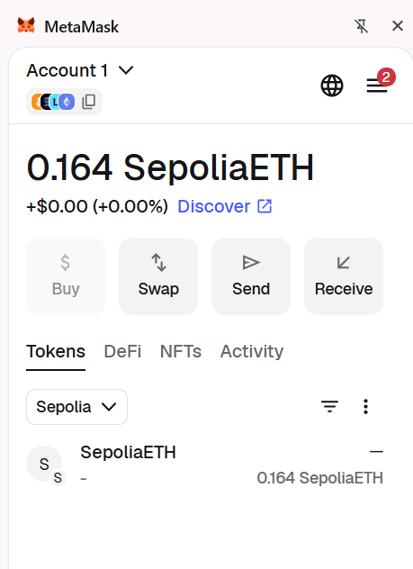

Step 5: Connect MetaMask to Remix IDE
- Open Remix IDE.
- Go to the Deploy & Run Transactions tab.
- In the Environment dropdown, select Injected Provider - MetaMask.
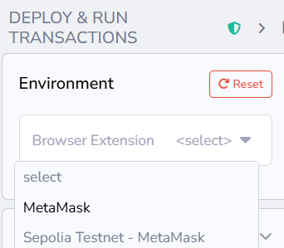

A MetaMask popup will appear; click Connect to link your 0x7D11... account to Remix.
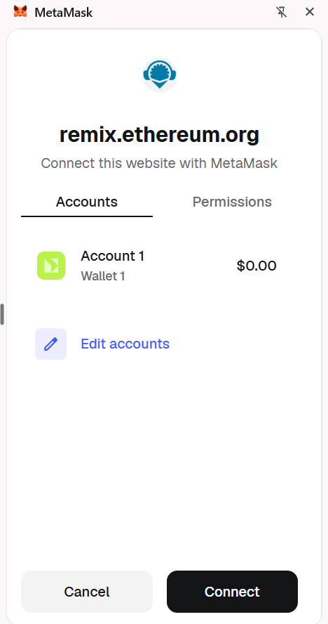

Step 6: Create and Compile the Contract
- Open your LandRegistry.sol file.
- Go to the Solidity Compiler tab.
- Select Compiler 0.8.0 (or the version in your code).
- Click Compile LandRegistry.sol.

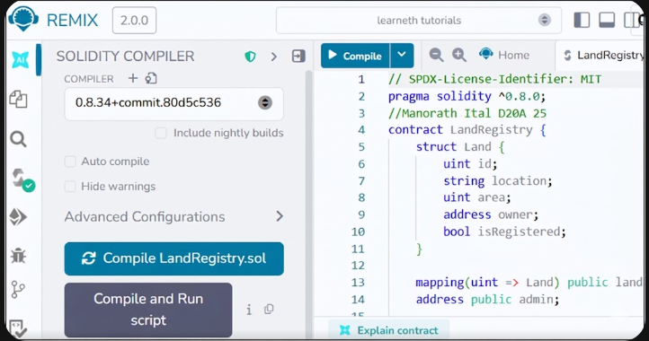

Step 7: Deploy and Verify the transaction
- Go back to the Deploy & Run Transactions tab.
- Ensure Injected Provider is still selected (you should see "Custom (11155111) network").
- Click the orange Deploy button.
- MetaMask Action: A popup will show the gas fee. Click Confirm.
- Wait: Look at the bottom terminal. Wait for the green checkmark that says "transacted."

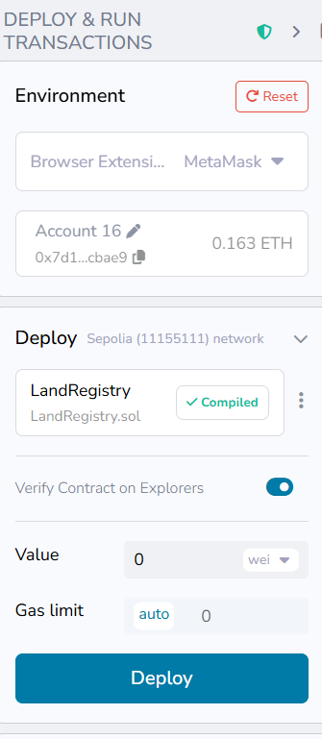 | 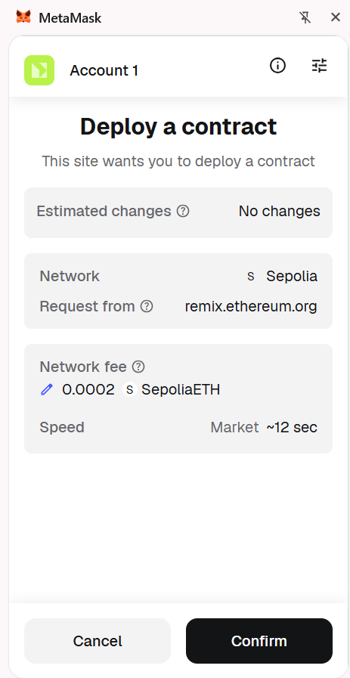  After clicking on deploy button
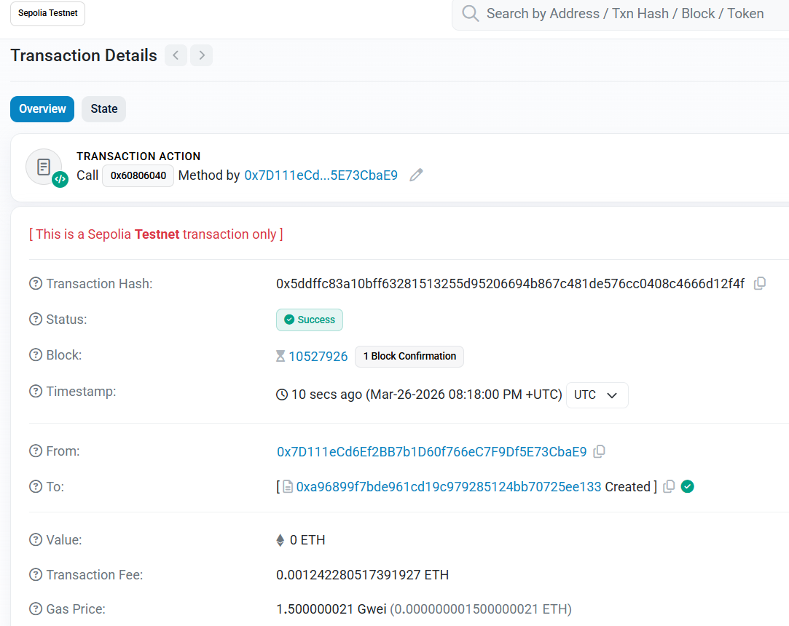
Transaction is verified on Sepolia Etherscan

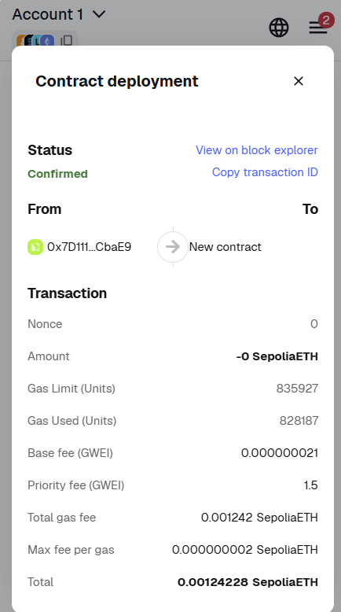

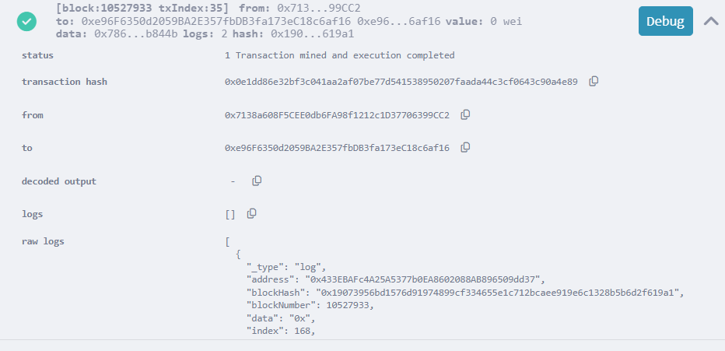

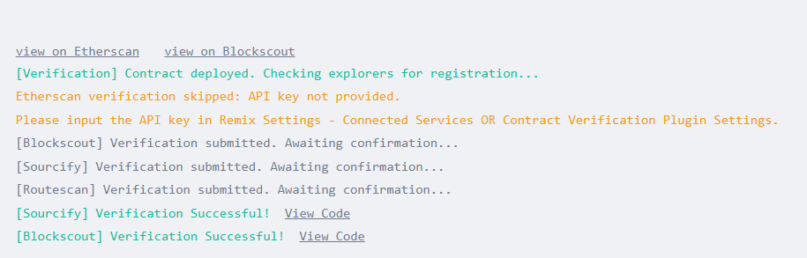

Step 8: Interact with the Contract
- In Remix, under "Deployed Contracts," expand LandRegistry.
- Run registerLand with ID 1, Location "Mumbai", and your address.
- MetaMask Action: You must click Confirm in MetaMask again because this action changes the blockchain state.

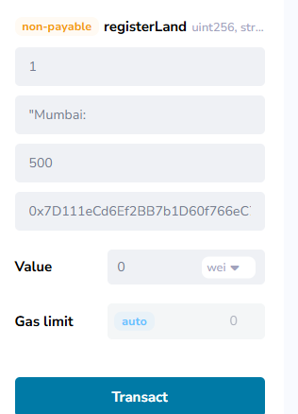
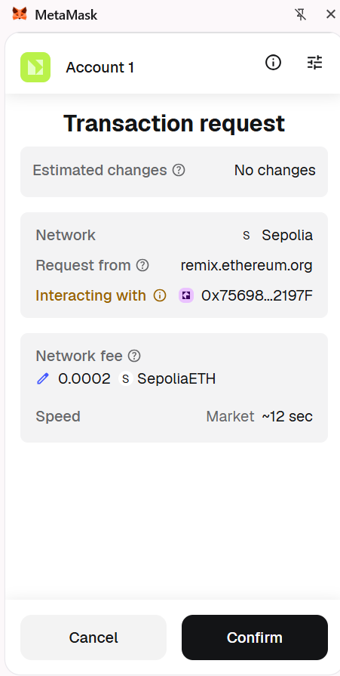

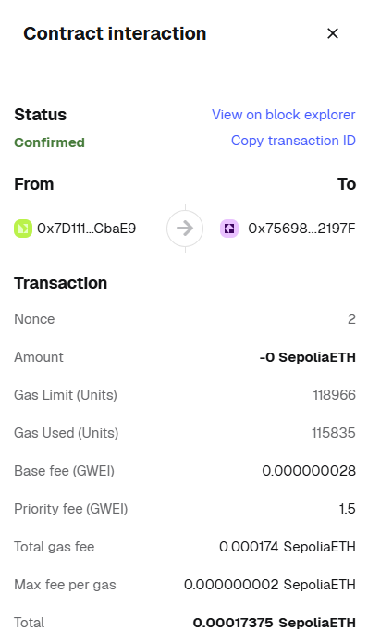

Conclusion:-

This experiment helped in understanding how smart contracts automate processes and execute securely on the Ethereum blockchain. Using Solidity and Remix IDE, the development, deployment, and interaction with smart contracts become simple and efficient, forming the foundation for decentralized applications.

