Blockchain Experiment 3

Aim : Create a Cryptocurrency using Python and perform mining in the Blockchain created.

Theory :

- Blockchain Overview

A blockchain is a distributed, decentralized digital ledger used to record transactions securely across multiple computers (nodes). Instead of relying on a central authority, every node in the network maintains its own copy of the blockchain.
Each block in the blockchain contains:

  - A list of transactions

  - A timestamp

  - The hash of the previous block

  - Its own cryptographic hash

The blocks are linked together using hashes, forming a chain. Any attempt to modify data in a block changes its hash, which breaks the chain and makes tampering easily detectable. This property ensures data integrity, transparency, and immutability.

Mining

Mining is the process by which new blocks are added to the blockchain. It involves:

  - Collecting pending transactions

  - Creating a block header

  - Solving a computationally difficult problem known as Proof-of-Work (PoW)

In Proof-of-Work, miners repeatedly change a nonce value to generate a hash that satisfies the network’s difficulty requirement (such as leading zeroes). Once a valid hash is found, the block is added to the blockchain and shared with other nodes. As an incentive, miners receive a cryptocurrency reward for their computational effort.

Multi-Node Blockchain Network

In this experiment, a multi-node blockchain network is simulated using three nodes running on different ports (5001, 5002, and 5003).
Each node:

  - Operates independently

  - Maintains its own copy of the blockchain

  - Communicates with peer nodes to share newly mined blocks

This setup demonstrates how blockchain achieves decentralization and synchronization without a central server.

Consensus Mechanism

To ensure consistency across all nodes, the Longest Chain Rule is used as the consensus mechanism.
When different versions of the blockchain exist, the node accepts the longest valid chain as the correct one. This rule ensures that all nodes eventually agree on a single transaction history, even if temporary differences arise.

Transactions and Mining Reward

Transactions in the cryptocurrency system include:

  - Sender address

  - Receiver address

  - Transaction amount

When a block is mined, all pending transactions are added to the block. Additionally, a special transaction is created to reward the miner with newly generated cryptocurrency. This reward mechanism motivates miners to maintain and secure the network.

Chain Replacement

The chain replacement process ensures network consistency. When the /replace_chain endpoint is triggered:
  - A node requests blockchain data from its peers

  - Validates the received chains

  - Replaces its own chain if a longer and valid chain is found

This mechanism helps resolve conflicts and keeps all nodes synchronized.

Code :

import datetime import hashlib import json
from flask import Flask,jsonify,request

import requests

from uuid import uuid4

from urllib.parse import urlparse class Blockchain:
def init (self):

self.chain=[] self.transactions=[]
self.create_block(proof=1,previous_hash='0') self.nodes=set()
def create_block(self,proof,previous_hash):

block={'index':len(self.chain)+1,'timestamp':str(datetime.datetime.now()),'proof':proof,'previous
_hash':previous_has h,'transactions':self.transactions} self.transactions=[]
self.chain.append(block)

return block

def get_previous_block(self): return self.chain[-1]
def proof_of_work(self,previous_proof): new_proof=1

check_proof=False while not check_proof:

hash_operation=hashlib.sha256(str(new_proof**2-previous_proof**2).encod e()).hexdigest() if hash_operation[:4]=='0000':
check_proof=True else:
new_proof+=1 return new_proof
def hash(self,block): encoded_block=json.dumps(block,sort_keys=True).encode() return hashlib.sha256(encoded_block).hexdigest()
def is_chain_valid(self,chain): previous_block=chain[0] block_index=1
while block_index<len(chain): block=chain[block_index]
if block['previous_hash']!=self.hash(previous_block): return False
previous_proof=previous_block['proof'] proof=block['proof']
hash_operation=hashlib.sha256(str(proof**2-previous_proof**2).encode ()).hexdigest() if hash_operation[:4]!='0000':
return False

previous_block=block
=

block_index+=1 return True
def add_transaction(self,sender,receiver,amount): self.transactions.append({'sender':sender,'receiver':receiver,'amo unt':amount}) previous_block=self.get_previous_block()
return previous_block['index']+1 def add_node(self,address):
parsed_url=urlparse(address) self.nodes.add(parsed_url.netloc)
def replace_chain(self): network=self.nodes longest_chain=None max_length=len(self.chain) for node in network:
response=requests.get(f'http://{node}/get_chain') if response.status_code==200:
length=response.json()['length'] chain=response.json()['chain']
if length>max_length and self.is_chain_valid(chain): max_length=length

longest_chain=chain if longest_chain:
self.chain=longest_chain return True

return False app=Flask( name )
node_address=str(uuid4()).replace('-','') blockchain=Blockchain() @app.route('/mine_block',methods=['GET']) def mine_block():
previous_block=blockchain.get_previous_block() previous_proof=previous_block['proof'] proof=blockchain.proof_of_work(previous_proof) previous_hash=blockchain.hash(previous_block) blockchain.add_transaction(sender=node_address,receiver='Richard',amount=1) block=blockchain.create_block(proof,previous_hash)
response={'message':'Congratulations, you just mined a block!','index':block['index'],'timestamp':block['timestamp'],'proof':block['proof'],'previous_hash'
:block['previous_ha sh'],'transactions':block['transactions']} return jsonify(response),200
@app.route('/add_transaction',methods=['POST'])

def add_transaction():

json_data=request.get_json() transaction_keys=['sender','receiver','amount']
if not all(key in json_data for key in transaction_keys):

return 'Some elements of the transaction are missing',400 index=blockchain.add_transaction(json_data['sender'],json_data['receiver'],json
_data['amount']) response={'message':f'This transaction will be added to Block

{index}'}

return jsonify(response),201
=

@app.route('/connect_node',methods=['POST']) def connect_node():
json_data=request.get_json() nodes=json_data.get('nodes') if nodes is None:
return "No node",400 for node in nodes:
blockchain.add_node(node) response={'message':'All the nodes are now
connected.','total_nodes':list(blockchain.nodes)} return jsonify(response),201

@app.route('/replace_chain',methods=['GET']) def replace_chain():
is_chain_replaced=blockchain.replace_chain()

if is_chain_replaced:

response={'message':'The chain was replaced by the longest one.','new_chain':blockchain.chain} else:
response={'message':'The chain is already the largest one.','actual_chain':blockchain.chain} return jsonify(response),200
app.run(host='0.0.0.0',port=5000)

Output :
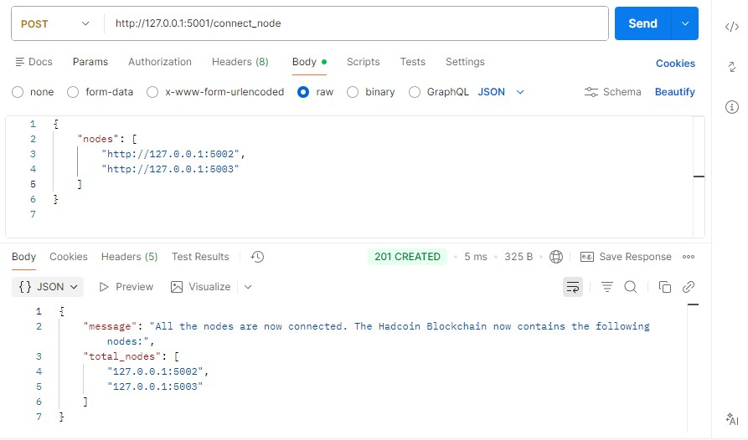

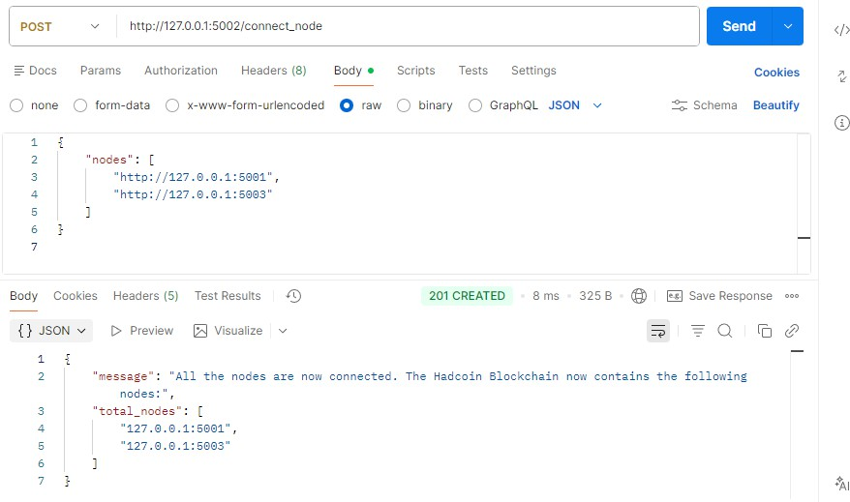
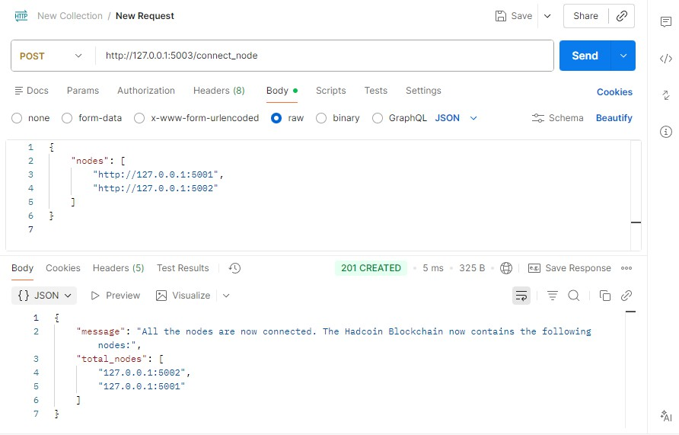

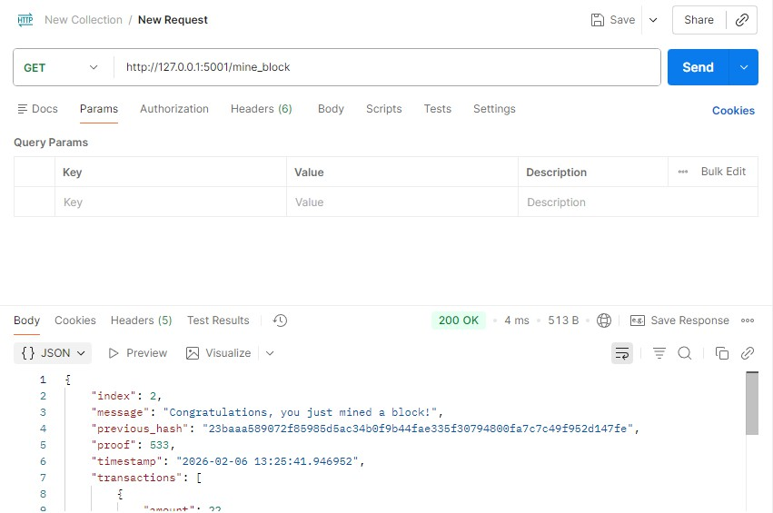

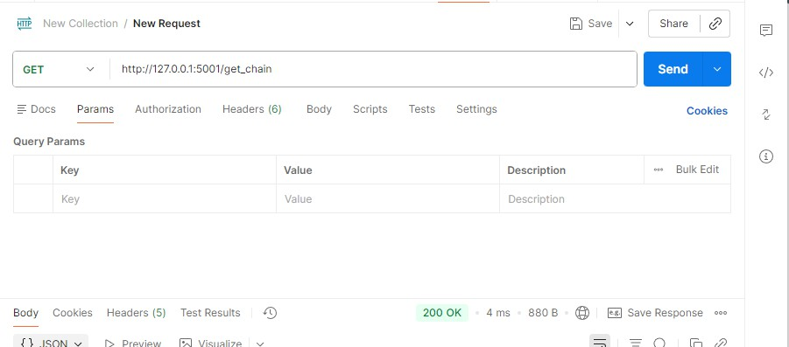
{
"chain": [
{
"index": 1,
"previous_hash": "0",
"proof": 1,
"timestamp": "2026-02-06 12:58:40.478764",
"transactions": []
},
{
"index": 2,
"previous_hash":
"23baaa589072f85985d5ac34b0f9b44fae335f30794800fa7c7c49f952d147fe", "proof": 533,
"timestamp": "2026-02-06 13:25:41.946952",
"transactions": [
{
"amount": 22,
"receiver": "ITAL", "sender": "MANORATH"
},
{
"amount": 1,
"receiver": "Richard",
"sender": "fc6c57a7d9f04e15aa9f10bf9e9f96d0"
}
]
},

{
"index": 3,
"previous_hash":
"fcc5e4ebc37bb887e3a4e84cdd40e74bb0c3a473a7cc0a45b3c090c2cfd388e9", "proof": 45293,
"timestamp": "2026-02-06 13:35:55.810244",
"transactions": [
{
"amount": 25,
"receiver": "ITAL", "sender": "MONU"
},
{
"amount": 1,
"receiver": "Richard",
"sender": "fc6c57a7d9f04e15aa9f10bf9e9f96d0"
}
]
}
],
"length": 3
}
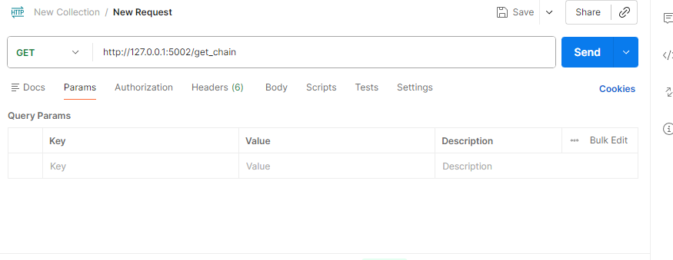
{
"chain": [
{
"index": 1,
"previous_hash": "0",
"proof": 1,

"timestamp": "2026-02-06 12:58:40.478764",
"transactions": []
},
{
"index": 2,
"previous_hash":
"23baaa589072f85985d5ac34b0f9b44fae335f30794800fa7c7c49f952d147fe", "proof": 533,
"timestamp": "2026-02-06 13:25:41.946952",
"transactions": [
{
"amount": 22,
"receiver": "ITAL", "sender": "MANORATH"
},
{
"amount": 1,
"receiver": "Richard",
"sender": "fc6c57a7d9f04e15aa9f10bf9e9f96d0"
}
]
}
],
"length": 2
}
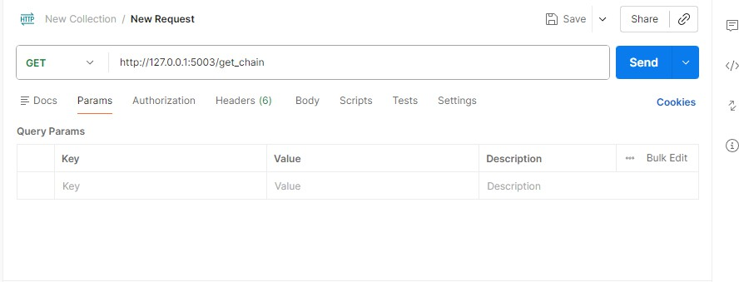
{
"chain": [
{
"index": 1,

"previous_hash": "0",
"proof": 1,
"timestamp": "2026-02-06 12:58:40.478764",
"transactions": []
},
{
"index": 2,
"previous_hash":
"23baaa589072f85985d5ac34b0f9b44fae335f30794800fa7c7c49f952d147fe", "proof": 533,
"timestamp": "2026-02-06 13:25:41.946952",
"transactions": [
{
"amount": 22,
"receiver": "ITAL", "sender": "MANORATH"
},
{
"amount": 1,
"receiver": "Richard",
"sender": "fc6c57a7d9f04e15aa9f10bf9e9f96d0"
}
]
}
],
"length": 2
}
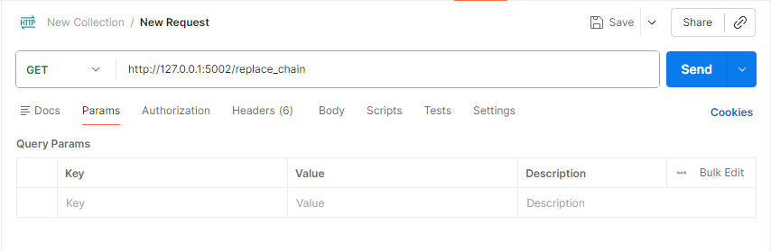
{
"message": "The nodes had different chains so the chain was replaced by the
longest one.",
"new_chain": [

{
"index": 1,
"previous_hash": "0",
"proof": 1,
"timestamp": "2026-02-06 12:58:40.478764",
"transactions": []
},
{
"index": 2,
"previous_hash":
"23baaa589072f85985d5ac34b0f9b44fae335f30794800fa7c7c49f952d147fe", "proof": 533,
"timestamp": "2026-02-06 13:25:41.946952",
"transactions": [
{
"amount": 22,
"receiver": "ITAL", "sender": "MANORATH"
},
{
"amount": 1,
"receiver": "Richard",
"sender": "fc6c57a7d9f04e15aa9f10bf9e9f96d0"
}
]
},
{

"index": 3,

"fcc5e4ebc37bb887e3a4e84cdd40e74bb0c3a473a7cc0a45b3c090c2cfd388e9", "proof": 45293,
"timestamp": "2026-02-06 13:35:55.810244",
"transactions": [
{

"previous_hash":

"amount": 25,
"receiver": "ITAL", "sender": "MONU"
},
{
"amount": 1,

"receiver": "Richard",
"sender": "fc6c57a7d9f04e15aa9f10bf9e9f96d0"
}
]
}
]
}
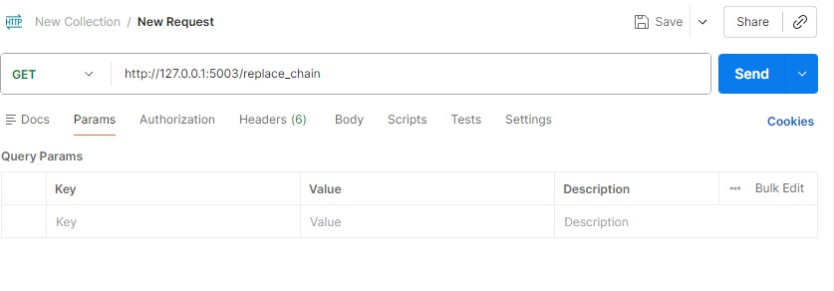
{
"message": "The nodes had different chains so the chain was replaced by the
longest one.",
"new_chain": [
{
"index": 1,
"previous_hash": "0",
"proof": 1,
"timestamp": "2026-02-06 12:58:40.478764",
"transactions": []
},
{
"index": 2,
"previous_hash":
"23baaa589072f85985d5ac34b0f9b44fae335f30794800fa7c7c49f952d147fe", "proof": 533,
"timestamp": "2026-02-06 13:25:41.946952",
"transactions": [
{
"amount": 22,
"receiver": "ITAL", "sender": "MANORATH"
},

{
"amount": 1,
"receiver": "Richard",
"sender": "fc6c57a7d9f04e15aa9f10bf9e9f96d0"
}
]
},
{

"index": 3,

"fcc5e4ebc37bb887e3a4e84cdd40e74bb0c3a473a7cc0a45b3c090c2cfd388e9", "proof": 45293,
"timestamp": "2026-02-06 13:35:55.810244",
"transactions": [
{

"previous_hash":

"amount": 25,
"receiver": "ITAL", "sender": "MONU"
},
{
"amount": 1,
"receiver": "Richard",
"sender": "fc6c57a7d9f04e15aa9f10bf9e9f96d0"
}
]
}
]
}
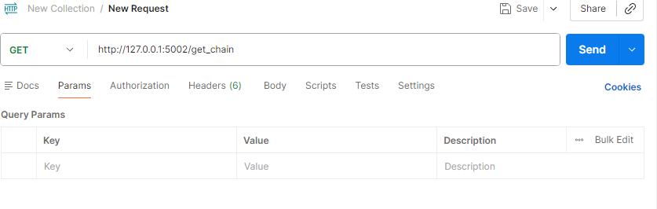
{
"chain": [
{

"index": 1,
"previous_hash": "0",
"proof": 1,
"timestamp": "2026-02-06 12:58:40.478764",
"transactions": []
},
{
"index": 2,
"previous_hash":
"23baaa589072f85985d5ac34b0f9b44fae335f30794800fa7c7c49f952d147fe", "proof": 533,
"timestamp": "2026-02-06 13:25:41.946952",
"transactions": [
{
"amount": 22,
"receiver": "ITAL", "sender": "MANORATH"
},
{
"amount": 1,
"receiver": "Richard",
"sender": "fc6c57a7d9f04e15aa9f10bf9e9f96d0"
}
]
},
{

"index": 3,

"fcc5e4ebc37bb887e3a4e84cdd40e74bb0c3a473a7cc0a45b3c090c2cfd388e9", "proof": 45293,
"timestamp": "2026-02-06 13:35:55.810244",
"transactions": [
{

"previous_hash":

"amount": 25,
"receiver": "ITAL", "sender": "MONU"
},
{
"amount": 1,
"receiver": "Richard",

"sender": "fc6c57a7d9f04e15aa9f10bf9e9f96d0"
}
]
}
],
"length": 3
}
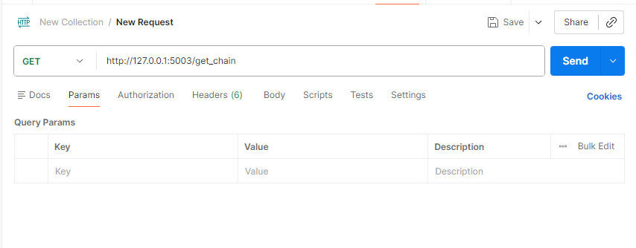
{
"chain": [
{
"index": 1,
"previous_hash": "0",
"proof": 1,
"timestamp": "2026-02-06 12:58:40.478764",
"transactions": []
},
{
"index": 2,
"previous_hash":
"23baaa589072f85985d5ac34b0f9b44fae335f30794800fa7c7c49f952d147fe", "proof": 533,
"timestamp": "2026-02-06 13:25:41.946952",
"transactions": [
{
"amount": 22,
"receiver": "ITAL", "sender": "MANORATH"
},
{

"amount": 1,
"receiver": "Richard",
"sender": "fc6c57a7d9f04e15aa9f10bf9e9f96d0"
}
]
},
{

"index": 3,

"fcc5e4ebc37bb887e3a4e84cdd40e74bb0c3a473a7cc0a45b3c090c2cfd388e9", "proof": 45293,
"timestamp": "2026-02-06 13:35:55.810244",
"transactions": [
{

"previous_hash":

"amount": 25,
"receiver": "ITAL", "sender": "MONU"
},
{
"amount": 1,
"receiver": "Richard",
"sender": "fc6c57a7d9f04e15aa9f10bf9e9f96d0"
}
]
}
],
"length": 3
}
Conclusion: In this experiment, a basic cryptocurrency system was designed and implemented using Python by applying fundamental blockchain principles such as block generation, cryptographic hashing, Proof-of-Work mining, transaction processing, and decentralized networking. A Flask-based framework was used to enable communication between multiple nodes, with each node maintaining its own copy of the blockchain ledger. The mining process required solving the Proof-of-Work challenge, after which new blocks were added to the chain and miners received rewards. The system also supported transaction validation and inclusion of verified transactions into newly mined blocks. Through this implementation, the experiment offered hands-on insight into the functioning of blockchain technology, demonstrating how consensus, decentralization, and mining together enable the secure operation of cryptocurrencies in distributed environments.

