Name: Manorath Sunil Ital
Class:D20A
Roll No:25

Aim: To implement the Blockchain platform Ganache and deploy a simple Solidity smart contract using Metamask and Remix IDE.

Theory:

1. Introduction to Blockchain

Blockchain is a distributed, decentralized digital ledger that records transactions across multiple nodes in a network. Each transaction is stored in a block, and blocks are linked together using cryptographic hashes, forming a secure and immutable chain.

Key features:

Decentralization – No central authority controls the system

Immutability – Data cannot be altered once recorded

Transparency – Transactions are visible to all participants

Security – Uses cryptographic techniques

2. What is Ganache?

Ganache is a personal blockchain simulator used for developing, testing, and debugging Ethereum-based decentralized applications (DApps).

It is part of the Truffle Suite, which provides tools for smart contract development.

Ganache creates a local blockchain environment that mimics the behavior of the real Ethereum network.

3. Features of Ganache

a. Local Blockchain

Ganache runs a blockchain locally on your system, allowing developers to test without using real cryptocurrency.

b. Pre-funded Accounts

Provides multiple accounts with preloaded Ether

Useful for testing transactions without cost

c. Instant Mining

Transactions are mined instantly

No waiting time like real networks

d. Detailed Transaction Logs

Displays:

Transaction hash

Gas usage

Block number

Events

e. Smart Contract Testing

Supports deployment and testing of smart contracts written in Solidity.

f. Customizable Settings

Gas limit

Gas price

Number of accounts

Network ID

4. Architecture of Ganache
Ganache simulates the Ethereum architecture:

a. Accounts Layer
- Contains multiple Ethereum accounts
- Each account has:
  - Address
  - Private key
  - Balance

b. Blockchain Layer
- Stores blocks and transactions
- Each block contains:
  - Block number
  - Timestamp
  - Transactions

c. Virtual Machine
Ganache uses the Ethereum Virtual Machine to execute smart contracts.

d. RPC Server
- Provides JSON-RPC API
- Allows interaction using tools like Web3.js

5. Working of Ganache
- Ganache starts a local blockchain network
- It generates multiple accounts with Ether
- Developers deploy smart contracts
- Transactions are executed
- Ganache mines blocks instantly
- Results are displayed in logs

6. Advantages of Using Ganache
- No real Ether required
- Faster testing (instant mining)
- Easy debugging with detailed logs
- Safe environment (no risk of real loss)
- Ideal for beginners and developers

7. Limitations of Ganache
- Not a real decentralized network
- Does not simulate real-world latency
- Limited scalability testing
- Not suitable for production deployment

8. Applications of Ganache
- Smart contract development
- Testing decentralized applications (DApps)
- Learning Ethereum blockchain concepts
- Debugging transactions

Implementation:-

1. Set Up Ganache (The Local Blockchain)
- Download & Install: Go to the Truffle Suite website and install Ganache.
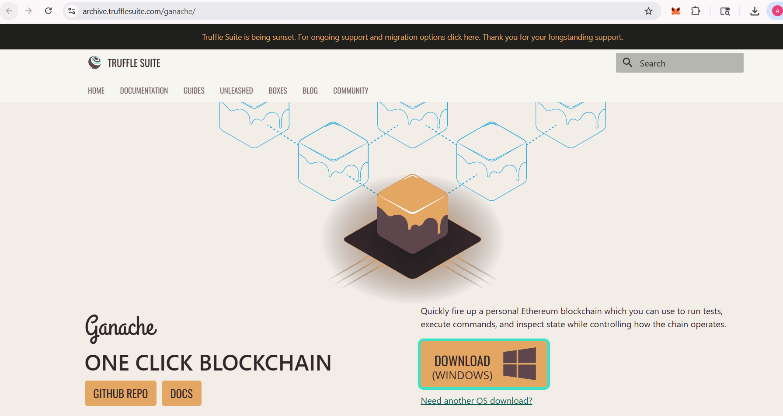

- Launch: Open Ganache and select "Quickstart".
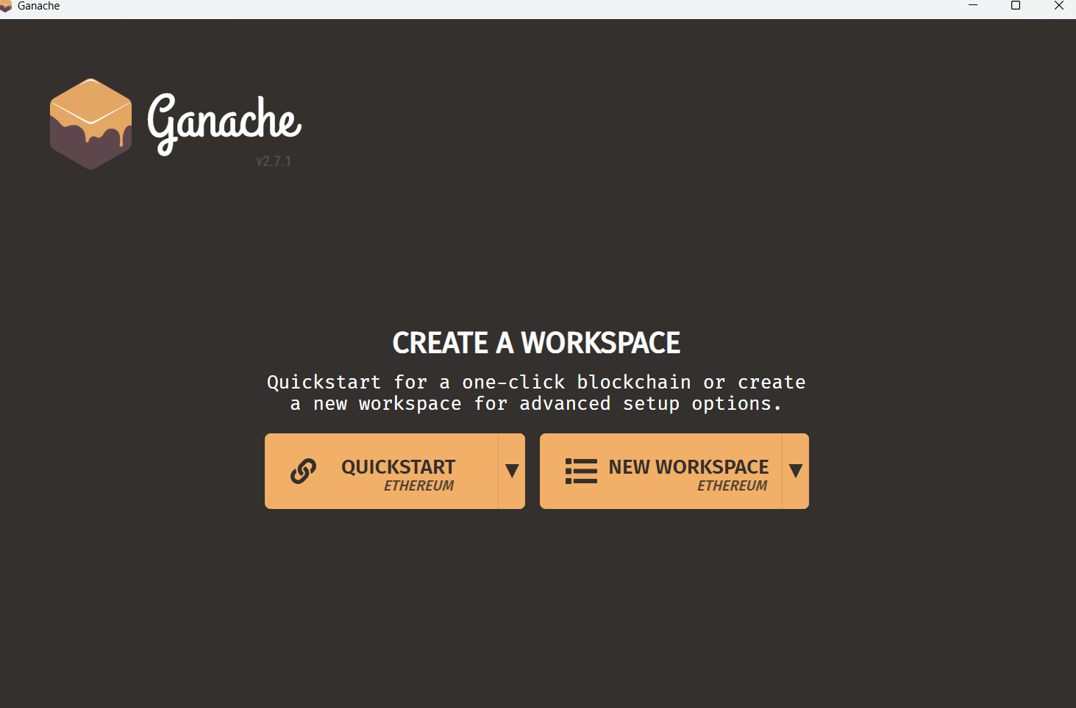

- Identify Details: You will see a list of 10 addresses, each with 100 ETH.
  - Look at the top bar for RPC Server. It usually says HTTP://127.0.0.1:7545.
  - Look at the Network ID. It is usually 5777.
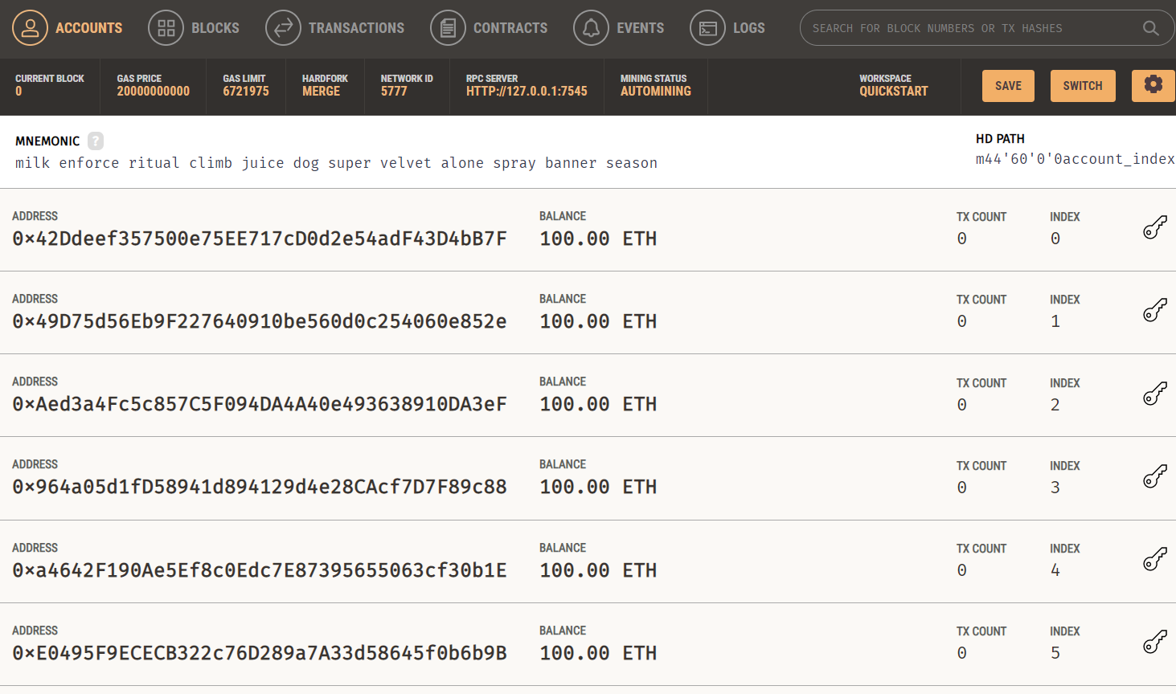

2. Connect Ganache to MetaMask
MetaMask doesn't know about your local Ganache "server" yet, so we have to add it manually.
- Open MetaMask -> Click the Network Dropdown (top left) -> Add Network.
- Select "Add a network manually" at the bottom.
- Enter these details:
  - Network Name: Localhost 8545
  - New RPC URL: http://127.0.0.1:7545
  - Chain ID: 1377
  - Currency Symbol: ETH
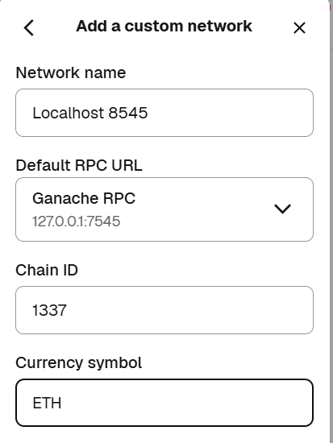
- Import Account:
  - In Ganache, click the Key Icon on the far right of the first address.
  - Copy the Private Key.
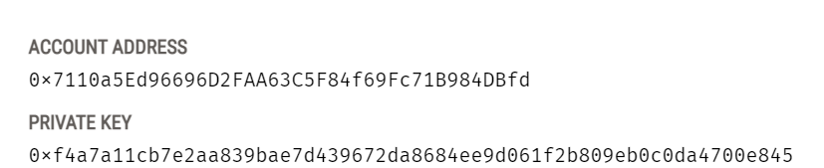

  - In MetaMask, click the Account Circle -> Import Account -> Paste the Private Key.
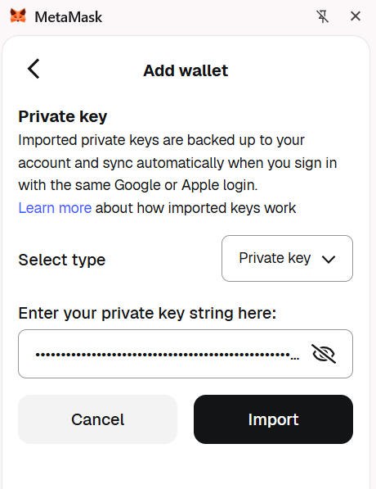

  - You should now see 100 ETH in MetaMask!
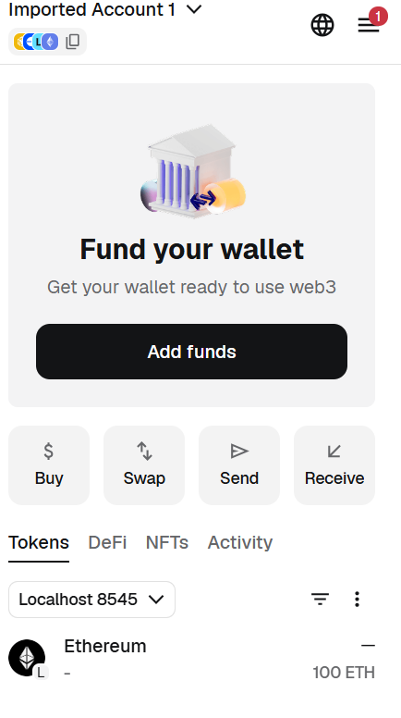

3. Connect Remix to MetaMask (Injected Provider)
- In Remix, go to the Deploy & Run Transactions tab.
- Set Environment to Injected Provider - MetaMask.
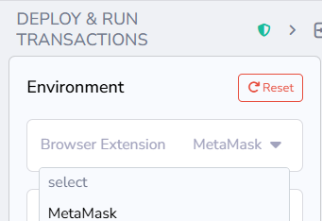
- MetaMask will ask to connect to "Ganache Local." Click Confirm.
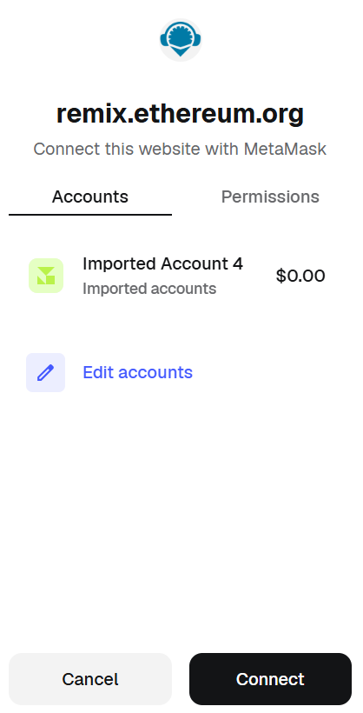

4. Compile and Deploy
- Compile your LandRegistry.sol.
- In the Deploy tab, click Deploy.
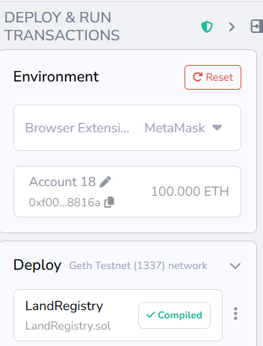
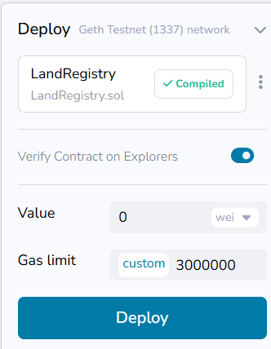

- MetaMask will pop up. Since this is your local Ganache, the transaction will be instant and the gas cost will be deducted from your 100 ETH.
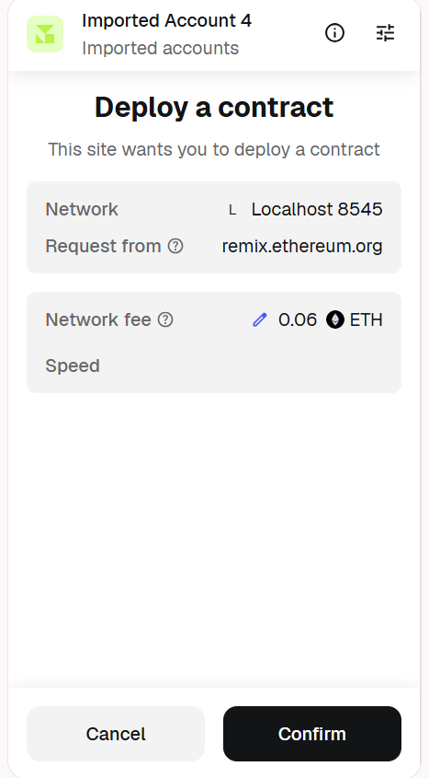
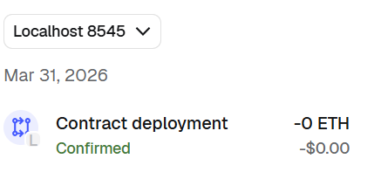

5. Check Transaction Details in Ganache
- Open the Ganache Desktop App.
- Click the Transactions tab at the top.
- You will see a "Contract Creation" transaction. Click it to see the gas used, the "TX Hash," and the block number
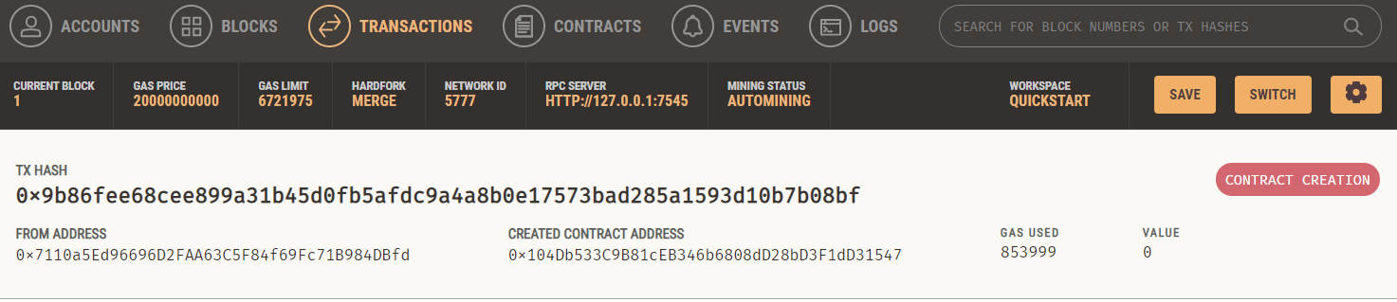
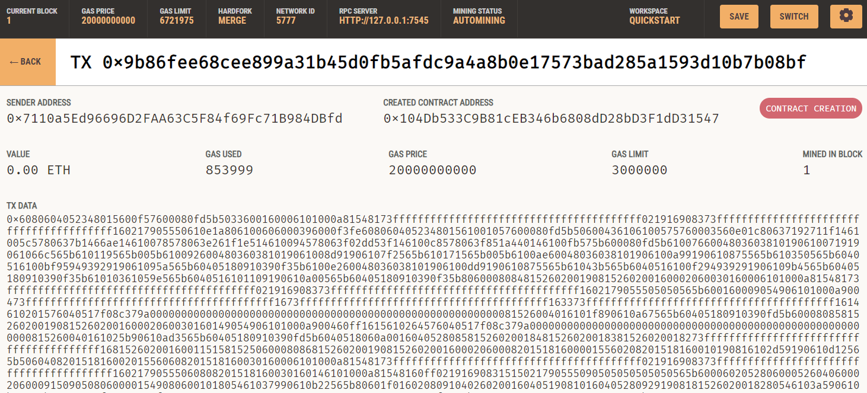

In the Accounts tab, we can see that the some balance has been deducted from the first address as part of the transaction that has taken place
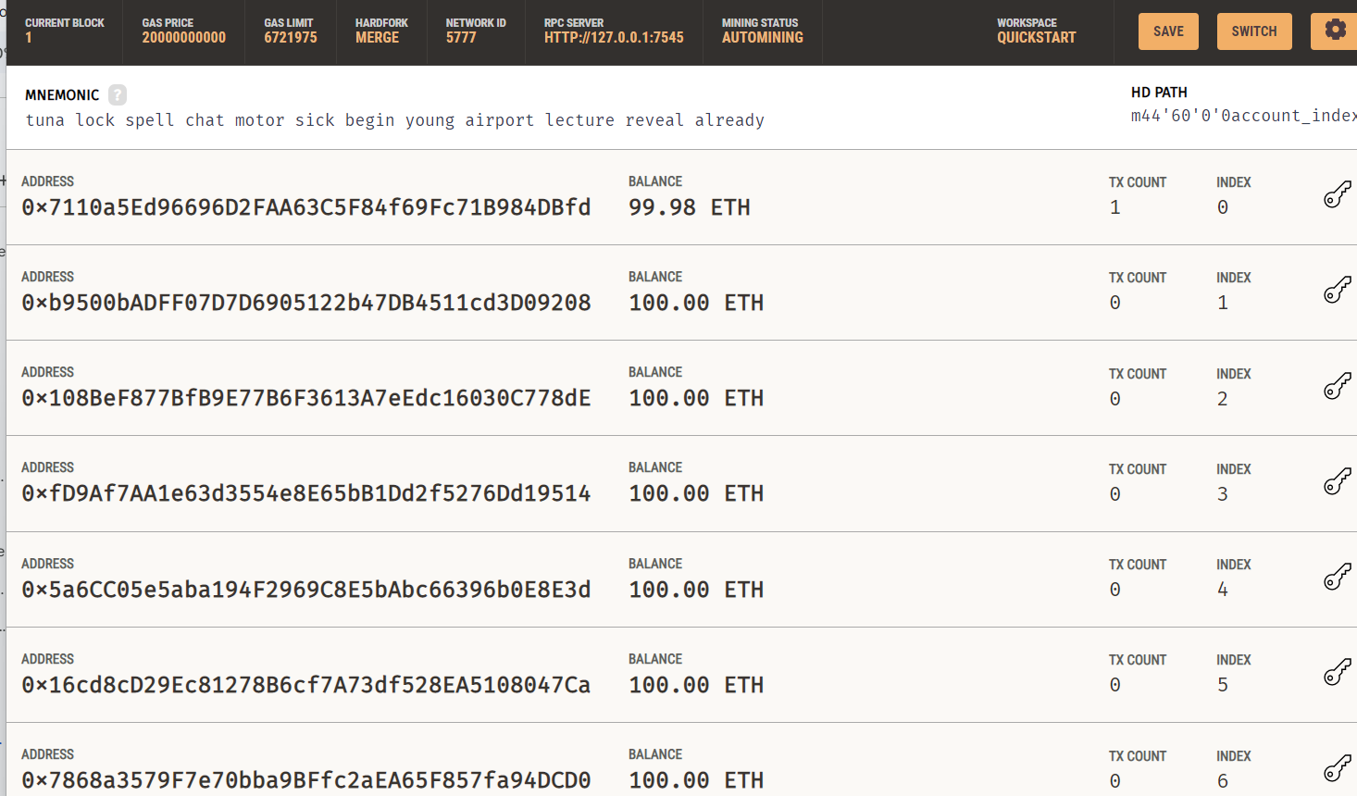

Conclusion:-

The experiment successfully demonstrated the deployment of a LandRegistry smart contract on a local blockchain using Ganache, MetaMask, and Remix IDE. By configuring a custom RPC network and aligning the Chain ID, a secure bridge was established to authorize a pre-funded account for transaction gas. This process verified the contract's compilation and its successful migration to a private ledger, confirming the integrity of the decentralized data storage. The setup provides a cost-effective, local environment for testing full-scale blockchain application logic.

