**EXPERIMENT NO: - 03**

Manorath Ital

D15A/19

**AIM:** - To include icons, images, fonts in Flutter app.

**Theory: -**

**Incorporating Icons, Images, and Custom Fonts into FilmyFun App**

**FilmyFun** is a user-friendly movie ticket booking app that allows users to easily select showtimes and reserve tickets. A crucial aspect of creating an engaging and visually appealing app is incorporating various visual elements, such as icons, images, and custom fonts. These elements enhance the overall user experience and help the app stand out.

Like most modern mobile applications, FilmyFun uses resources such as assets and code to provide a dynamic user experience. Assets, such as images, icons, and custom fonts, are integral in delivering a rich and intuitive interface. These resources are bundled with the app and are made available during runtime.

**Visual Elements and Their Role in the App**

Visual elements—icons, images, and fonts—play an essential role in app development. These elements are used to improve usability, convey information quickly, and enhance branding.

1. **Enhanced User Experience**: Icons and images make the app visually attractive and easier to navigate.
2. **Information Conveyance**: Icons help reduce text and convey actions intuitively.
3. **Branding**: Custom icons and images align with FilmyFun's branding, making it memorable and recognizable.

**Incorporating Icons in FilmyFun**

Icons serve as intuitive visual shortcuts, providing a quick way for users to identify actions and navigate the app. Flutter provides a wide variety of built-in icons through the Icons class, and custom icons can be added via third-party packages like flutter_launcher_icons or font_awesome_flutter.

**Example of adding an icon**:

Icon(

Icons.movie,

size: 40,

);

**Adding Images in FilmyFun**

Images are crucial for enhancing the visual experience in FilmyFun. Flutter allows for images to be added from multiple sources:

1. **Assets (Stored Locally)**
   * To add an image stored locally in the project, place the image in the assets/images/ folder.
   * Declare the image path in the pubspec.yaml file.

flutter:

assets:

- assets/images/movie_poster.png

* Display the image in the app using the Image.asset method:

Image.asset('assets/images/movie_poster.png');

**Incorporating Custom Fonts in FilmyFun**

While Flutter's default font is **Roboto**, you may want to add custom fonts to align with your app's branding and overall design aesthetic. Adding custom fonts is simple:

1. **Download the font** and place it in the assets/fonts/ folder of the project.
2. **Declare the font** in the pubspec.yaml file.

flutter:

fonts:

- family: CustomFont

fonts:

- asset: assets/fonts/CustomFont-Regular.ttf

3.**Use the custom font** in your app:

Text(

'Welcome to FilmyFun!',

style: TextStyle(fontFamily: 'CustomFont', fontSize: 24),

);

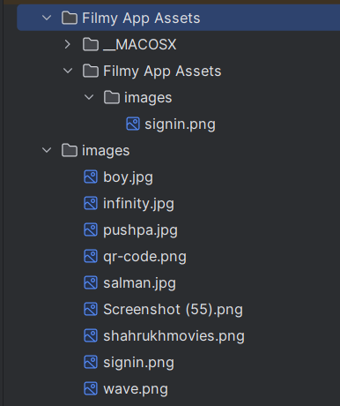 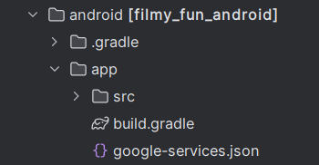

Pubspec.yaml

name: filmy_fun  
description: "FilmyFun-Movie Ticket Booking App"  
# The following line prevents the package from being accidentally published to  
# pub.dev using `flutter pub publish`. This is preferred for private packages.  
publish_to: 'none' # Remove this line if you wish to publish to pub.dev  
  
# The following defines the version and build number for your application.  
# A version number is three numbers separated by dots, like 1.2.43  
# followed by an optional build number separated by a +.  
# Both the version and the builder number may be overridden in flutter  
# build by specifying --build-name and --build-number, respectively.  
# In Android, build-name is used as versionName while build-number used as versionCode.  
# Read more about Android versioning at https://developer.android.com/studio/publish/versioning  
# In iOS, build-name is used as CFBundleShortVersionString while build-number is used as CFBundleVersion.  
# Read more about iOS versioning at  
# https://developer.apple.com/library/archive/documentation/General/Reference/InfoPlistKeyReference/Articles/CoreFoundationKeys.html  
# In Windows, build-name is used as the major, minor, and patch parts  
# of the product and file versions while build-number is used as the build suffix.  
version: 1.0.0+1  
  
environment:  
 sdk: ^3.6.2  
  
# Dependencies specify other packages that your package needs in order to work.  
# To automatically upgrade your package dependencies to the latest versions  
# consider running `flutter pub upgrade --major-versions`. Alternatively,  
# dependencies can be manually updated by changing the version numbers below to  
# the latest version available on pub.dev. To see which dependencies have newer  
# versions available, run `flutter pub outdated`.  
dependencies:  
 flutter:  
 sdk: flutter  
 carousel_slider: ^5.0.0  
 curved_navigation_bar: ^1.0.3 # Use the latest version  
 intl: ^0.18.0  
 firebase_auth: ^5.4.2  
 cloud_firestore: ^5.6.3  
 random_string: ^2.3.1  
 firebase_core: ^3.11.0  
 shared_preferences:  
 flutter_stripe:  
 http:  
  
  
 # The following adds the Cupertino Icons font to your application.  
 # Use with the CupertinoIcons class for iOS style icons.  
 cupertino_icons: ^1.0.8  
  
dev_dependencies:  
 flutter_test:  
 sdk: flutter  
  
 # The "flutter_lints" package below contains a set of recommended lints to  
 # encourage good coding practices. The lint set provided by the package is  
 # activated in the `analysis_options.yaml` file located at the root of your  
 # package. See that file for information about deactivating specific lint  
 # rules and activating additional ones.  
 flutter_lints: ^5.0.0  
  
# For information on the generic Dart part of this file, see the  
# following page: https://dart.dev/tools/pub/pubspec  
  
# The following section is specific to Flutter packages.  
flutter:  
  
 # The following line ensures that the Material Icons font is  
 # included with your application, so that you can use the icons in  
 # the material Icons class.  
 uses-material-design: true  
  
 # To add assets to your application, add an assets section, like this:  
 assets:  
 - images/  
 # - images/a_dot_ham.jpeg  
  
 # An image asset can refer to one or more resolution-specific "variants", see  
 # https://flutter.dev/to/resolution-aware-images  
  
 # For details regarding adding assets from package dependencies, see  
 # https://flutter.dev/to/asset-from-package  
  
 # To add custom fonts to your application, add a fonts section here,  
 # in this "flutter" section. Each entry in this list should have a  
 # "family" key with the font family name, and a "fonts" key with a  
 # list giving the asset and other descriptors for the font. For  
 # example:  
 # fonts:  
 # - family: Schyler  
 # fonts:  
 # - asset: fonts/Schyler-Regular.ttf  
 # - asset: fonts/Schyler-Italic.ttf  
 # style: italic  
 # - family: Trajan Pro  
 # fonts:  
 # - asset: fonts/TrajanPro.ttf  
 # - asset: fonts/TrajanPro_Bold.ttf  
 # weight: 700  
 #  
 # For details regarding fonts from package dependencies,  
 # see https://flutter.dev/to/font-from-package

Home.dart

import 'package:carousel_slider/carousel_slider.dart';  
import 'package:filmy_fun/pages/detail_page.dart';  
import 'package:flutter/material.dart';  
  
class home extends StatefulWidget {  
 const home({super.key});  
  
 @override  
 State<home> createState() => _homeState();  
}  
  
class _homeState extends State<home> {  
 final List<String> imageUrls = [  
 "images/infinity.jpg",  
 "images/salman.jpg",  
 "images/shahrukhmovies.png",  
 ];  
 @override  
 Widget build(BuildContext context) {  
 return Scaffold(  
 backgroundColor: Colors.*black*,  
 body: Container(  
 margin: EdgeInsets.only(top: 40.0, left: 20.0),  
 child:  
 Column(crossAxisAlignment: CrossAxisAlignment.start, children: [  
 Row(  
 children: [  
 Image.asset(  
 "images/wave.png",  
 height: 40,  
 width: 40,  
 fit: BoxFit.cover,  
 ),  
 SizedBox(  
 width: 10.0,  
 ),  
 Text(  
 "Hello, Manorath",  
 style: TextStyle(  
 color: Colors.*white*,  
 fontSize: 22.0,  
 fontWeight: FontWeight.*bold*),  
 ),  
 Spacer(),  
 Padding(  
 padding: const EdgeInsets.only(right: 20.0),  
 child: ClipRRect(  
 borderRadius: BorderRadius.circular(60),  
 child: Image.asset(  
 "images/Screenshot (55).png",  
 height: 60,  
 width: 60,  
 fit: BoxFit.cover,  
 ),  
 ),  
 )  
 ],  
 ),  
 SizedBox(height: 10.0),  
 Text(  
 "Welcome To",  
 style: TextStyle(  
 color: Color.fromARGB(186, 255, 255, 255),  
 fontSize: 19.0,  
 fontWeight: FontWeight.*bold*),  
 ),  
 Row(  
 children: [  
 Text(  
 "Filmy",  
 style: TextStyle(  
 color: Colors.*white*,  
 fontSize: 36.0,  
 fontWeight: FontWeight.*bold*),  
 ),  
 Text(  
 "Fun",  
 style: TextStyle(  
 color: Color(0xffedb41d),  
 fontSize: 36.0,  
 fontWeight: FontWeight.*bold*),  
 )  
 ],  
 ),  
 SizedBox(  
 height: 20.0,  
 ),  
 Center(  
 child: CarouselSlider(  
 items: imageUrls.map((url) {  
 return Builder(builder: (context) {  
 return Container(  
 width: MediaQuery.*of*(context)  
 .size  
 .width, // Fixed incorrect comma  
 child: ClipRRect(  
 borderRadius: BorderRadius.circular(10),  
 child: Image.asset(url, fit: BoxFit.cover),  
 ),  
 );  
 });  
 }).toList(),  
 options: CarouselOptions(  
 height: 250,  
 autoPlay: false,  
 enlargeCenterPage: true,  
 aspectRatio: 16 / 9,  
 viewportFraction: 1.0), // Fixed missing .toList()  
 )),  
 SizedBox(  
 height: 25.0,  
 ),  
 Text(  
 "Top Trending Movies",  
 style: TextStyle(  
 color: Colors.*white*,  
 fontSize: 24.0,  
 fontWeight: FontWeight.*bold*),  
 ),  
 SizedBox(  
 height: 20.0,  
 ),  
 Container(  
 height: 250,  
 child: ListView(  
 scrollDirection: Axis.horizontal,  
 children: [  
 GestureDetector(  
 onTap: () {  
 Navigator.*push*(  
 context,  
 MaterialPageRoute(  
 builder: (context) => DetailPage(  
 image: "images/infinity.jpg",  
 name: "Infinity Wars",  
 shortdetail: "Action, Adventure",  
 moviedetail:  
 "Avengers: Infinity War is a 2018 American superhero film based on the Marvel Comics superhero team the Avengers Produced by Marvel Studios and distributed by Walt Disney Studios Motion Pictures, it is the sequel to The Avengers (2012) and Avengers: Age of Ultron (2015), and the 19th film in the Marvel Cinematic Universe (MCU)",  
 price: '50',  
 )));  
 },  
 child: Container(  
 decoration: BoxDecoration(  
 border: Border.all(color: Colors.*white*),  
 borderRadius: BorderRadius.circular(20)),  
 child: Stack(  
 children: [  
 ClipRRect(  
 borderRadius: BorderRadius.circular(20),  
 child: Image.asset(  
 "images/infinity.jpg",  
 height: 220,  
 width: 180,  
 fit: BoxFit.cover,  
 ),  
 ),  
 Container(  
 padding: EdgeInsets.only(left: 10.0),  
 margin: EdgeInsets.only(top: 180),  
 height: 220,  
 width: 180,  
 decoration: BoxDecoration(  
 color: Colors.*black45*,  
 borderRadius: BorderRadius.only(  
 bottomRight: Radius.circular(20),  
 bottomLeft: Radius.circular(20))),  
 child: Column(  
 crossAxisAlignment: CrossAxisAlignment.start,  
 children: [  
 Text(  
 "Infinity Wars",  
 style: TextStyle(  
 color: Colors.*white*,  
 fontSize: 25.0,  
 fontWeight: FontWeight.*bold*),  
 ),  
 Text(  
 "Action, Adventure",  
 style: TextStyle(  
 color: Color.fromARGB(173, 255, 255, 255),  
 fontSize: 16.0,  
 fontWeight: FontWeight.*bold*),  
 ),  
 ],  
 ),  
 ),  
 ],  
 ),  
 ),  
 ),  
 SizedBox(width: 20.0),  
 Container(  
 decoration: BoxDecoration(  
 border: Border.all(color: Colors.*white*),  
 borderRadius: BorderRadius.circular(20)),  
 child: Stack(  
 children: [  
 ClipRRect(  
 borderRadius: BorderRadius.circular(20),  
 child: Image.asset(  
 "images/pushpa.jpg",  
 height: 220,  
 width: 180,  
 fit: BoxFit.cover,  
 ),  
 ),  
 Container(  
 padding: EdgeInsets.only(left: 10.0),  
 margin: EdgeInsets.only(top: 180),  
 height: 220,  
 width: 180,  
 decoration: BoxDecoration(  
 color: Colors.*black45*,  
 borderRadius: BorderRadius.only(  
 bottomRight: Radius.circular(20),  
 bottomLeft: Radius.circular(20))),  
 child: Column(  
 crossAxisAlignment: CrossAxisAlignment.start,  
 children: [  
 Text(  
 "Pushpa 2",  
 style: TextStyle(  
 color: Colors.*white*,  
 fontSize: 25.0,  
 fontWeight: FontWeight.*bold*),  
 ),  
 Text(  
 "Action, Thriller,",  
 style: TextStyle(  
 color: Color.fromARGB(173, 255, 255, 255),  
 fontSize: 16.0,  
 fontWeight: FontWeight.*bold*),  
 ),  
 ],  
 ),  
 ),  
 ],  
 ),  
 ),  
 SizedBox(width: 20.0),  
 Container(  
 decoration: BoxDecoration(  
 border: Border.all(color: Colors.*white*),  
 borderRadius: BorderRadius.circular(20)),  
 child: Stack(  
 children: [  
 ClipRRect(  
 borderRadius: BorderRadius.circular(20),  
 child: Image.asset(  
 "images/salman.jpg",  
 height: 220,  
 width: 180,  
 fit: BoxFit.cover,  
 ),  
 ),  
 Container(  
 padding: EdgeInsets.only(left: 10.0),  
 margin: EdgeInsets.only(top: 180),  
 height: 220,  
 width: 180,  
 decoration: BoxDecoration(  
 color: Colors.*black45*,  
 borderRadius: BorderRadius.only(  
 bottomRight: Radius.circular(20),  
 bottomLeft: Radius.circular(20))),  
 child: Column(  
 crossAxisAlignment: CrossAxisAlignment.start,  
 children: [  
 Text(  
 "Pushpa 2",  
 style: TextStyle(  
 color: Colors.*white*,  
 fontSize: 25.0,  
 fontWeight: FontWeight.*bold*),  
 ),  
 Text(  
 "Action, Thriller,",  
 style: TextStyle(  
 color: Color.fromARGB(173, 255, 255, 255),  
 fontSize: 16.0,  
 fontWeight: FontWeight.*bold*),  
 ),  
 ],  
 ),  
 ),  
 ],  
 ),  
 )  
 ],  
 ),  
 )  
 ]),  
 ));  
 }  
}

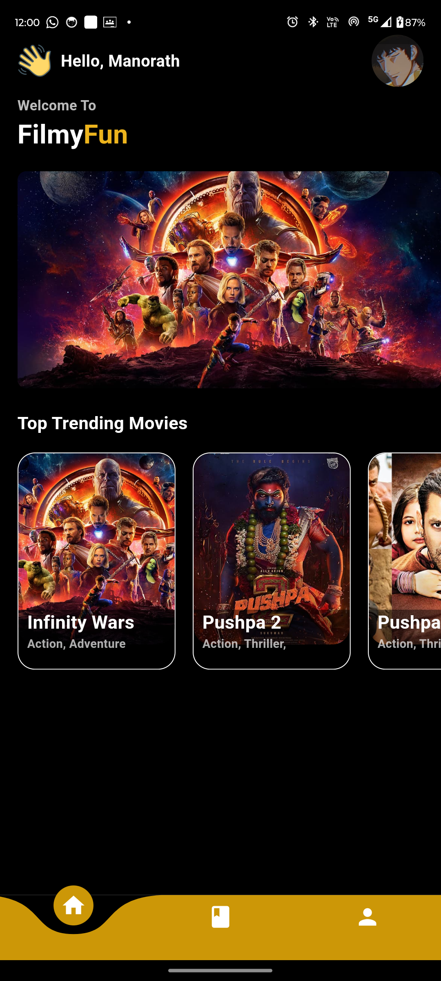

ICONS:

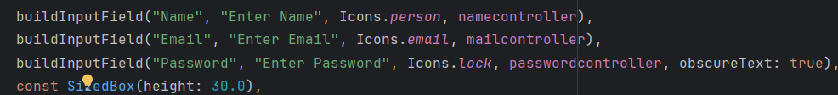

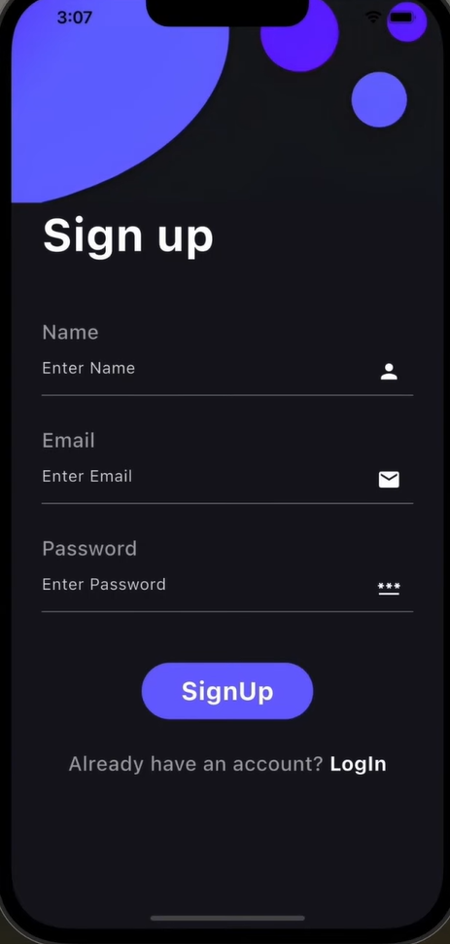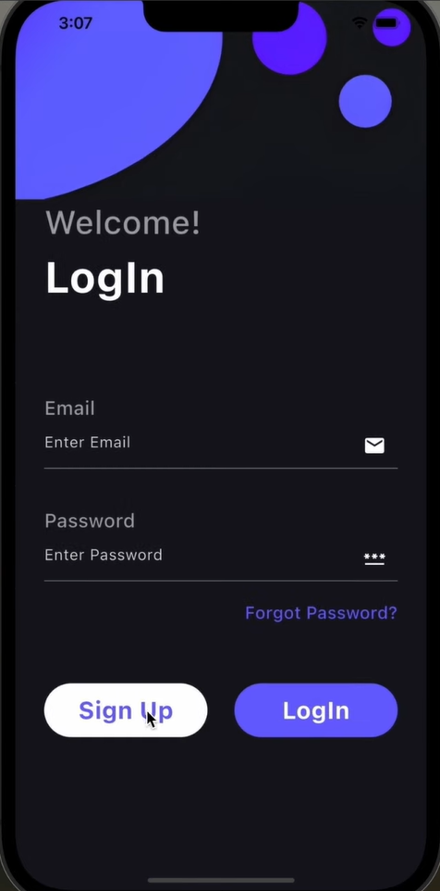

**Conclusion**

By incorporating icons, images, and custom fonts into the FilmyFun app, you can create an intuitive, visually appealing, and engaging user experience. These visual elements contribute to the overall aesthetic, enhance usability, and ensure your app stands out in a competitive market. Whether displaying movie posters, providing easy navigation with icons, or using custom fonts for unique branding, these resources will elevate the look and feel of your app.