ADVANCE DEVOPS EXP-10

**MANORATH ITAL D15A/19**

**Aim:** To perform Port, Service monitoring, Windows/Linux server monitoring using Nagios.

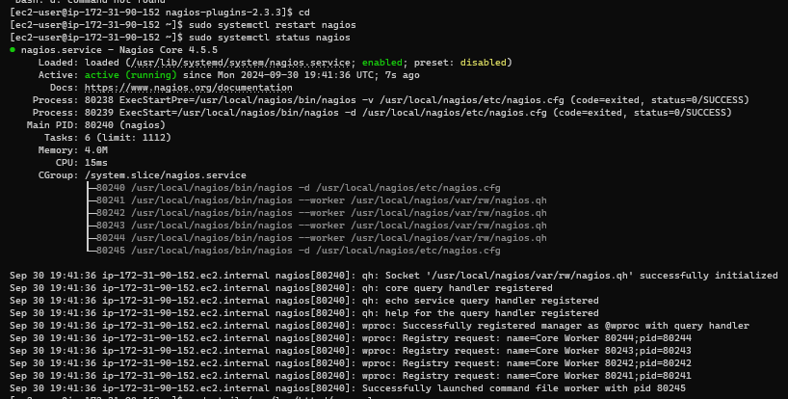**Step-1.** Conﬁrm Nagios is Running on the Server. sudo systemctl status nagios Proceed if you see that Nagios is active and running.

**Step-2.** Create an Ubuntu 20.04 Server EC2 Instance

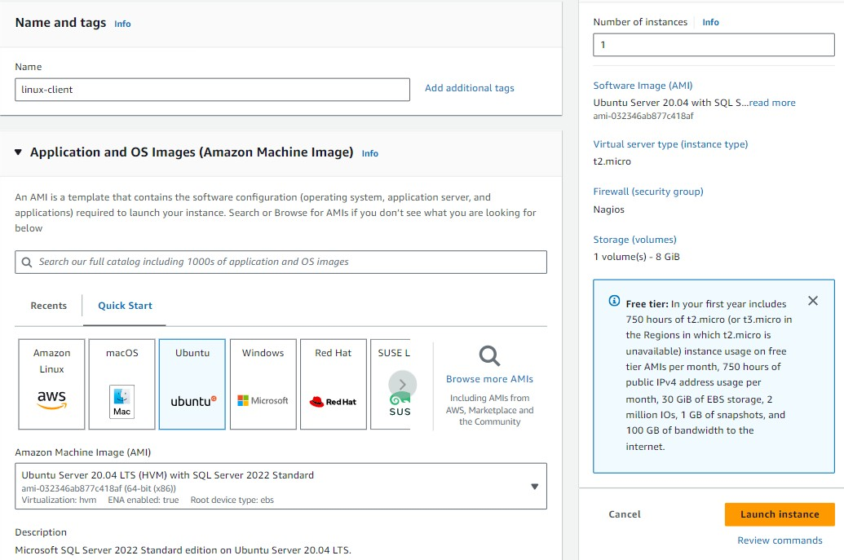

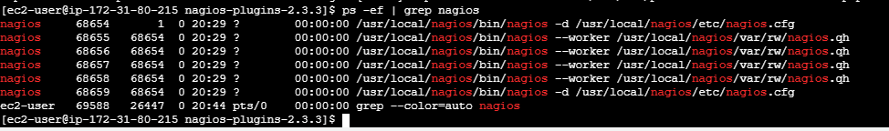**Step-3:** Verify Nagios Process on the Server

**Step-4:** Become Root User and Create Directories-

sudo su , mkdir -p /usr/local/nagios/etc/objects/monitorhosts/linuxhosts

**and to copy the same conﬁg ﬁle**- cp /usr/local/nagios/etc/objects/localhost.cfg,

/usr/local/nagios/etc/objects/monitorhosts/linuxhosts/linuxserver.cfg

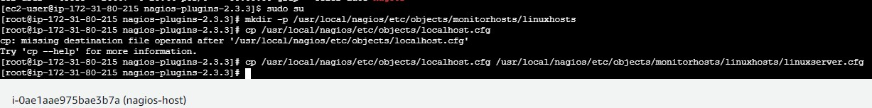

**Step-5:** Edit the Conﬁguration File

sudo nano /usr/local/nagios/etc/objects/monitorhosts/linuxhosts/linuxserver.cfg

* Change hostname to linuxserver everywhere in the file
* Change address to the public IP address of your linux-client.
* Change host_group name under hostgroup to linux_server

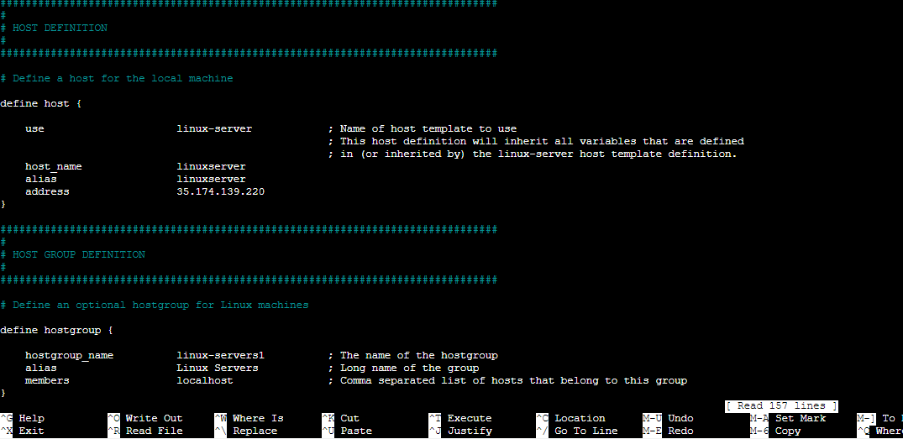

**Step-6:** Update Nagios Conﬁguration

sudo nano /usr/local/nagios/etc/nagios.cfg

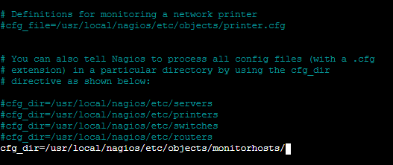**Add the command -** cfg_dir=/usr/local/nagios/etc/objects/monitorhosts/

**Step-7:** Verify Conﬁguration Files

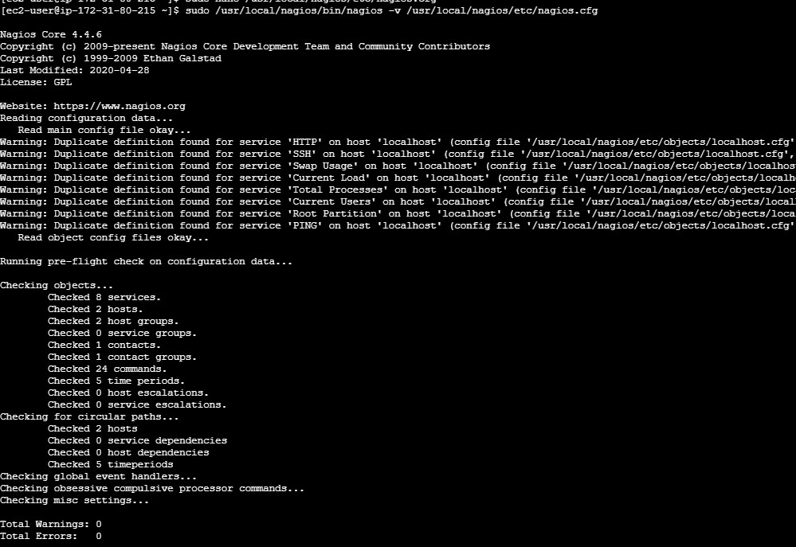sudo /usr/local/nagios/bin/nagios -v /usr/local/nagios/etc/nagios.cfg

**Step-8:** Restart Nagios Service sudo systemctl restart nagios

**Step-9:. SSH into the Client Machine**

Use SSH or EC2 Instance Connect to access the linux-client.

**Step-10:** Update Package Index and Install Required Packages sudo apt update -y

sudo apt install gcc -y

sudo apt install -y nagios-nrpe-server nagios-plugins

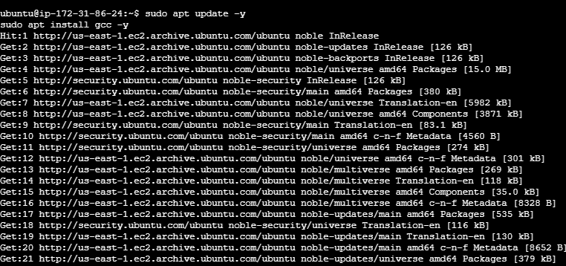

**Step-11:** Edit NRPE Conﬁguration File Commands -

sudo nano /etc/nagios/nrpe.cfg

Add your Nagios host IP address under allowed_hosts: allowed_hosts=<Nagios_Host_IP>

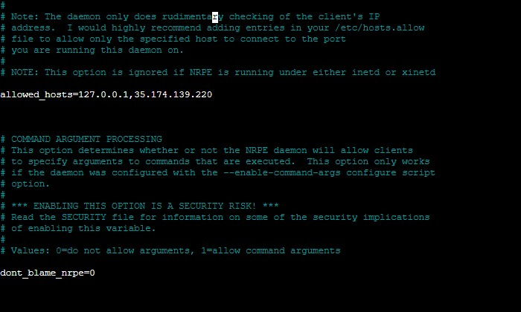

**Step-12:** Restart NRPE Server

Commands -

sudo systemctl restart nagios-nrpe-server

**Step-13:**Check Nagios Dashboard

Open your browser and navigate to http://<Nagios_Host_IP>/nagios. Log in with nagiosadmin and the password you set earlier.

You should see the new host linuxserver added. Click on Hosts to see the host details.

Click on Services to see all services and ports being monitored

