ADVANCE DEVOPS EXP-11

**MANORATH ITAL D15A/19**

**Aim:** To understand AWS Lambda,Its workflow,various functions and create your first Lambda functions using Python/ Java / Nodejs.

**Step 1:** Login to your AWS Personal/Academy Accout.Open lambda andclick on create function button.

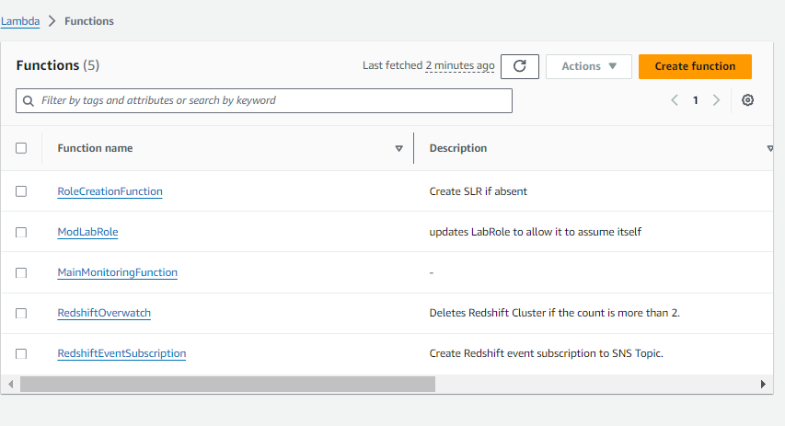

**Step 2:** Now Give a name to your Lambda function, Select the language to use to write your function. Note that the console code editor supports only Node.js, Python, and Ruby. So will select Python 3.12 , Architecture as x86, and Exceution role to Create a new role with basic Lambda permissions.

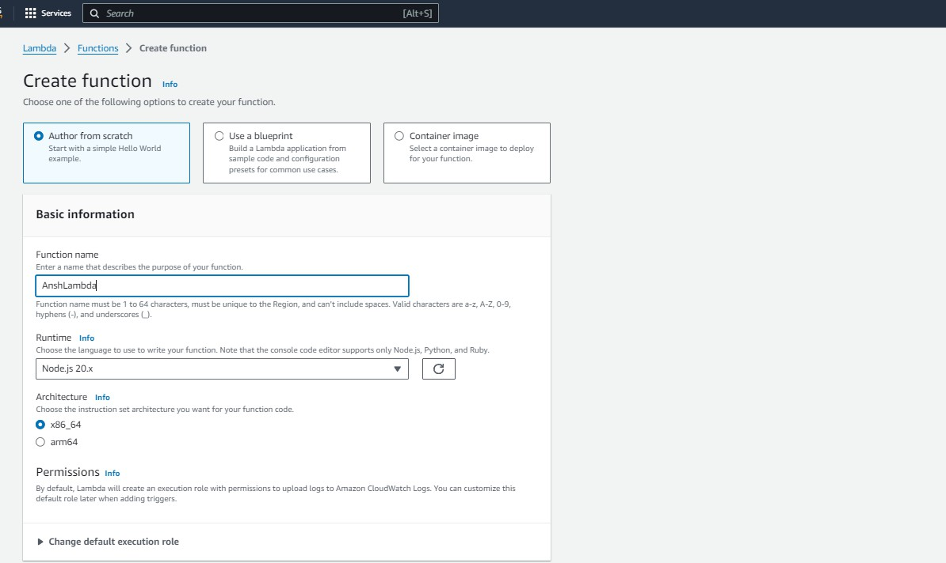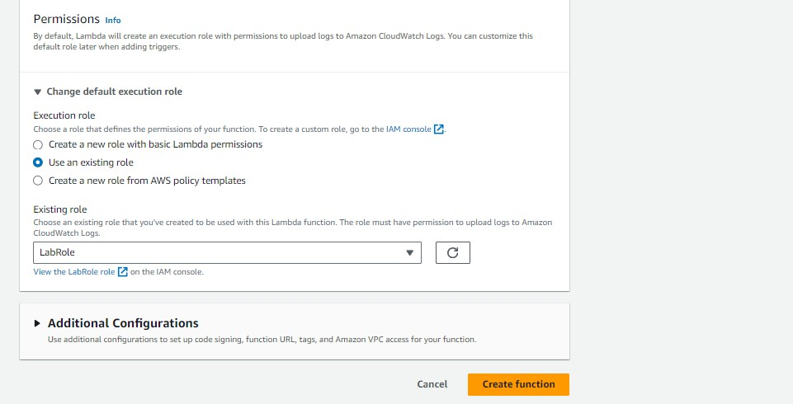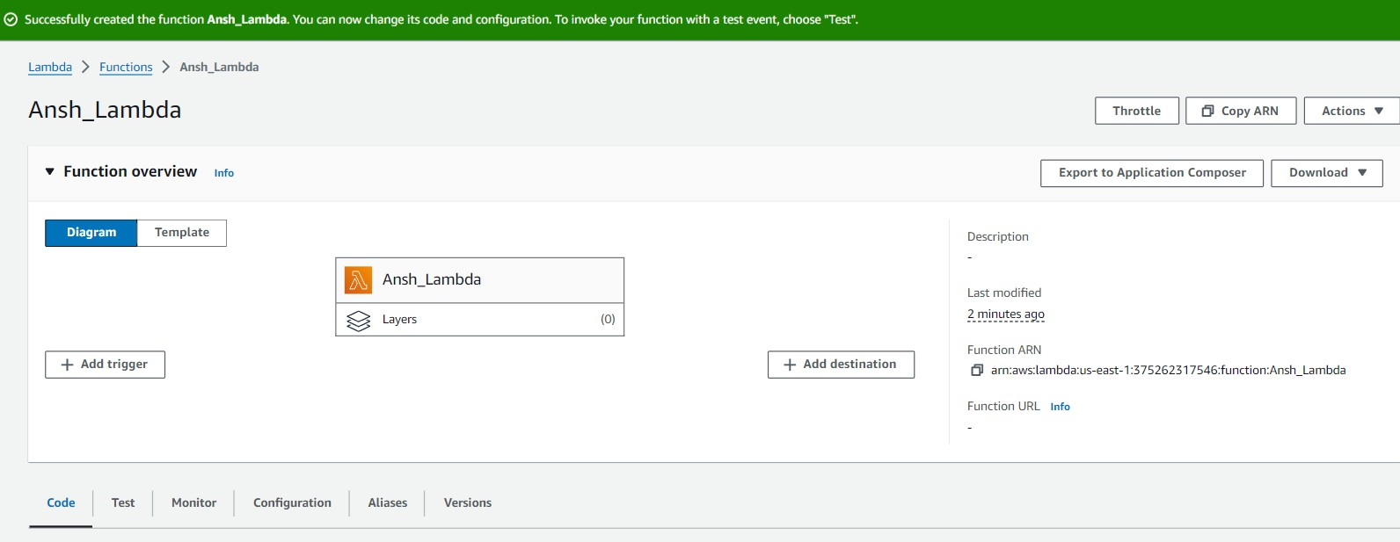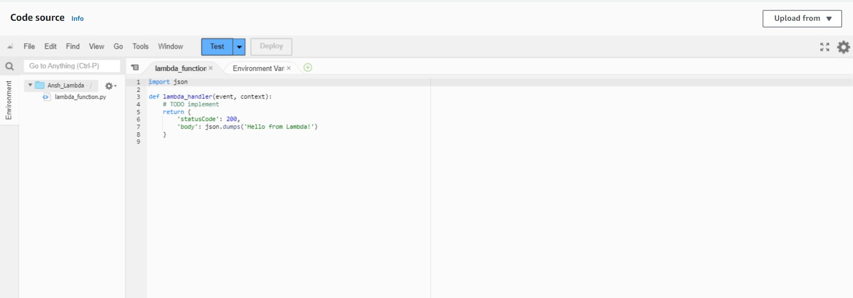

So See or Edit the basic settings go to configuration then click on edit general setting.

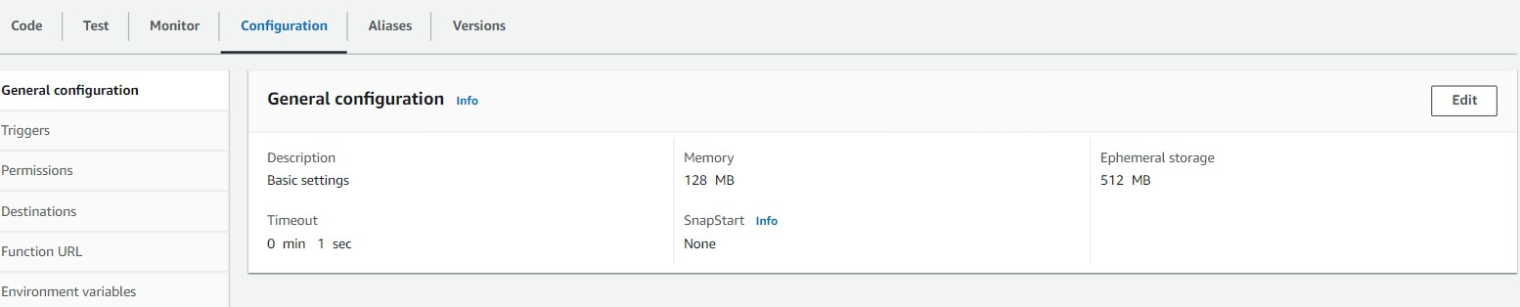

Here, you can enter a description and change Memory and Timeout. I’ve changed the Timeout period to 1 sec since that is sufficient for now.

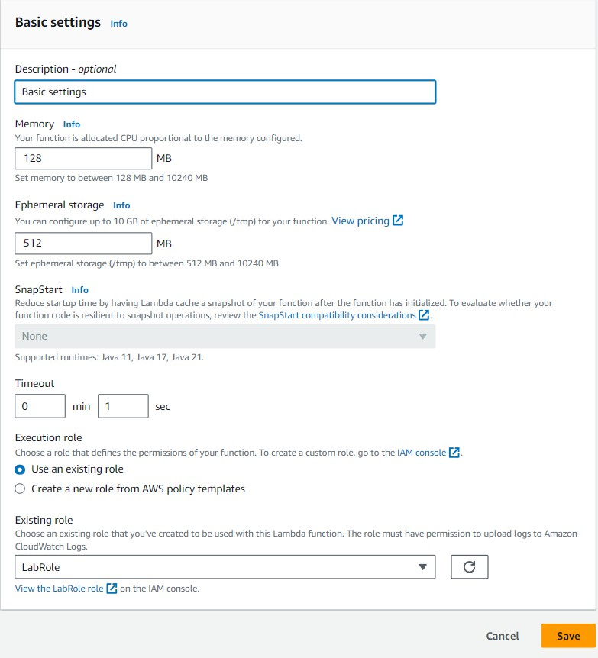

**Step 3:** Now Click on the Test tab then select Create a new event, give a name to the event and select Event Sharing to private, and select hello-world template.

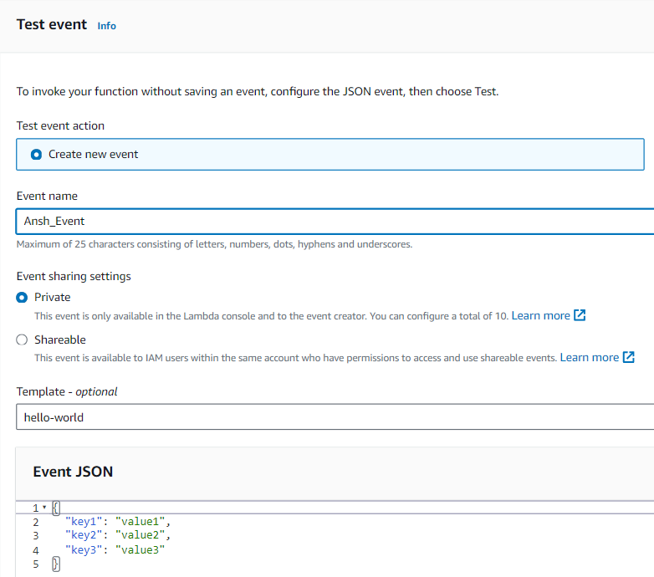

**Step 4:** Now In Code section select the created event from the dropdown of test then click on test . You will see the below output.

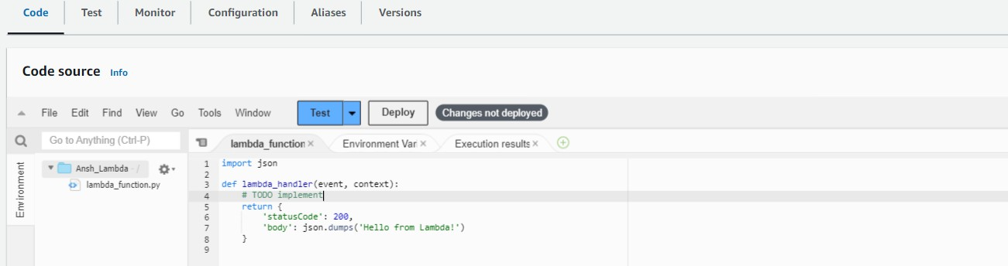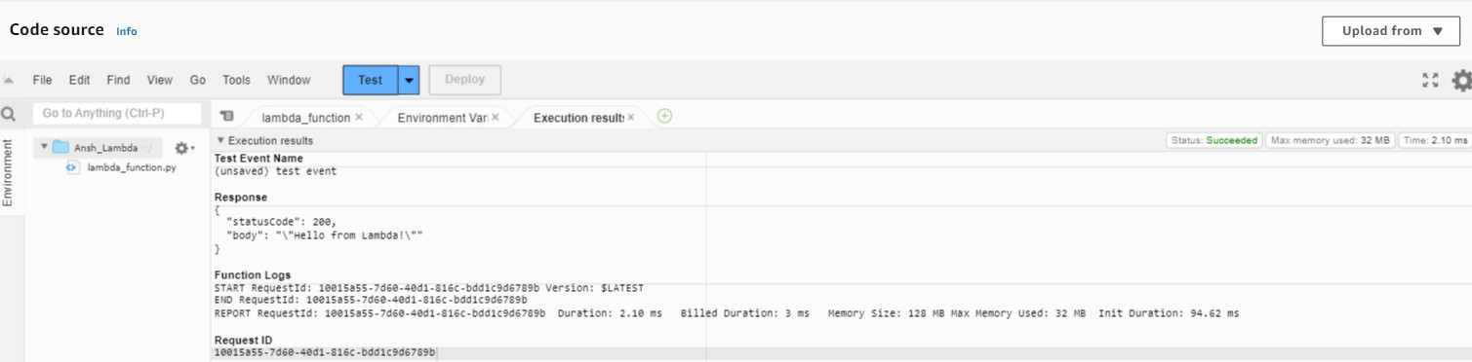

**Step 5:** You can edit your lambda function code. I have changed the code to display the new String.

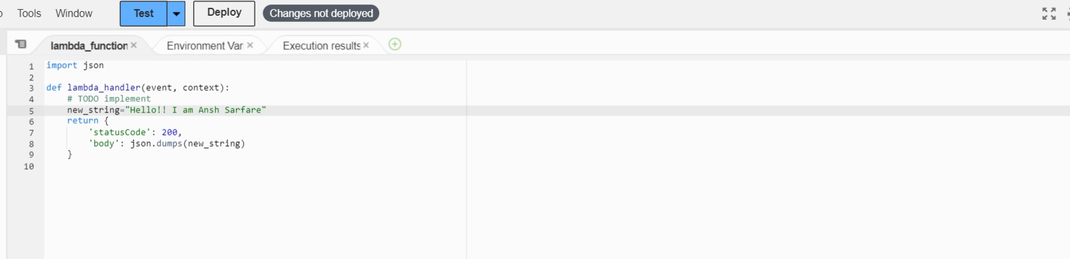

**Step 6:** Now click on the test and observe the output. We can see the status code 200 and your string output and function logs. On successful deployment.

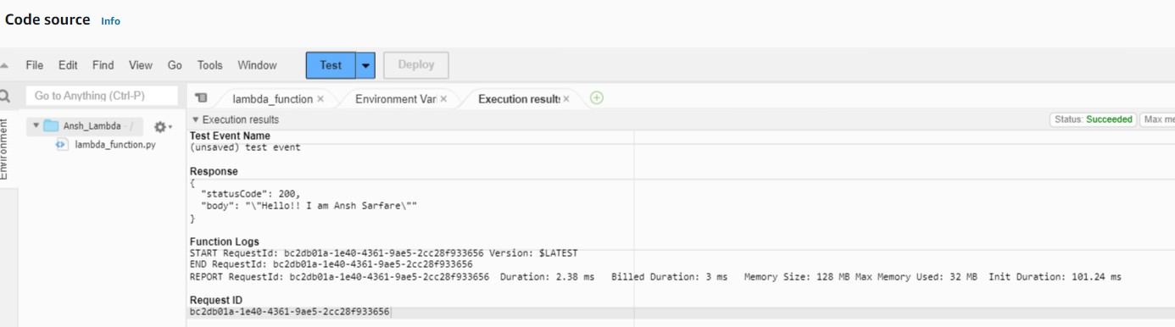

This error had occurred because the new string was not passed properly in the return statement

**error:**

