ADVANCE DEVOPS EXP-12

**MANORATH ITAL D15A/19**

**Aim:** To create a Lambda function which will log “An image has been added” once you add an object to a specific bucket in S3.

**Step 1:** Login to your AWS Personal account. Now open S3 from services and click on create S3 bucket and create a bucket.

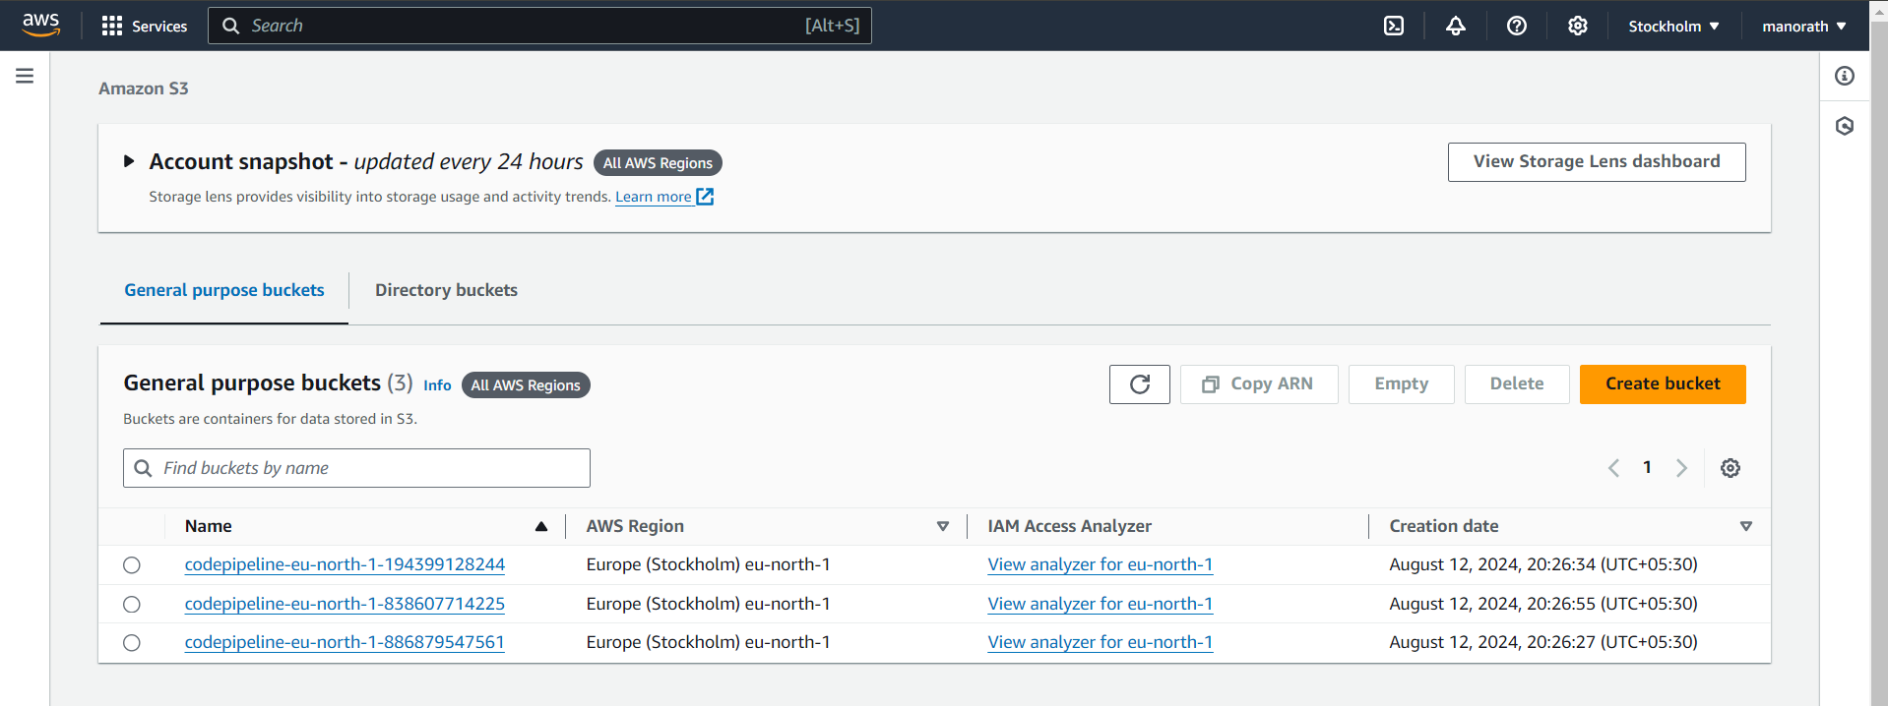

**Step 2:** Now Give a name to the Bucket, select general purpose project and deselect the Block public access and keep other this to default.

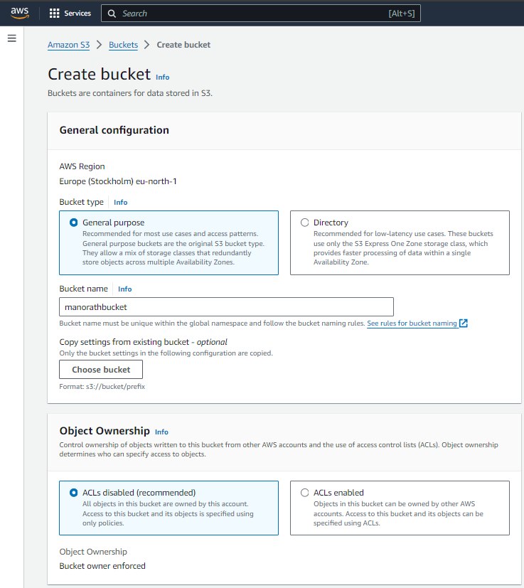

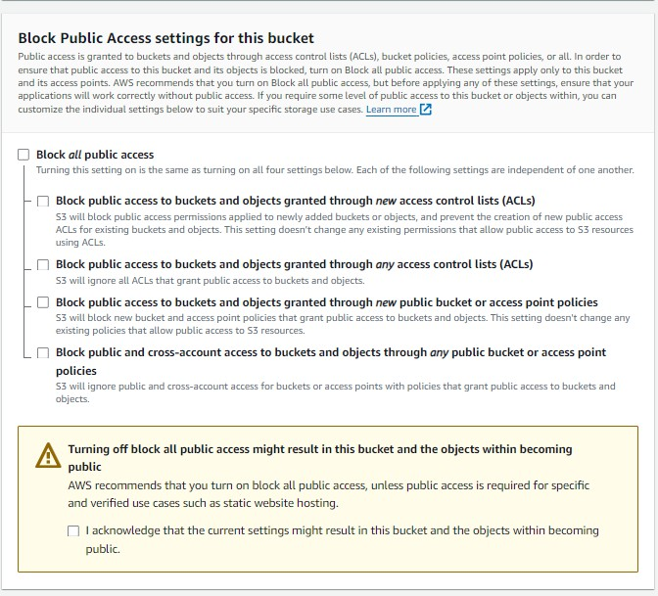

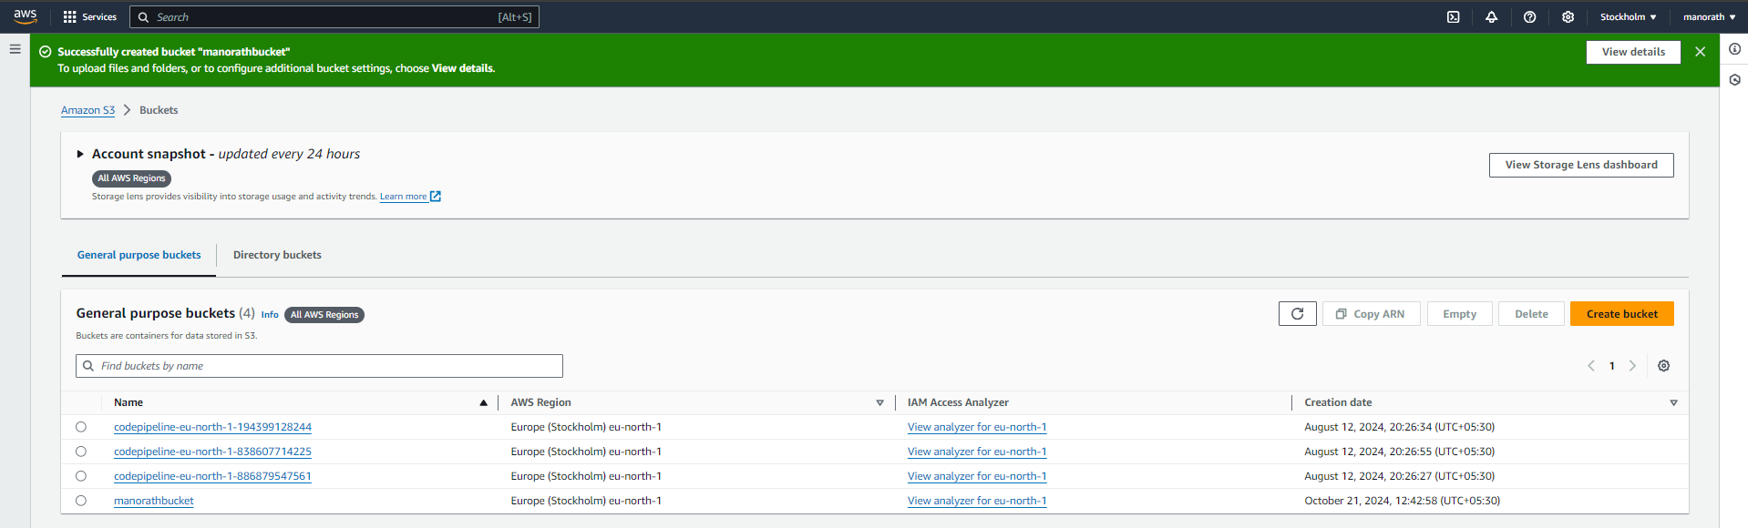

**Step 3:** Open lambda console and click on create function button.Give a name to your Lambda function, Select the language to use to write your function. Note that the console code editor supports only Node.js, Python, and Ruby. So will select Python 3.12

, Architecture as x86, and existing Execution role

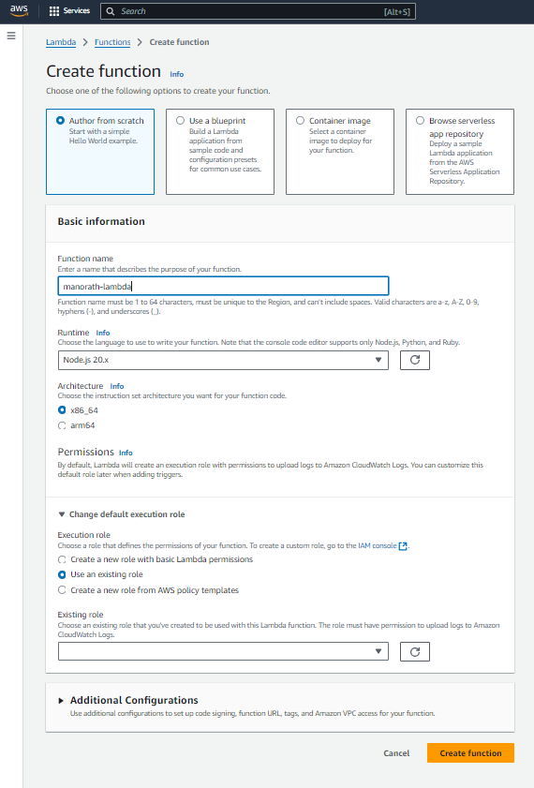

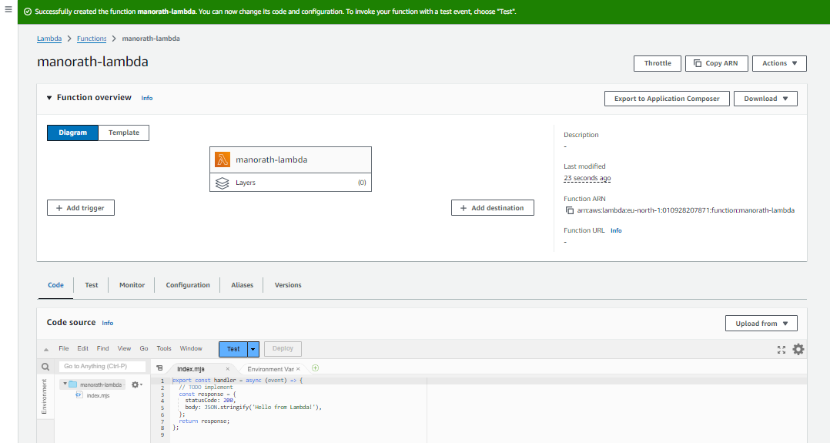

So See or Edit the basic settings go to configuration then click on edit general setting.

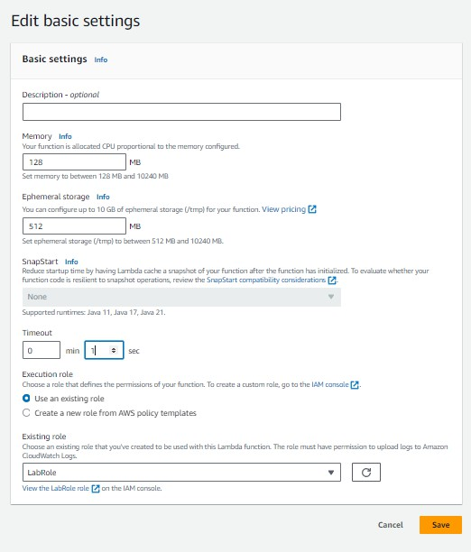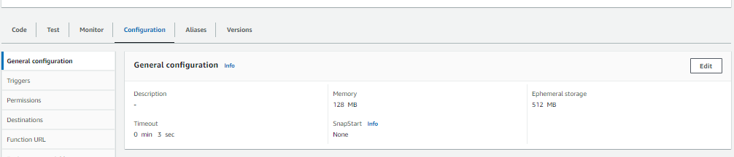

**Step 4:** Now Click on the Test tab then select Create a new event, give a name to the event and select Event Sharing to private, and select s3 put template.

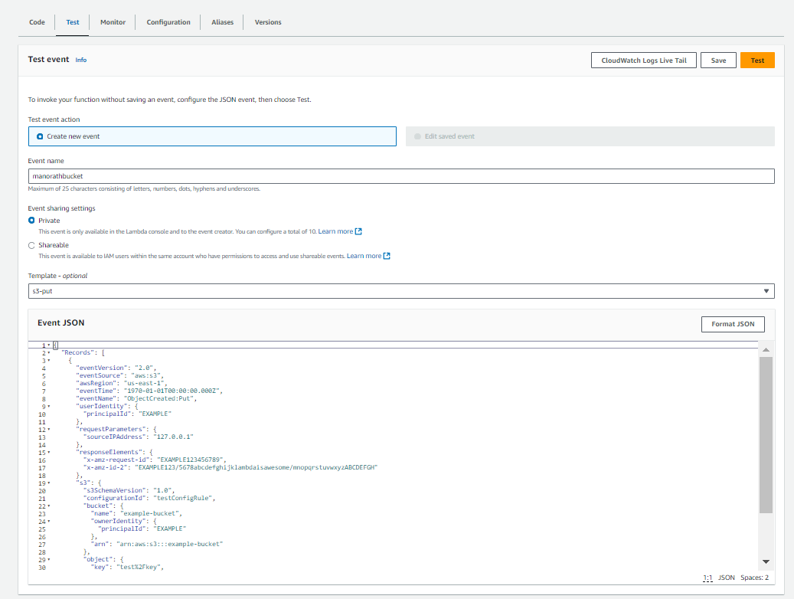

**Step 5:** Now In Code section select the created event from the dropdown .

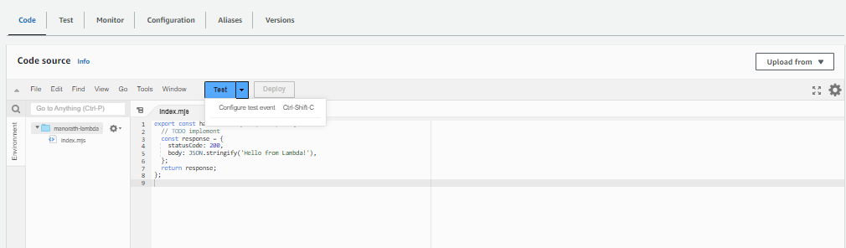

**Step 6:** Now In the Lambda function click on add tigger.

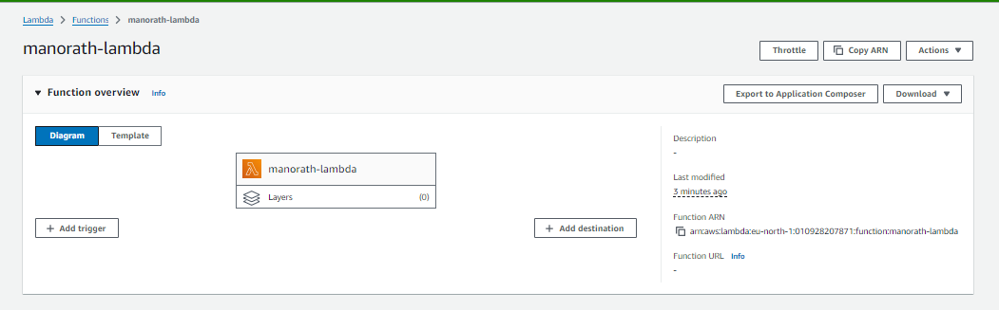

Now select the source as S3 then select the bucket name from the dropdown, keep other things to default and also you can add prefix to image.

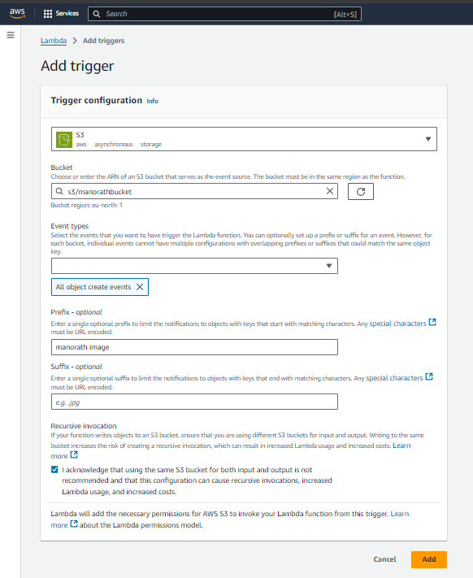

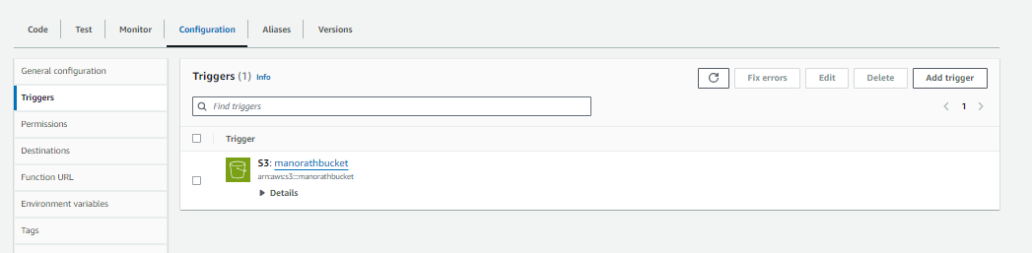

**Step 7:** Now Write code that logs a message like “An Image has been added” when triggered. Save the file and click on deploy

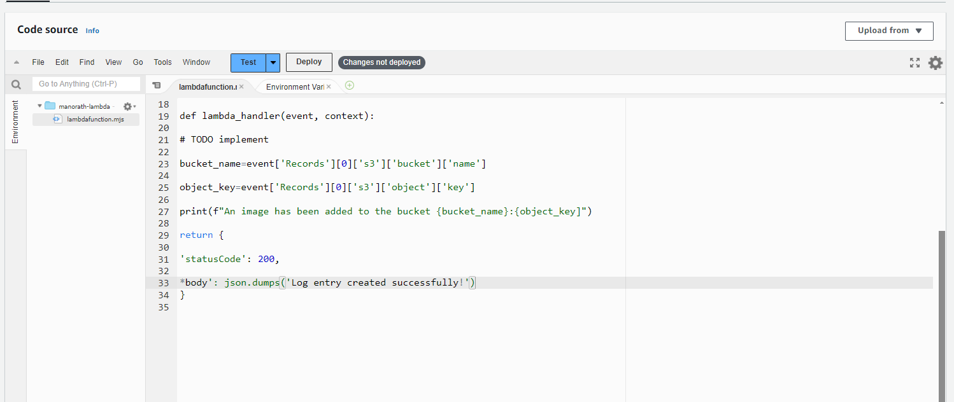

**Step 8:** Now upload any image to the bucket

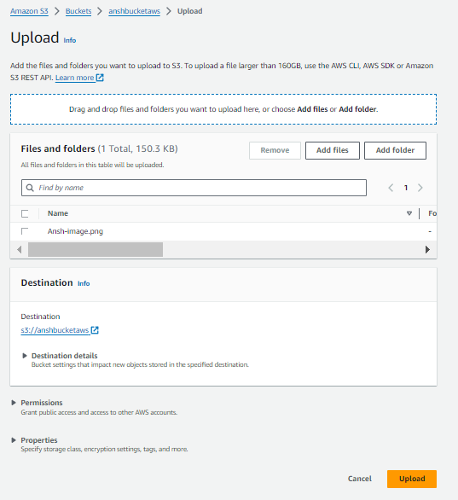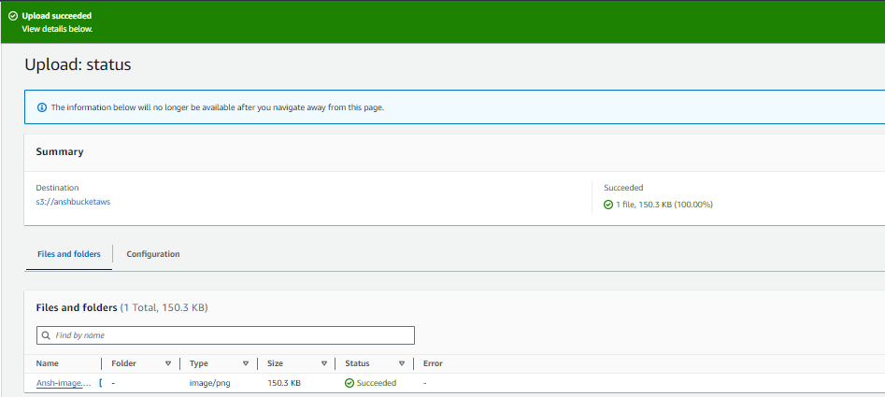

**Step 10:** Now to click on test in lambda to check whether it is giving log when image is added to S3.

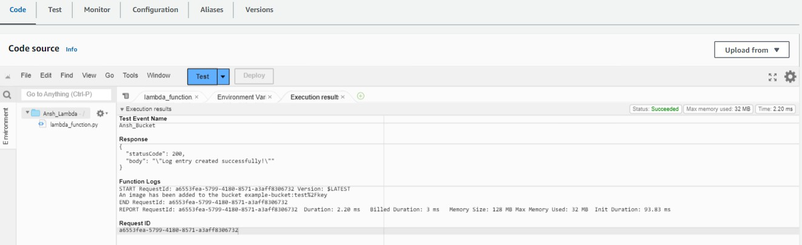

**Step 11:** Now Lets see the log on Cloud watch.To see it go to monitor section and then click on view cloudwatch logs.

