**EXPERIMENT NO: - 08**

**AIM:** - Create a Jenkins CICD Pipeline with SonarQube / GitLab Integration to perform a static analysis of the code to detect bugs, code smells, and security vulnerabilities on a sample Web / Java / Python application.

* Open up Jenkins Dashboard on localhost, port 8080 or whichever port it is at for you.
* Run SonarQube in a Docker container using this command –

docker run -d --name sonarqube -e SONAR_ES_BOOTSTRAP_CHECKS_DISABLE=true -p 9000:9000 sonarqube:latest

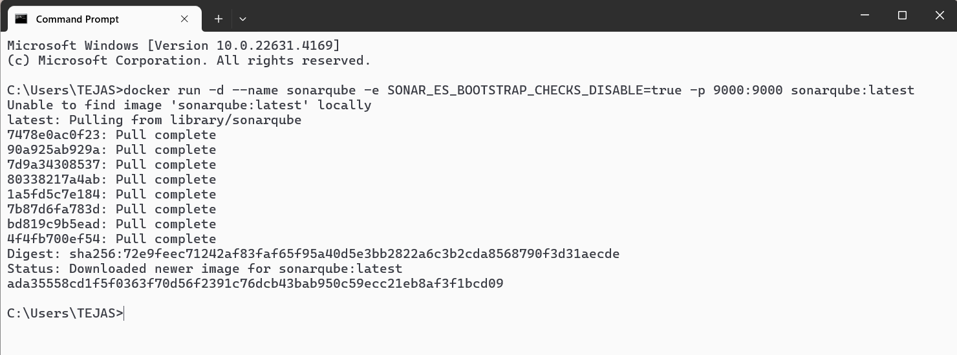

* Once the container is up and running, you can check the status of SonarQube at localhost port 9000. Login to SonarQube using username admin and password admin.

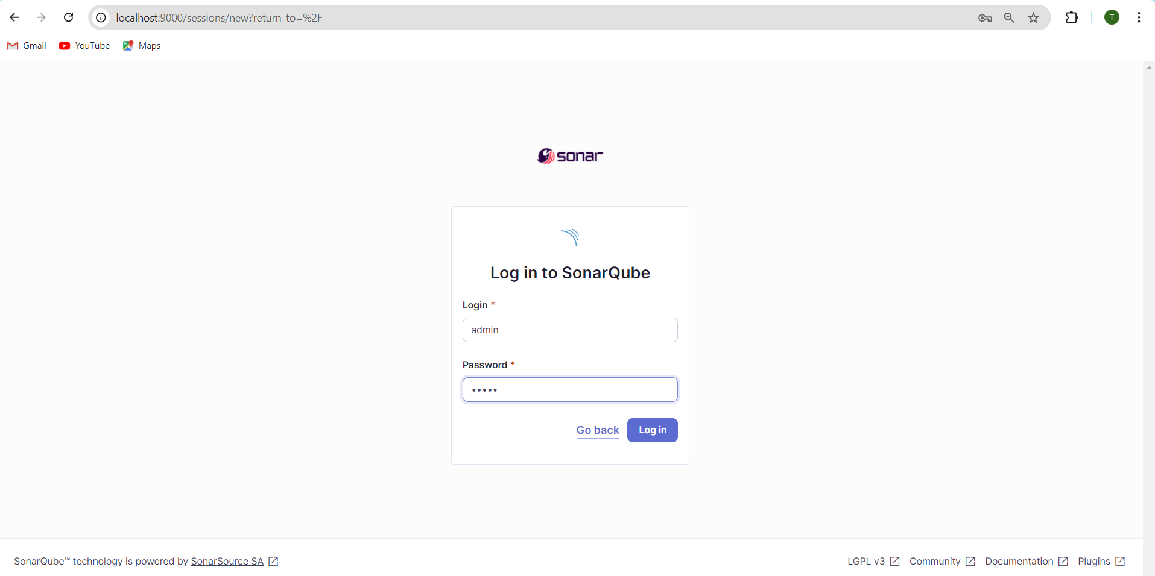

* It also gives an option to update the password, for the security purposes

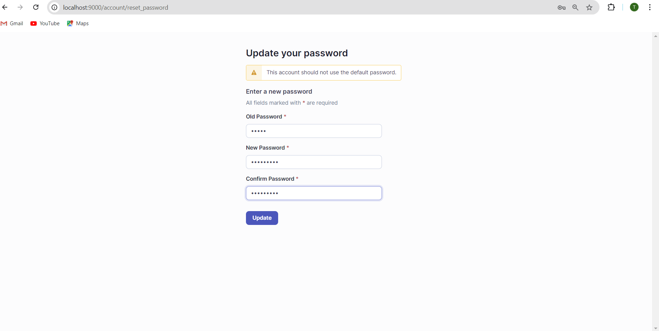

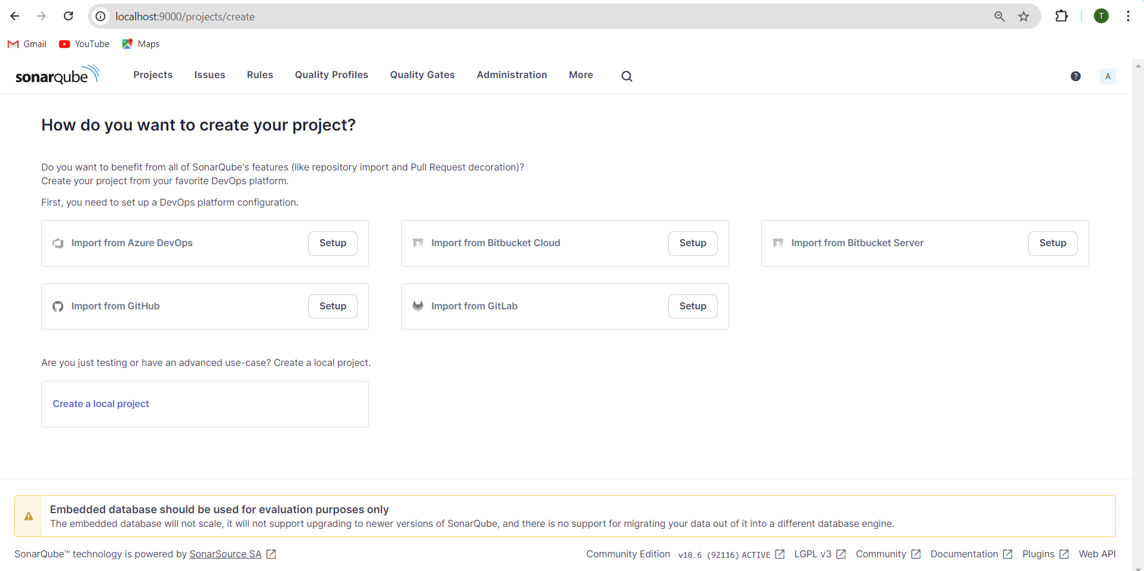

* Create a manual project in SonarQube with the name sonarqube-test

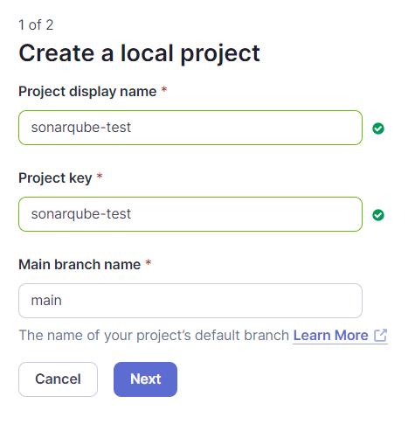

* Setup the project and come back to Jenkins Dashboard.

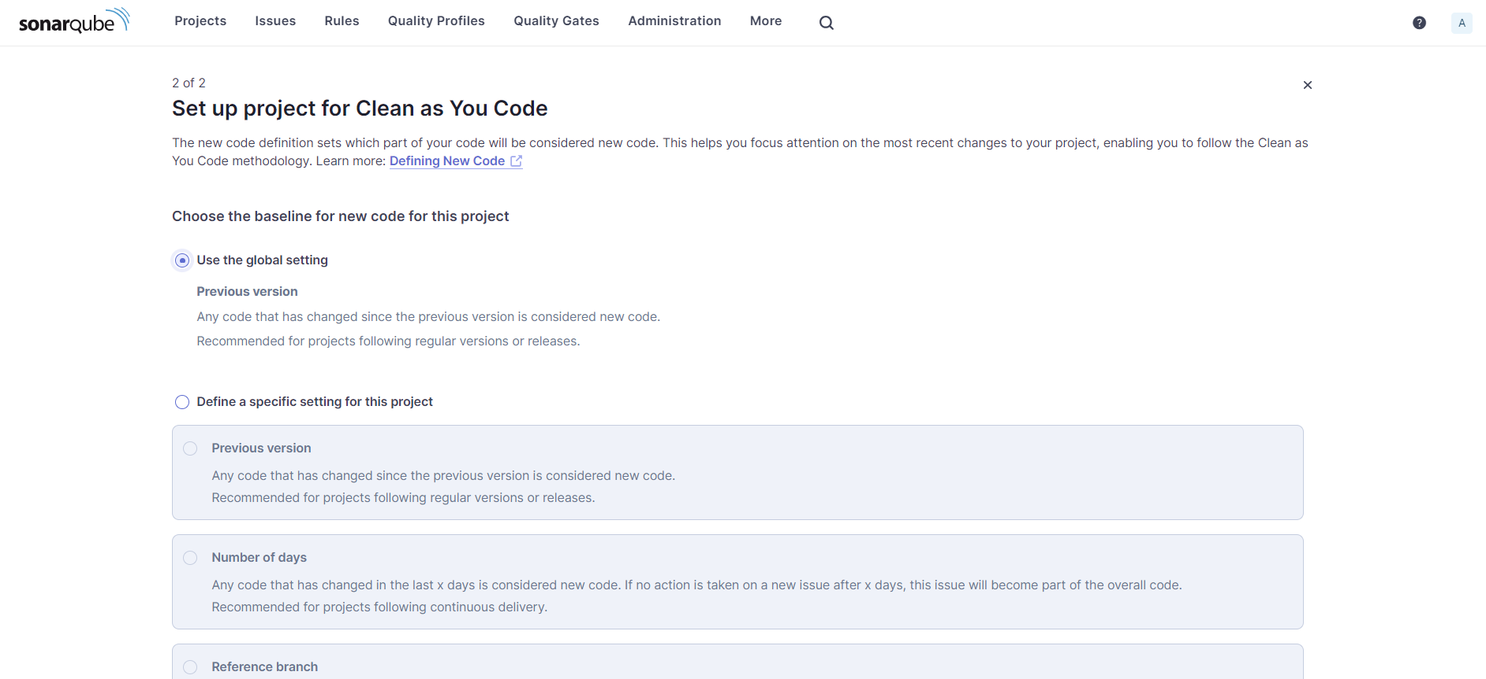

* Go to Manage Jenkins and search for SonarQube Scanner for Jenkins and install it.

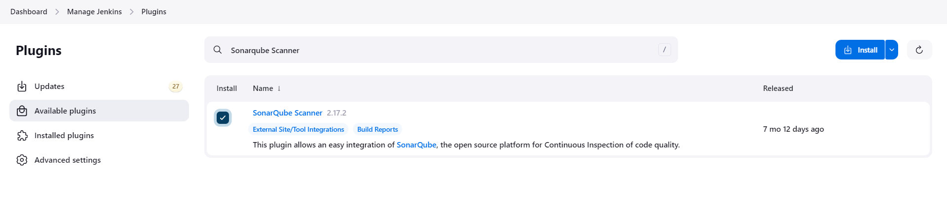

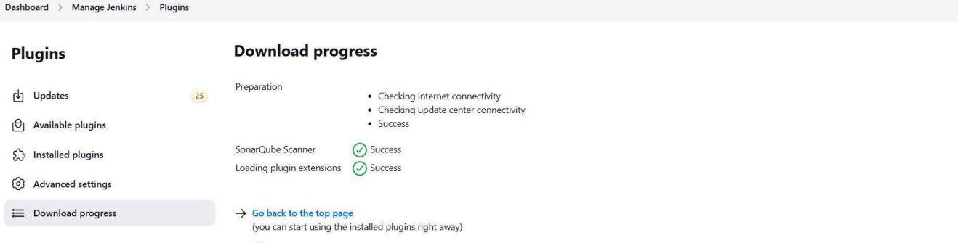

* Under Jenkins ‘Manage Jenkins’ then go to ‘system’, scroll and look for SonarQube Servers and enter the details. Enter the Server Authentication token if needed.

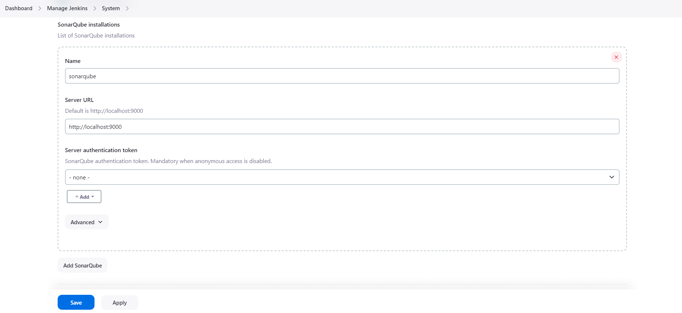

* Search for SonarQube Scanner under Global Tool Configuration. Choose the latest configuration and choose Install automatically. Dashboard > Manage Jenkins > Tools

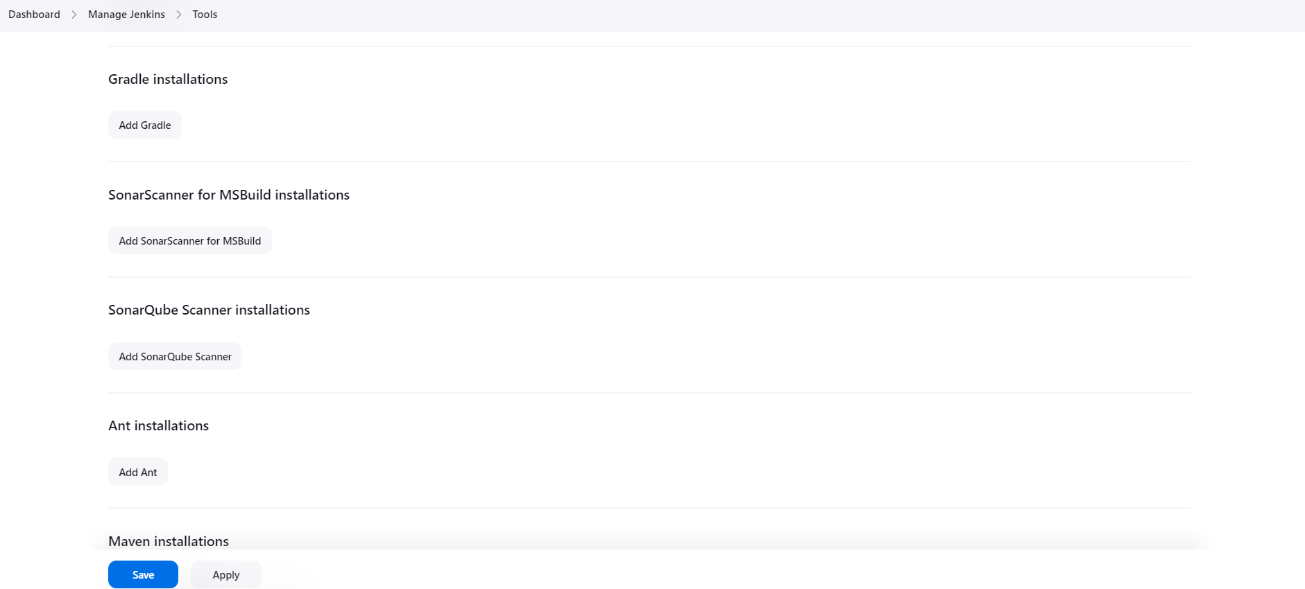

* Check the “Install automatically” option. → Under name any name as identifier → Check the “Install automatically” option.

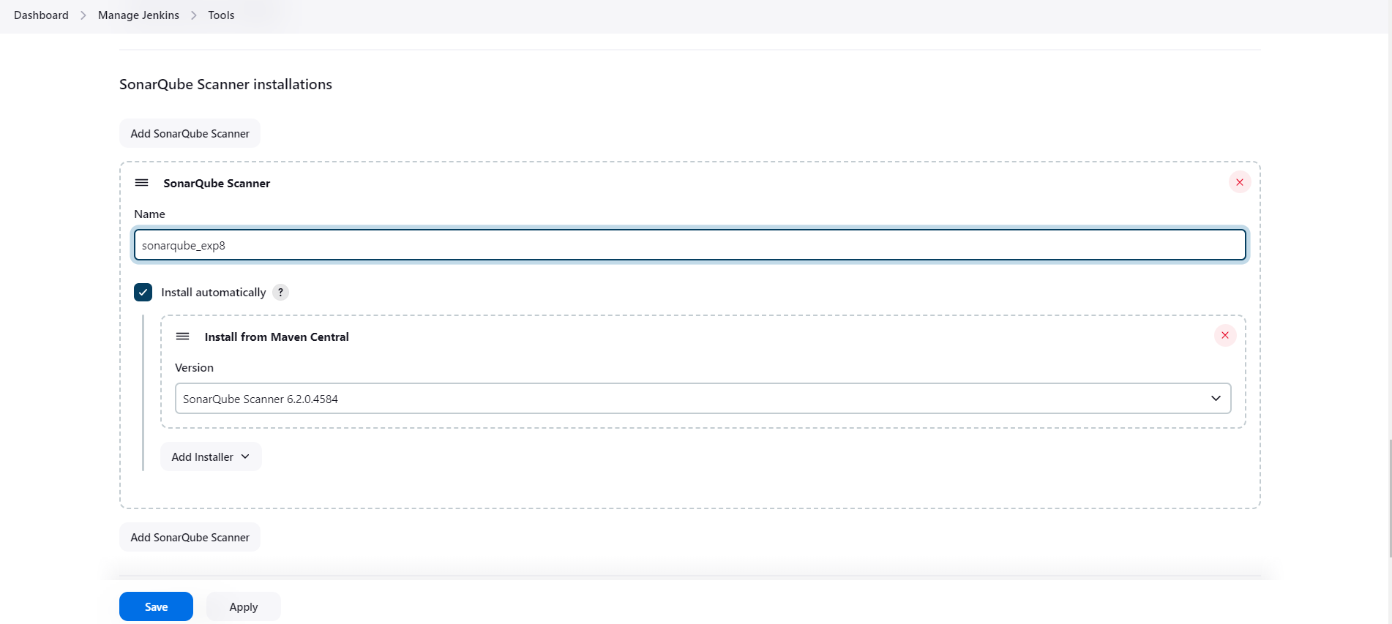

* Generating a token on sonarqubes for authentication [optional]

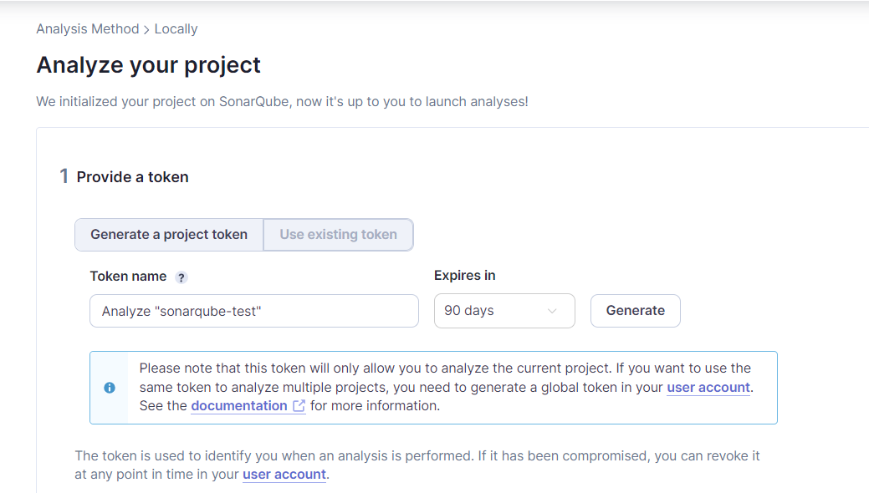

* Copy the token you get here and save it securely as we would need it in Jenkins.

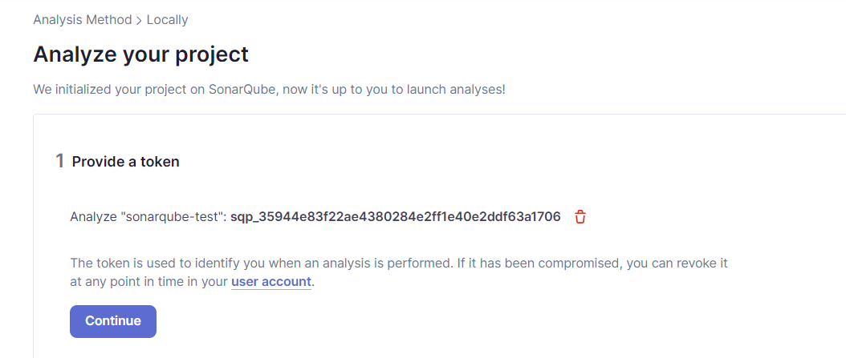

* Update the Token in Jenkins

Click on global under the domains part of Stores scoped to Jenkins section.Further click on add credentials.Proceed with the following details.Make sure to copy the token generated earlier in sonarqube and give any suitable name as the ID.

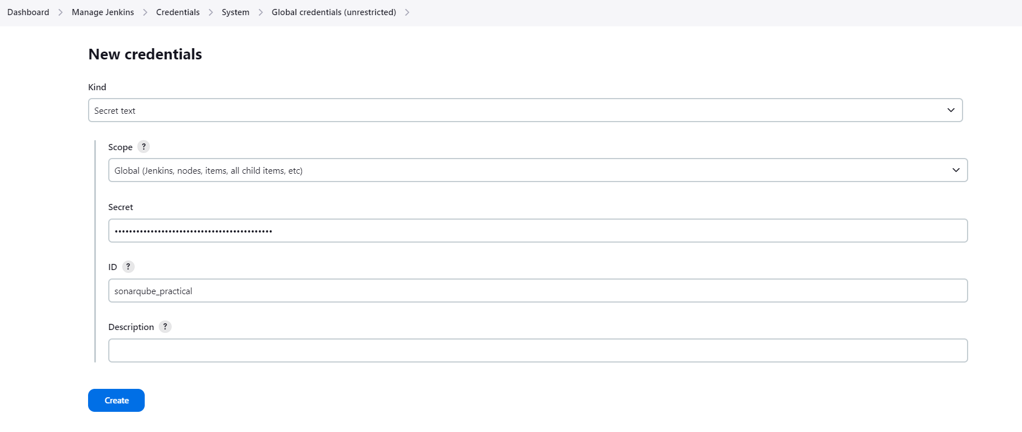

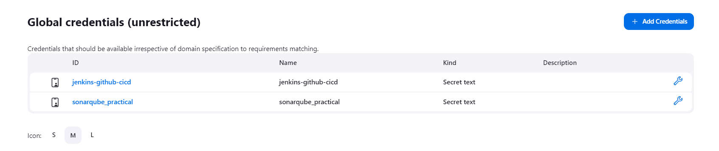

* Now go to Manage Jenkins—>System—>SonarQube servers and proceed with the following details. Reference the authentication token generated in the previous step.

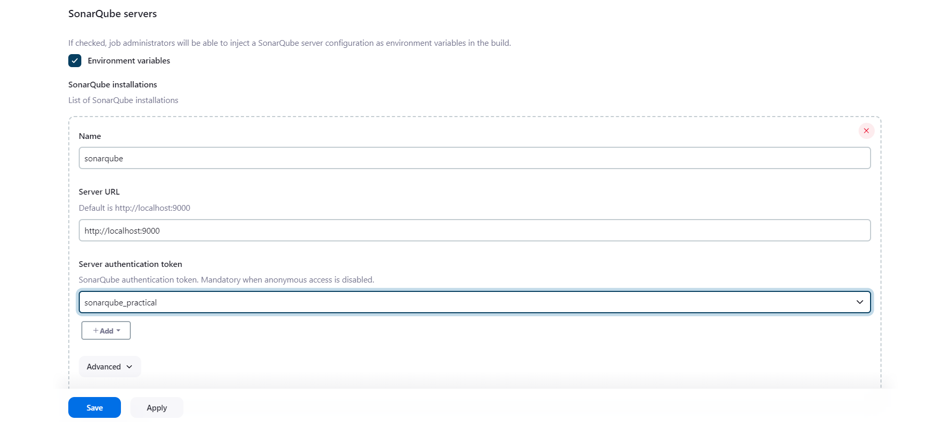

* After configuration, create a New Item → choose a pipeline project

Under Pipeline script, enter the following:

It is a java sample project which has a lot of repetitions and issues that will be detected by SonarQube.

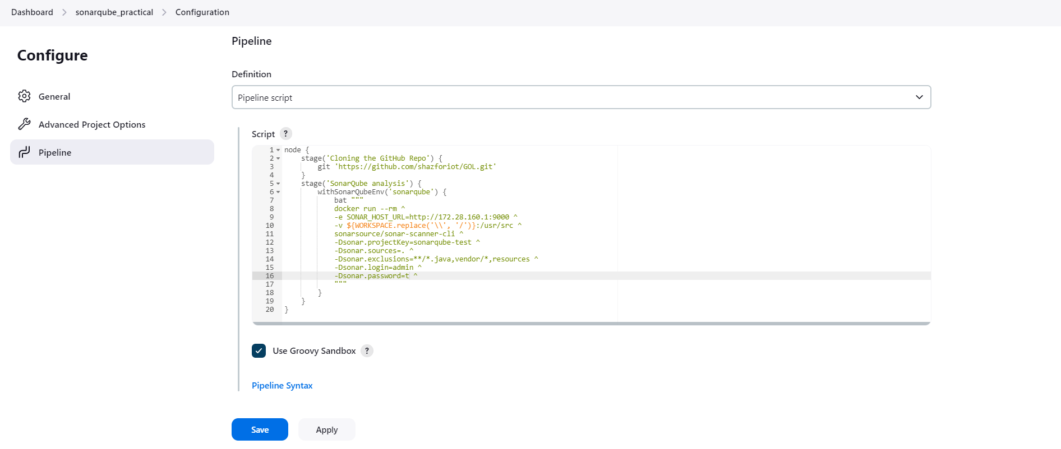

* Build project

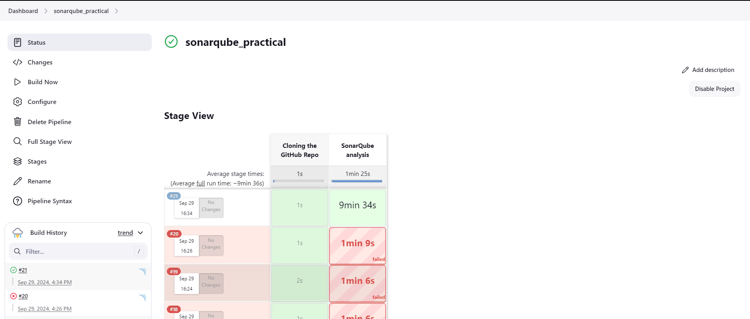

* Check Console

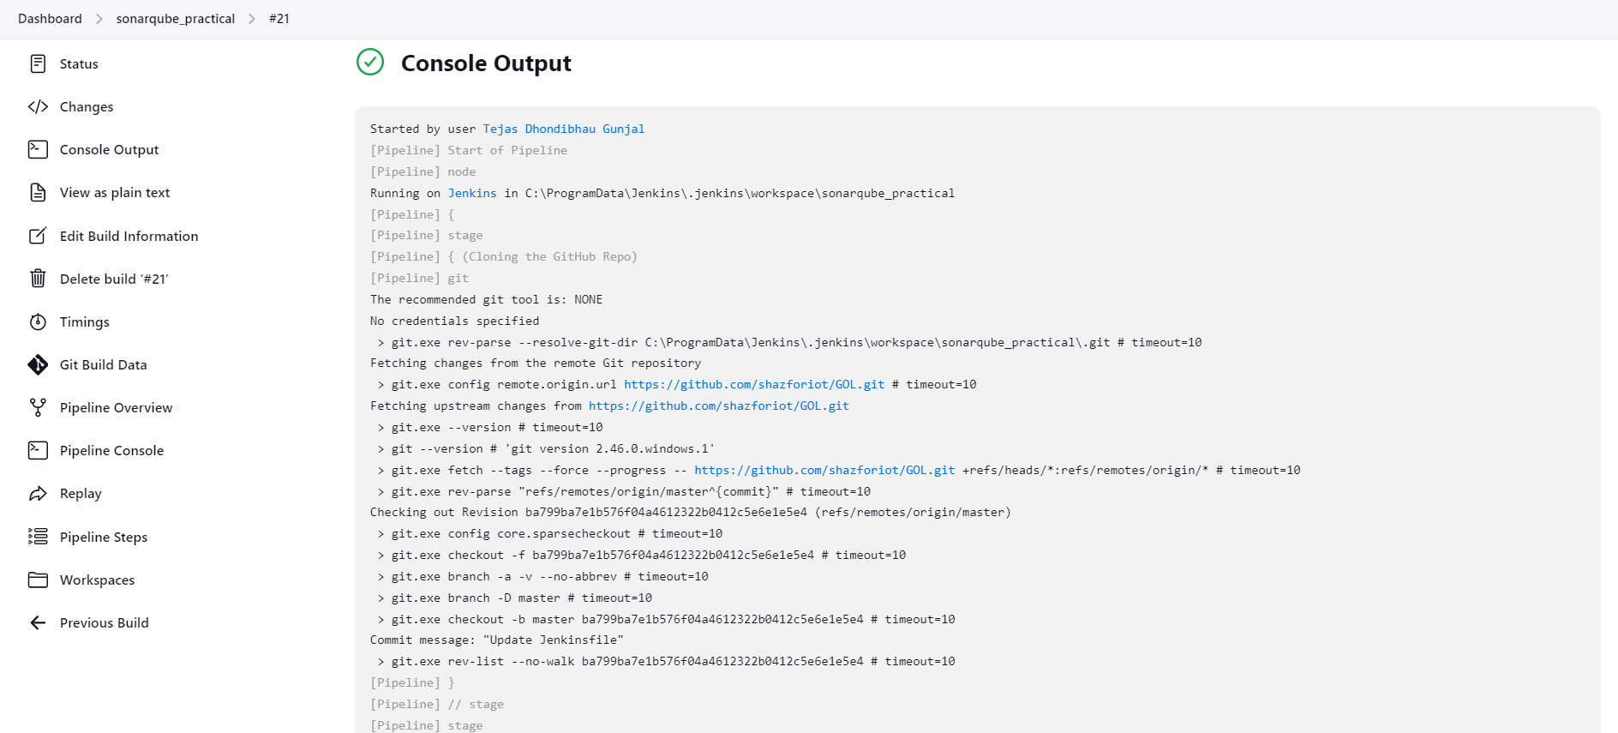



* Now, check the project in SonarQube

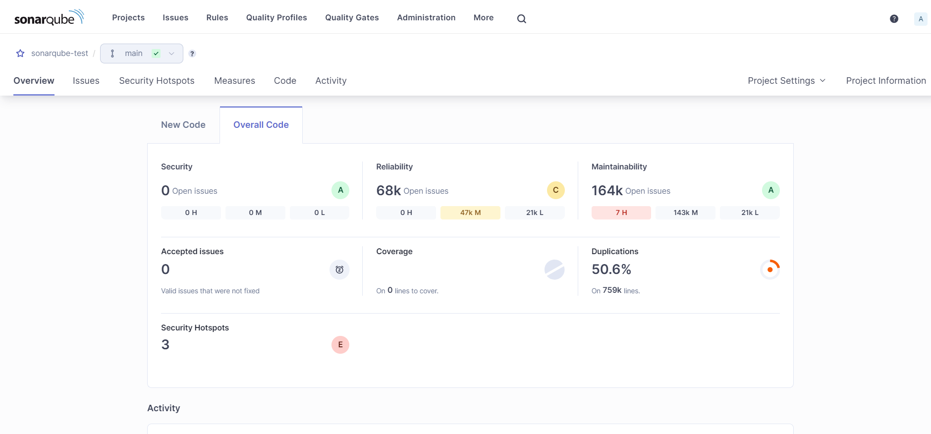

* Code Problems

Consistency

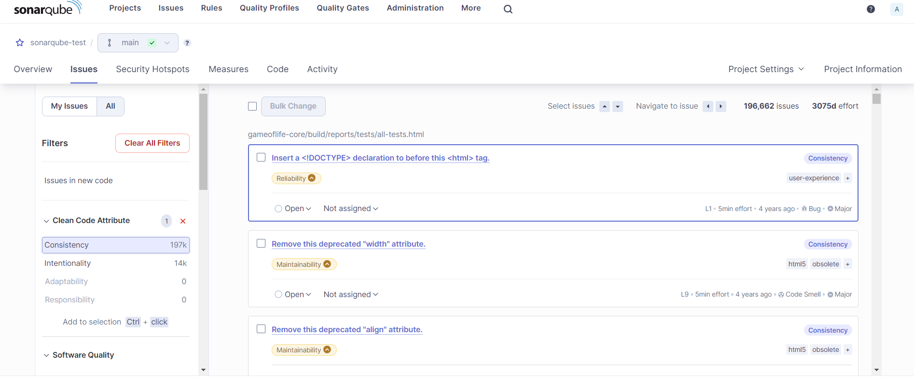

Intentionality

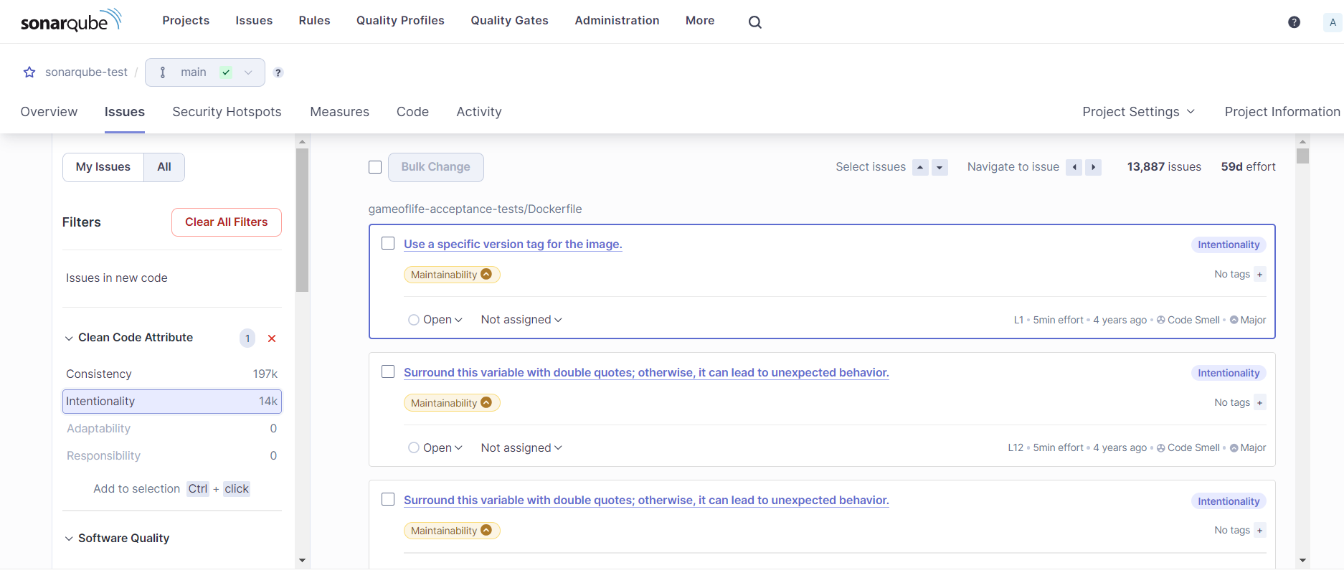

Bugs

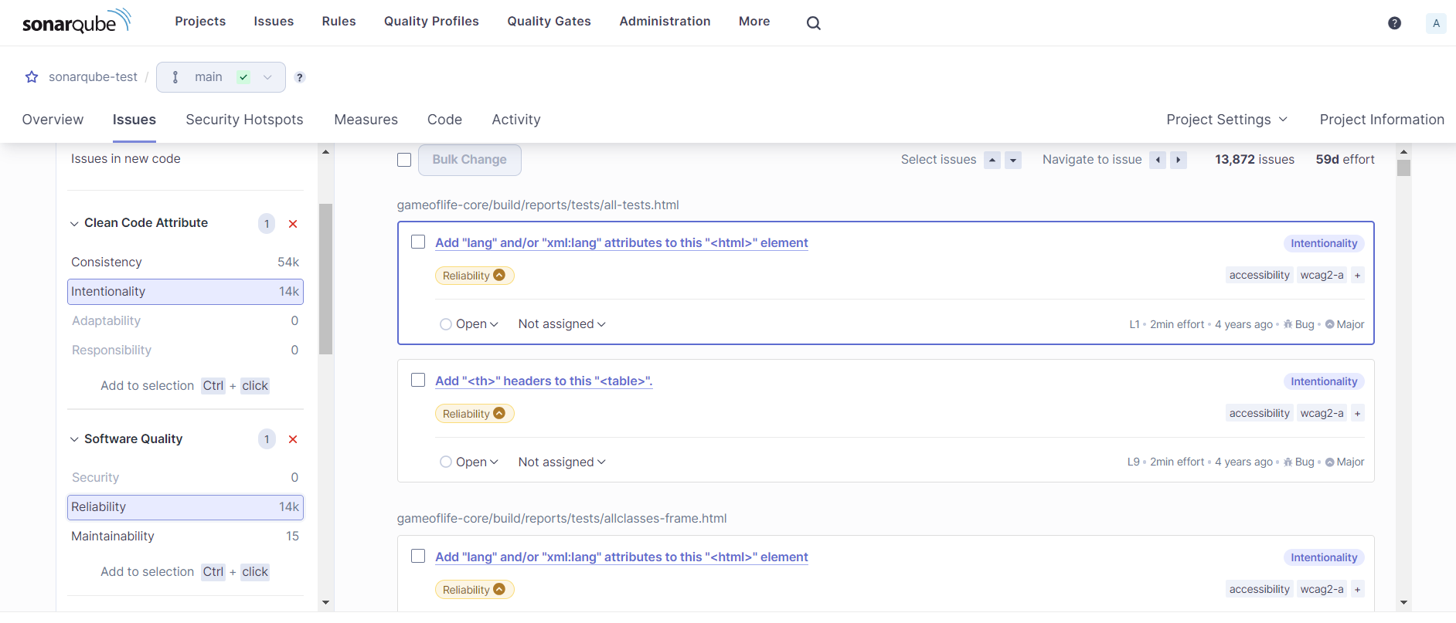

Code Smells

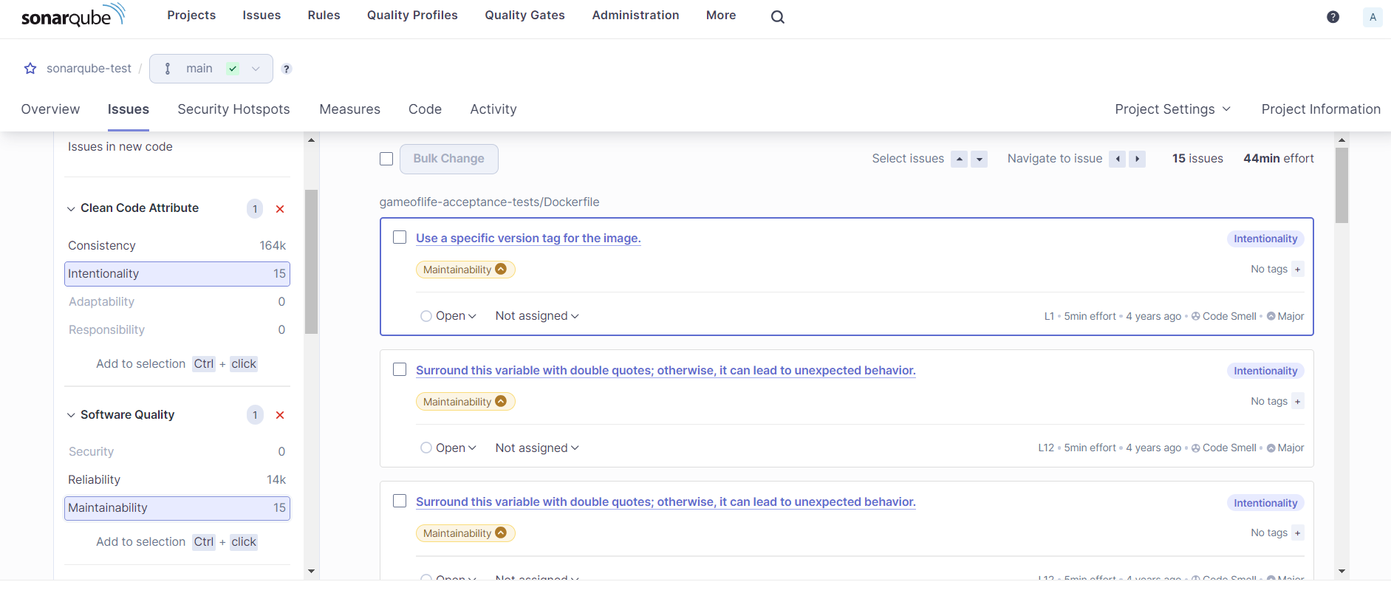

Reliability

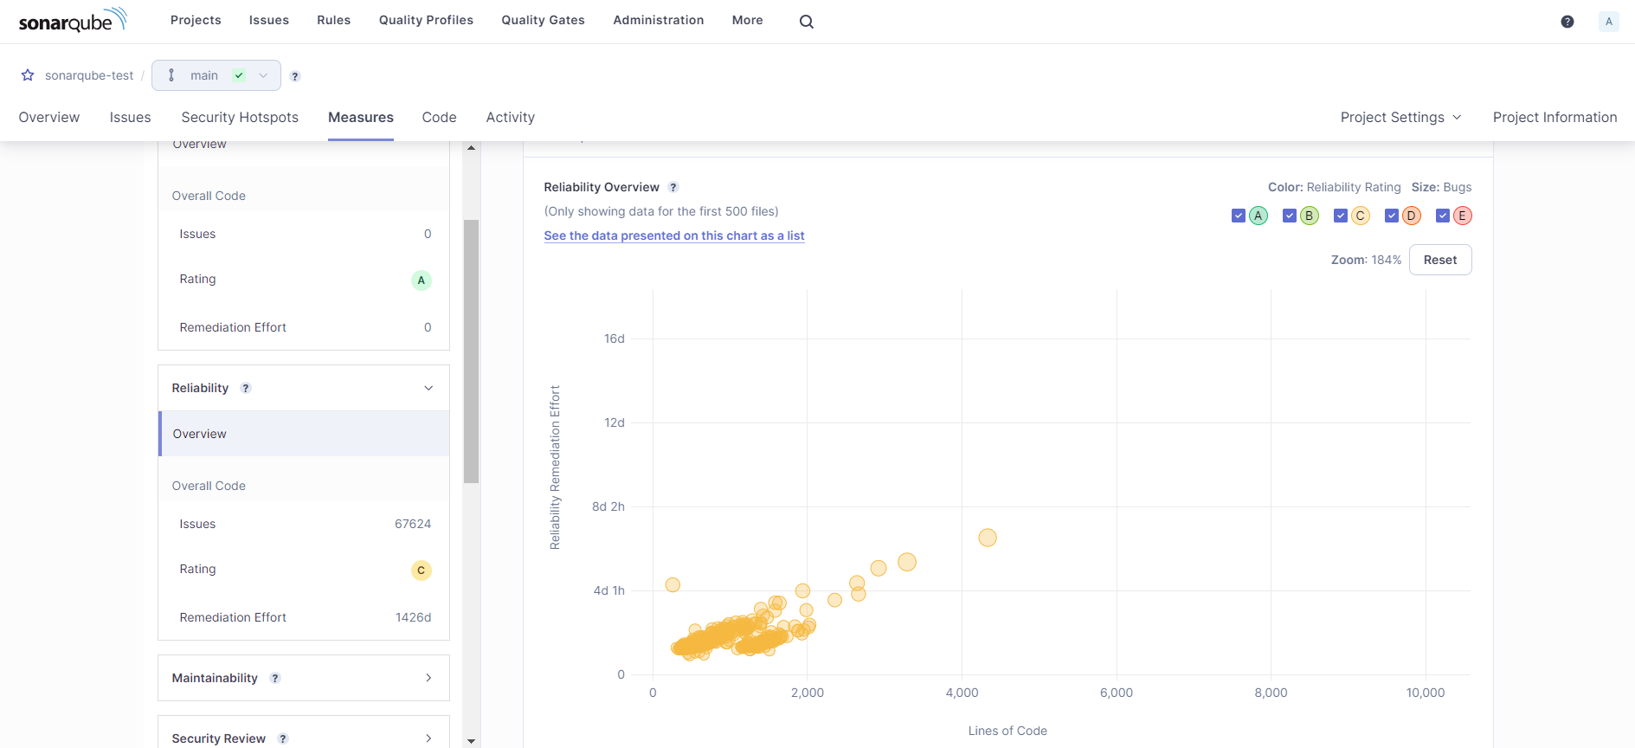

Duplications

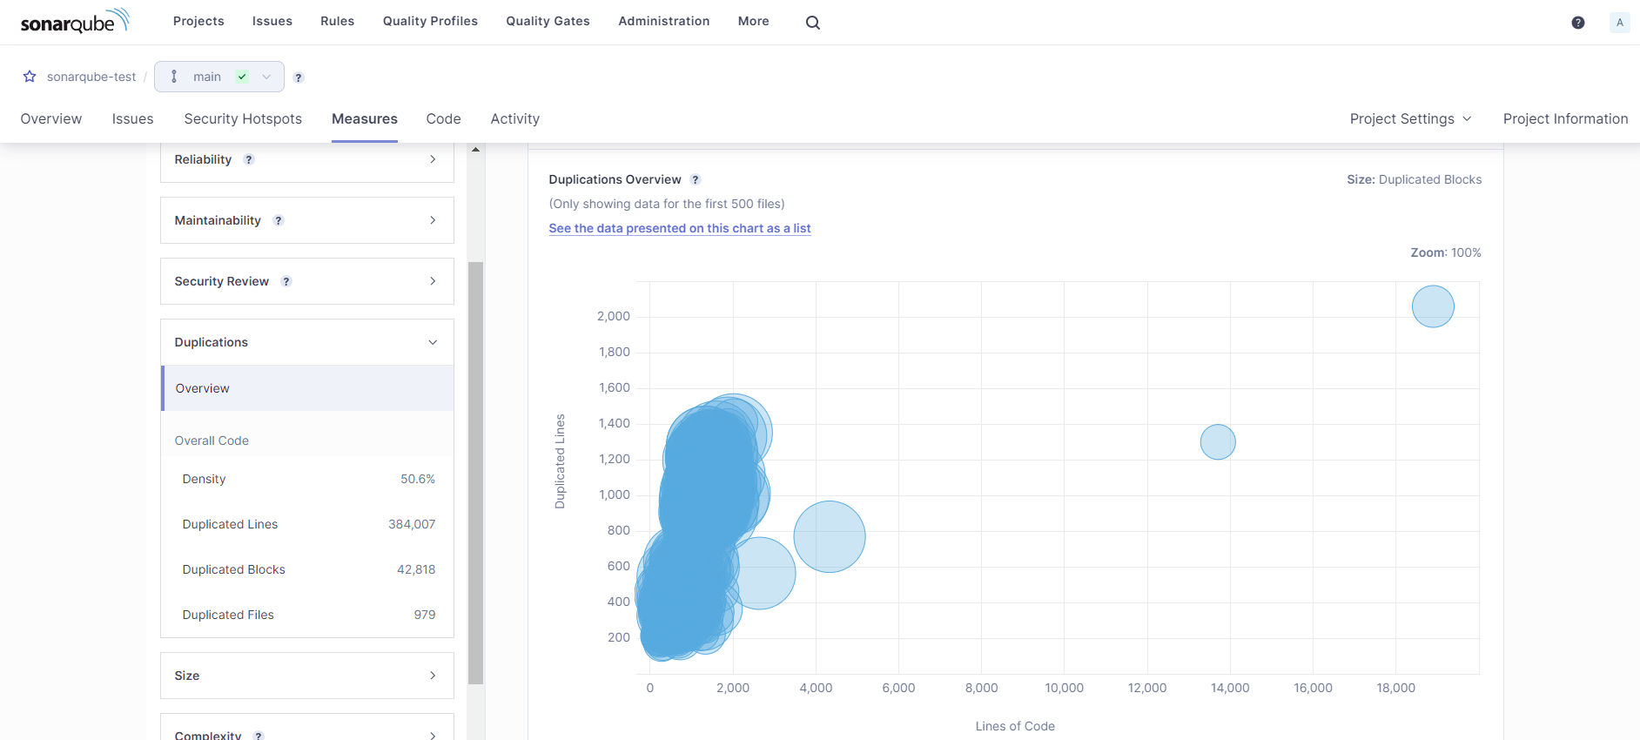

Cyclomatic Complexities

