AI ASSISTED LAB ASSIGNMENT – 6

RESPONSIVE AI

Name: U.V.MANOHAR REDDY

Roll_no:2503A52397

Batch_no:14

Task-1: generate a Python script that stores user data

(name, email, password) in a file. Revised version with encrypted password storage

(e.g., hashing and salt).

Analyze:

Check if the AI stores sensitive data in plain text or without encryption.

Input:

import hashlib

import secrets

# This revised script hashes passwords before storing them, improving security.

def hash_password(password, salt=None):

# Add a unique salt before hashing the password.

salt = salt or secrets.token_hex(16)

hashed_password = hashlib.pbkdf2_hmac(

'sha256', password.encode(), salt.encode(), 100_000

).hex()

return salt, hashed_password

def store_user_data_hashed_password(username, email, password, filename='user_data_hashed.txt'):

salt, hashed_pwd = hash_password(password)

with open(filename, 'a') as f:

f.write(f"Name: {username}, Email: {email}, Salt: {salt}, Hashed Password: {hashed_pwd}\n")

print(f"User data (with hashed password) stored in {filename}")

# Get user input

name_revised = input("Enter your name (Revised): ")

email_revised = input("Enter your email (Revised): ")

password_revised = input("Enter your password (Revised): ")

# Store data with hashed password

store_user_data_hashed_password(name_revised, email_revised, password_revised)

print("\nComparison:\n")

print(f"Original password: {password_revised}")

salt, hashed_password = hash_password(password_revised)

print(f"Salt: {salt}")

print(f"Hashed password (salted SHA-256): {hashed_password}")

Output:

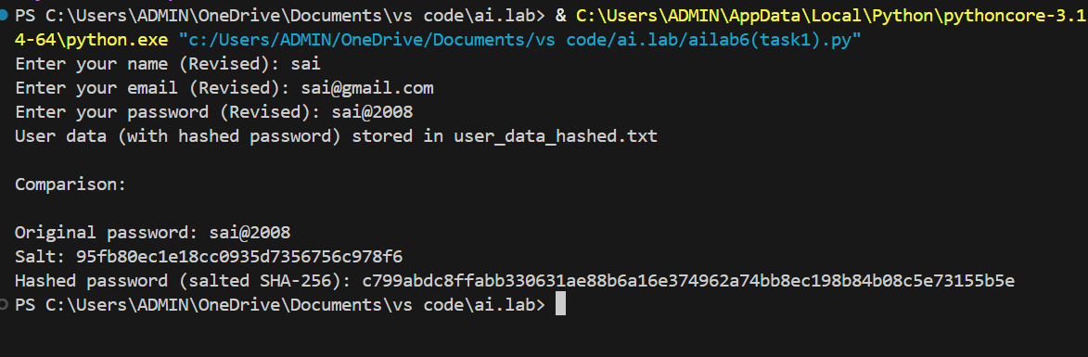

Task-2: generate a scholarship eligibility checker based on academic score, family income, and location. Examine whether the logic unfairly favors or disadvantages any group.

Analyze:

Code snippet with observations on fairness. Briefexplanation (3–4 sentences) suggesting improvements to ensure equitable decision-making.

Input:
"""Fair scholarship eligibility checker with fairness observations."""

def check_scholarship_eligibility(academic_score, family_income, location):
"""Evaluate eligibility using transparent academic and financial criteria."""
if not 0 <= academic_score <= 100:
raise ValueError("academic_score must be between 0 and 100")
if family_income < 0:
raise ValueError("family_income cannot be negative")

# Scores are published, reviewable, and location provides support only.
academic_points = academic_score * 0.6
financial_need_points = max(0, min(40, (60000 - family_income) / 1500))
support_locations = {"rural", "remote", "underserved"}
location_points = 5 if location.strip().lower() in support_locations else 0
total_score = academic_points + financial_need_points + location_points

return {
"eligible": total_score >= 60,
"score": round(total_score, 2),
"breakdown": {
"academic": round(academic_points, 2),
"financial_need": round(financial_need_points, 2),
"location_support": location_points,
},
}

# Fairness observations:
# 1. Academic score and income are explicit, measurable factors.
# 2. Location can disadvantage people if it acts as a proxy for race or access;
# this version gives limited support to underserved areas and excludes nobody.
# 3. One national income threshold may be unfair because living costs vary by area.
# 4. Approval rates should be audited across demographic groups, with human review
# for borderline cases and an appeal process.

if __name__ == "__main__":
print(check_scholarship_eligibility(85, 30000, "rural"))

# Improvements: Adjust income thresholds for regional living costs and use only
# necessary data. Test outcomes for disparate impact with diverse data, publish
# the criteria, allow appeals, and require human review of close decisions.

Output:

Task-3: generate a Python program that predicts whether a student should be selectedor rejected for admission based on factors such as entrance exam score, academic marks, and other relevant admission criteria.

Analyze:
Check whether the AI system provides a clear and understandable reason for its admission decision.
Input:
"""Task 3: Transparency in an AI-based admission system.

This example intentionally contrasts an opaque decision with an explainable one.
It is a classroom demonstration, not a real admissions system.
"""

def opaque_admission_decision(student):
"""Return a decision without explaining how it was reached."""
score = (
0.45 * student["entrance_score"]
+ 0.35 * student["academic_marks"]
+ 0.20 * student["interview_score"]
)
return "Selected" if score >= 70 else "Rejected"

def transparent_admission_decision(student):
"""Return a decision together with the factors and their contributions."""
weights = {
"entrance_score": 0.45,
"academic_marks": 0.35,
"interview_score": 0.20,
}
contributions = {
name: student[name] * weight for name, weight in weights.items()
}
total = sum(contributions.values())
decision = "Selected" if total >= 70 else "Rejected"

influential = sorted(contributions.items(), key=lambda item: item[1], reverse=True)
reasons = [
f"{name.replace('_', ' ').title()}: {student[name]:.1f}/100 "
f"(contribution {value:.2f})"
for name, value in influential
]
reasons.append(f"Weighted total: {total:.2f}/100; selection threshold: 70.00")
return decision, reasons

def main():
student = {
"name": "Amina",
"entrance_score": 82,
"academic_marks": 76,
"interview_score": 68,
}

print("TRANSPARENCY RISKS")
print("- An opaque system gives a decision without a reason.")
print("- Students cannot identify errors, appeal fairly, or understand the criteria.")
print("- Hidden data or biased weights may produce unfair outcomes.")

print("\nOPAQUE EXAMPLE (no explanation)")
print(f"{student['name']}: {opaque_admission_decision(student)}")

decision, reasons = transparent_admission_decision(student)
print("\nREVISED TRANSPARENT VERSION")
print(f"{student['name']}: {decision}")
print("Important factors influencing the decision:")
for reason in reasons:
print(f"- {reason}")

if __name__ == "__main__":
main()

Output:
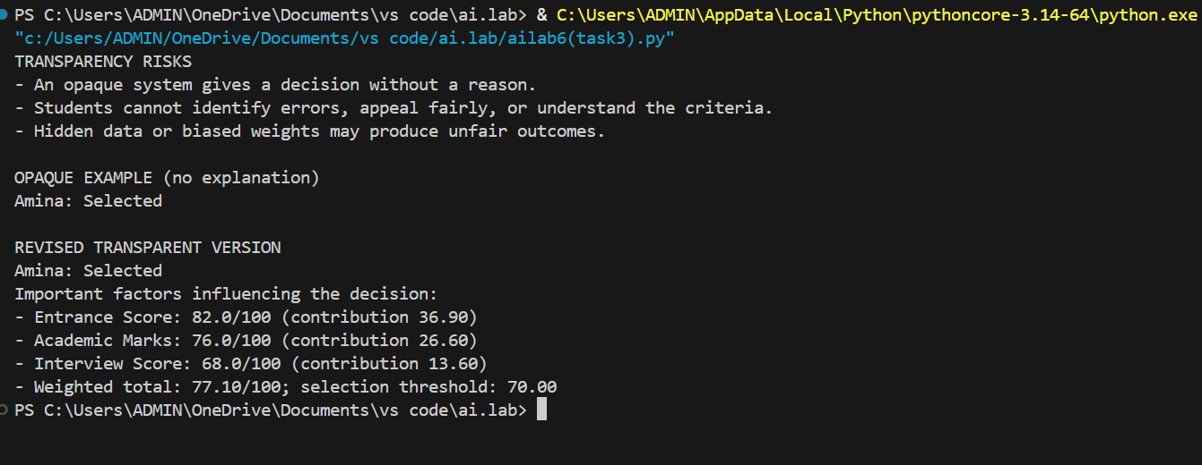

Task-4: Generate an employee performance evaluation system using inputs such as project completion rate, teamwork score, and attendance. Analyze the scoring logic for any unethical weighting or hidden bias.
Analyze:

Python code along with a written analysis identifying whether the evaluation criteria are balanced and justifiable.

Input:
"""Task 4: Ethical employee performance scoring system.

The weights are explicit, configurable, and reviewed for potential bias. This
example is a decision-support tool; it must not be the sole basis for hiring,
pay, promotion, or dismissal decisions.
"""

from dataclasses import dataclass

@dataclass
class Employee:
name: str
completion_rate: float # 0-100
teamwork_score: float # 0-100, based on documented peer/manager evidence
attendance: float # 0-100, excluding approved/protected leave

WEIGHTS = {
"completion_rate": 0.40,
"teamwork_score": 0.35,
"attendance": 0.25,
}

def validate_weights(weights):
if any(weight < 0 for weight in weights.values()):
raise ValueError("Weights cannot be negative.")
if abs(sum(weights.values()) - 1.0) > 1e-9:
raise ValueError("Weights must add up to 1.0.")

def validate_employee(employee):
for field in ("completion_rate", "teamwork_score", "attendance"):
value = getattr(employee, field)
if not 0 <= value <= 100:
raise ValueError(f"{field} must be between 0 and 100.")

def calculate_score(employee, weights=WEIGHTS):
validate_weights(weights)
validate_employee(employee)
return sum(getattr(employee, metric) * weight
for metric, weight in weights.items())

def rating(score):
if score >= 90:
return "Outstanding"
if score >= 75:
return "Strong"
if score >= 60:
return "Developing"
return "Needs support"

def ethical_review(weights=WEIGHTS):
"""Flag design risks rather than making unsupported claims about people."""
validate_weights(weights)
warnings = []
if weights.get("attendance", 0) > 0.30:
warnings.append("Attendance has a high weight; exclude approved/protected leave and consider flexible work.")
if weights.get("teamwork_score", 0) > 0.40:
warnings.append("Teamwork is subjective at this weight; use multiple documented raters and a clear rubric.")
if weights.get("completion_rate", 0) > 0.60:
warnings.append("Completion rate may favor easy projects; adjust for project scope and resources.")
if not warnings:
warnings.append("No obvious weighting concern; still audit outcomes for disparate impact and allow review.")
return warnings

def read_score(label):
while True:
try:
value = float(input(f"{label} (0-100): "))
if 0 <= value <= 100:
return value
except ValueError:
pass
print("Enter a number from 0 to 100.")

def main():
print("Ethical Employee Performance Evaluation")
employee = Employee(
input("Employee name: ").strip() or "Unnamed employee",
read_score("Project completion rate"),
read_score("Teamwork score"),
read_score("Attendance (approved/protected leave excluded)"),
)
score = calculate_score(employee)
print(f"\nScore: {score:.2f}/100")
print(f"Rating: {rating(score)}")
print("\nEthical review:")
for warning in ethical_review():
print(f"- {warning}")
print("Use documented evidence, explain the result, and provide an appeal or human review.")

if __name__ == "__main__":
main()

Output:

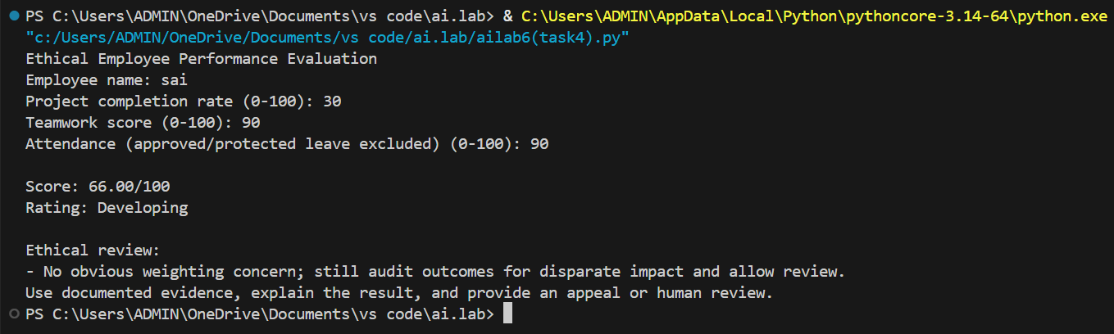

Task-5: generate a user feedback form application. Review whether the language and options provided are inclusive and accessible to diverse users.

Analyze:
Revised version of the form code that uses inclusive language, supports accessibility features, and avoids exclusionary assumptions.

Input:
"""Task 5: Accessible and inclusive user feedback form."""

import tkinter as tk
from tkinter import messagebox, ttk

class FeedbackForm(tk.Tk):
def __init__(self):
super().__init__()
self.title("Inclusive User Feedback")
self.geometry("650x600")
self.minsize(550, 500)

style = ttk.Style(self)
style.configure("TLabel", font=("Arial", 11))
style.configure("Heading.TLabel", font=("Arial", 17, "bold"))
style.configure("TButton", font=("Arial", 11), padding=7)

form = ttk.Frame(self, padding=20)
form.pack(fill="both", expand=True)
form.columnconfigure(1, weight=1)

ttk.Label(form, text="Share your feedback", style="Heading.TLabel").grid(
row=0, column=0, columnspan=2, sticky="w"
)
ttk.Label(
form,
text="Questions marked * are required. You may skip optional questions.",
wraplength=600,
).grid(row=1, column=0, columnspan=2, sticky="w", pady=(5, 18))

ttk.Label(form, text="* How would you rate your experience?").grid(
row=2, column=0, sticky="w", pady=7
)
self.rating = tk.StringVar()
self.rating_box = ttk.Combobox(
form,
textvariable=self.rating,
values=("Excellent", "Good", "Okay", "Poor", "Very poor", "Prefer not to say"),
state="readonly",
)
self.rating_box.grid(row=2, column=1, sticky="ew", pady=7)
self.rating_box.set("Select an option")

ttk.Label(form, text="What could we improve?").grid(
row=3, column=0, sticky="nw", pady=7
)
self.comments = tk.Text(form, height=6, wrap="word", font=("Arial", 11))
self.comments.grid(row=3, column=1, sticky="ew", pady=7)
self.comments.insert("1.0", "Optional: share as much or as little as you wish.")
self.comments.configure(fg="#555555")
self.comments.bind("<FocusIn>", self.clear_hint)

ttk.Label(form, text="Gender identity (optional)").grid(
row=4, column=0, sticky="w", pady=7
)
self.gender = ttk.Combobox(
form,
values=("Woman", "Man", "Non-binary", "Another identity",
"Prefer to self-describe", "Prefer not to say"),
)
self.gender.grid(row=4, column=1, sticky="ew", pady=7)

ttk.Label(form, text="Accessibility needs (optional)").grid(
row=5, column=0, sticky="w", pady=7
)
self.accessibility = ttk.Combobox(
form,
values=("No specific needs", "Screen reader support",
"Keyboard-only navigation", "Captions or transcripts",
"High contrast or larger text", "Other / prefer not to say"),
)
self.accessibility.grid(row=5, column=1, sticky="ew", pady=7)

ttk.Label(form, text="Email for a reply (optional)").grid(
row=6, column=0, sticky="w", pady=7
)
self.email = ttk.Entry(form)
self.email.grid(row=6, column=1, sticky="ew", pady=7)

ttk.Label(
form,
text="We do not require your name, pronouns, or personal details.",
wraplength=600,
).grid(row=7, column=0, columnspan=2, sticky="w", pady=10)

buttons = ttk.Frame(form)
buttons.grid(row=8, column=0, columnspan=2, sticky="e", pady=10)
ttk.Button(buttons, text="Clear form", command=self.clear).pack(side="left", padx=6)
ttk.Button(buttons, text="Submit feedback", command=self.submit).pack(side="left")

self.bind("<Alt-c>", lambda event: self.clear())
self.bind("<Alt-s>", lambda event: self.submit())

def clear_hint(self, _event=None):
if self.comments.get("1.0", "end-1c") == "Optional: share as much or as little as you wish.":
self.comments.delete("1.0", "end")
self.comments.configure(fg="black")

def clear(self):
self.rating_box.set("Select an option")
self.comments.delete("1.0", "end")
self.comments.insert("1.0", "Optional: share as much or as little as you wish.")
self.comments.configure(fg="#555555")
self.gender.set("")
self.accessibility.set("")
self.email.delete(0, "end")

def submit(self):
if self.rating.get() == "Select an option":
messagebox.showwarning("Required information", "Please select an experience rating.")
self.rating_box.focus_set()
return
messagebox.showinfo("Thank you", "Your feedback was submitted. Thank you for helping us improve!")
self.clear()

if __name__ == "__main__":
FeedbackForm().mainloop()

Output:
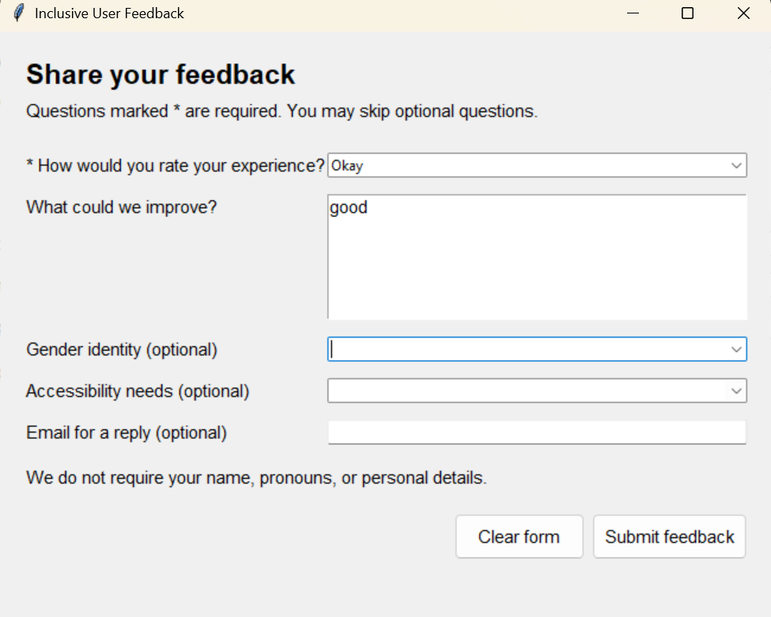

Task-6: generate a Python program that predicts whether a person should be approved or rejected for a loan based on information such as income, age, employment status, credit score, and loan amount.

Analyze:

Check whether the AI-generated system makes decisions unfairly based on gender, religion,race, or other sensitive/unrelated personal attributes.

Input:

"""Task 6: Fairness in a loan approval system.

The first function demonstrates bias; the second uses only relevant financial

information and ignores protected attributes.

"""

def biased_decision(applicant):

"""Intentionally unfair example for comparison."""

score = 0

score += 2 if applicant["income"] >= 50000 else 0

score += 2 if applicant["credit_score"] >= 680 else 0

score += 1 if applicant["employment_status"] == "employed" else 0

score += 1 if applicant["age"] >= 25 else 0

# These rules are discriminatory and are included only to expose the risk.

if applicant["gender"] == "female":

score -= 1

if applicant["religion"] == "minority_religion":

score -= 2

if applicant["race"] == "minority_race":

score -= 2

return "Approved" if score >= 4 else "Rejected"

def fair_decision(applicant):

"""Approve based on financial factors, not gender, religion, or race."""

score = 0

score += 3 if applicant["income"] >= 50000 else 0

score += 3 if applicant["credit_score"] >= 680 else 0

score += 2 if applicant["employment_status"] == "employed" else 0

score += 1 if applicant["debt_to_income"] <= 0.35 else 0

score += 1 if applicant["loan_amount"] <= applicant["income"] * 3 else 0

return "Approved" if score >= 7 else "Rejected"

def main():

applicants = [

{"name": "Alex", "income": 60000, "age": 35, "employment_status": "employed",

"credit_score": 720, "loan_amount": 120000, "debt_to_income": 0.25,

"gender": "male", "religion": "religion_a", "race": "majority_race"},

{"name": "Jordan", "income": 60000, "age": 35, "employment_status": "employed",

"credit_score": 720, "loan_amount": 120000, "debt_to_income": 0.25,

"gender": "female", "religion": "minority_religion", "race": "minority_race"},

{"name": "Casey", "income": 40000, "age": 29, "employment_status": "employed",

"credit_score": 650, "loan_amount": 90000, "debt_to_income": 0.40,

"gender": "nonbinary", "religion": "religion_a", "race": "majority_race"},

]

print("Fairness risks identified:")

print("- Gender, religion, and race can cause direct discrimination.")

print("- Biased historical data or proxy variables can create disparate impact.")

print("- People with identical finances may receive different decisions.")

print("\nComparison (Alex and Jordan have identical finances):")

for applicant in applicants:

print(f"{applicant['name']}: biased={biased_decision(applicant)}, "

f"fair={fair_decision(applicant)}")

print("\nWhy the revised system is fairer:")

print("It ignores protected attributes and uses income, credit score, "

"employment, debt burden, and loan size. Outcomes should still be "

"audited across groups for disparate impact.")

if __name__ == "__main__":

main()

Output:
