AI ASSISTED LAB ASSIGNMENT – 4.1

Advanced Prompt Engineering – Zero-shot, One-shot, and Few-shot Techniques

Name: U.V.Manohar Reddy

Roll_no:2503A52397

Batch_no:14

Problem -1: Customer Email Classification

Input:

#generate a Python Customer email classification using prompt engineering
CATEGORIES = ["Billing", "Technical Support", "Feedback", "Others"]

# Five short sample emails, with their expected categories.
sample_emails = [
("Billing", "I was charged twice for my monthly subscription."),
("Technical Support", "The mobile app crashes whenever I try to log in."),
("Feedback", "The new dashboard is clean and easy to navigate."),
("Others", "What are your office hours on public holidays?"),
("Billing", "Please send me a copy of my latest invoice."),
]

def zero_shot_prompt(email):
"""Build a classification prompt without examples."""
return f"""Classify the customer email into exactly one category:
{', '.join(CATEGORIES)}.
Reply with only the category name.

Email: {email}"""

def one_shot_prompt(email):
"""Build a classification prompt with one labeled example."""
category, example = sample_emails[0]
return f"""Classify emails as Billing, Technical Support, Feedback, or Others.
Reply with only the category name.

Example:
Email: {example}
Category: {category}

New email:
{email}"""

def few_shot_prompt(email):
"""Build a classification prompt with three labeled examples."""
examples = "\n\n".join(
f"Email: {text}\nCategory: {category}"
for category, text in sample_emails[:3]
)
return f"""Classify the new customer email as Billing, Technical Support, Feedback, or Others.
Reply with only the category name.

Labeled examples:
{examples}

New email:
{email}"""

if __name__ == "__main__":
new_email = "My payment was declined, but the amount is still showing as pending."
print("ZERO-SHOT\n", zero_shot_prompt(new_email))
print("\nONE-SHOT\n", one_shot_prompt(new_email))
print("\nFEW-SHOT\n", few_shot_prompt(new_email))

Explanation:

Zero-shot is concise but can be ambiguous without examples. One-shot improves consistency by showing the expected format and task style. Few-shot is generally most reliable because it demonstrates several categories, though it uses more prompt tokens.

Output:
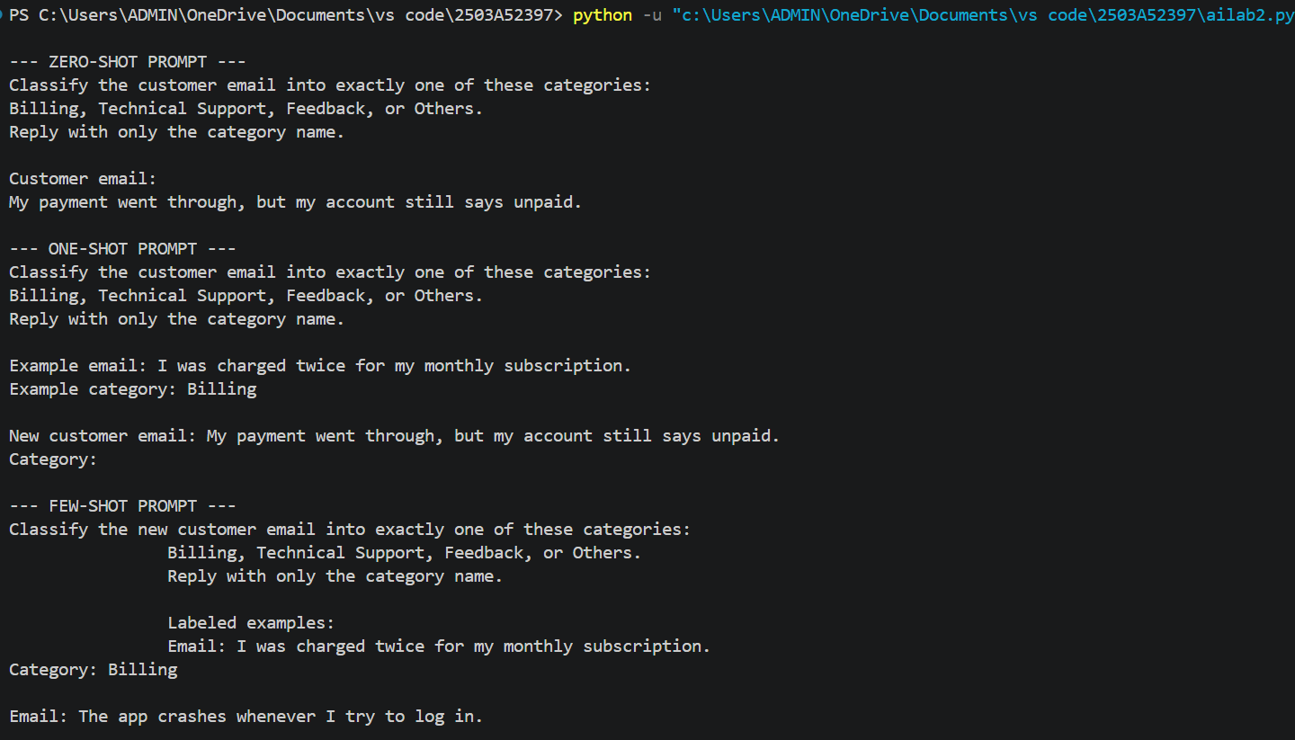
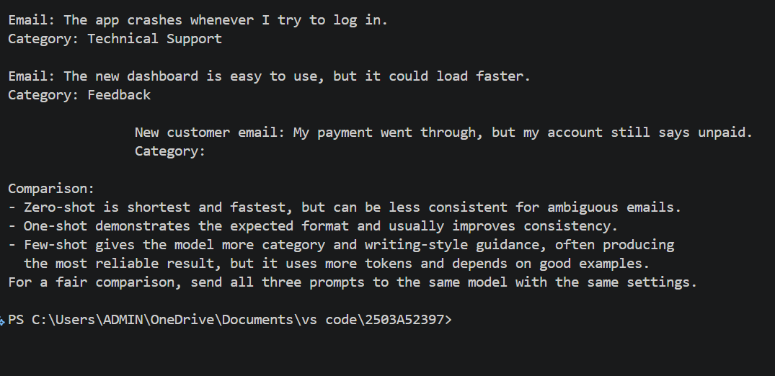

Problem-2: Intent Classification for Chatbot Queries

Input:
# generate Intent classification using zero-shot, one-shot, and few-shot prompts.

INTENTS = ["Account Issue", "Order Status", "Product Inquiry", "General Question"]

SAMPLE_DATA = [
("I cannot log in to my account.", "Account Issue"),
("Where is my order?", "Order Status"),
("Does this laptop come with a warranty?", "Product Inquiry"),
("How can I contact customer support?", "General Question"),
("Please help me reset my password.", "Account Issue"),
("When will my package arrive?", "Order Status"),
]

TEST_QUERIES = [
("My password reset email never arrived.", "Account Issue"),
("Can you tell me the status of order #4821?", "Order Status"),
("Is this phone compatible with wireless charging?", "Product Inquiry"),
("What are your customer service hours?", "General Question"),
]

def zero_shot_prompt(query):
"""Build a classification prompt with no labeled examples."""
return f"""Classify this customer query into exactly one of these intents:
{', '.join(INTENTS)}.
Reply with only the intent name.

Customer query: {query}
Intent:"""

def one_shot_prompt(query):
"""Build a prompt containing one labeled example."""
return f"""Classify each customer query into exactly one of these intents: {', '.join(INTENTS)}.
Reply with only the intent name.

Example:
Customer query: Where is my order?
Intent: Order Status

Customer query: {query}
Intent:"""

def few_shot_prompt(query):
"""Build a prompt containing four labeled examples."""
examples = [
("I cannot log in to my account.", "Account Issue"),
("Where is my order?", "Order Status"),
("Does this laptop come with a warranty?", "Product Inquiry"),
("How can I contact customer support?", "General Question"),
]
labeled_examples = "\n\n".join(
f"Customer query: {text}\nIntent: {intent}"
for text, intent in examples
)
return f"""Classify the customer query into exactly one of these intents:
{', '.join(INTENTS)}.
Reply with only the intent name.

{labeled_examples}

Customer query: {query}
Intent:"""

def evaluate(predictions):
"""Return accuracy and per-query results for LLM predictions."""
results = [
(query, expected, predicted, expected == predicted)
for (query, expected), predicted in zip(TEST_QUERIES, predictions)
]
accuracy = sum(row[3] for row in results) / len(results)
return accuracy, results

if __name__ == "__main__":
print("SAMPLE DATA")
for query, intent in SAMPLE_DATA:
print(f"{query} -> {intent}")

print("\nPROMPT EXAMPLES")
query = TEST_QUERIES[0][0]
for name, builder in (("Zero-shot", zero_shot_prompt),
("One-shot", one_shot_prompt),
("Few-shot", few_shot_prompt)):
print(f"\n--- {name} ---\n{builder(query)}")

print("\nEVALUATION")
print("Send every TEST_QUERIES item to the same LLM with each prompt.")
print("Pass the returned labels to evaluate(predictions) and compare accuracy.")
print("Typical comparison: zero-shot is the baseline, one-shot improves format consistency, and few-shot generally handles ambiguity best.")

Explanation:

Typical comparison: zero-shot is the baseline, one-shot improves format consistency, and few-shot generally handles ambiguity best.

.

Output:
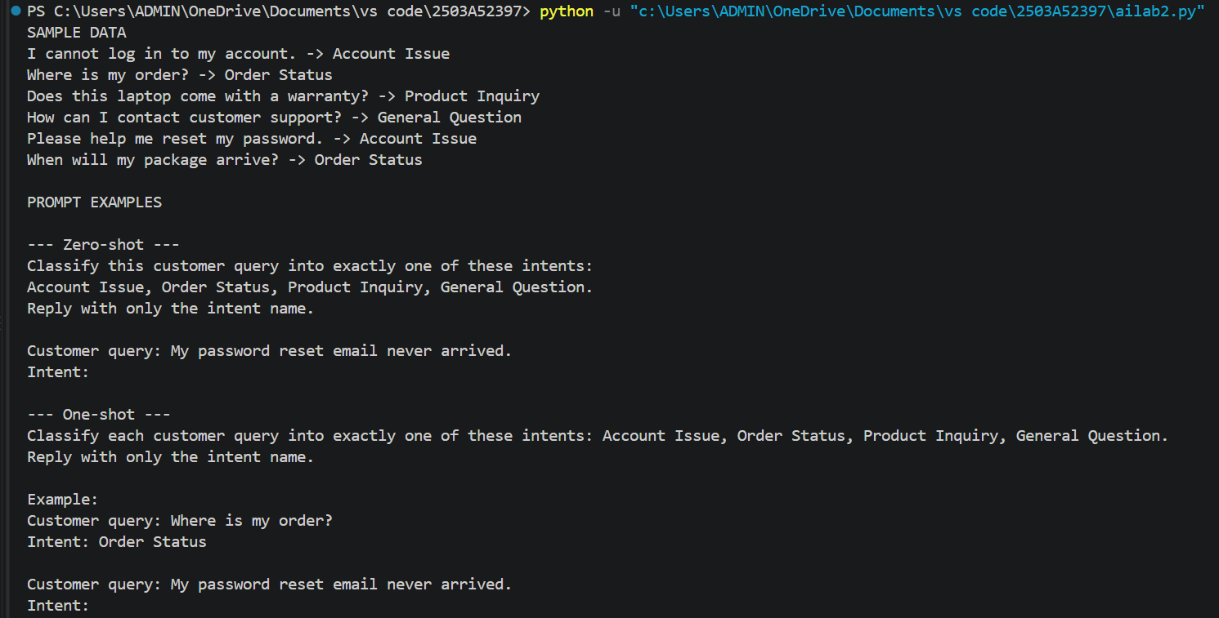
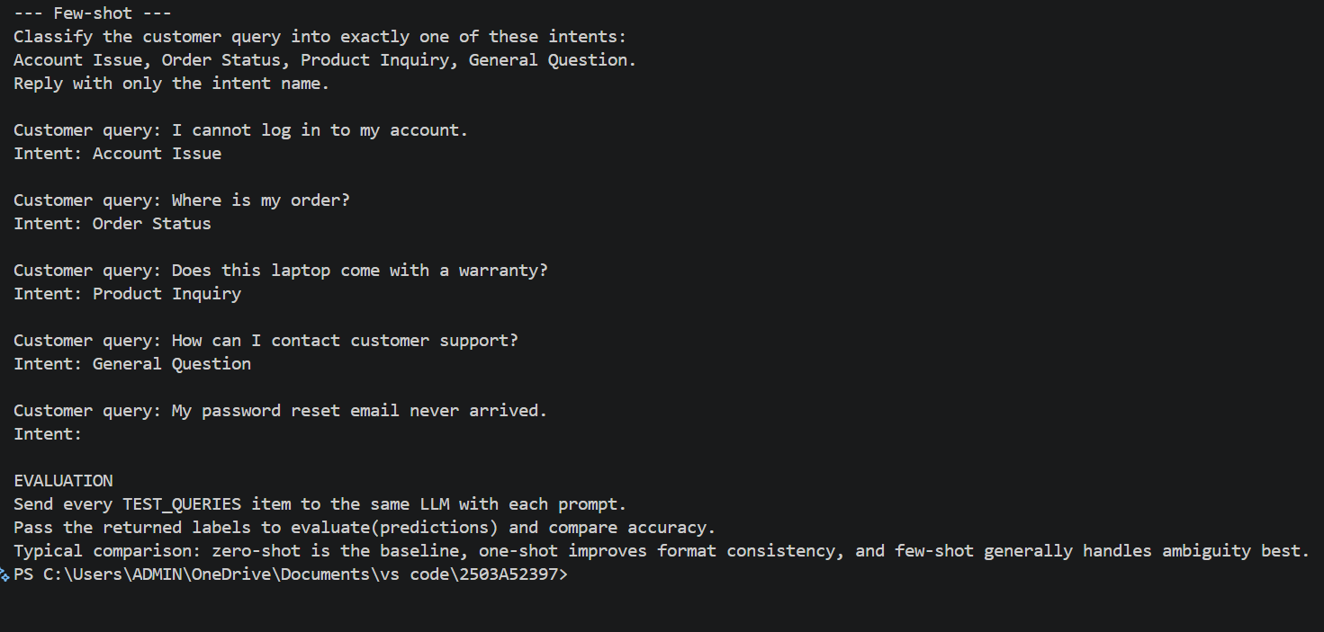

Problem-3: Student Feedback Analysis

Input:

#Generate Python code for Prompt designs for classifying university student feedback sentiment."""

"""Prompt designs for classifying university student feedback sentiment."""

zero_shot_prompt = """
Classify the following university student feedback as exactly one of:
Positive, Negative, or Neutral.
Return only the label.

Feedback: {feedback}
""".strip()

one_shot_prompt = """
Classify university student feedback as exactly one of: Positive, Negative,
or Neutral. Return only the label.

Example:
Feedback: "The library is quiet, comfortable, and has excellent resources."
Label: Positive

Feedback: {feedback}
Label:
""".strip()

few_shot_prompt = """
Classify university student feedback as exactly one of: Positive, Negative,
or Neutral. Return only the label.

Examples:
Feedback: "The professors are supportive and the lectures are engaging."
Label: Positive

Feedback: "The computer lab is overcrowded and several computers do not work."
Label: Negative

Feedback: "The cafeteria serves food at reasonable prices."
Label: Neutral

Feedback: {feedback}
Label:
""".strip()

def explain_example_benefit():
"""Explain why labeled examples improve classification accuracy."""
return (
"Examples show the expected labels and how to interpret ambiguous wording. "
"Multiple, varied examples help the model recognize positive, negative, "
"and neutral patterns consistently, reducing confusion and improving "
"classification accuracy."
)

if __name__ == "__main__":
feedback = "The new study spaces are helpful, but they close too early."
print(zero_shot_prompt.format(feedback=feedback))
print("\n" + explain_example_benefit())

Explanation:

"Examples show the expected labels and how to interpret ambiguous wording. "Multiple, varied examples help the model recognize positive, negative, "and neutral patterns consistently, reducing confusion and improving " classification accuracy.

Output:

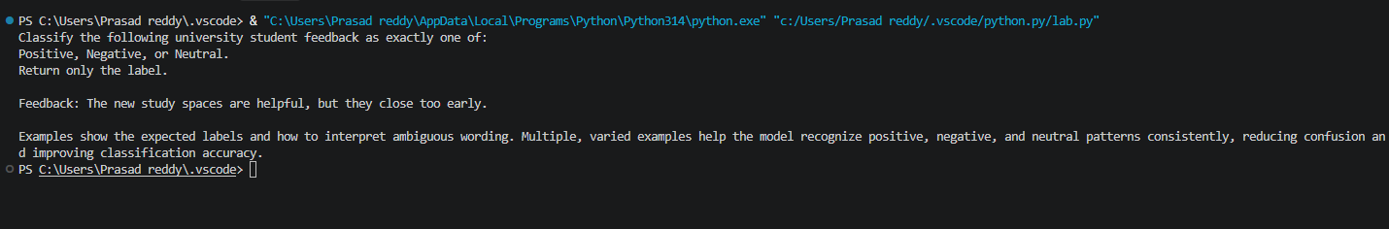

Problem-4: Course Recommendation System

Input:

#Generate a r Prompt-based course recommendation system.

"""Prompt-based course recommendation system."""

def zero_shot_prompt(query):
return f"""Classify this learner query as exactly one of Beginner, Intermediate, or Advanced.
Return only the level and a short reason.

Learner query: {query}"""

def one_shot_prompt(query):
return f"""Classify learner queries as Beginner, Intermediate, or Advanced.
Return only the level and a short reason.

Example query: What is a variable in Python?
Example label: Beginner

Learner query: {query}"""

def few_shot_prompt(query):
return f"""Classify learner queries as Beginner, Intermediate, or Advanced.
Use these labeled examples and return only the level and a short reason.

Query: What is a variable in Python?
Label: Beginner

Query: How do I use list comprehensions and decorators?
Label: Intermediate

Query: How can I optimize a distributed neural network for low latency?
Label: Advanced

Learner query: {query}"""

def recommend_course(level):
courses = {
"beginner": "Introduction and fundamentals courses",
"intermediate": "Applied projects and skill-building courses",
"advanced": "Expert, optimization, and research courses",
}
return courses.get(level.strip().lower(), "Unknown level")

def main():
query = input("Enter a learner query: ").strip()
print("\nZERO-SHOT PROMPT:\n" + zero_shot_prompt(query))
print("\nONE-SHOT PROMPT:\n" + one_shot_prompt(query))
print("\nFEW-SHOT PROMPT:\n" + few_shot_prompt(query))
print("\nFew-shot prompting improves recommendations by showing multiple labeled examples.")
print("It clarifies class boundaries, reduces ambiguity, and improves consistency.")

if __name__ == "__main__":
main()

Explanation:
Classify this learner query as exactly one of Beginner, Intermediate, or Advanced. Return only the level and a short reason.

Output:

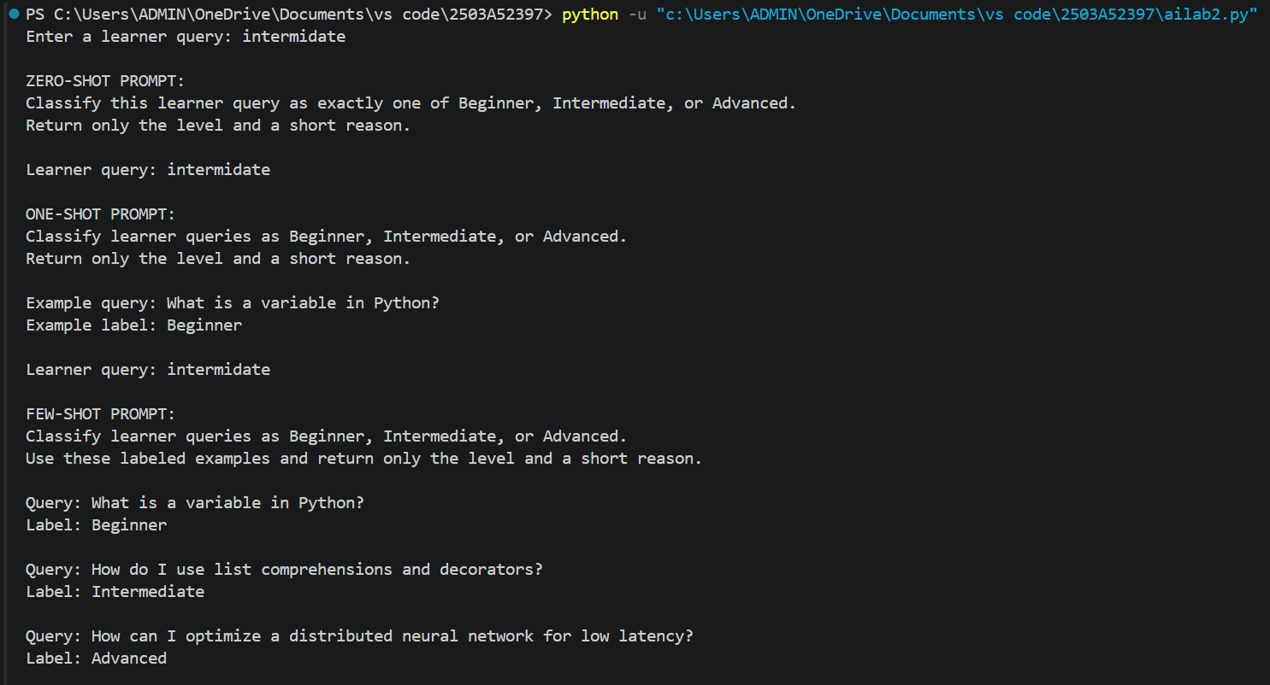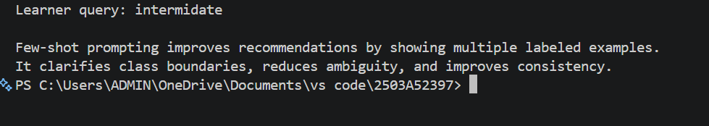

Problem-5: Social Media Post Moderation

Input:

#Generate a pyhton Prompt designs for social-media post moderation.

"""Prompt designs for social-media post moderation."""

def zero_shot_prompt(post: str) -> str:
"""Create a moderation prompt without examples."""
return f"""Classify the following social media post as exactly one of:
Acceptable, Offensive, or Spam.

Definitions:
- Acceptable: Safe, relevant, and non-abusive content.
- Offensive: Hate, harassment, threats, or seriously abusive content.
- Spam: Unwanted repetitive advertising, scams, or promotional content.

Return only the category name.
Post: {post}
"""

def one_shot_prompt(post: str) -> str:
"""Create a moderation prompt with one labeled example."""
return f"""Classify each post as exactly one of: Acceptable, Offensive, or Spam.
Return only the category name.

Example:
Post: "Thanks for sharing this helpful information!"
Category: Acceptable

Post: {post}
Category:"""

def few_shot_prompt(post: str) -> str:
"""Create a moderation prompt with multiple representative examples."""
return f"""Classify the post as exactly one of: Acceptable, Offensive, or Spam.
Return only the category name.

Examples:
1. Post: "The sunset looks beautiful today."
Category: Acceptable
2. Post: "People like you should leave this community."
Category: Offensive
3. Post: "You won a prize! Click this link and pay a small fee now."
Category: Spam
4. Post: "I disagree, but I respect your point of view."
Category: Acceptable

Post: {post}
Category:"""

def moderation_challenges() -> str:
"""Summarize common limitations of zero-shot moderation."""
return """Zero-shot moderation can be inconsistent because labels may be ambiguous,
context and cultural norms vary, sarcasm and coded language are difficult to detect,
and new slang or evasion techniques may not match the model's assumptions. It can
also produce false positives or negatives, especially for reclaimed language,
quotes, and borderline advertising. Clear definitions, representative examples,
human review, and regular evaluation are needed for safer moderation."""

if __name__ == "__main__":
post = input("Enter a post to moderate: ")
print("\nZero-shot prompt:\n", zero_shot_prompt(post))
print("\nOne-shot prompt:\n", one_shot_prompt(post))
print("\nFew-shot prompt:\n", few_shot_prompt(post))
print("\nChallenges:\n", moderation_challenges())

Explanation:

Zero-shot moderation can be inconsistent because labels may be ambiguous, context and cultural norms vary, sarcasm and coded language are difficult to detect, and new slang or evasion techniques may not match the model's assumptions. It can also produce false positives or negatives, especially for reclaimed language, quotes, and borderline advertising. Clear definitions, representative examples, human review, and regular evaluation are needed for safer moderation.

Output:
