certificate of originality

This is to certify that the project “STUDENT DATABASE SYSTEM” is completely an original work and purely for academic use and is being submitted in partial fulfilment for the Degree of Master Of Computer Science under University Of North Bengal.
Therefore, this project has not been submitted for any commercial purpose nor it has any commercial value.

Dr. Ardhendu Mandal Abhishek Paudyal Manoj Mahanta
(Associate Professor) (Project Member) (Project Member)

Acknowledgement

ABSTRACT
The STUDENT BIO DATA SYSTEM focuses on basic operation of an institutes information system. It is developed using Visual Basics 6.0. It can perform operations like Inserting, Deleting, Editing student information. With this application a user (admin) can get every information about student’s information of an institute. This system provides better and efficient service and also reduces the reduces the workload of an institute. The system also provides facility for proper monitoring and reduce paperwork. The main objective of this project is to build a rigid and robust integrated student database system that will track and store records of students. The system is free of errors and very efficient and less time consuming due to the care taken to develop it.

CONTENTS

1.INTRODUCTIon

The proposed system is intended to make life easy. The main purpose of the project is to build an integrated student database system to facilitate easy access of records of students across departments. The Student Database System will allow the administrator to edit, update and list personal and academic details of students. It will also enhance efficient management of student’s information.
Student Database System deals with all kind of student details, college details, course details, curriculum, batch details and other resource related details too. It tracks all the details of a student from the day one to the end of his course which can be used for all reporting purpose, tracking of attendance, progress in the course, completed semesters years, coming semester year curriculum details, exam details, project or any other assignment details, final exam result; and all these will be available for future references too.

  - Proposed System
The proposed system will have the following features:
- Login module: Login module will help in authentication of admin accounts. Users who have valid login id and password can only login into their respective accounts.
- User Management: This module will help the administrator in adding and deleting information of students.
- Search module: This model allows one to search for a particular student or group of students using search criteria such as name of student, Index number, course code etc.

2. Project management
2.1. System Requirement Analysis
This Software has some special configuration while developing the software.
2.1.1. Hardware
- Processor : Pentium
- RAM : 2 GB
- Hard Disk : 1 TB Hard disk
2.1.2. Software
- Operating System : Microsoft XP/ 2000/ VISTA/ WINDOWS 7
- Platform : Microsoft Visual Studio 6.0
- Database : Access/SQL
- Application Software : MS Office 2010

2.2. System Deployment Requirements
2.2.1. Hardware
- Processor : Pentium
- RAM : 2 GB
- Hard Disk : 10 GB Hard disk

2.3. Feasibility Study
A feasibility study is carried out to select the best system that meets performance requirements.
The main aim of the feasibility study activity is to determine whether it would be financially and technically feasible to develop the product. The feasibility study activity involves the analysis of the program and collection of all relevant information relating to the product such as the different data item which would be input to the system, the processed required to be carried out on these data, the output data required to be produced by the system as well as various constraints on the behaviour of the system.
2.3.1 Technical Feasibility
This assessment is based on an outline design of system requirements, to determine whether there is technical expertise to handle the completion of the project.
The technical feasibility is focused on gaining an understanding of the present technical resources of the organization and their applicability to the expected needs of the proposed system. It is an evaluation of the hardware and software and how it meets the need of the proposed system.
This project was technically feasible as there were no technical issues faced to complete the project. All the resources required to complete the project were present.
2.3.2. Schedule Feasibility
A project will fail if it takes too long to be completed before it is useful. Typically this means how long will it take to develop the system, an if it can be completed in a given time period using some methods like payback period. Schedule feasibility is a measure of how reasonable the project timetable is.
It is feasible when schedule is consider for developing the software. The project stared at march 2019 and deadline at may 2019 in which it took 30 days to prepare the SRS, gather tools, software, hardware to work on the project. It took 15 days to plan for the project, understand the software work life cycle. It took 45 days to design the software, code the software, integrate the software, test the software and prepare the documentation.
Therefore ample of time was there in hand to successfully execute the software.

2.4. Time Scheduling
2.4.1 Gantt Chart
A Gantt chart makes it simple to create, view and monitor project activities and tasks over a given time. Typically, each activity, process or task in a Gantt chart is represented by a horizontal bar scaled parallel to a calendar and /or dates. The start and end of each bar represents the start and end of that particular activity. Gantt Chart helps in quick understanding the different tasks in a project, their schedule and any overlapping tasks or activities. Gantt chart are commonly used in software project management activities and are frequently created and managed through project management software.
MONTH  ACTIVITIES | MARCH | APRIL | MAY | JUNE
Feasibility Study
Requirement analysis
Design

Coding and Testing
Documentation

3. DESIGN
3.1. E-R Diagram
An entity relationship diagram is crucial to create a good database design. It is used as a high level data model, which is useful in developing a conceptual design for databases.
An entity is real world item or concept that exists on its own. Entities are equivalent to databases tables in a relational database, with each row of a table representing an instance of that entity.
An attribute of an entity is a particular property that describes the entity. A relationship is the association that describes the interaction between entities. Cardinality is the number of instances of one entity that is associated with each instance of another entity. In general, there may be one-to-one, one-to-many, many-to-one or many-to-many relationships.

3.2. Database Design & Snapshots
Database design is the process of producing a detailed data model of a database. This data model contains all the needed logical and physical design choices and physical storage parameters needed to generate a design in a data definition in a language, which can then be used to create a database.

4. code overview
4.1 User Interface
A good user interface provides a “userfriendly” experience, allowing the user to interact with this software or hardware in natural and initiative way.
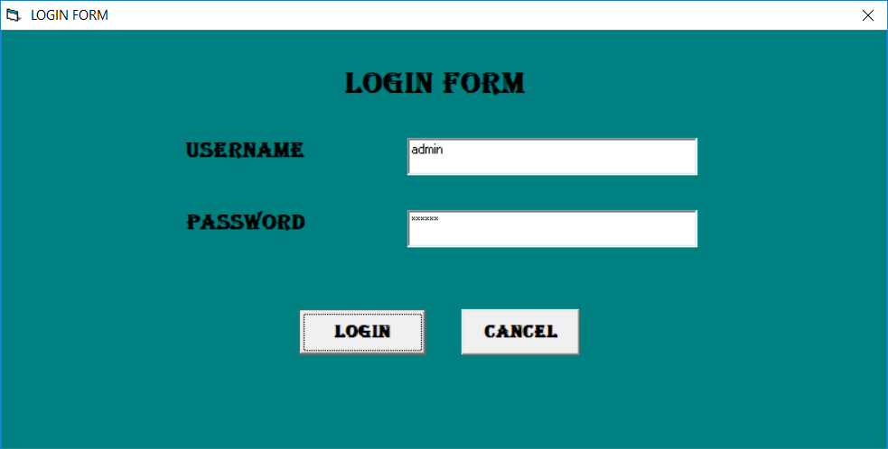
Login form

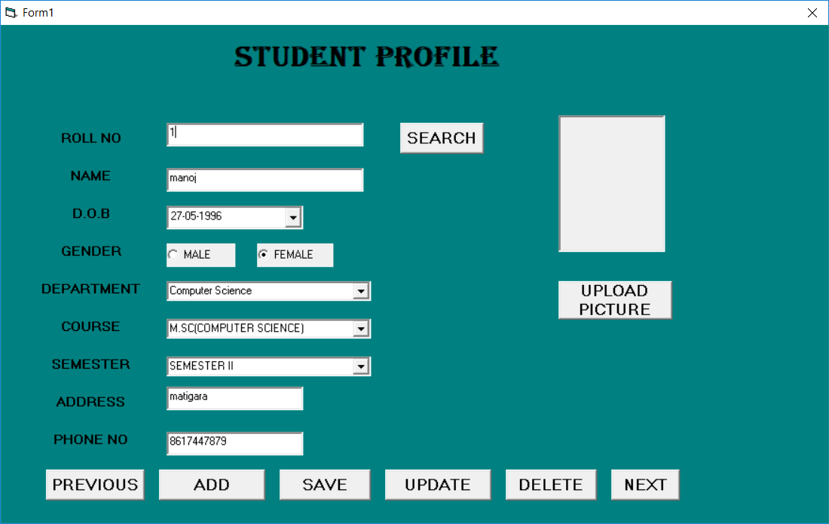
Fill up form

5. Testing

6.FUTURE SCOPE
The modules that will be done in the future are as follows:
- A student will have their user id and password to login into the system and can view their profiles.
- Online payment of fees.

7.CONCLUSION

