**VENDOR PERFORMANCE ANALYSIS**

**SUMMARY STATISTICS**

|  |
| --- |
| **Vendor Number brand Purchase Price Actual Price** |
| Min. : 2 Min. : 58 Min. : 0.36 Min. : 0.49 |
| 1st Qu.: 3951 1st Qu.: 5794 1st Qu.: 6.84 1st Qu.: 10.99 |
| Median : 7153 Median :18762 Median : 10.46 Median : 15.99 |
| Mean : 10651 Mean :18039 Mean : 24.39 Mean : 35.64 |
| 3rd Qu.: 9552 3rd Qu.:25514 3rd Qu.: 19.48 3rd Qu.: 28.99 |
| Max. : 201359 Max. : 90631 Max. : 5681.81 Max. :7499.99 |
|  |

|  |
| --- |
| **TotalSalesQuantity TotalSalesDollars TotalSalesPrice TotalExciseTax** |
| Min. : 0 Min. : 0 Min. : 0.0 Min. : 0.0 |
| 1st Qu.: 33 1st Qu.: 729 1st Qu.: 289.7 1st Qu.: 4.8 |
| Median : 261 Median : 5298 Median : 2857.8 Median : 46.6 |
| Mean : 3078 Mean : 42239 Mean : 18793.8 Mean : 1774.2 |
| 3rd Qu.: 1929 3rd Qu.: 28397 3rd Qu.: 16059.6 3rd Qu.: 418.6 |
| Max. :334939 Max. :5101920 Max. :672819.3 Max. :368242.8 |

|  |
| --- |
| **TotalQuantityPurchase Total Purchase Dollars freight Cost** |
| Min. : 1 Min. : 1 Min. : 0.09 |
| 1st Qu.: 36 1st Qu.: 453 1st Qu.: 14069.87 |
| Median : 262 Median : 3655 Median : 50293.62 |
| Mean : 3141 Mean : 30107 Mean : 61433.76 |
| 3rd Qu.: 1976 3rd Qu.: 20738 3rd Qu.: 79528.99 |
| Max. : 337660 Max. : 3811252 Max. :257032.07 |

|  |
| --- |
| **GrossProfit profitmargin stockturnover salestoPurchaseRatio** |
| Min. : -52002.8 Min. : -Inf Min. : 0.0000 Min. : 0.000 |
| 1st Qu.: 52.9 1st Qu.:13.32 1st Qu.: 0.8072 1st Qu.: 1.154 |
| Median : 1399.6 Median :30.41 Median : 0.9815 Median : 1.437 |
| Mean : 12132.4 Mean : -Inf Mean : 1.7068 Mean : 2.504 |
| 3rd Qu.: 8660.2 3rd Qu.:39.96 3rd Qu.: 1.0393 3rd Qu.: 1.665 |
| Max. :1290667.9 Max. :99.72 Max. :274.5000 Max. :352.929 |

**HISTOGRAM**

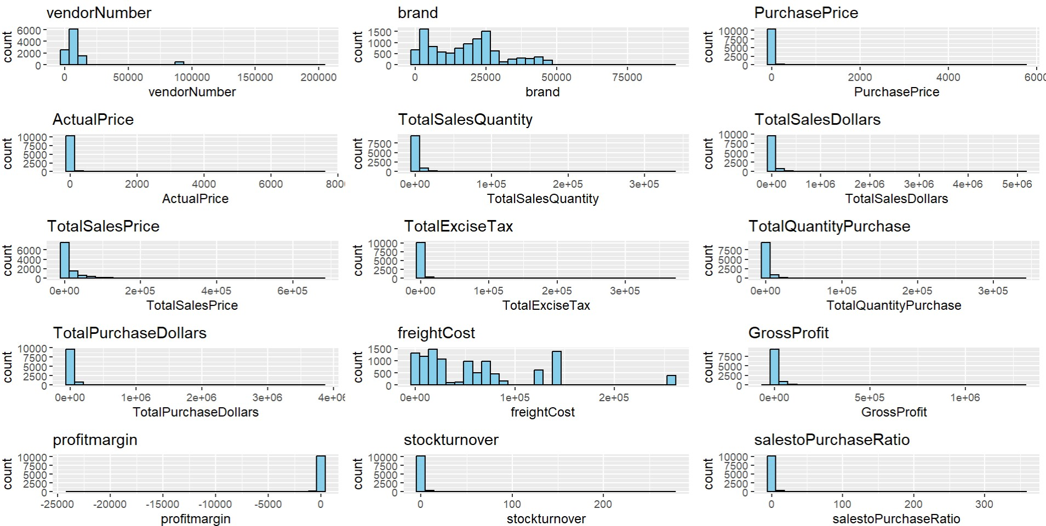

**NEGATIVE AND ZERO VALUES**

**GROSS PROFIT:** Negative values indicating potential losses due high costs or heavy discount.

**Profit Margin :** Has a minimum of –infinity which suggests instances where revenue is zero or even lower than the total cost.

**Total sales quantity and sales dollar :** Some products show zero sales, indicating they were purchased but never sold

**DATA FILTERING**

To enhance the reliability of the insights, we removed inconsistent data points:

GROSS PROFIT <= 0

PROFIT MARGIN<=0

TOTAL SALES QUANTITY = 0

**CORRELATION INSIGHTS**

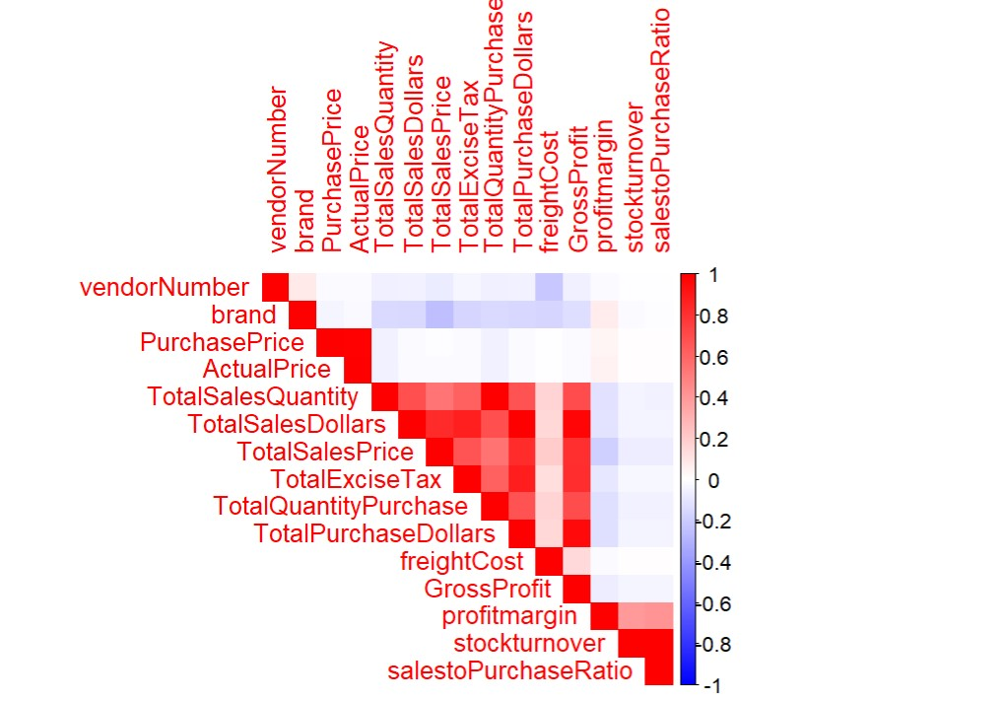

**PURCHASE PRICE vs. SALES DOLLARS AND GROSS PROFIT**

Weak correlation indicating the price variations do not significantly impact sales revenue or profit.

**TOTAL PURCHASE QUANTITY vs. TOTAL SALES QUANTITY**

Strong correlation confirming efficient inventory turnover.

**PROFIT MARGIN vs. TOTAL SALES PRICE**

Negative correlation suggesting increasing sales prices may lead to reduced margins.

**STOCK TURNOVER vs. GROSS PRFIT AND PROFIT MARGIN**

Weak negative correlation indicating that faster stock turnover does not necessarily equate to high profitability.

**RESEARCH QUESTIONS & KEY FINDINGS**

**Brands for promotional or pricing adjustments**

|  |
| --- |
| sales profit brand |
| 1 9.99 66.46647 22161 |
| 2 11.58 65.97582 18073 |
| 3 15.95 83.44828 8527 |
| 4 27.86 89.80617 2626 |
| 5 27.96 82.15308 6064 |
| 6 35.97 73.53350 5654 |
| 7 35.98 63.50750 3063 |
| 8 44.94 88.49577 21691 |
| 9 47.45 85.07903 5224 |
| 10 49.96 65.53243 37398 |
| 11 63.96 81.20700 7316 |
| 12 64.95 89.00693 16330 |
| 13 65.66 96.43619 5683 |
| 14 65.94 67.33394 20333 |
| 15 67.41 73.74277 401 |
| 16 67.83 80.68701 20050 |
| 17 71.76 67.55853 46664 |
| 18 71.91 92.33764 22619 |
| 19 71.96 86.11729 22226 |
| 20 73.98 65.51771 11881 |
| 21 74.99 68.03574 23137 |
| 22 77.94 73.33847 267 |
| 23 83.58 91.32568 6129 |
| 24 85.14 99.16608 3065 |
| 25 85.41 82.64840 3250 |
| 26 89.80 66.92650 17342 |
| 27 89.93 75.64773 12354 |
| 28 89.94 83.92262 15954 |
| 29 89.97 73.33556 5181 |
| 30 94.81 96.54045 46135 |
| 31 97.86 80.82976 11341 |
| 32 99.90 76.36637 3991 |
| 33 99.98 65.51310 20274 |
| 34 99.99 67.53675 20066 |
| 35 101.94 78.94840 17358 |
| 36 103.98 67.53222 19592 |
| 37 104.39 79.79692 3170 |
| 38 104.79 68.22216 11820 |
| 39 104.97 77.47928 22554 |
| 40 109.89 76.52198 19304 |
| 41 111.87 82.56905 5818 |
| 42 119.94 87.65216 3196 |
| 43 124.95 84.84994 5104 |
| 44 125.97 77.16917 19586 |
| 45 129.90 68.00616 8558 |
| 46 131.94 88.81310 19137 |
| 47 132.93 90.14519 21159 |
| 48 134.91 70.76570 17033 |
| 49 139.91 77.59274 20257 |
| 50 139.93 71.61438 43871 |
| 51 139.96 83.22378 22543 |
| 52 141.29 66.45198 3697 |
| 53 142.87 81.82964 45993 |
| 54 143.28 98.97404 6127 |
| 55 143.82 77.76387 23905 |
| 56 143.91 82.50295 2108 |
| 57 155.88 65.97383 37733 |
| 58 156.42 97.23820 7902 |
| 59 157.86 70.86026 31789 |
| 60 159.98 65.51444 19435 |
| 61 160.77 88.55508 19396 |
| 62 160.86 65.53525 18658 |
| 63 161.73 97.46491 17172 |
| 64 167.76 96.79304 6066 |
| 65 167.88 65.51108 20605 |
| 66 167.94 75.49125 926 |
| 67 167.94 87.27522 957 |
| 68 167.94 88.74003 24154 |
| 69 175.84 95.93949 5250 |
| 70 175.92 91.77467 37921 |
| 71 179.88 89.62642 22097 |
| 72 179.88 67.54503 39434 |
| 73 180.54 80.74665 4173 |
| 74 181.87 75.03711 17856 |
| 75 188.73 65.07709 650 |
| 76 191.89 73.48481 12133 |
| 77 194.85 78.49628 28565 |
| 78 197.82 77.16106 38526 |
| 79 199.95 69.92248 935 |
| 80 199.95 76.66417 20776 |
| 81 203.83 64.54398 19347 |
| 82 203.88 73.74926 2858 |
| 83 208.89 69.07463 17320 |
| 84 209.94 78.35572 22534 |
| 85 212.95 63.62526 18632 |
| 86 213.87 83.74246 2976 |
| 87 215.82 86.84089 3371 |
| 88 219.78 69.69697 44781 |
| 89 220.83 78.60345 20941 |
| 90 223.93 71.23655 41634 |
| 91 227.15 96.24037 35290 |
| 92 230.89 93.89753 16531 |
| 93 231.71 69.31078 18963 |
| 94 234.96 66.24106 23792 |
| 95 235.96 67.10459 21473 |
| 96 237.83 69.05353 17322 |
| 97 239.76 67.51752 14654 |
| 98 240.39 87.30396 3892 |
| 99 246.87 77.86689 2213 |
| 100 249.95 86.20524 20250 |
| 101 252.77 96.85089 122 |
| 102 265.81 87.85599 6957 |
| 103 269.73 74.78960 17863 |
| 104 272.79 96.82540 20420 |
| 105 279.80 94.24589 22225 |
| 106 279.80 97.66619 41231 |
| 107 284.81 79.35466 16190 |
| 108 284.91 64.91524 129 |
| 109 285.78 64.01078 954 |
| 110 287.76 67.72310 14826 |
| 111 287.82 72.39942 20592 |
| 112 287.91 92.33788 37940 |
| 113 293.04 94.60824 5361 |
| 114 293.72 95.07694 40566 |
| 115 297.79 63.41046 21686 |
| 116 298.77 94.12257 18668 |
| 117 299.76 66.21297 18732 |
| 118 302.75 67.22048 23517 |
| 119 303.62 71.17449 19398 |
| 120 303.81 69.42826 20689 |
| 121 308.23 64.84443 18627 |
| 122 309.69 97.67832 1007 |
| 123 314.70 73.84175 23542 |
| 124 314.79 65.24667 75 |
| 125 316.80 97.00442 9191 |
| 126 318.83 68.42204 6040 |
| 127 319.90 93.37606 19612 |
| 128 319.98 66.66667 16998 |
| 129 323.73 64.45186 826 |
| 130 323.73 85.28403 43013 |
| 131 325.62 78.07260 20784 |
| 132 326.71 67.75122 16369 |
| 133 329.89 81.44836 20722 |
| 134 334.95 73.33333 18093 |
| 135 335.76 67.33381 17182 |
| 136 335.93 90.72426 11259 |
| 137 342.51 77.46635 46327 |
| 138 342.86 90.66091 20189 |
| 139 345.86 88.75846 44033 |
| 140 346.17 88.26588 19746 |
| 141 346.50 75.68831 8801 |
| 142 349.86 67.74710 20960 |
| 143 349.90 93.42098 22533 |
| 144 350.46 87.64481 8038 |
| 145 350.73 84.97990 39104 |
| 146 352.82 64.79791 23538 |
| 147 354.42 71.68614 2707 |
| 148 356.79 93.73301 14217 |
| 149 359.76 65.51034 24734 |
| 150 359.80 79.58866 17528 |
| 151 359.82 96.24534 20442 |
| 152 359.88 94.40091 2396 |
| 153 361.35 81.41691 7851 |
| 154 373.83 68.41345 18662 |
| 155 374.22 84.06285 8282 |
| 156 374.75 97.03803 6916 |
| 157 376.74 64.48479 3753 |
| 158 379.80 93.33333 34021 |
| 159 389.57 70.92179 4104 |
| 160 389.70 71.42417 3131 |
| 161 391.86 88.92462 3777 |
| 162 395.01 91.64578 18000 |
| 163 395.78 66.20345 15496 |
| 164 395.78 93.94108 20376 |
| 165 395.78 64.70767 24275 |
| 166 398.79 85.56634 1565 |
| 167 398.97 86.13931 5371 |
| 168 399.60 98.13313 4357 |
| 169 399.60 91.49149 21300 |
| 170 399.96 83.33333 21340 |
| 171 404.70 73.84729 33586 |
| 172 406.58 76.09327 23414 |
| 173 409.59 96.44034 4319 |
| 174 409.59 89.98022 24926 |
| 175 409.72 94.18627 18419 |
| 176 409.75 75.95607 18773 |
| 177 410.85 98.61750 8151 |
| 178 411.82 87.86363 2027 |
| 179 416.08 68.15997 3719 |
| 180 417.81 67.55942 19836 |
| 181 419.30 83.25543 17911 |
| 182 419.86 85.61663 23494 |
| 183 419.88 88.66343 19695 |
| 184 419.93 70.84514 20466 |
| 185 424.83 67.98719 21446 |
| 186 439.92 67.73959 23338 |
| 187 449.70 67.80965 21413 |
| 188 449.75 70.06337 23495 |
| 189 450.31 79.38753 1972 |
| 190 450.59 88.37968 20549 |
| 191 455.76 67.11427 44764 |
| 192 458.83 69.24351 39013 |
| 193 461.58 98.11084 8563 |
| 194 461.58 76.34213 17263 |
| 195 469.26 82.67059 3888 |
| 196 471.24 76.34539 8495 |
| 197 476.19 83.57588 5603 |
| 198 477.60 72.16499 22004 |
| 199 479.47 76.34889 17339 |
| 200 480.87 68.38231 24724 |
| 201 483.56 89.34155 3729 |
| 202 483.78 85.90268 363 |
| 203 484.11 82.25403 3058 |
| 204 485.72 70.40270 16503 |
| 205 485.82 77.01618 20576 |
| 206 489.86 76.18707 22549 |
| 207 489.95 73.76059 1404 |
| 208 493.81 96.39537 17385 |
| 209 494.67 87.95561 18452 |
| 210 499.90 92.42448 2577 |
| 211 503.64 63.40243 16360 |
| 212 505.74 79.32535 29676 |
| 213 508.68 83.67540 45495 |
| 214 509.49 69.23983 22032 |
| 215 510.93 80.29476 18624 |
| 216 515.88 94.55300 22624 |
| 217 516.53 82.73866 18962 |
| 218 519.96 82.01400 2106 |
| 219 524.85 81.86148 24006 |
| 220 527.52 64.28571 140 |
| 221 527.67 89.17884 2938 |
| 222 528.77 85.31498 34792 |
| 223 530.41 96.49328 19832 |
| 224 531.72 63.50711 2918 |
| 225 531.81 69.92911 2913 |
| 226 535.68 76.74731 41417 |
| 227 538.89 81.85158 2914 |
| 228 539.94 67.74086 20684 |
| 229 543.67 64.70653 45494 |
| 230 543.79 63.96403 36571 |
| 231 545.58 64.37369 369 |
| 232 549.75 66.44475 23078 |
| 233 558.87 69.43475 19591 |
| 234 561.37 87.91172 33707 |
|  |

234 brands exhibit lower sales but high profit margin which can be benefitted from target marketing and promotions.

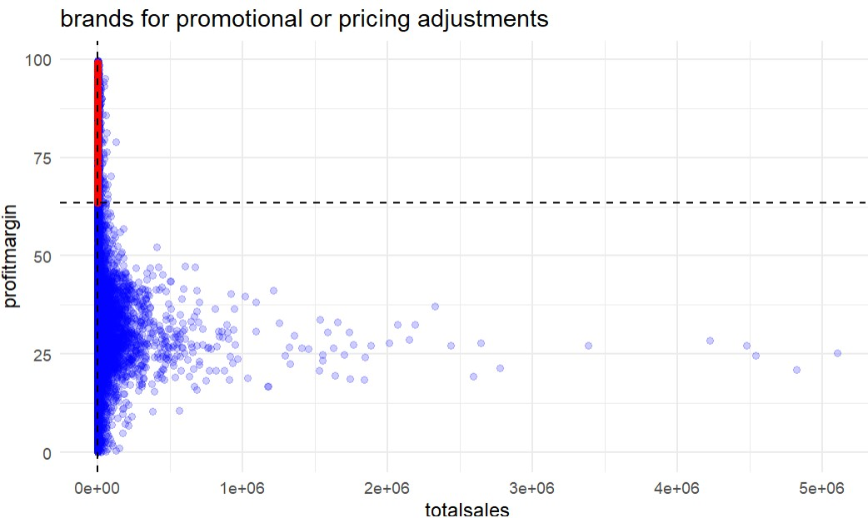

Red indicates Target brands

Blue indicates all brands

**TOP VENDORS BY SALES AND PURCHASE CONTRIBUTION**

VendorNo purchase% purchase grossprofit sales cumulative%

|  |  |  |  |  |  |  |
| --- | --- | --- | --- | --- | --- | --- |
| **1** | 3960 | 0.15830903 | 50959797 | 17780038 | 68739835 | 0.1583090 |
| **2** | 4425 | 0.08655366 | 27861690 | 13098428 | 40960118 | 0.2448627 |
| **3** | 12546 | 0.07518824 | 24203151 | 7695470 | 31898621 | 0.3200509 |
| **4** | 17035 | 0.07494263 | 24124092 | 8155453 | 32279544 | 0.3949936 |
| **5** | 480 | 0.05475097 | 17624379 | 7380987 | 25005366 | 0.4497445 |
| **6** | 1392 | 0.04838111 | 15573918 | 8893216 | 24467134 | 0.4981256 |
| **7** | 1128 | 0.04202983 | 13529433 | 4947179 | 18476612 | 0.5401555 |
| **8** | 9165 | 0.04103940 | 13210614 | 4592032 | 17802646 | 0.5811949 |
| **9** | 3252 | 0.03817825 | 12289608 | 6264167 | 18553775 | 0.6193731 |
| **10** | 9552 | 0.03397264 | 10935817 | 4500249 | 15436066 | 0.6533458 |

The top 10 vendors contribute 65.3% of total purchases while remaining contributes 34.7% .

**IDENTIFYING VENDORS WITH LOW INVENTORY TURNOVER**

VENDORNO. STOCKTURNOVER

|  |  |  |
| --- | --- | --- |
| **21** | 1650 | 0.65432099 |
| **22** | 1655 | 0.76442233 |
| **23** | 1703 | 0.64406780 |
| **24** | 2000 | 0.99672811 |
| **25** | 2242 | 0.99753860 |
| **26** | 2396 | 0.96913580 |
| **27** | 2450 | 0.98678414 |
| **28** | 2496 | 0.90608035 |
| **29** | 2555 | 0.99820740 |
| **30** | 2561 | 0.94974088 |
| **31** | 2876 | 0.75423729 |
| **32** | 3089 | 0.92788180 |
| **33** | 3252 | 0.96645881 |
| **34** | 3551 | 0.43560606 |
| **35** | 3664 | 0.93266822 |
| **36** | 3924 | 0.99117673 |
| **37** | 3950 | 0.99282051 |
| **38** | 3951 | 0.00000000 |
| **39** | 3960 | 0.99370296 |
| **40** | 4380 | 0.99372830 |
| **41** | 4425 | 0.97688950 |
| **42** | 4466 | 0.98085278 |
| **43** | 4550 | 0.99598814 |
| **44** | 4692 | 0.90351794 |
| **45** | 4848 | 0.98583106 |
| **46** | 4901 | 0.00000000 |
| **47** | 4950 | 0.96696052 |
| **48** | 5083 | 0.30833333 |
| **49** | 5270 | 0.93477683 |
| **50** | 5455 | 0.99695895 |
| **51** | 5612 | 0.00000000 |
| **52** | 5992 | 0.96689157 |
| **53** | 6213 | 0.99414433 |
| **54** | 6215 | 0.91264031 |
| **55** | 6280 | 0.20634921 |
| **56** | 6355 | 0.27360000 |
| **57** | 6359 | 0.98725456 |
| **58** | 6785 | 0.99123400 |
| **59** | 6830 | 0.75130617 |
| **60** | 7153 | 0.95516846 |
| **61** | 7154 | 0.97712107 |
| **62** | 7239 | 0.97669650 |
| **63** | 7240 | 0.98889977 |
| **64** | 7245 | 0.99191037 |
| **65** | 7255 | 0.98256104 |
| **66** | 7749 | 0.91428571 |
| **67** | 8004 | 0.95833049 |
| **68** | 8112 | 0.95359089 |
| **69** | 8150 | 0.89286523 |
| **70** | 8320 | 0.98939779 |
| **71** | 8352 | 0.98863451 |
| **72** | 8664 | 0.99010269 |
| **73** | 8673 | 0.99455509 |
| **74** | 8735 | 0.61705686 |
| **75** | 8892 | 0.94410955 |
| **76** | 8920 | 0.99777601 |
| **77** | 9099 | 0.04166667 |
| **78** | 9165 | 0.96945356 |
| **79** | 9206 | 0.98620324 |
| **80** | 9260 | 0.65791448 |
| **81** | 9552 | 0.99871795 |
| **82** | 9622 | 0.95771144 |
| **83** | 9625 | 0.93826680 |
| **84** | 9744 | 0.99685039 |
| **85** | 9815 | 0.99439720 |
| **86** | 9819 | 0.98046115 |
| **87** | 10000 | 0.99336944 |
| **88** | 10050 | 0.22415330 |
| **89** | 10754 | 0.81859908 |
| **90** | 11567 | 0.98479704 |
| **91** | 12331 | 0.98065601 |
| **92** | 12546 | 0.98341998 |
| **93** | 17031 | 0.98928571 |
| **94** | 17032 | 0.80301602 |
| **95** | 17033 | 0.95073755 |
| **96** | 17035 | 0.99857529 |
| **97** | 17037 | 0.76092333 |
| **98** | 28750 | 0.78629032 |
| **99** | 28776 | 0.45077720 |
| **100** | 90010 | 0.99187817 |
| **101** | 90011 | 0.65808824 |
| **102** | 90017 | 0.82016349 |
| **103** | 90024 | 0.88919164 |
| **104** | 90027 | 0.91666667 |
| **105** | 90032 | 0.96925684 |
| **106** | 90037 | 0.94656489 |
| **107** | 90046 | 0.92785235 |
| **108** | 90047 | 0.96333126 |
| **109** | 90051 | 0.86621315 |
| **110** | 90052 | 0.99101796 |
| **111** | 90053 | 0.91107383 |
| **112** | 90056 | 0.87963261 |
| **113** | 90057 | 0.85858586 |
| **114** | 90058 | 0.98286530 |
| **115** | 90059 | 0.34058760 |
| **116** | 98450 | 0.17907801 |
| **117** | 99166 | 0.69801980 |
| **118** | 172662 | 0.81588448 |
| **119** | 173357 | 0.79707792 |

**FINAL RECOMMENDATION**

Revaluate pricing for low sales, high margin brands to boost sales volume without sacrificing probability.

Diversify vendor partnerships to reduce dependency on few suppliers.

Optimize slow moving inventory by adjusting purchase quantities, launching clearance sale.

Enhance marketing and distribution strategies for low performing vendors to drive higher sales volumes.