A UNIFIED ELECTRONIC MEDICAL RECORD SYSTEM BASED ON CLOUD COMPUTING
Third Year of Engineering In Computer Engineering By
Name | Class | Roll no.
MANSI MEHTA | B.E 4 | 11
VARSHIL MEHTA | B.E 4
SOUMYA PANICKAR | B.E 4 | 14
SHUBHAM VORA | B.E 4 | 58


Guide
MILIND KHAIRNAR
SNEHAL SHIWALE

Department of Computer Engineering

Shah and Anchor Kutchhi Engineering College, Mumbai
University of Mumbai, Mumbai

Year 2017-2018
Index

Abstract 1

Introduction 1

Flow Chart 2

References 3
1

ABSTRACT
.

INTRODUCTION

Nowadays the important details are stored in a virtual memory, which reduces the inefficiency for storing data manually. This virtual memory is nothing but a cloud. Besides of storing the important data there are many advantage a user can leverage from cloud computing. The main are listed below,
1) The user can access the multiple data servers from any location at a go.
2) Enhancement of the application is easy, as the user need not worry about the infrastructure enhancement.
3) Cloud computing is an eco-friendly incentive which will replace the hardware components with services.
Currently, healthcare organizations depend on procedures that consist of paper medical records, handwritten notes, etc. Now to reduce all this time-consuming paper work healthcare services system will be deployed in a cloud environment, which will meet the storage and management of user data. A physician expects to view his patient record on the go through mobile. An organization expects to view a centralized data. They want to view data from all the different hospitals in a single place for business analysis.
This paper presents the Electronic Medical Record(EMR) system because of which all the medical records are maintained in a centralized database in the form of an electronic record and the records are stored in the cloud. This records can be accessed by patients as well as by doctors through an application. The doctor can view the history of the patient, update the record and can forward the record to other doctors only after entering the patient's Aadhaar card number. Only registered doctors can do all this work. The Aadhar card number verifies where it is an authorized user or not.
This healthcare application on smart phone monitor patient's health wirelessly and it also provides real-time updates of the patient's health status to the doctor and the other medical professionals via the cloud.

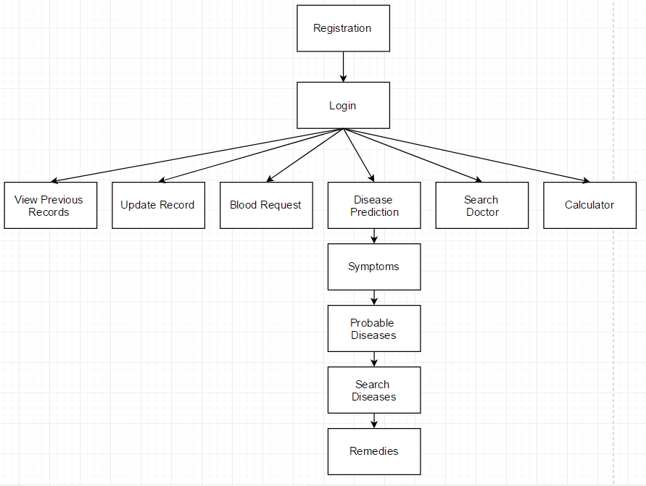

Fig 1: Block Diagram for patient

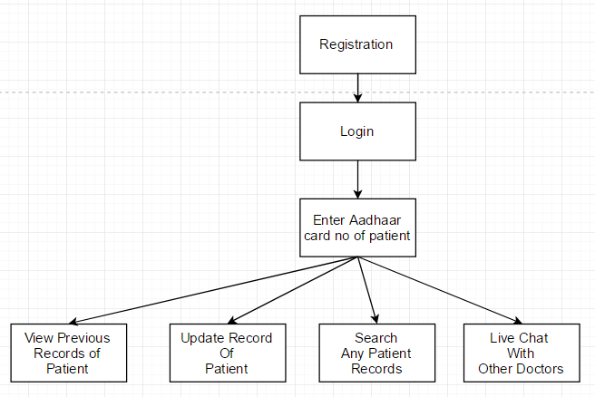

Fig 2: Block Diagram for patient

REFERENCES

[1] N. S. Abual Karim and M. Ahmed, “An Overview of Electronic Health Record (HER) Implementation Framework and Impact on Health Care Organizations in Malaysia: A Case Study”, IEEE International Conference on Management of Innovation and Technology (ICMIT), 2010.

[2] S. Biswas, Anisuzzaman, T. Akhter, et al., “Cloud Based Healthcare Application Architecture and Electronic Medical Record Mining: An Integrated Approach to Improve Healthcare System”, 17th International Conference on
Computer and Information Technology (ICCIT), 2014.

[3] S.K mun and J.W Turner, “Telemedicine: Emerging emedicine,” Annual Review of Biomedical engineering, 1999.

[4] Robbins CL, Hutchings Y, Dietz PM, Kuklina EV, “Callaghan WM: History of preterm birth and subsequent cardiovascular disease: a systematic review”, American Journal of Obstetrics and Gynecology, 210(4), 285-297, 2014.Y. HaCohen Kerner, “Automatic Extraction of Keywords from Abstracts”, Lecture Notes in Computer Science, LNCS 2773,2003.

[5] EMR boat records: http://www.emrbots.org/.Last accessed on,29-08-2015.

4

