
Mahavir Education Trust's Shah & Anchor Kutchhi Engineering College, Chembur, Mumbai 400 088 UG Program in Computer Engineering

Unified Electronic Medical Health Record Using Cloud Computing

Academic Year 2017-2018

ABSTRACT

Currently the healthcare system in India is unevenly Distributed and fragmented. The files and folders in which information is stored deteriorate with time. In case of emergencies it becomes difficult for the doctors to retrieve the required patient medical record immediately. So our aim is to build Unified Electronic Medical Record(EMR) that enables to provide best care to the patients by enabling all the Doctors to have access to patient information wherever they are and at whatever time by migrating to cloud.

INDRODUCTION

In recent years, website usage has seen tremendous growth. With a boom in the e-health industry web computing merging with cloud is the upcoming trend. Nowadays the important details are stored in a virtual memory, which reduces the inefficiency for storing data manually. This virtual memory is nothing but a cloud. Besides of storing the important data there are many advantage a user can leverage from cloud computing.
1) The user can access the multiple data servers from any location at a go.
2) Enhancement of the application is easy, as the user need not worry about the infrastructure enhancement.
3) Cloud computing is an eco-friendly incentive which will replace the hardware components with services.

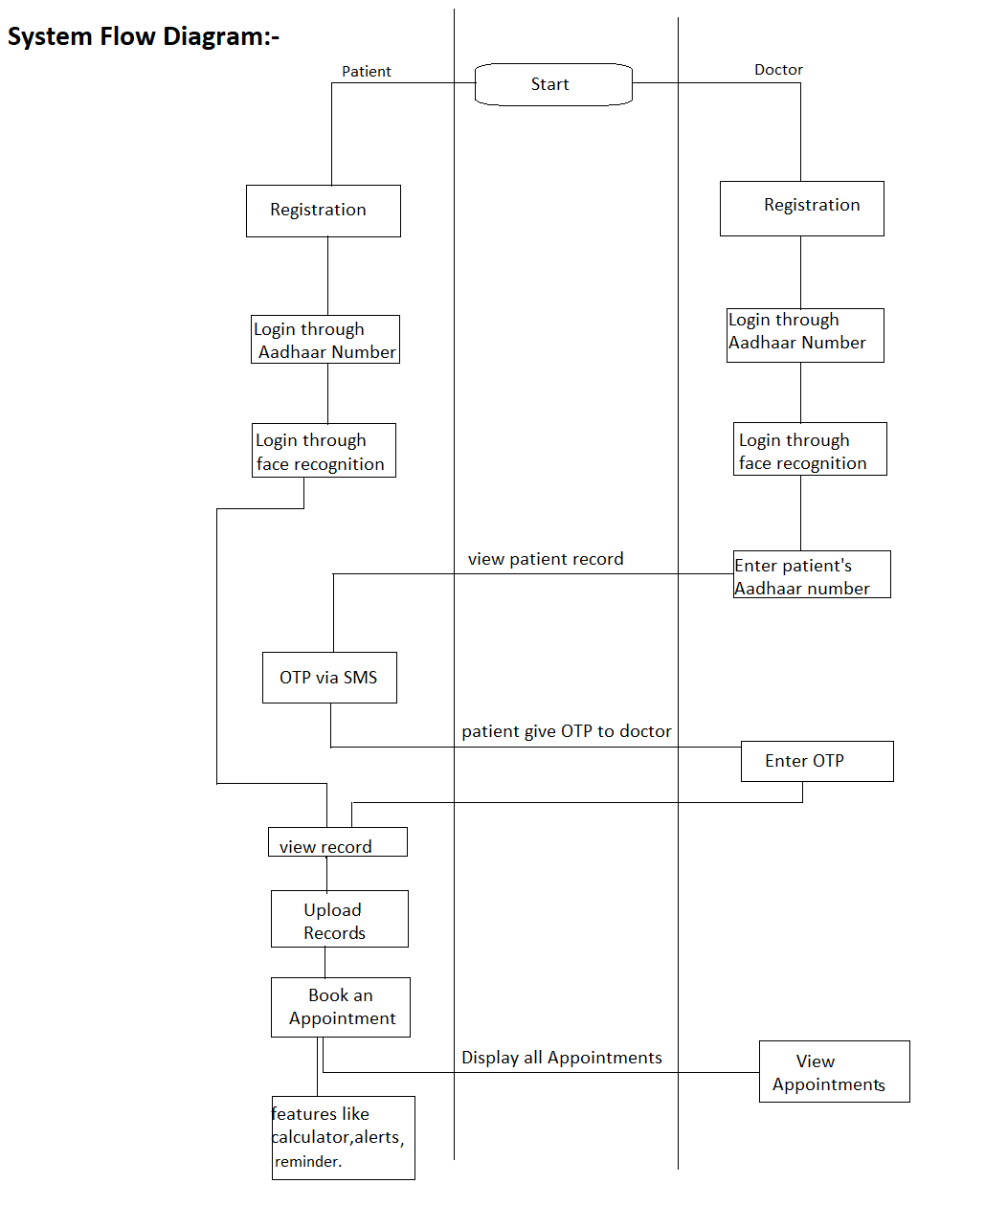

REFRENCES

- http://localhost/upload.php/

- https://localhost/phpmadmin/
- https://localhost/index.php/

WORKING

The Project is implemented in PHP (Hypertext Preprocessor). And the Backend is AWS. The Patient and Doctor will have to register themselves. The Patient and Doctor has to login through Aadhaar card number and a password. Also, Patient can login through face recognition. The patient can upload and see their reports. The Doctor can see patient record by entering patient Aadhaar number and a OTP received to patient. After authentication doctor can view records. Patient can book an appointment. Doctor only gets information about how many appointments he has in a day. Also, Patient access other features of the application.

RESULT AND CONCLUSION

The application will help smooth out the process of storing Electronic record on cloud and will have good use in medical environment. The application is useful in case of emergency.

PROJECT GUIDE

- Prof. Milind Khairnar

PROJECT MEMBER

- Mansi Mehta BE4-13

- Soumya Panickar BE4-14
- Varshil Mehta BE4-37
- Shubham Vora BE4-58

