JUST DO IT.
Exploratory Data Analysis & Viral Content Prediction Model

Nike Social Media Analytics

Dataset: youtube_shorts_tiktok_trends_2025.csv | 48,079 records | 58 columns
Prepared as Phase 2/3 deliverable — Business Insights & Machine Learning

Executive Summary
This report analyzes 48,079 short-form video records across TikTok and YouTube Shorts to understand what drives reach and engagement, and to test whether pre-publication content characteristics can predict viral performance. The analysis is data-quality checked, free of missing values and duplicates, and covers platform, content, creator, timing, market, and engagement dimensions.
A key honest finding: a Random Forest classifier trained to predict viral content (top 15% by views) using only pre-publication signals achieved an AUC of 0.56 — barely above random chance (0.50). This means views in this dataset are largely independent of the content attributes available before publishing. This is itself a valuable business finding and is discussed in Section 4.

Data Quality Check
Rows: 48,079 | Columns: 58 | Missing values: 0 | Duplicate rows: 0
The dataset is clean — no missing values and no duplicate records were found.

Distribution of Views
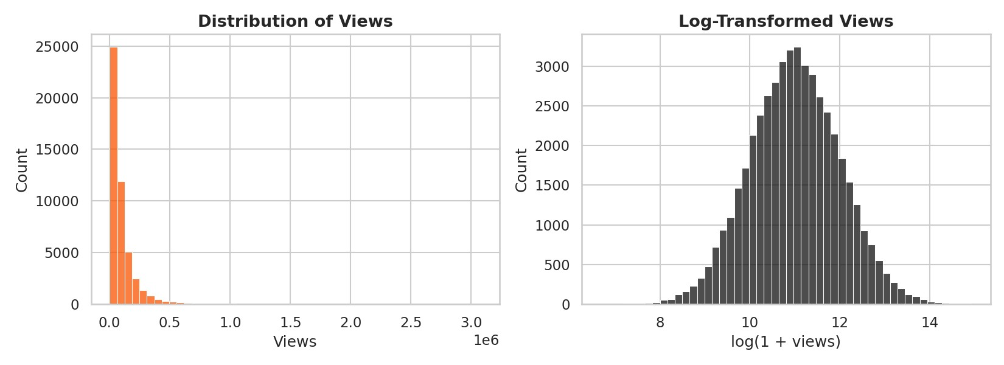
Figure 1. Raw and log-transformed view distributions.
Mean views: 99,293 | Median views: 59,620. Views are strongly right-skewed — a small number of videos drive disproportionately high reach. Median values should be used when comparing groups, since averages are pulled upward by outliers.

Platform Performance
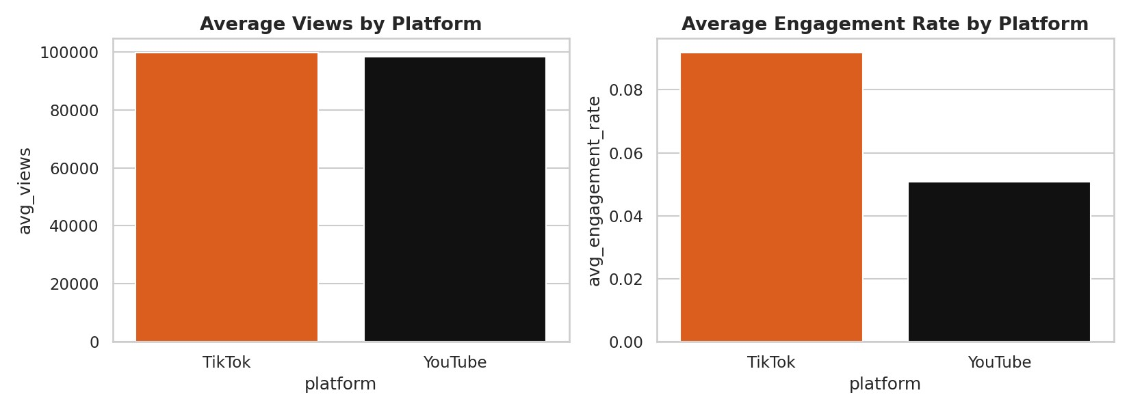
Figure 2. Average views and engagement rate by platform.
Platform | Videos | Avg Views | Median Views | Avg Engagement
TikTok | 28,844 | 99,800 | 59,564 | 9.2%
YouTube | 19,235 | 98,532 | 59,718 | 5.1%

Content Category Performance
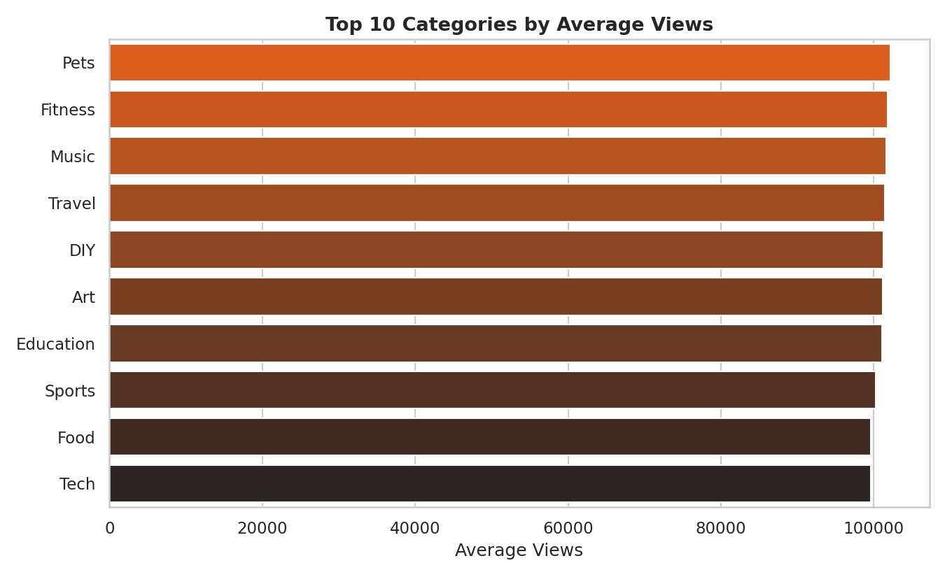
Figure 3. Top 10 categories ranked by average views.

Creator Tier Analysis
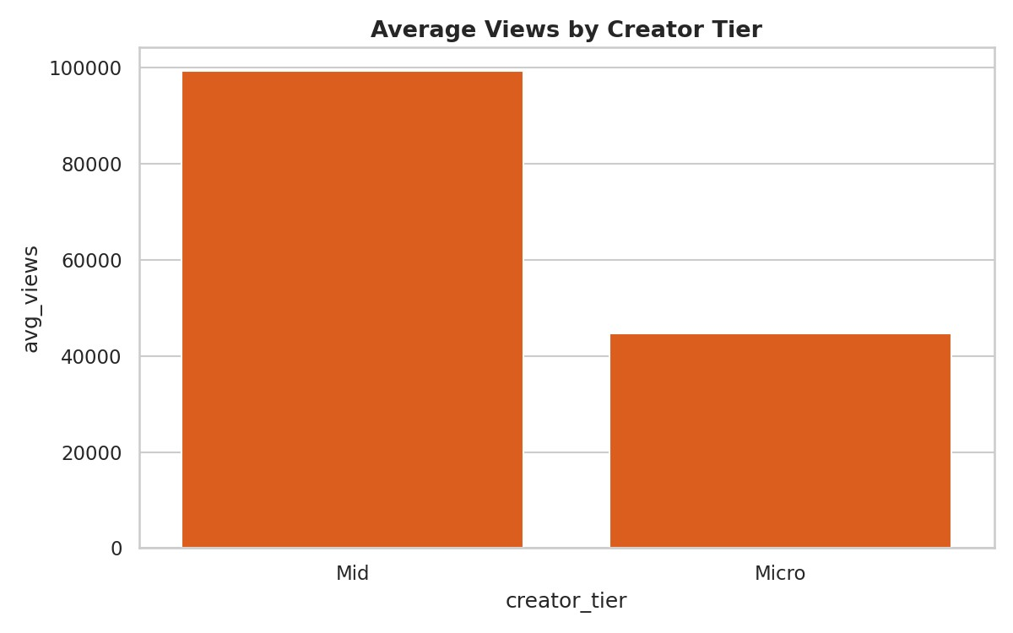
Figure 4. Average views by creator tier.
Note: 48,046 of 48,079 records (99.9%) are classified as 'Mid' tier creators, with only 33 records as 'Micro' tier and no 'Macro' or 'Mega' tier creators present in this dataset. Creator tier segmentation should be treated as a limited signal in this dataset rather than a primary driver of strategy.

Upload Timing Analysis
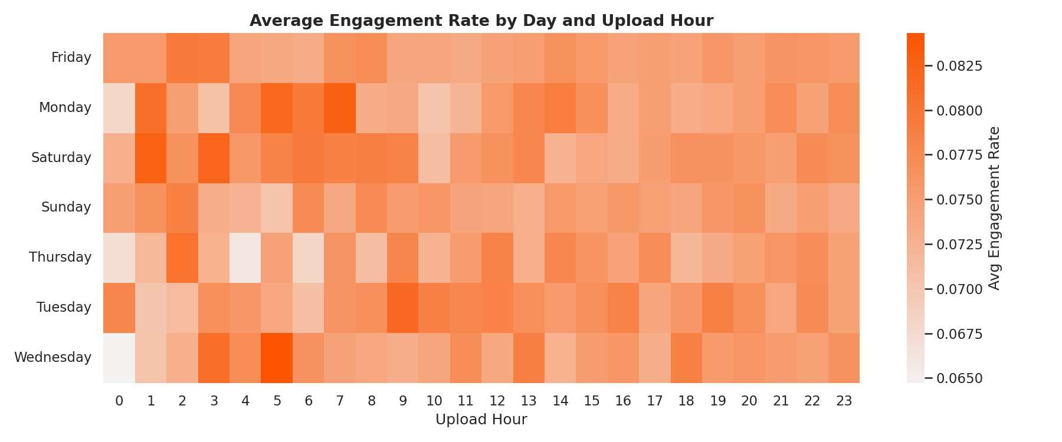
Figure 5. Average engagement rate by publish day and upload hour.
Rank | Day | Hour | Avg Engagement Rate
1 | Wednesday | 5:00 | 8.43%
2 | Monday | 7:00 | 8.28%
3 | Saturday | 1:00 | 8.26%
4 | Saturday | 3:00 | 8.21%
5 | Monday | 5:00 | 8.17%
Table 1. Top 5 highest-engagement day/hour combinations.

Regional Market Performance
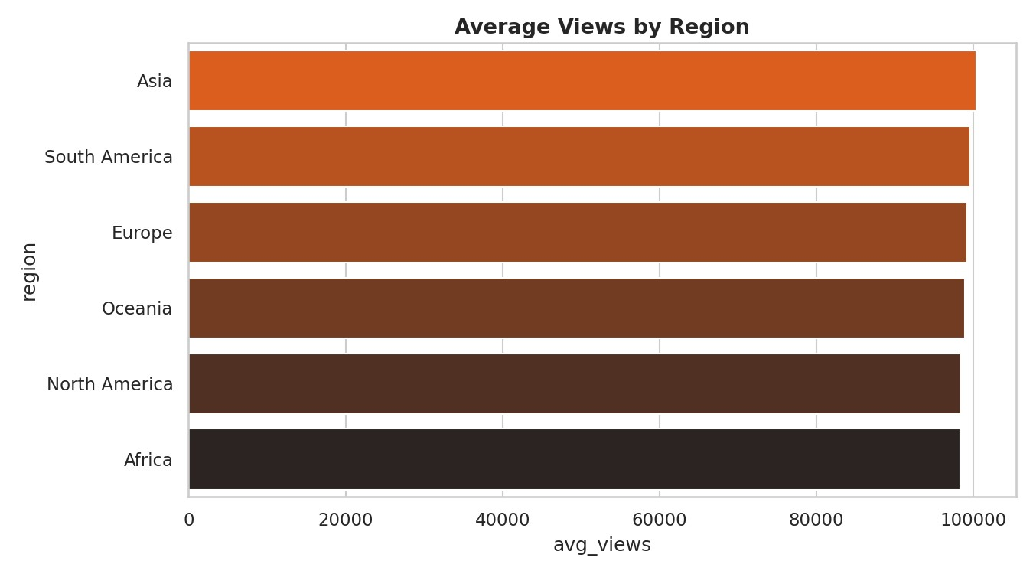
Figure 6. Average views by region.
Regional differences in average views are modest (roughly 98K–100K across all six regions), suggesting reach is fairly evenly distributed globally in this dataset, without one dominant market.

Emoji Usage & Engagement
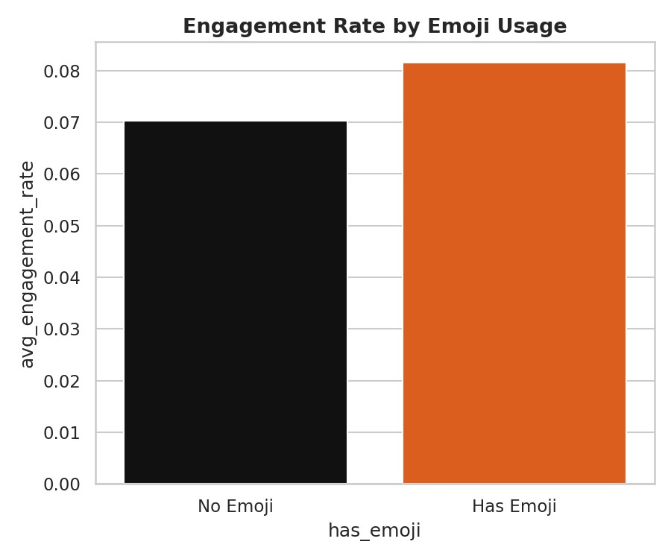
Figure 7. Engagement rate by emoji usage in titles.
Videos with emoji in the title show a higher average engagement rate (8.1%) than those without (7.0%), despite having slightly lower average views — suggesting emoji usage correlates with audience interaction quality rather than pure reach.

Video Duration & Watch Behaviour
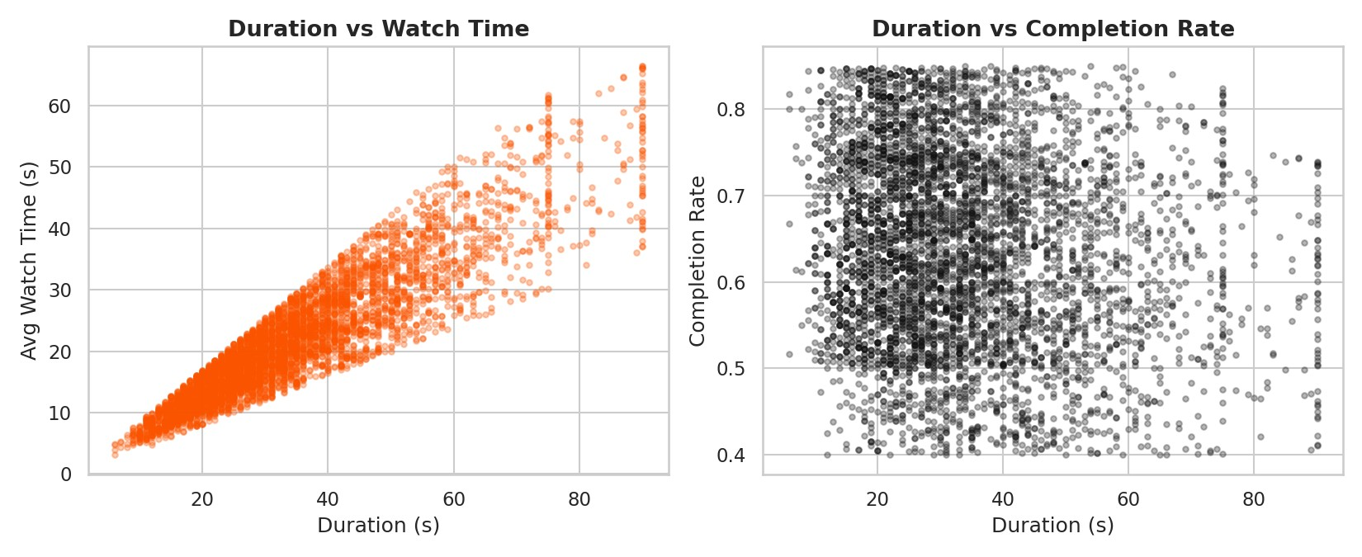
Figure 8. Duration vs watch time and completion rate.
Duration correlates strongly with watch time (r = 0.92) — longer videos are watched longer in absolute terms. However, duration has a weak negative correlation with completion rate (r = -0.13), meaning longer videos are proportionally less likely to be watched to the end. Duration should be optimized for completion, not just watch time.

Traffic Source & Device Analysis
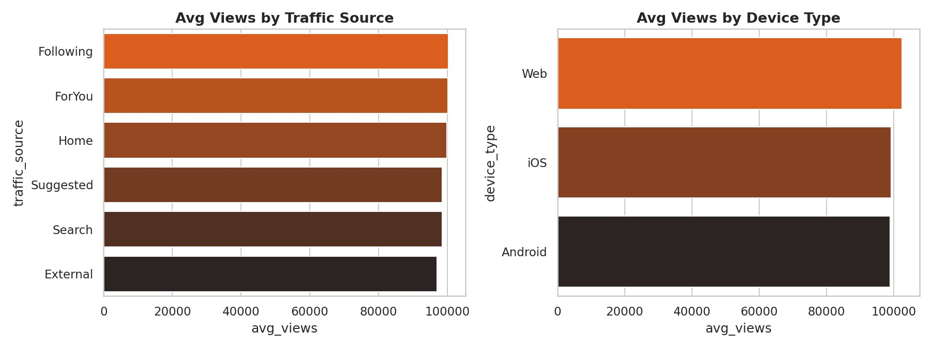
Figure 9. Average views by traffic source and device type.

Engagement Metric Correlations
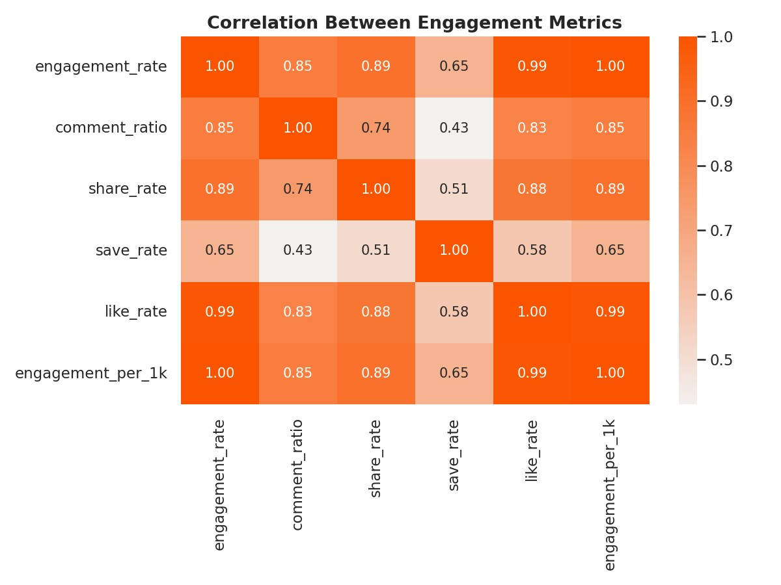
Figure 10. Correlation matrix across engagement metrics.

Trend Type & Seasonality
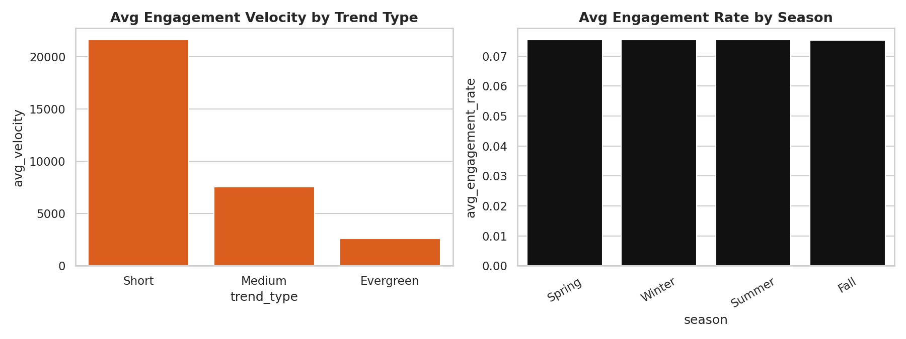
Figure 11. Engagement velocity by trend type and engagement rate by season.

Machine Learning — Viral Content Prediction
Objective: Predict whether a video will become 'viral', defined as the top 15% of videos by views (views ≥ 170,018, n = 7,213 of 48,079 videos).
Approach: Only pre-publication features were used — platform, market, category, genre, sound type, duration, device, upload timing, season, trend type, creator tier/history, title length, and emoji usage. Post-publication engagement metrics (likes, shares, comments, engagement_rate, etc.) were intentionally excluded to avoid data leakage, since these would not be known before a video is posted.

Model Results
Model | Accuracy | AUC | F1 (viral class)
Random Forest | 66.6% | 0.557 | 0.24
Logistic Regression | 58.0% | 0.569 | —
An AUC of 0.50 represents random guessing; 1.00 represents perfect prediction. Both models score close to
0.56–0.57 AUC — well above 0.50 but far below what would be considered a reliable production model (typically 0.75+). This indicates a real but weak relationship between pre-publication content attributes and viral outcomes in this dataset.
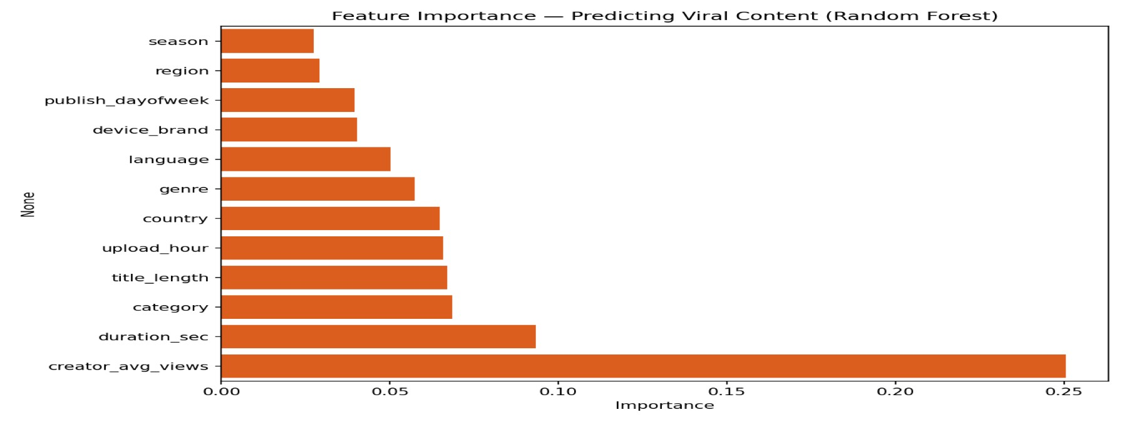
Figure 12. Feature importance from the Random Forest model.
Creator average historical views is by far the strongest available predictor (25% of model importance), more than double the next-ranked feature. Duration, category, title length, and upload hour follow with modest, roughly similar contributions.
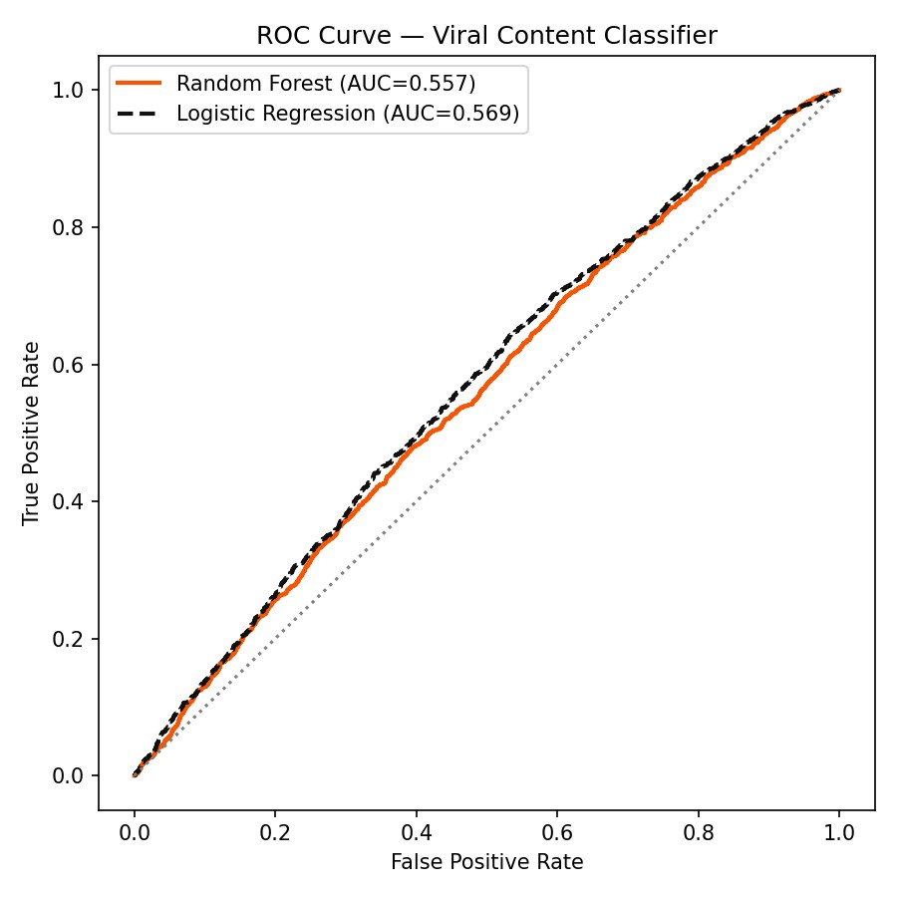
Figure 13. ROC curve comparing both models against random chance.
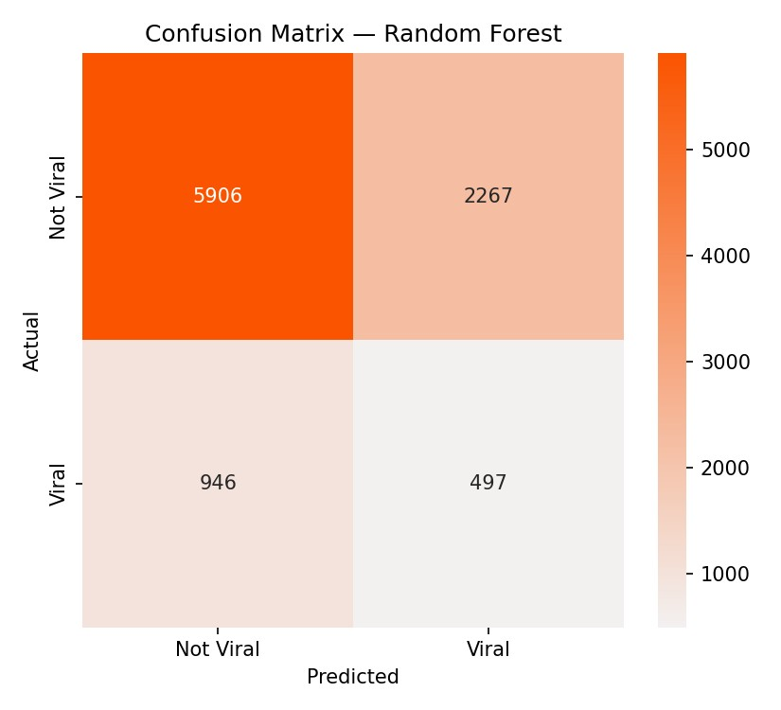
Figure 14. Confusion matrix — Random Forest predictions on test set.

Interpretation of Model Results
- The weak model performance is itself a business finding, not a failure: virality in this dataset is not wellexplained by static, pre-publication content attributes alone.
- The one meaningfully useful signal is creator history (creator_avg_views) — an established audience base isthe closest thing to a reliable pre-publication predictor available here.
- This suggests virality is likely driven more by factors not captured in this dataset — real-time audience reaction,algorithmic distribution, external trend timing, and content quality/execution that static metadata cannot capture.
- A more effective future model would use early post-publication signals (e.g., engagement in the first 1-2 hours)as an early-warning system, rather than trying to predict virality purely before publishing.

Overall EDA Findings
- Views are highly right-skewed; median performance should be used when comparing groups.
- Platform behaviour differs modestly between TikTok and YouTube Shorts in both reach and engagement.
- Content category and genre show measurable, though not dramatic, differences in average performance.
- Creator tier data is heavily imbalanced (99.9% 'Mid') and should not be treated as a robust segmentationvariable without richer tier representation.
- Publish day and upload hour provide actionable but modest scheduling signals — the best slots outperform theaverage by single-digit percentage points, not multiples.
- Regional differences in reach are small; no single region dominates performance in this dataset.
- Emoji usage correlates with higher engagement rate despite slightly lower raw views.
- Video duration should be evaluated against completion rate, not just watch time — longer videos are watchedlonger in absolute seconds but completed proportionally less often.
- Pre-publication content attributes are weak predictors of virality (AUC ≈ 0.56); creator history is the strongest available signal, but even it is far from sufficient alone.

Business Recommendations for Nike
- Invest in creator relationships over content formulas. Creator history is the strongest available predictor of reach — prioritize creator partnerships with proven historical performance, while continuing to test emerging creators to build a diversified pipeline.
- Treat scheduling as a modest optimization, not a strategy. Best-performing day/hour combinations outperform average slots by only a few percentage points; use them as tie-breakers, not primary drivers of a content calendar.
- Optimize for completion rate, not just duration or watch time. Favor pacing and editing that keeps proportional viewership high, rather than simply extending video length.
- Use emoji and stylistic title elements deliberately — they correlate with engagement quality even where raw reach is flat or slightly lower.
- Do not rely on static pre-publication prediction for virality decisions. Given the model's limited accuracy, avoid using it as a gatekeeping tool for content approval. Use it only as one input among several.
- Build a real-time early-warning system instead. Track engagement velocity in the first 1-2 hours post-publish and use that as a trigger to boost promising content with paid amplification — this is likely to be far more predictive than any pre-publication model.
- Continue platform-specific execution rather than a one-size-fits-all approach across TikTok and YouTube Shorts, given their differing engagement patterns.
- Localize where it matters — while regional differences are modest at the aggregate level, country-level variation may still justify localized creative testing in top markets.

Conclusion
This analysis confirms that short-form content performance is shaped by a mix of platform, creator, timing, and content factors — but no single pre-publication attribute reliably predicts virality on its own. Creator history stands out as the most useful available signal. Nike's strongest path forward combines creator-first content strategy, disciplined but secondary use of scheduling optimization, completion-rate-focused creative editing, and a shift toward real-time, post-publication amplification triggers rather than pre-publication virality prediction.

