**Project-Based Learning Report**

on

**Design of Fuzzy Interference System based Air Conditioning.**

Submitted in the partial fulfillment of the requirements

For the Project-based learning in **Fuzzy Logic, Neural Networks & Genetic Algorithms** in

Electronics & Communication Engineering

By

**Aryan Verma 2014111134**

**Manvendra Vikram 2014111136**

**Geetika Sharan**  **2014111140**

Under the guidance of the Course In-charge

Prof. V.P Kaduskar

Department of Electronics & Communication Engineering

Bharati Vidyapeeth

(Deemed to be University)

College of Engineering,

Pune – 411043

**CERTIFICATE**

Certified that the Project Based Learning report entitled, **“Design of Fuzzy Interference System based Air Conditioning.”** is work done by

**Aryan Verma 2014111134**

**Manvendra Vikram 2014111136**

**Geetika Sharan**  **2014111140**

in partial fulfillment of the requirements for the award of credits for Project Based Learning (PBL) in course of **Fuzzy Logic, Neural Networks & Genetic Algorithms** of Bachelor of Technology Semester V, in Electronics and Communication Engineering.

**Date: 15th November 2022**

**Prof. V.P Kaduskar Dr. Arundhati A. Shinde Course In-charge Professor & Head (ECE)**

**INDEX**

|  |
| --- |
| **Serial No. Title Page No.** |

|  |  |  |
| --- | --- | --- |
| **1** | Problem Statement and its solution | 1 |
| **2** | Project Description | 2-6 |
| **3** | Fuzzy Rule Base | 7-8 |
| **4** | Project outcome & Result | 9-10 |
| **5** | Case Study | 11 |
| **6** | Conclusion | 12 |
| **7** | Appendix | 12 |

**Problem Statement**

 Design an automatic Air-conditioner controlling system. The consumption of air conditioning devices is exponentially increased in warm countries like India. The enhancement in the utilization of the cooling devices makes it essential for them to have stable energy consumption by providing steady compressor speed. Achieving an appropriate mechanism for compressor speed control requires the use of a Fuzzy Inference System (FIS).

**Solution of Problem Statement**

Fuzzy logic control was developed to control the compressor motor speed, fan speed, fin direction, and operation mode to maintain the room temperature at or close to the set point temperature and save energy and keep devices from damage. This system consists of four sensors for feedback control: first for input electric volt which is used to save devices from damage due to alternated voltages, second for temperature third for humidity and fourth for dew point. Simulation of the Fuzzy logic algorithm for the Air conditioning controlling system is carried out based on MATLAB.

**Project Description**

INTRODUCTION

The human brain can reasons with imprecise environments or decision based on uncertain or value judgment like the air is fine or the speed is fast or facts that are partially true. The fuzzy logic is a branch of machine intelligence that help computers to process and utilize vague data of humanistic systems . Fuzzy inference systems (FIS) are information processing systems using fuzzy logic mechanism to represent the human reasoning process and to make decisions based on uncertain, imprecise environments. FIS consists of four parts fuzzfier, rules, inference engine, and defuzzfier as shown in the following . To design FIS, needed the perioral experiences of human experts about field of research or knowledge base that observed and collected from operations of systems. Fuzzy logic manipulates such imprecise and vague data as fine or fast help engineering to controls and describes systems using commonsense rules that refer to indefinite quantities. So that it is possible to transition from one rule to another as the input is varied smoothly. These rules are linguistically natural representation of human's (or expert's) Knowledge base, that provides easy understanding knowledge representing scheme for explain information that has been learnt by a computer. For air condition system to manipulate temperature and the humidity close to an aimed value, and to save the electrical energy that taken by Air Condition compressor / Fan while utilizing all available resources in the most efficient manner. Fuzzy logic system structure consists of database or prior knowledge that have to be crisp value to allow fuzzification using membership function , fuzzy control that manage fuzzification, rules evaluation, and defuzzification the output that also is crisp values.

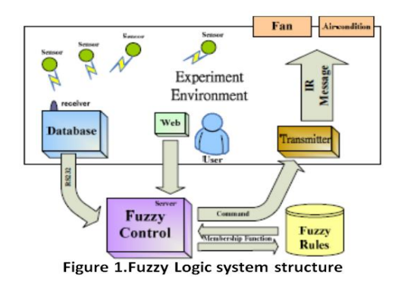

BASIC DESIGN OF AN AIR-CONDITIONER

An air conditioner (often referred to as AC) is a home appliance, system, or mechanism designed to dehumidify and extract heat from an area. The cooling is done using a simple refrigeration cycle which consists basically of the following steps:

1. The compressor compresses cool Freon gas, causing it to become hot, high-pressure Freon gas.

2. This hot gas runs through a set of coils so it can dissipate its heat, and it condenses into a liquid.

3. The Freon liquid runs through an expansion valve, and in the process, it evaporates to become cold, low-pressure Freon gas.

4. This cold gas runs through a set of coils that allow the gas to absorb heat and cool down the air inside the building.

FUZZY LOGIC ALGORITHM

The fuzzy logic algorithm is an algorithm that solves the problems expressed in the basic IF-THEN rule format. It consists of four steps as following:

**Step 1:** linguistic Variables are the input variables of the system whose values are words or sentences from a natural language, instead of numerical values. A linguistic variable is generally decomposed into a set of linguistic terms. Membership Functions Membership functions are used in the fuzzification and defuzzification steps of an FLS, to map the non-fuzzy input values to fuzzy linguistic terms and vice versa. A membership function is used to quantify a linguistic term. Fuzzy Rules In an FLS, a rule base is constructed to control the output variable. A fuzzy rule is a simple IF-THEN rule with a condition and a conclusion.

**Step 2:** Fuzzification means adding uncertainty by design to crisp sets or to sets that are already fuzzy and spreading the information provided by a crisp number or symbol to its vicinity so that the close neighborhood of the crisp number can be recognized by the computational tools.

**Step 3:** Inference For each rule which represented in fuzzy level as set of restriction on the output based on certain conditions of the input. That restriction modeled by fuzzy set and relations and connected by linguistic connections like and, or, not and else, Obtaining the output which is a new fuzzy set which is the conclusion of rule since an implication operator is applied to the value of the antecedent obtained.

**Step 4:** defuzzification is the process of converting the result in fuzzy set form to a crisp result. It is important process for hardware application which process based on crisp data exchange. There is not theory to justify behavior of exchange other than commonsense reasoning such that the defuzzified output must represent a weight, voted, or must suitable solution. There are two main mechanism centroid method which based on finding a balance point of a property and maxima method which based in search for the highest pack whereas

Input Variables

Air Condition Fuzzy logic control System takes four variables into consideration showing in the following block:

1. **User temperature** (16ᵒC→30ᵒC continuous control): users' temperature that received by electronic, thermostat, are represented by three membership functions low, optimal, high

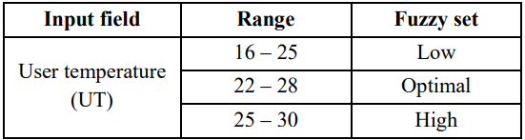**Table 1. User temperature**

**Figure 2.**

1. **Temperature difference:** The different between room temperature actually and user temperature , are represented by four membership functions negative, zero, positive, large

**Table 2. Temperature difference**

**Figure 3.**

1. **dew point temperature:** Dew point describes information about dew point temperature inside the room. Using two membership functions optimal, humid.

Dew point**

**Figure 4.**

1. **Electricity Volt:** Electric volt describes the information about alternating volt that difference and then according to that difference by controlling in compressor and fan to stand by or work as rule listed

**

**Figure 5.**

Output membership function

1. **Compressor Speed (SC):** Compressor speed is characterized as low, medium and high different from 0 to 100 %.

**Table 5. Compressor speed** 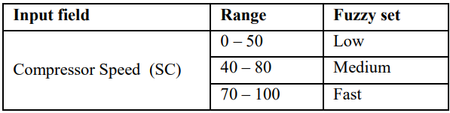

**Figure 6.**

1. **Fan Speed (Fc):** Fan speed is characterized as low, medium and high varied from 0 to 100 %.

**Table 6. Fan Speed** 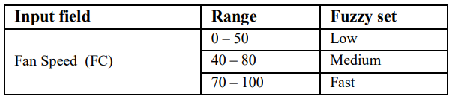

**Figure 7.**

1. **Mode of Operation (Mo):** Air conditioning system can act as a cooler as well as dehumidifier. In the cooling state, it will regulate the air to release cool air. But as a dehumidifier, it can absorb the humid content of the air by passing dry air into the room. This process does not increase the temperature of the room. This setting preference is usually not given to the user and is performed implicitly by the AC.

**Figure 8.**

FUZZY RULE BASE

|  |  |  |  |  |  |  |  |
| --- | --- | --- | --- | --- | --- | --- | --- |
|  | **UT** | **Tdiff** | **Td** | **EV** | **CS** | **Fs** | **Mo** |
| 1 | Low | Negative | Optim | Low | Low | Low | Ac |
| 2 | Optim | Negative | Optim | Low | Low | Low | Ac |
| 3 | High | Negative | Optim | Low | Low | Low | Ac |
| 4 | Low | Zero | Optim | Low | Low | Low | Ac |
| 5 | Optim | Zero | Optim | Low | Low | Low | Ac |
| 6 | High | Zero | Optim | Low | Low | Low | Ac |
| 7 | Low | Positive | Optim | Low | Low | Low | Ac |
| 8 | Optim | Positive | Optim | Low | Low | Low | Ac |
| 9 | High | Positive | Optim | Low | Low | Low | Ac |
| 10 | Low | Large | Optim | Low | Low | Low | Ac |
| 11 | Optim | Large | Optim | Low | Low | Low | Ac |
| 12 | High | Large | Optim | Low | Low | Low | Ac |
| 13 | Low | Negative | Optim | High | Low | Low | Ac |
| 14 | Optim | Negative | Optim | High | Low | Low | Ac |
| 15 | High | Negative | Optim | High | Low | Low | Ac |
| 16 | Low | Zero | Optim | High | Low | Fast | Ac |
| 17 | Optim | Zero | Optim | High | Low | Medium | Ac |
| 18 | High | Zero | Optim | High | Low | Low | Ac |
| 19 | Low | Positive | Optim | High | Fast | Fast | Ac |
| 20 | Optim | Positive | Optim | High | Medium | Medium | Ac |
| 21 | High | Positive | Optim | High | Medium | Medium | Ac |
| 22 | Low | Large | Optim | High | Fast | Fast | Ac |
| 23 | Optim | Large | Optim | High | Fast | Fast | Ac |
| 24 | High | Large | Optim | High | Fast | Fast | Ac |
| 25 | Low | Negative | Humid | Low | Low | Low | Ac |
| 26 | Optim | Negative | Humid | Low | Low | Low | Ac |
| 27 | High | Negative | Humid | Low | Low | Low | Ac |
| 28 | Low | Zero | Humid | Low | Low | Low | Ac |
| 29 | Optim | Zero | Humid | Low | Low | Low | Ac |
| 30 | High | Zero | Humid | Low | Low | Low | Ac |
| 31 | Low | Positive | Humid | Low | Low | Low | Ac |
| 32 | Optim | Positive | Humid | Low | Low | Low | Ac |
| 33 | High | Positive | Humid | Low | Low | Low | Ac |
| 34 | Low | Large | Humid | Low | Low | Low | Ac |
| 35 | Optim | Large | Humid | Low | Low | Low | Ac |
| 36 | High | Large | Humid | Low | Low | Low | Ac |
| 37 | Low | Negative | Humid | High | Fast | Fast | De |
| 38 | Optim | Negative | Humid | High | Low | Low | De |
| 39 | High | Negative | Humid | High | Low | Low | De |
| 40 | Low | Zero | Humid | High | Medium | Fast | De |
| 41 | Optim | Zero | Humid | High | Medium | Fast | De |
| 42 | High | Zero | Humid | High | Fast | Medium | De |
| 43 | Low | Positive | Humid | High | Fast | Fast | Ac |
| 44 | Optim | Positive | Humid | High | Fast | Fast | Ac |
| 45 | High | Positive | Humid | High | Medium | Fast | Ac |
| 46 | Low | Large | Humid | High | Fast | Fast | Ac |
| 47 | Optim | Large | Humid | High | Fast | Fast | Ac |
| 48 | High | Large | Humid | High | Fast | Fast | Ac |

**Table 7. Rules Viewer**

Project outcome & Result:

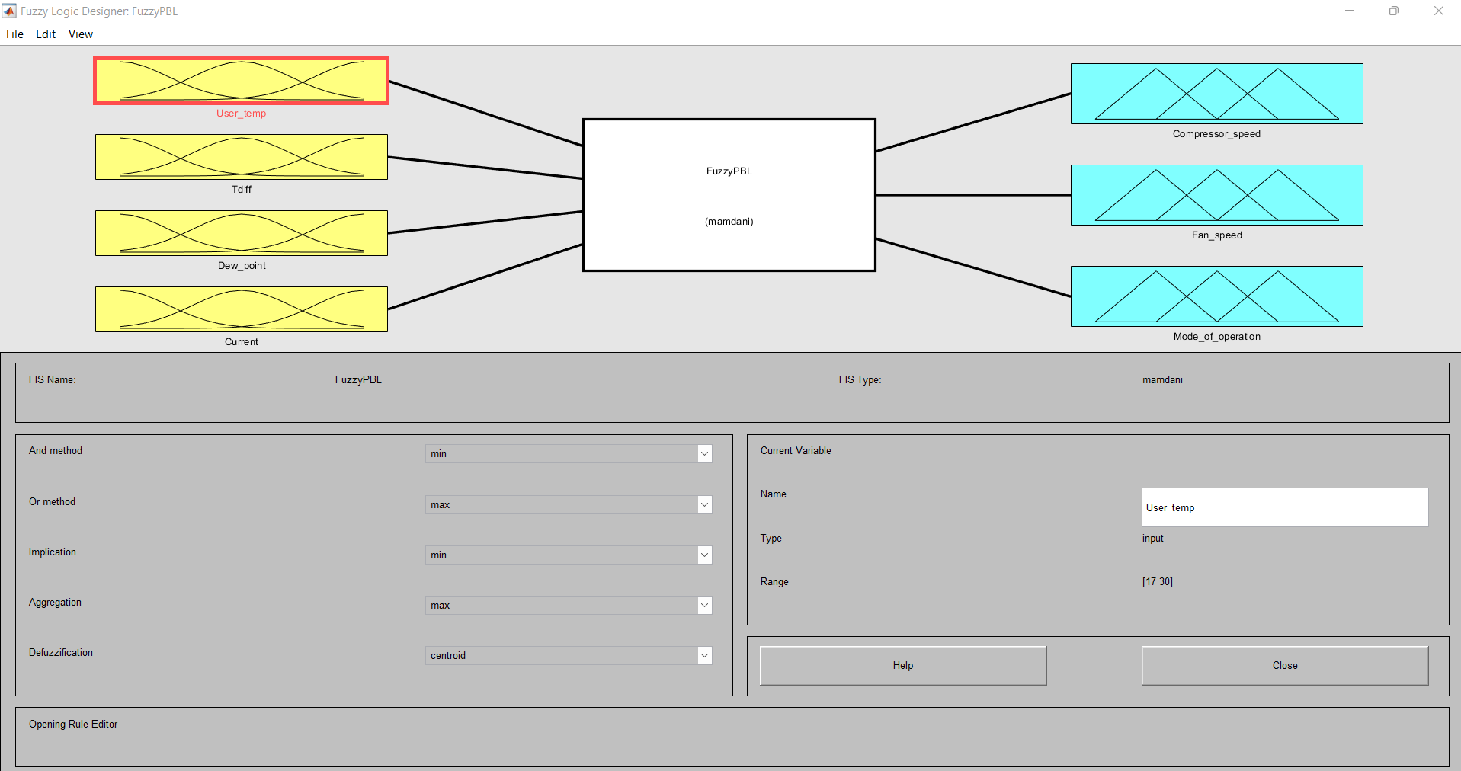**Figure 9. Fuzzy Logic Designer**

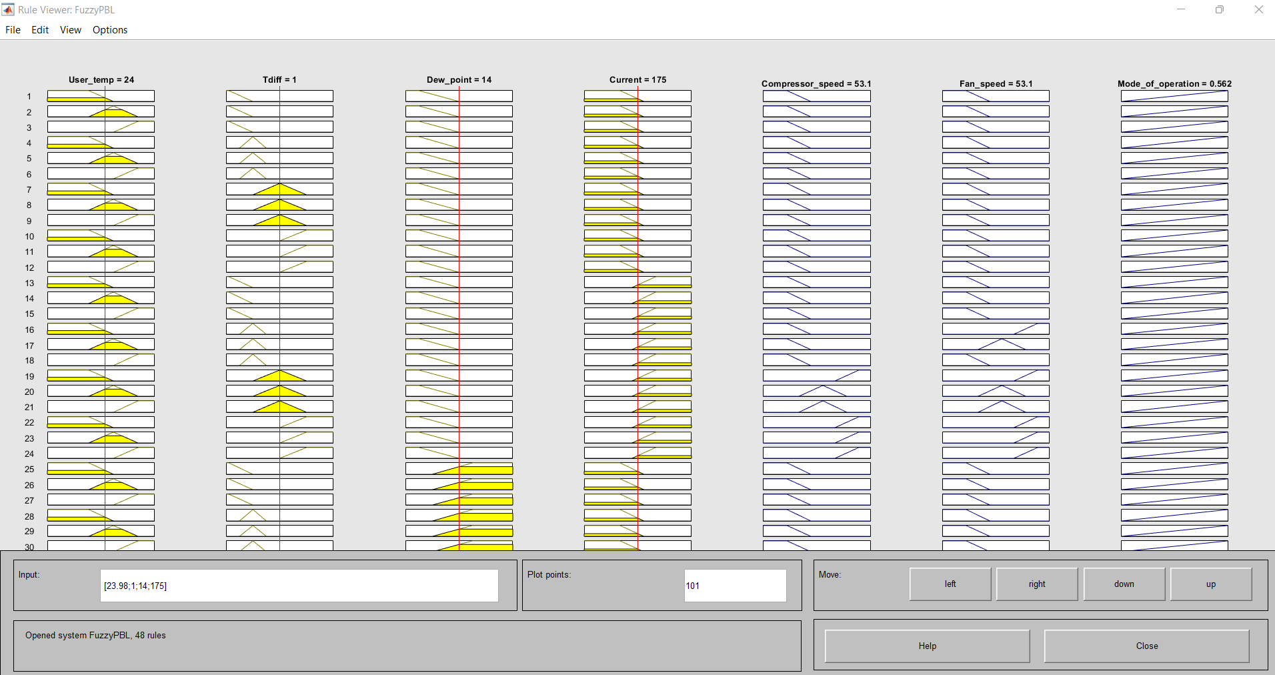

**Figure 10. Rule viewer**

CO2: Design fuzzy system for application in electronics and communication engineering.

**Case Study**

Using Mamdani fuzzy system for the illustration which uses max aggregation and centroid method for defuzzification. The FIS Editor defines the Fuzzy Base Class, the various inputs, i.e., User temperature (Ut), Temperature Difference (Tdiff), Dew Point (Td), and Electric Volt (EV), and the various output variables like Compressor Speed (Sc), Fan Speed (Sf), Mode of Operation (Mo). We will use a neural network that can help fuzzy systems learn rules which can accept pairs of input and output data and cluster them in a small number of classes. Fuzzy rules can be designed manually by a user, or automatically, i.e., the Rule Editor generates rules for all combinations of selected input variables and a user fills consequent fuzzy terms. Inputs and sub-sequentially provide the fuzzy outputs. By adding intelligence to the system like fuzzy logic which is dealing with problems that are difficult and complex to study we develop an Air Condition system that controls humidity in its own way without giving users any scope for changing the set point for the target humidity unlike the scope, it offers to change the set point for the target temperature through a thermostat. Air Conditioning systems that are used to cool the rooms now can perform a variety of functions.

**Conclusion**

The project “Design of Fuzzy Interference System based Air Conditioning.” has helped us to understand the concept of Fuzzyfication & Defuzzification. We used the Fuzzy Interference System of MATLAB and with each step, we explored and learned the various concepts of each of these functions. We learned how to use these concepts for solving real-world-based problems through Data Science. Overall, it was an enriching experience for all of us.

**Appendix**

<https://github.com/MANVENDRAVIKRAM/Fuzzy-Logic.git>